1. IO-311

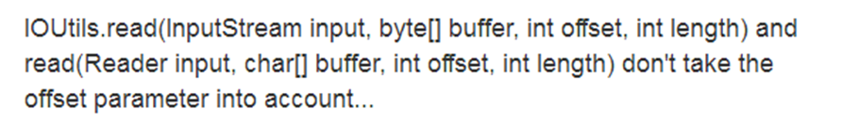

Type：Speculative Generality

reason：There are redundant parameters “offset” in the Read function

Link：

<https://issues.apache.org/jira/browse/IO-311?jql=project%20%3D%20IO%20AND%20status%20in%20(Resolved%2C%20Closed)%20ORDER%20BY%20key%20DESC>

1. IO-312

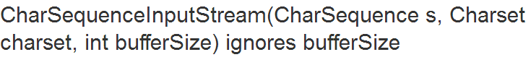

Type：Speculative Generality

Reason：There are redundant parameters “bufferSize” in the CharSequenceInputStream function

Link：

[https://issues.apache.org/jira/browse/IO-312?jql=project%20%3D%20IO%20AND%20status%20in%20(Resolved%2C%20Closed)%20ORDER%20BY%20key%20DESC](https://issues.apache.org/jira/browse/IO-311?jql=project%20%3D%20IO%20AND%20status%20in%20(Resolved%2C%20Closed)%20ORDER%20BY%20key%20DESC)

1. IO-322



Type：Data Clumps

reason：The Charsets class replaces some of the original variables and methods

Link：

[https://issues.apache.org/jira/browse/IO-322?jql=project%20%3D%20IO%20AND%20status%20in%20(Resolved%2C%20Closed)%20ORDER%20BY%20key%20DESC](https://issues.apache.org/jira/browse/IO-311?jql=project%20%3D%20IO%20AND%20status%20in%20(Resolved%2C%20Closed)%20ORDER%20BY%20key%20DESC)

1. IO-457

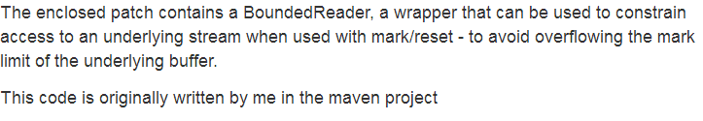

Type：Data Clumps

Reason：The BoundedReader class replaces some of the original variables and methods

Link：

[https://issues.apache.org/jira/browse/IO-457?jql=project%20%3D%20IO%20AND%20status%20in%20(Resolved%2C%20Closed)%20ORDER%20BY%20key%20DESC](https://issues.apache.org/jira/browse/IO-311?jql=project%20%3D%20IO%20AND%20status%20in%20(Resolved%2C%20Closed)%20ORDER%20BY%20key%20DESC)

1. IO-459

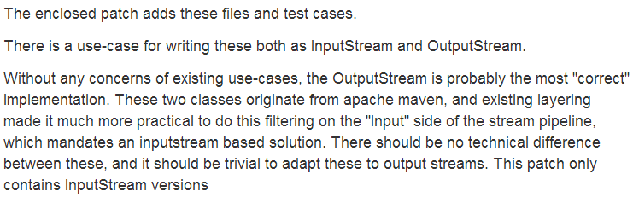

Type：Data Clumps

Reason：The WindowsLineEndingInputStream and UnixLineEndingInputStreamr class replaces some of the original variables and methods

Link：

[https://issues.apache.org/jira/browse/IO-459?jql=project%20%3D%20IO%20AND%20status%20in%20(Resolved%2C%20Closed)%20ORDER%20BY%20key%20DESC](https://issues.apache.org/jira/browse/IO-311?jql=project%20%3D%20IO%20AND%20status%20in%20(Resolved%2C%20Closed)%20ORDER%20BY%20key%20DESC)