Group 5 Name(s): Hien Nguyen, Reese Gregory, Andrew Thornton, Robert Fernandez

ISQS 3358-001

GIC #1

October 4th, 2019

1. **Database Table Design**

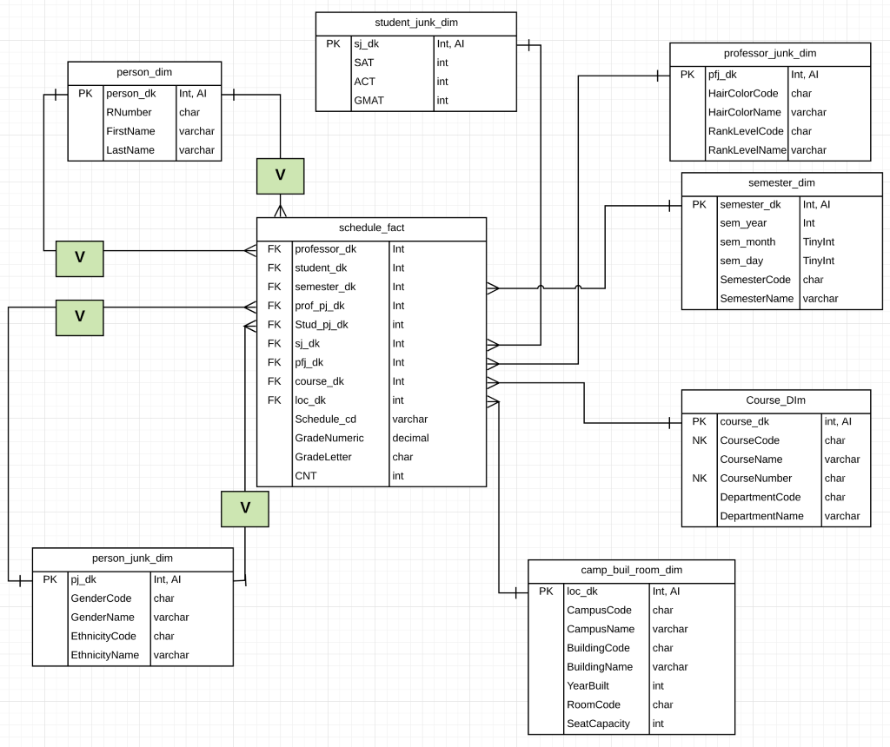

1. **SQL queries**
   1. select distinct concat(FirstName, ‘ ‘, LastName) as Professor_Name

from person_dim pd

inner join schedule_fact sf on pd.person_dk = sf.student_dk

where person_dk in (select professor_dk from schedule_fact);

1. select concat(SemesterName, ‘ ‘, sem_year) as Semester,

(count(course_dk)/count(distinct(student_dk))) as AvgCoursesTaken

from schedule_fact sf, semester_dim sd

where sf.semester_dk = sd.semester_dk

group by Semester;

1. select sf.loc_dk, concat(sd.SemesterName, ‘ ‘, sd.sem_year) as Semester,

(sum(sf.cnt)/ld.SeatCapacity) as RoomUtilization,

ld.RoomCode, ld.BuildingName

from schedule_fact sf

inner join location_dim ld on sf.loc_dk = ld.loc_dk

Inner join semester_dim sd on sf.semester_dk = sd.semester_dk

group by sf.loc_dk, Semester, ld.BuildingName, ld.RoomCode

order by Semester;

1. **Statement of Granularity for the fact tables**

One row per individual student performance rating in each course taken every semester.

1. **Statement of Dimensional History applied to each dimension table**

Type 0: N/A

Type 1: student_junk_dim, professor_junk_dim, person_junk_dim

Type 2: camp_buil_room_dim, person_dim, course_dim

Type 3: N/A