R PROGRAMMING • LAB RECORD

CALCULATOR
PROGRAMS IN R
Simple Calculator | Scientific Calculator
RStudio Practical • Menu-driven arithmetic and scientific operations

STUDENT & COURSE DETAILS
STUDENT NAME | HYDERABAD MOHAMMED NAWAZ
REGISTER NUMBER | 192325060
COURSE NAME | R PROGRAMMING
COURSE CODE | ITA0404

R PROGRAMMING LAB • ITA0404
PROGRAMMING • INPUT • PROCESSING • OUTPUT

QUESTION 1
Design and implement a Simple Calculator in R to perform addition, subtraction, multiplication, and division based on the user's choice.
PROGRAM
# SIMPLE CALCULATOR
cat("===== SIMPLE CALCULATOR =====\n")
num1 <- as.numeric(readline("Enter first number: "))
num2 <- as.numeric(readline("Enter second number: "))
cat("\n1 - Addition")
cat("\n2 - Subtraction")
cat("\n3 - Multiplication")
cat("\n4 - Division\n")
choice <- as.numeric(readline("Enter your choice: "))
if (choice == 1) {
cat("Result =", num1 + num2, "\n")
} else if (choice == 2) {
cat("Result =", num1 - num2, "\n")
} else if (choice == 3) {
cat("Result =", num1 * num2, "\n")
} else if (choice == 4) {
if (num2 == 0) {
cat("Cannot divide by zero\n")
} else {
cat("Result =", num1 / num2, "\n")
}
} else {
cat("Invalid choice\n")
}
OUTPUT
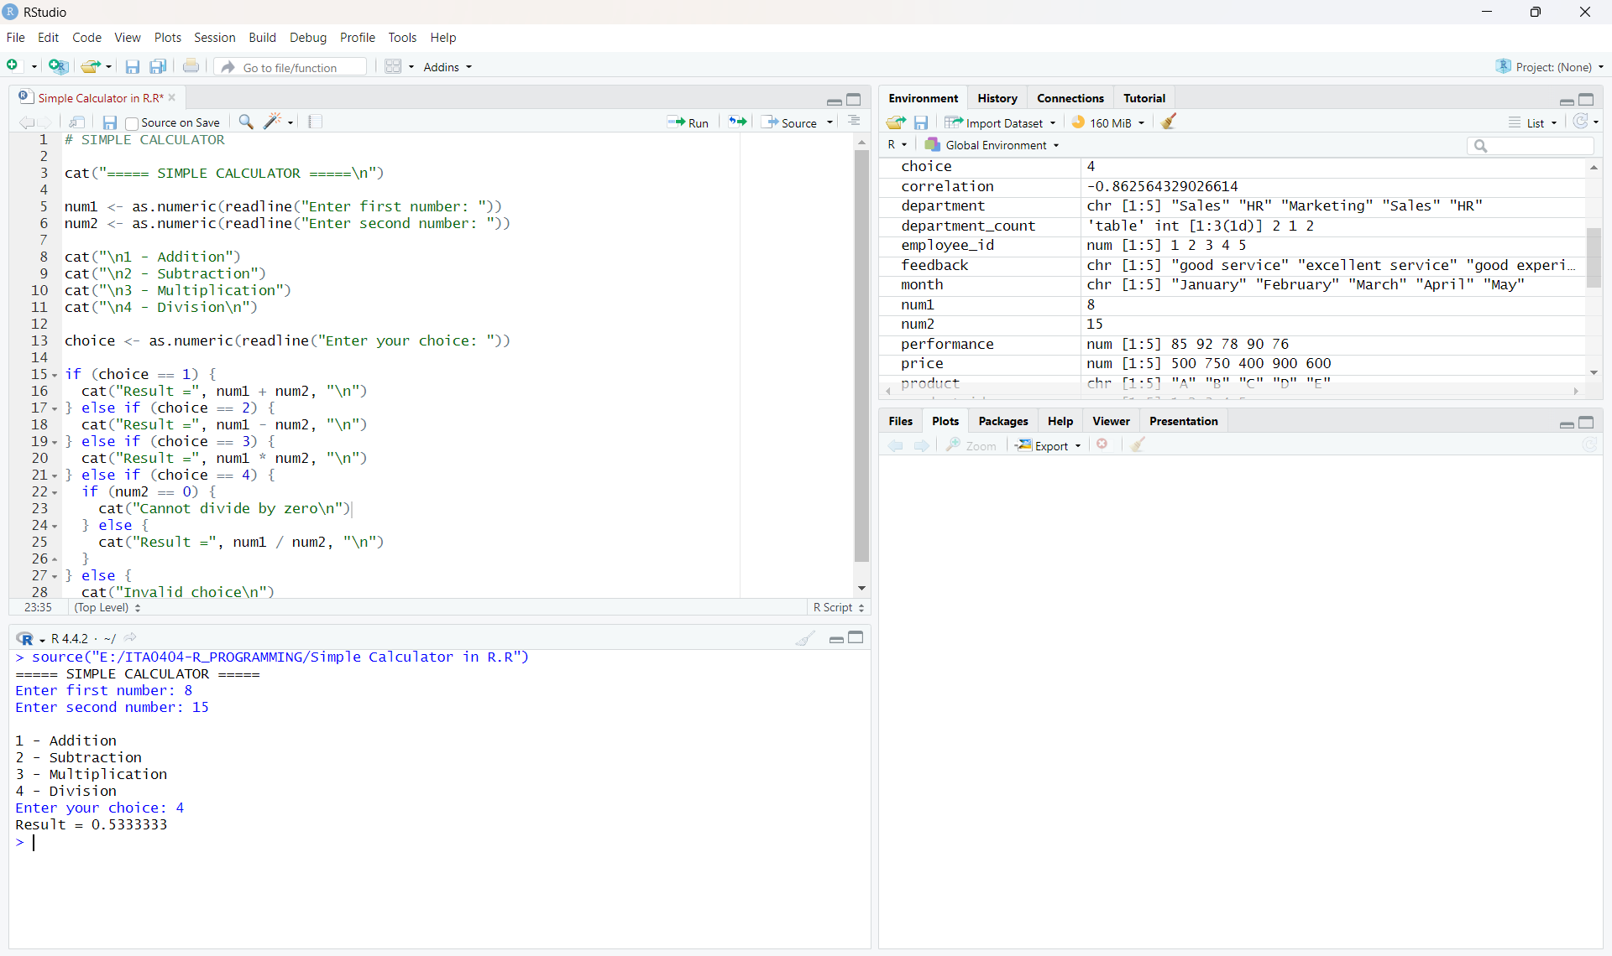

QUESTION 2
Design and implement a Scientific Calculator in R to perform arithmetic, power, square root, logarithm, exponential, trigonometric, and factorial operations.
PROGRAM
# SCIENTIFIC CALCULATOR IN R
cat("========== SCIENTIFIC CALCULATOR ==========\n")
cat("1. Addition\n")
cat("2. Subtraction\n")
cat("3. Multiplication\n")
cat("4. Division\n")
cat("5. Power\n")
cat("6. Square Root\n")
cat("7. Logarithm\n")
cat("8. Exponential\n")
cat("9. Sine\n")
cat("10. Cosine\n")
cat("11. Tangent\n")
cat("12. Factorial\n")
cat("============================================\n")
choice <- as.integer(readline("Enter your choice: "))
if (choice >= 1 && choice <= 5) {
a <- as.numeric(readline("Enter first number: "))
b <- as.numeric(readline("Enter second number: "))
if (choice == 1) {
result <- a + b
} else if (choice == 2) {
result <- a - b
} else if (choice == 3) {
result <- a * b
} else if (choice == 4) {
if (b == 0) {
result <- "Cannot divide by zero"
} else {
result <- a / b
}
} else {
result <- a ^ b
}
} else if (choice == 6) {
a <- as.numeric(readline("Enter a number: "))
result <- sqrt(a)
} else if (choice == 7) {
a <- as.numeric(readline("Enter a number: "))
result <- log(a)
} else if (choice == 8) {
a <- as.numeric(readline("Enter a number: "))
result <- exp(a)
} else if (choice == 9) {
a <- as.numeric(readline("Enter angle in degrees: "))
result <- sin(a * pi / 180)
} else if (choice == 10) {
a <- as.numeric(readline("Enter angle in degrees: "))
result <- cos(a * pi / 180)
} else if (choice == 11) {
a <- as.numeric(readline("Enter angle in degrees: "))
result <- tan(a * pi / 180)
} else if (choice == 12) {
a <- as.integer(readline("Enter a non-negative integer: "))
result <- factorial(a)
} else {
result <- "Invalid choice"
}
cat("\nResult:", result, "\n")
OUTPUT
