DSA0601 • DATA HANDLING AND VISUALIZATION
SET 5: WEBSITE ANALYTICS
Department | AIML
Course Code / Course Name | DSA0601 / Data Handling and Visualization
Experiment | Data Visualization using R and Tableau
Name | HYDERABAD MOHAMMED NAWAZ
Register Number | 192325060
Date | 01 October 2026
Day | Wednesday

Dataset: Website Traffic
Date | Page Views | Click-through Rate
2023-01-01 | 1500 | 2.3%
2023-01-02 | 1600 | 2.7%
2023-01-03 | 1400 | 2.0%
2023-01-04 | 1650 | 2.4%
2023-01-05 | 1800 | 2.6%

PROGRAM 1: Daily Page Views Line Chart
Create a line chart to visualize the trend in daily page views over time. Label the axes and title the chart.
date <- as.Date(c("2023-01-01","2023-01-02","2023-01-03",
"2023-01-04","2023-01-05"))
page_views <- c(1500,1600,1400,1650,1800)
plot(date, page_views, type="o",
xlab="Date", ylab="Page Views",
main="Daily Page Views", pch=16)

Output 1: Daily Page Views Line Chart
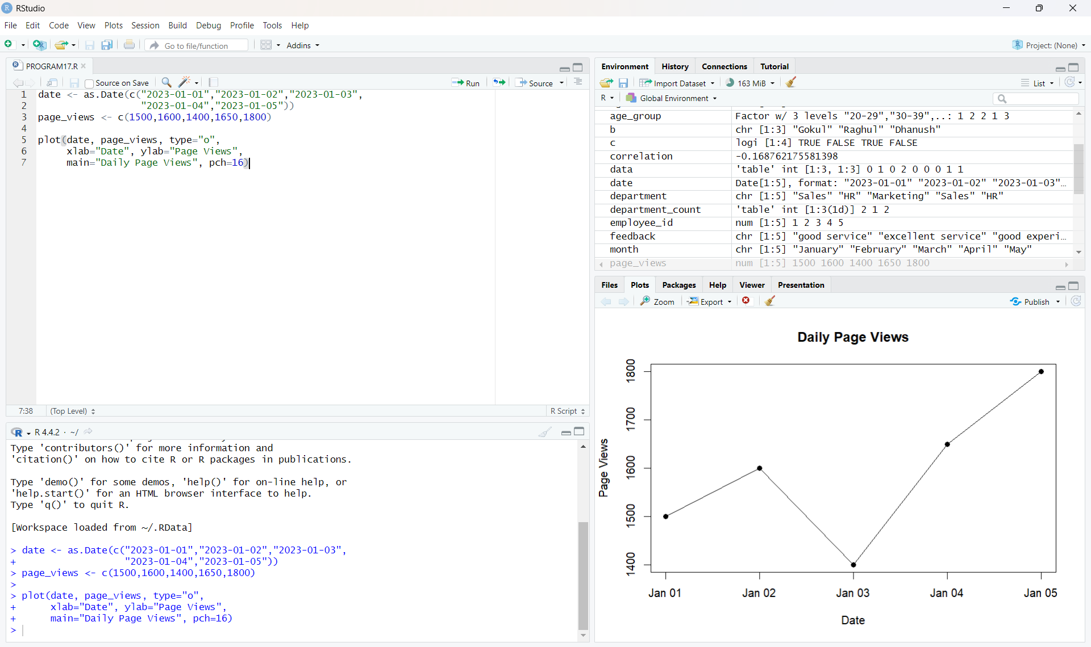
Observation: The page views are 1500, 1600, 1400, 1650 and 1800 from January 1 to January 5. The highest value is 1800 on January 5.
PROGRAM 2: Top N Days by Click-through Rate
Generate a bar chart showing the top N days with the highest click-through rates. N = 3 is used.
date <- c("2023-01-01","2023-01-02","2023-01-03",
"2023-01-04","2023-01-05")
ctr <- c(2.3,2.7,2.0,2.4,2.6)
n <- 3
top <- order(ctr, decreasing=TRUE)[1:n]
barplot(ctr[top], names.arg=date[top],
xlab="Date", ylab="Click-through Rate (%)",
main="Top 3 Click-through Rates", col="skyblue")
text(seq_along(top), ctr[top],
labels=paste0(ctr[top], "%"), pos=3)

Output 2: Top 3 Click-through Rate Bar Chart
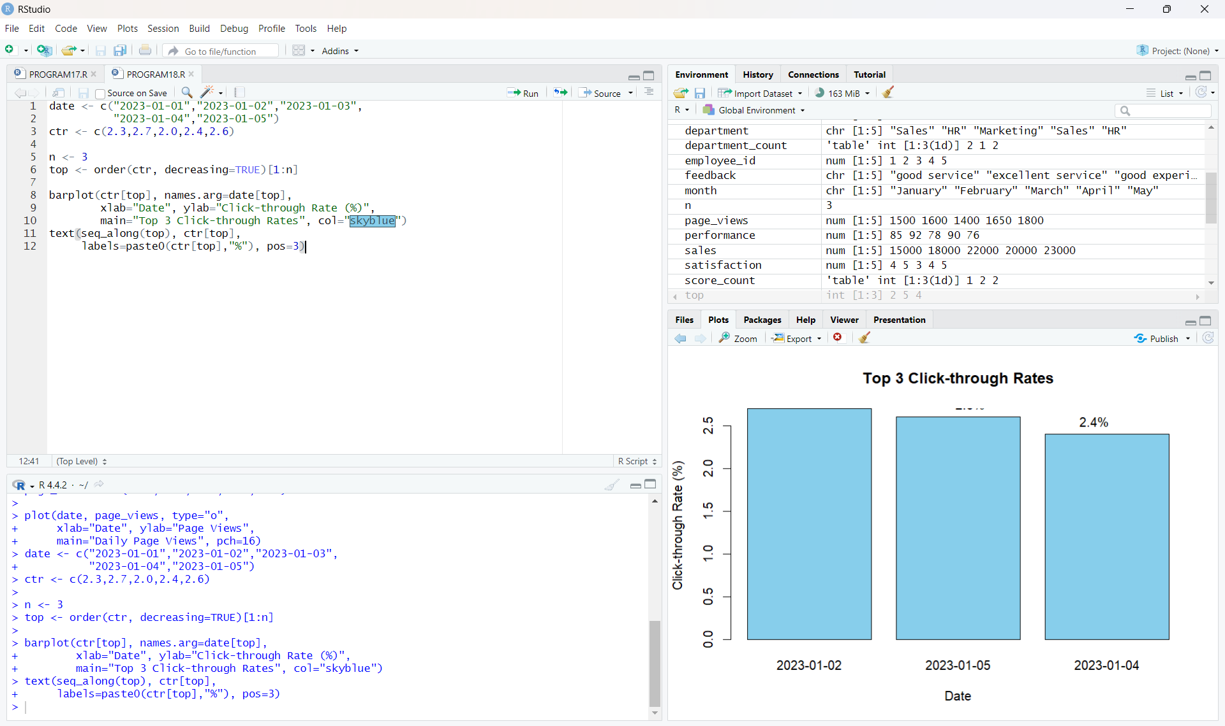
Observation: The bars are arranged in descending order: 2023-01-02 (2.7%), 2023-01-05 (2.6%), and 2023-01-04 (2.4%).
PROGRAM 3: Stacked Area Chart of User Interactions
Develop a stacked area chart to display the distribution of user interactions (likes, shares, comments) on a website.
Tableau configuration:
Columns : DAY(Date)
Rows : Measure Values
Marks : Area
Color : Measure Names
Measures : Likes, Shares, Comments
Keep Measure Names on Color and Measure Values on Rows
to create the stacked area chart.

Output 3: Stacked Area Chart of User Interactions
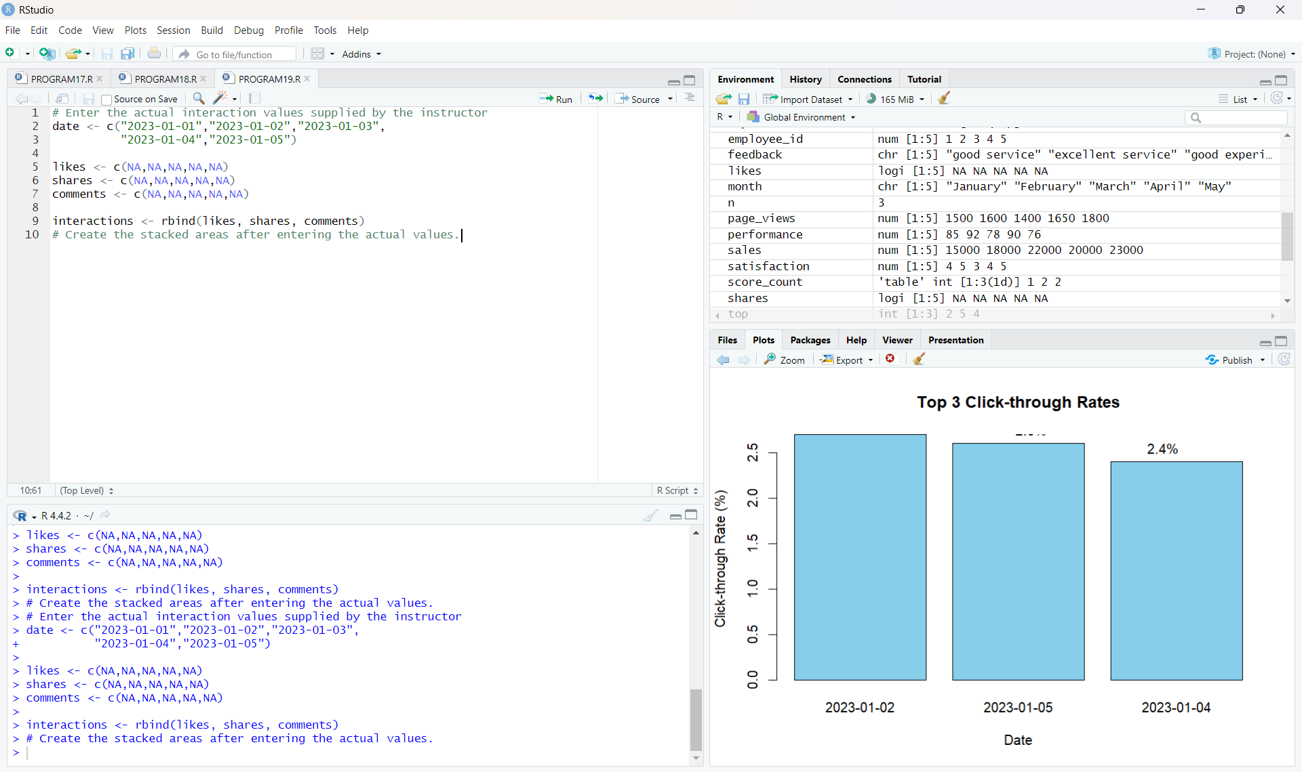
Observation: The checked Tableau output shows Likes, Shares and Comments as stacked areas over time, separated by the Measure Names legend.
PROGRAM 4: Tableau Website Analytics Dashboard
Build a Tableau dashboard with the line chart, bar chart, and stacked area chart for interactive exploration of website traffic data.
Tableau dashboard:
1. Create the three worksheets:
- Daily Page Views Line Chart
- Top Days by Click-through Rate
- Website User Interactions Over Time
2. Open Dashboard and add all three worksheets.
3. Resize and arrange the worksheets for readability.
4. Keep the Measure Names legend visible.
5. Use clear titles for all charts.

Output 4: Website Analytics Tableau Dashboard
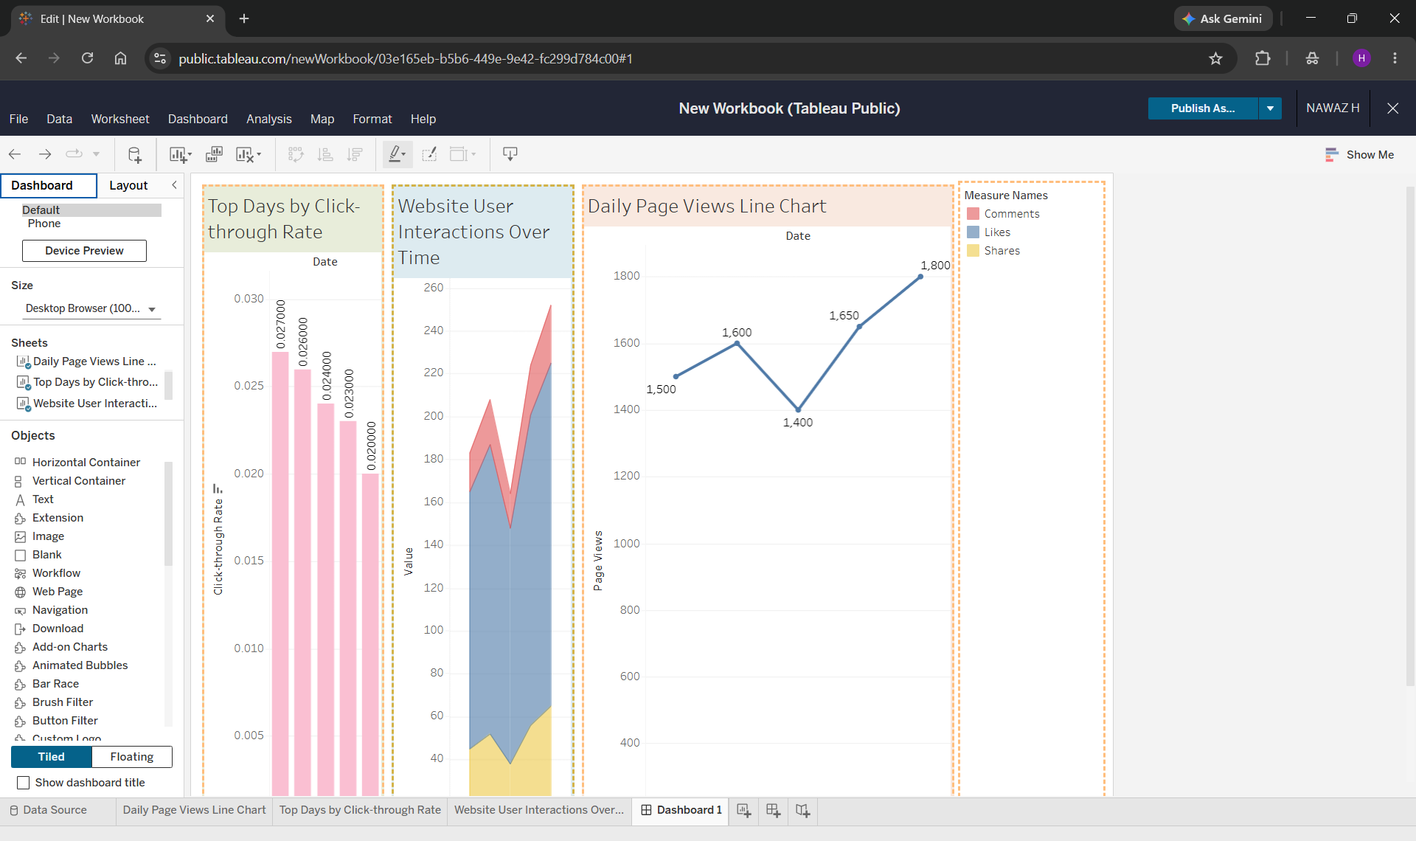
Observation: The final dashboard combines the daily page-view trend, descending click-through-rate comparison, and stacked user-interaction chart in one Tableau view.
RESULT
The Website Analytics experiment was successfully completed. Daily page views were visualized using a line chart, the top three click-through-rate days were identified in descending order using a bar chart, user interactions were represented using a stacked area chart in Tableau, and the visualizations were combined into a Tableau dashboard.

