LAB EXPERIMENT RECORD
Set 10: Survey Responses Analysis
Department | AIML
Course Code / Course Name | DSA0601 / Data Handling and Visualization
Experiment | Data Visualization using R and Tableau
Name | HYDERABAD MOHAMMED NAWAZ
Register Number | 192325060
Date | 05 October 2026
Day | Monday

Aim
To analyze survey response data using a bar chart, stacked bar chart, and tabular representation, and to develop a Tableau dashboard combining the visualizations for interactive exploration.
Dataset: Survey Responses
Survey ID | Question 1 | Question 2 | Question 3
1 | A | B | C
2 | B | A | D
3 | C | A | B

PROGRAM 1: Grouped Bar Chart for Question 1
Create a grouped bar chart to visualize the distribution of answers for Question 1. Label the chart elements.
# Program 1: Grouped Bar Chart for Question 1
responses_q1 <- c("A", "B", "C")
counts <- table(responses_q1)
barplot(counts,
beside = TRUE,
main = "Question 1 Response Distribution",
xlab = "Answer",
ylab = "Number of Responses",
col = "steelblue")

Output 1: Question 1 Response Distribution
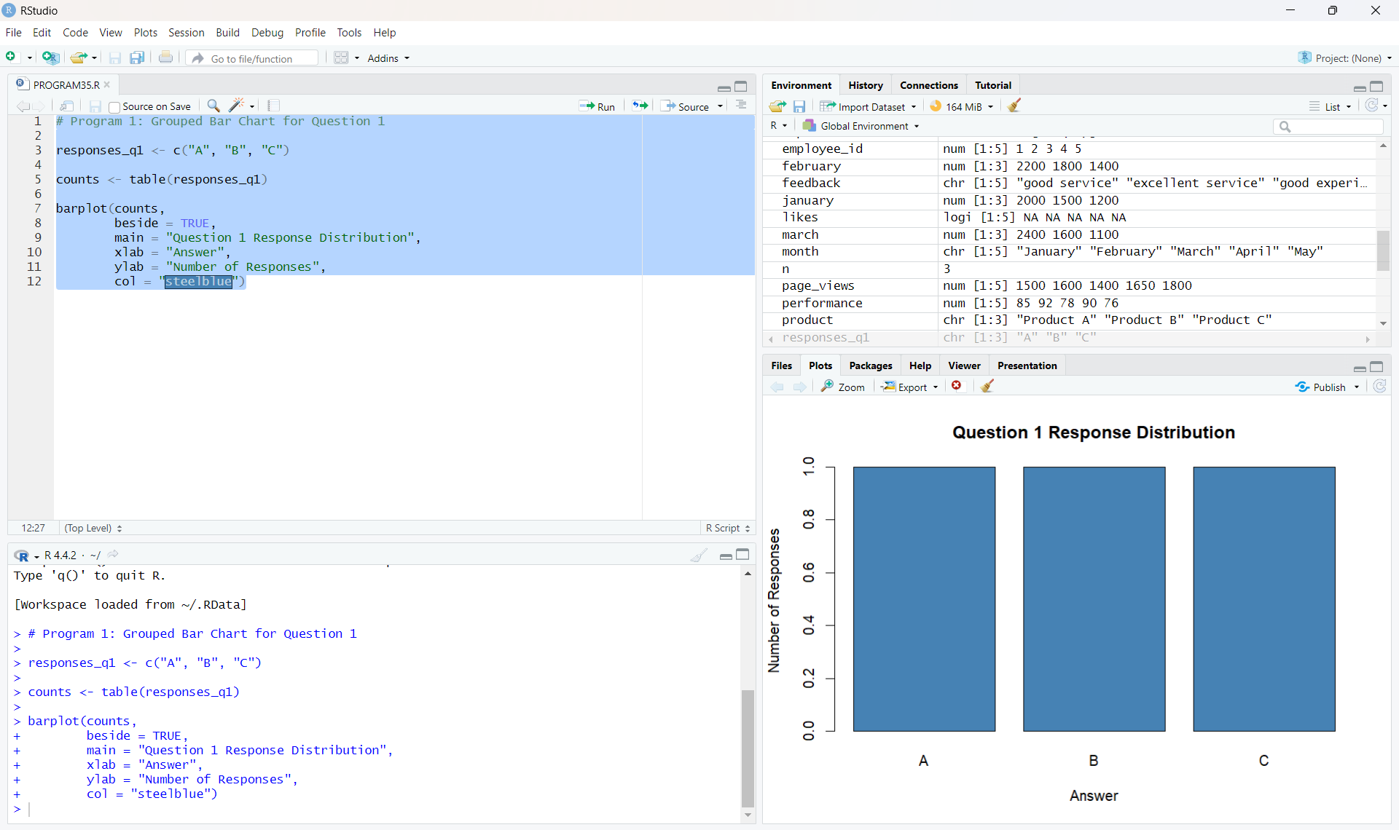
Output 1: Grouped Bar Chart for Question 1
Observation: The chart shows that answers A, B, and C each occur once in the given survey responses.

PROGRAM 2: Stacked Bar Chart for All Questions
Generate a stacked bar chart to represent the overall distribution of responses for all three questions.
# Program 2: Stacked Bar Chart for All Questions
survey_data <- matrix(c(
1, 1, 1, 0,
2, 1, 0, 0,
0, 1, 1, 1
), nrow = 3, byrow = TRUE)
colnames(survey_data) <- c("A", "B", "C", "D")
rownames(survey_data) <- c("Question 1", "Question 2", "Question 3")
barplot(survey_data,
beside = FALSE,
main = "Overall Distribution of Survey Responses",
xlab = "Question",
ylab = "Number of Responses",
col = c("steelblue", "orange", "tomato", "seagreen"),
legend.text = TRUE)

Output 2: Overall Distribution of Survey Responses
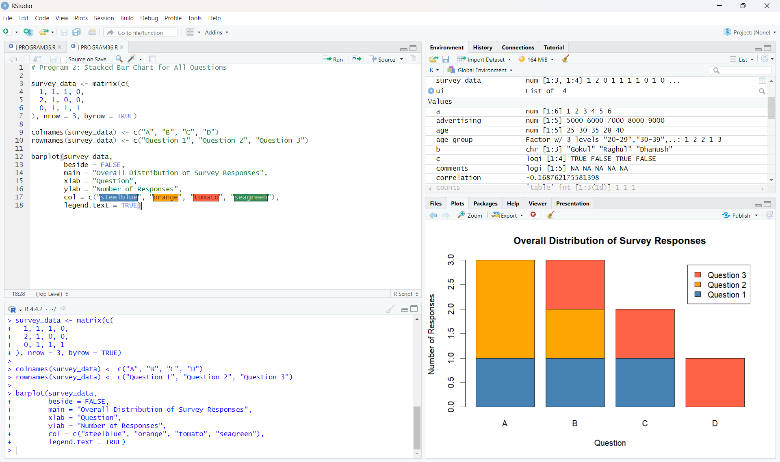
Output 2: Stacked Bar Chart for All Questions
Observation: The stacked bar chart displays the response distribution across answer categories A, B, C, and D for the three questions.

PROGRAM 3: Survey Response Table
Build a table to show the survey response data for each survey. Label the table elements.
# Program 3: Survey Response Table
survey_data <- data.frame(
Survey_ID = c(1, 2, 3),
Question_1 = c("A", "B", "C"),
Question_2 = c("B", "A", "A"),
Question_3 = c("C", "D", "B")
)
print(survey_data)

Output 3: Survey Response Table
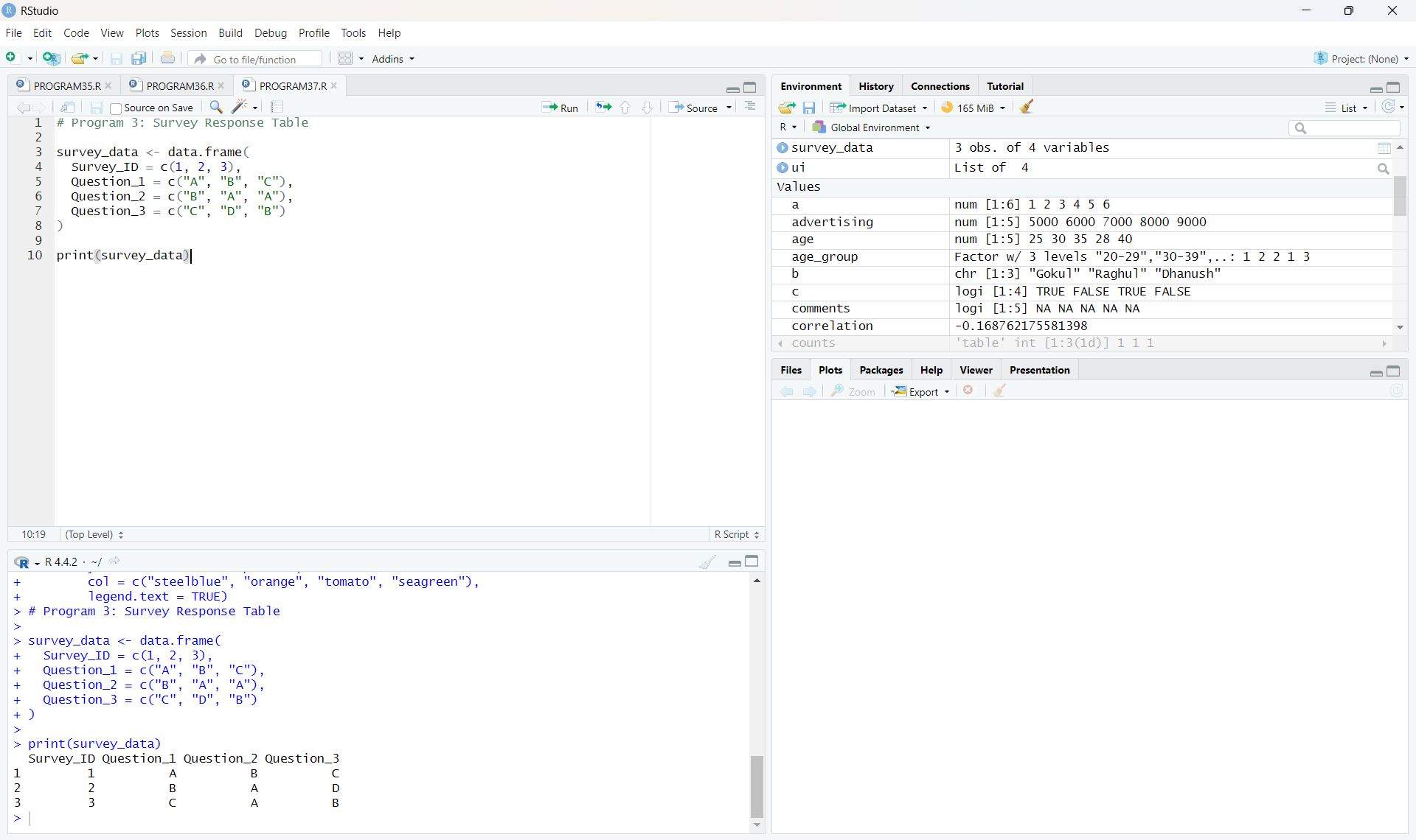
Output 3: Survey Response Table
Observation: The table displays the three survey records and their responses to Questions 1, 2, and 3.

PROGRAM 4: Tableau Dashboard
Develop a Tableau dashboard combining the grouped bar chart, stacked bar chart, and survey response table for interactive exploration of survey responses.
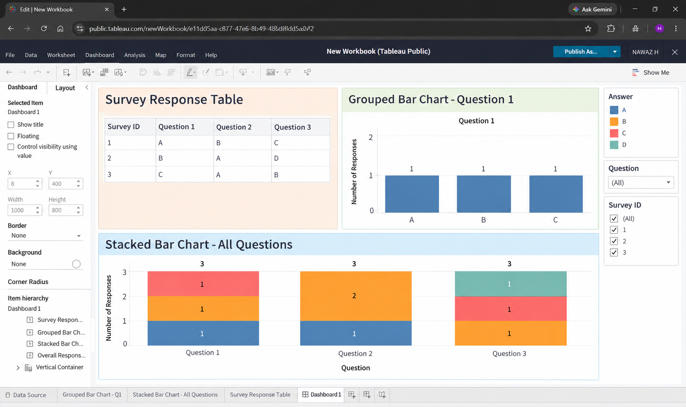
Output 4: Tableau Survey Responses Dashboard
Observation: The Tableau dashboard combines the survey response table, Question 1 bar chart, and stacked bar chart. The available filters allow the survey data to be explored interactively.

Procedure
- Create the survey response vectors and data frame in R.
- Use table() and barplot() to visualize the distribution of Question 1 responses.
- Create the response matrix and use barplot() with beside = FALSE for the stacked bar chart.
- Create and print the survey response table using data.frame().
- Enter the survey response data into Tableau and create the required worksheets.
- Combine the worksheets into a dashboard and add filters for interactive exploration.
Result
The survey response data was successfully visualized using a bar chart, stacked bar chart, and table in R. A Tableau dashboard was also created by combining the three visualizations for interactive exploration.
Key R Functions Used
Function | Purpose
table() | Creates frequency counts of survey responses.
barplot() | Creates grouped and stacked bar charts.
matrix() | Creates the response matrix for the stacked chart.
data.frame() | Creates the survey response table.
print() | Displays the survey response data.

