LAB EXPERIMENT RECORD
Set 1: Monthly Sales Data

Department | AIML
Course Code / Course Name | DSA0601 / Data Handling and Visualization
Experiment | Data Visualization using R
Name | HYDERABAD MOHAMMED NAWAZ
Register Number | 192325060
Date | 29 September 2026
Day | Tuesday

Aim
To visualize monthly sales data using a line chart, bar chart, and scatter plot, and to build an interactive dashboard using R and Shiny.
Dataset: Monthly Sales
Month | Sales ($)
January | 15000
February | 18000
March | 22000
April | 20000
May | 23000

PROGRAM 1: Line Chart of Monthly Sales
Create a line chart to visualize the monthly sales. Label the axes and title the chart appropriately.
# Dataset
month <- c("January", "February", "March", "April", "May")
sales <- c(15000, 18000, 22000, 20000, 23000)
# Line Chart
plot(sales,
type = "o",
xaxt = "n",
xlab = "Month",
ylab = "Sales ($)",
main = "Monthly Sales",
col = "blue")
axis(1, at = 1:5, labels = month)
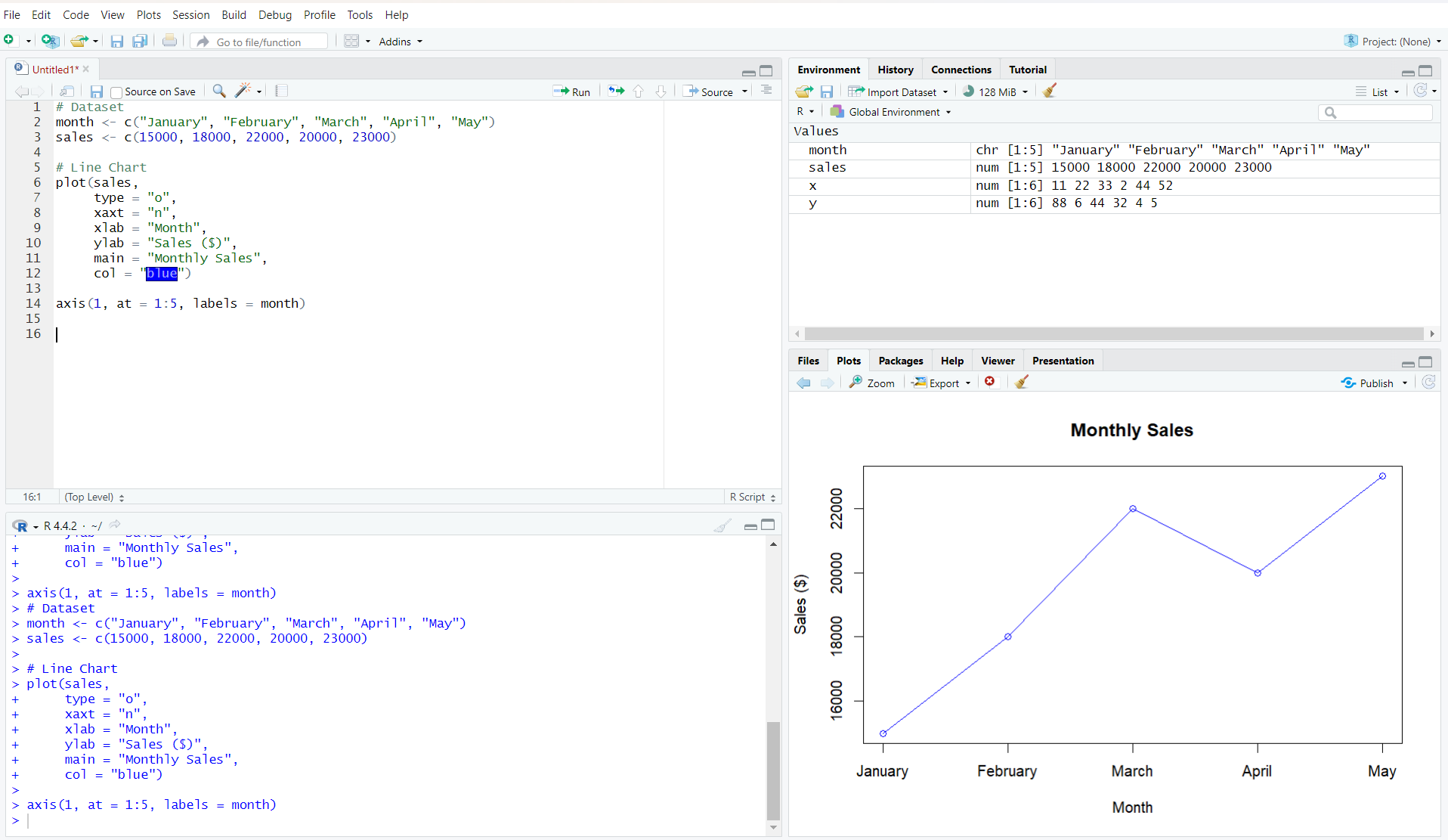
Output 1: Monthly Sales Line Chart
Observation: Sales increase from January to March, decrease slightly in April, and reach the highest value in May.

PROGRAM 2: Bar Chart of Sales
Generate a bar chart to display the sales values for the available months and label the chart elements.
# Dataset
month <- c("January", "February", "March", "April", "May")
sales <- c(15000, 18000, 22000, 20000, 23000)
# Bar Chart
barplot(sales,
names.arg = month,
xlab = "Month",
ylab = "Sales ($)",
main = "Monthly Sales",
col = "skyblue")
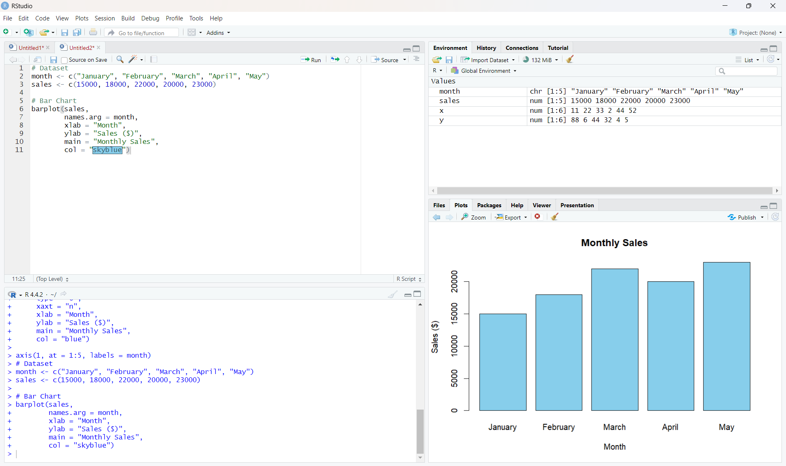
Output 2: Monthly Sales Bar Chart
Observation: The bar chart makes it easy to compare the sales of each month. May has the highest sales and January has the lowest.

PROGRAM 3: Scatter Plot of Advertising Budget vs Monthly Sales
Develop a scatter plot to explore the relationship between advertising budget and monthly sales.
# Dataset
sales <- c(15000, 18000, 22000, 20000, 23000)
advertising <- c(5000, 6000, 7000, 8000, 9000)
# Scatter Plot
plot(advertising, sales,
main = "Advertising Budget vs Monthly Sales",
xlab = "Advertising Budget ($)",
ylab = "Monthly Sales ($)",
pch = 19,
col = "red")
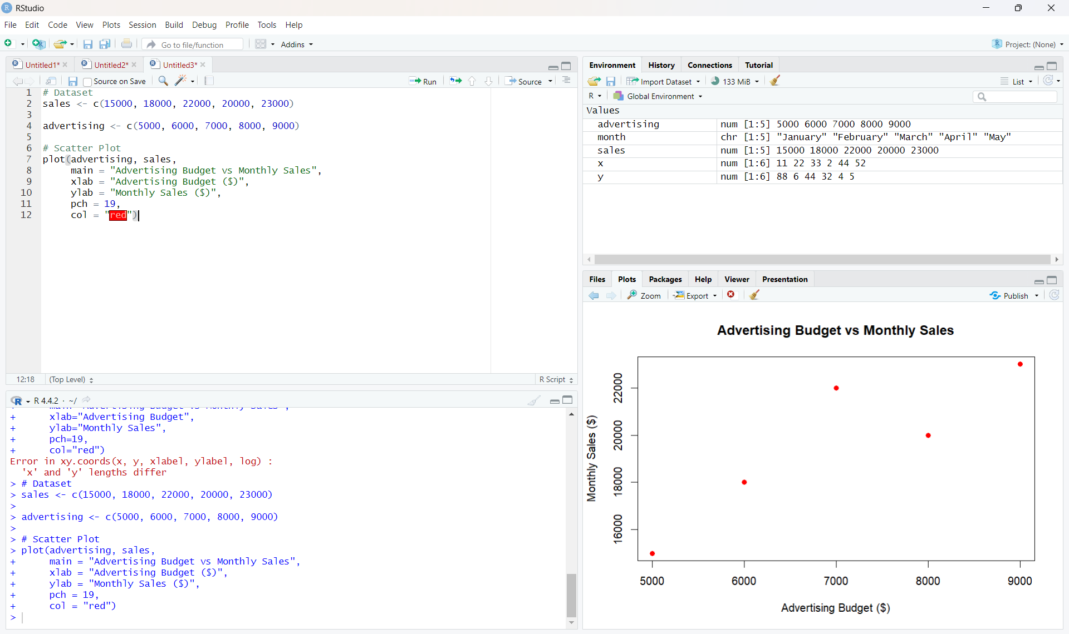
Output 3: Advertising Budget vs Monthly Sales Scatter Plot
Insight: The plotted points show a generally positive relationship: as the advertising budget increases from $5,000 to $9,000, monthly sales also generally increase. This suggests that higher advertising spending is associated with higher sales for the values plotted.
Note: The visible assignment table contains only Month and Sales. The advertising values used in the submitted R program are the five values shown in the user's executed program: 5000, 6000, 7000, 8000, and 9000.

PROGRAM 4: Interactive Sales Dashboard
Build an interactive dashboard combining the line chart and bar chart using the Shiny package.
library(shiny)
month <- c("January", "February", "March", "April", "May")
sales <- c(15000, 18000, 22000, 20000, 23000)
ui <- fluidPage(
titlePanel("Monthly Sales Dashboard"),
sidebarLayout(
sidebarPanel(
selectInput("chart",
"Select Chart:",
choices = c("Line Chart", "Bar Chart"))
),
mainPanel(
plotOutput("salesPlot")
)
)
)
server <- function(input, output) {
output$salesPlot <- renderPlot({
if (input$chart == "Line Chart") {
plot(sales,
type = "o",
xaxt = "n",
xlab = "Month",
ylab = "Sales ($)",
main = "Monthly Sales")
axis(1, at = 1:5, labels = month)
} else {
barplot(sales,
names.arg = month,
xlab = "Month",
ylab = "Sales ($)",
main = "Monthly Sales")
}
})
}
shinyApp(ui = ui, server = server)
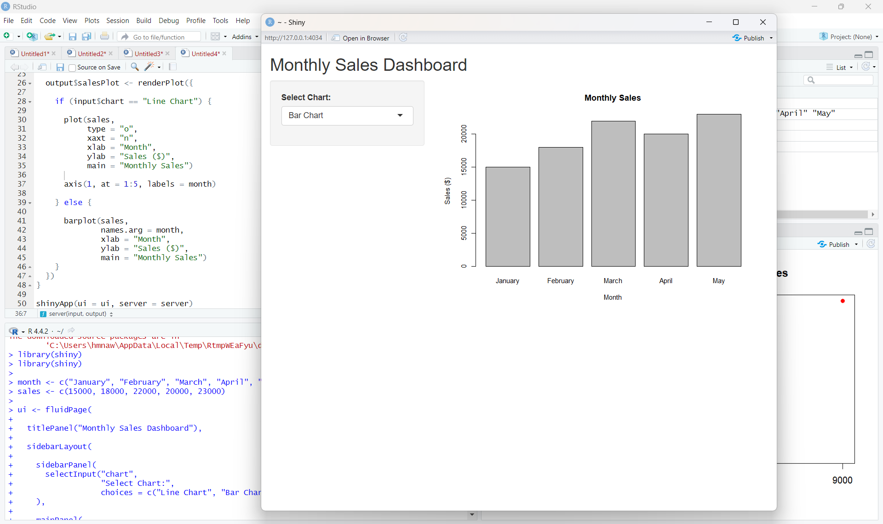
Output 4: Interactive Monthly Sales Dashboard
Observation: The dashboard provides a chart-selection control. Selecting Line Chart displays the monthly trend, while selecting Bar Chart displays the monthly sales comparison.

Procedure
1. Create the required month and sales vectors in R.
2. Use plot() to create the line chart with appropriate axis labels and title.
3. Use barplot() to compare the sales values for the available months.
4. Create advertising-budget and sales vectors of equal length and use plot() for the scatter plot.
5. Install and load the Shiny package, then create the UI and server components for the interactive dashboard.
6. Run the Shiny application and switch between the Line Chart and Bar Chart using the selection box.
Result
The monthly sales data was successfully visualized using line, bar, and scatter charts. An interactive Shiny dashboard was also created to switch between the line chart and bar chart.
Key R Functions Used
Function | Purpose
plot() | Creates line and scatter plots.
axis() | Adds custom axis labels.
barplot() | Creates bar charts.
fluidPage() | Creates the Shiny page layout.
selectInput() | Provides the chart selection control.
renderPlot() | Generates plots dynamically in Shiny.
shinyApp() | Runs the interactive Shiny application.

SET 2: CUSTOMER FEEDBACK ANALYSIS
Dataset: Customer Satisfaction
Dataset: Customer Satisfaction
Customer ID | Age | Satisfaction Score
1 | 25 | 4
2 | 30 | 5
3 | 35 | 3
4 | 28 | 4
5 | 40 | 5

PROGRAM 1: Histogram of Customer Ages
Create a histogram to represent the distribution of customer ages. Label the axes and title the chart.
# Dataset
age <- c(25, 30, 35, 28, 40)
# Histogram
hist(age,
main = "Distribution of Customer Ages",
xlab = "Age",
ylab = "Frequency",
col = "skyblue")
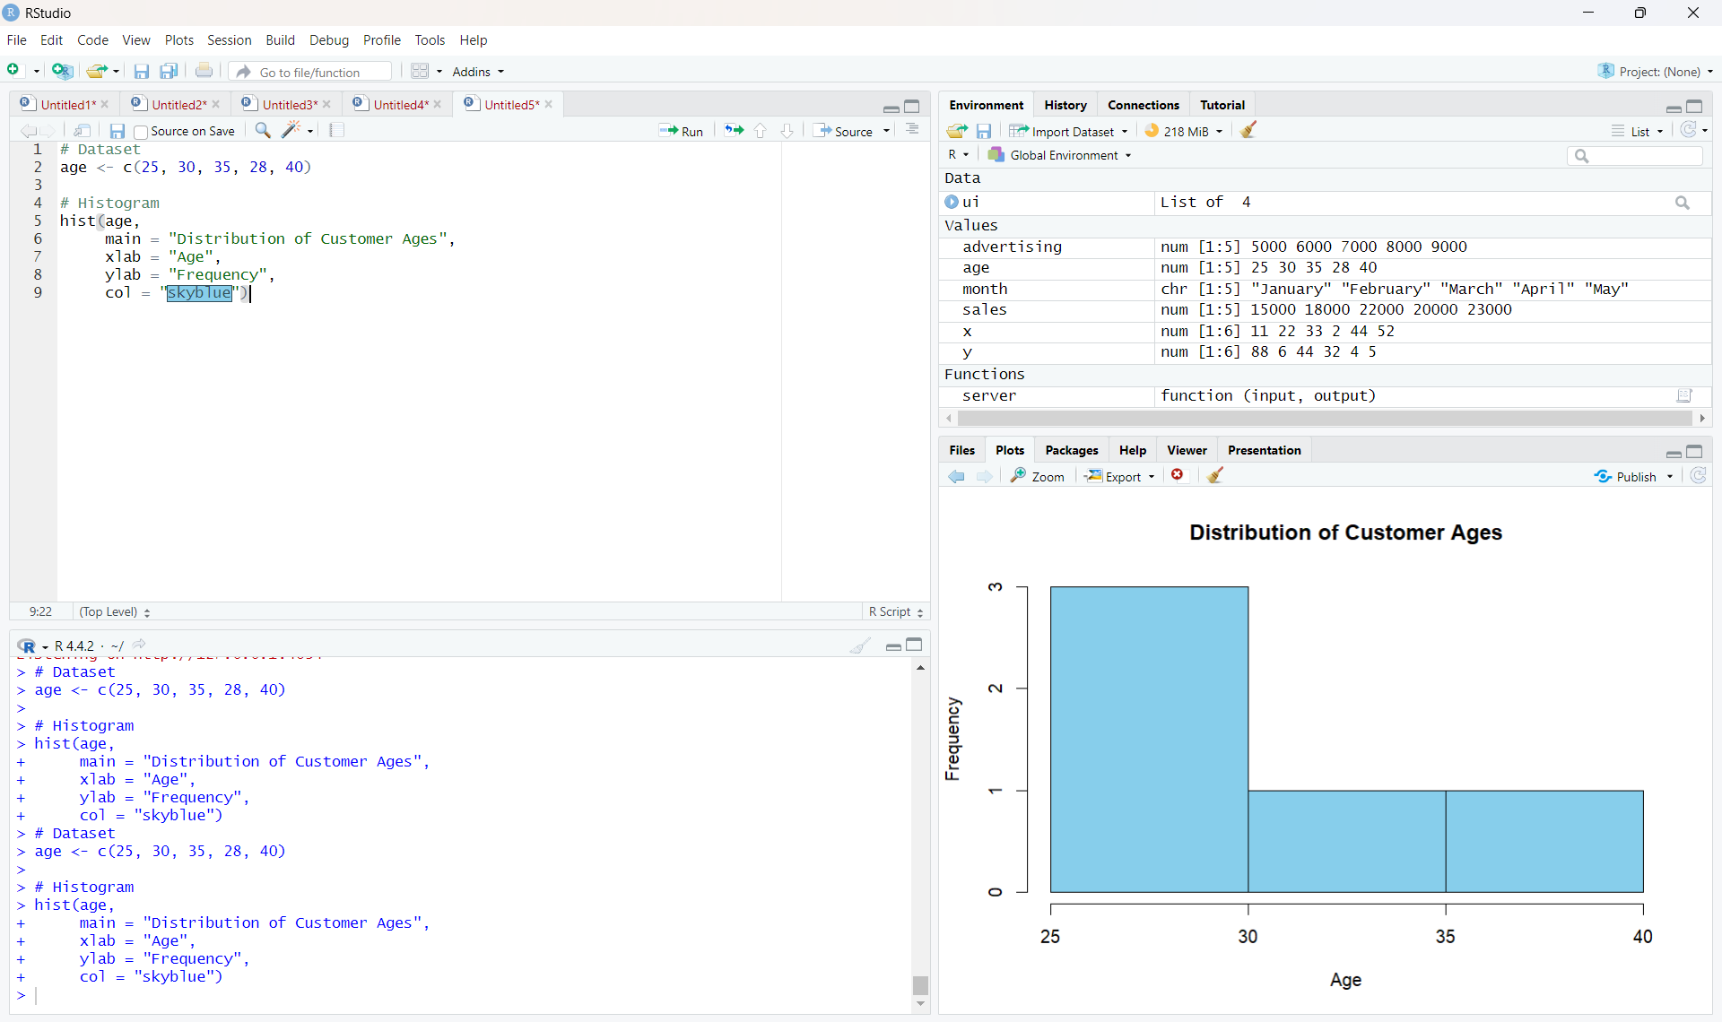
Output 1: Distribution of Customer Ages
Observation: The histogram represents the distribution of the five customer ages in the given dataset.
PROGRAM 2: Pie Chart of Satisfaction Scores
Generate a pie chart to display the overall distribution of customer satisfaction scores and include labels.
# Satisfaction scores
satisfaction <- c(4, 5, 3, 4, 5)
# Calculate frequency
score_count <- table(satisfaction)
# Pie Chart
pie(score_count,
labels = paste(names(score_count), "Score"),
main = "Customer Satisfaction Scores")
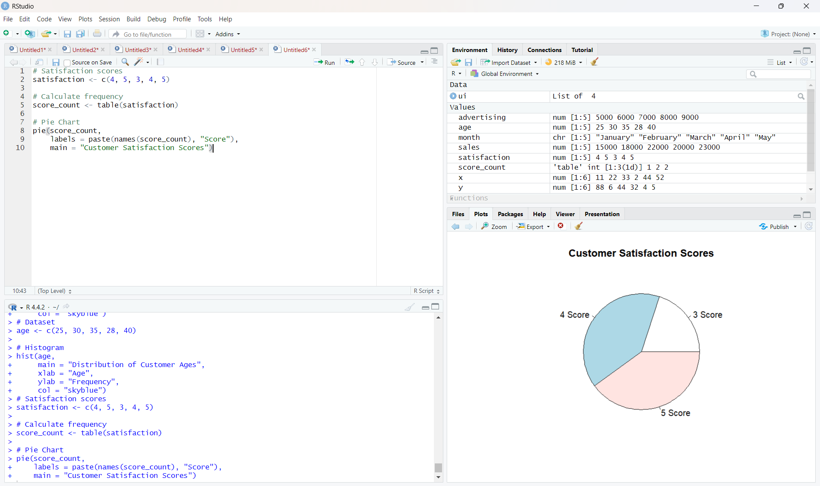
Output 2: Customer Satisfaction Scores Pie Chart
Observation: Scores 4 and 5 each occur twice, while score 3 occurs once.
PROGRAM 3: Stacked Bar Chart by Age Group
Build a stacked bar chart to visualize the distribution of customer satisfaction scores by age group.
# Dataset
age <- c(25, 30, 35, 28, 40)
satisfaction <- c(4, 5, 3, 4, 5)
# Create age groups
age_group <- cut(age,
breaks = c(20, 29, 39, 49),
labels = c("20-29", "30-39", "40-49"))
# Create table
data <- table(age_group, satisfaction)
# Stacked Bar Chart
barplot(data,
beside = FALSE,
main = "Satisfaction Scores by Age Group",
xlab = "Age Group",
ylab = "Number of Customers",
col = c("skyblue", "lightgreen", "orange"),
legend.text = TRUE)
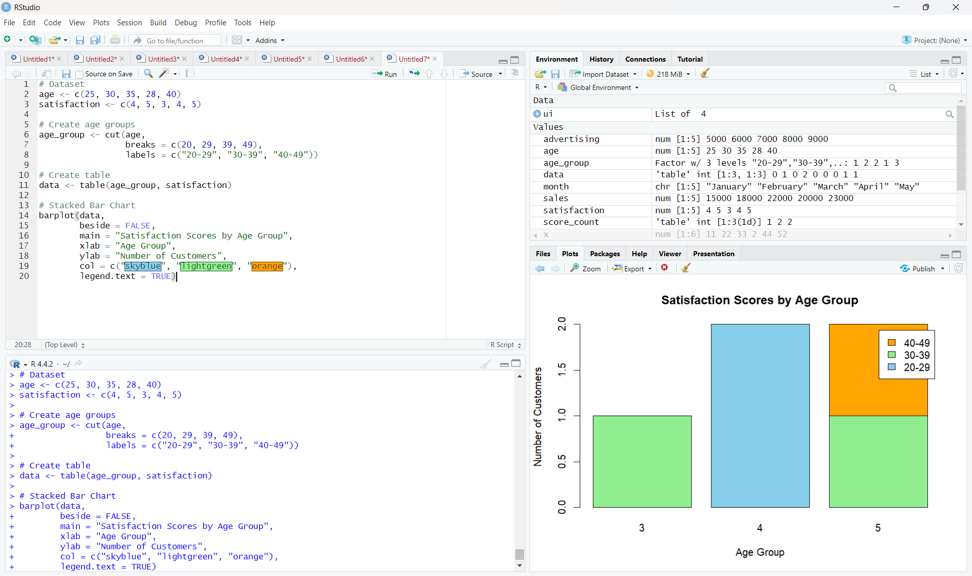
Output 3: Satisfaction Scores by Age Group
Observation: The code creates three age groups and stacks the satisfaction-score frequencies for each group.
Note: The supplied RStudio screenshot is inserted exactly as captured, including its displayed x-axis labels.
PROGRAM 4: Word Cloud of Customer Feedback
Develop a word cloud from open-ended customer feedback to identify prevalent customer sentiments.
library(wordcloud)
library(RColorBrewer)
feedback <- c(
"good service",
"excellent service",
"good experience",
"friendly staff",
"excellent service"
)
words <- unlist(strsplit(tolower(feedback), " "))
word_count <- table(words)
wordcloud(names(word_count),
freq = word_count,
min.freq = 1,
scale = c(3, 0.5),
colors = brewer.pal(8, "Dark2"),
random.order = FALSE)
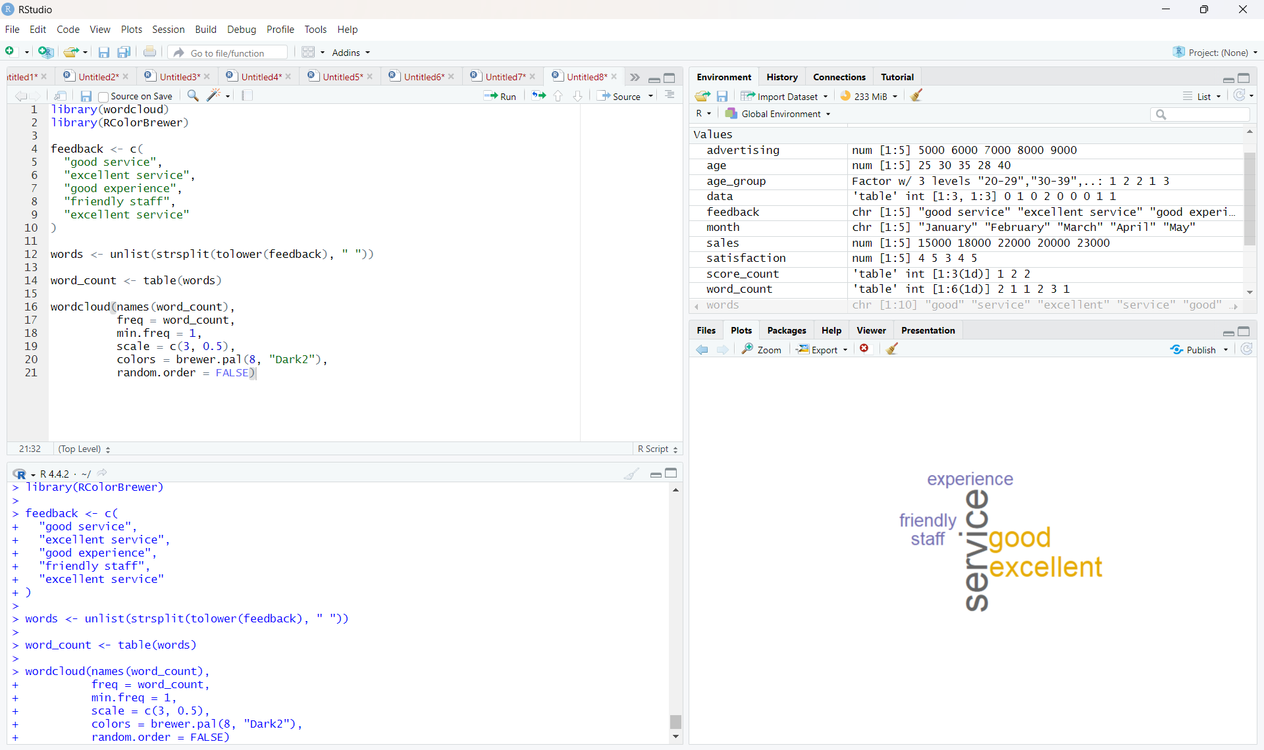
Output 4: Customer Feedback Word Cloud
Observation: The word cloud highlights frequently occurring terms in the supplied sample feedback, including service, excellent, good, friendly, and experience.
Set 2 Procedure
1. Create vectors for customer age and satisfaction score.
2. Use hist() to represent the distribution of customer ages.
3. Use table() and pie() to display the satisfaction score distribution.
4. Create age groups using cut(), form a frequency table, and use barplot() for the stacked bar chart.
5. Prepare open-ended feedback text, count the words, and use wordcloud() to visualize frequent terms.
Set 2 Result
The customer satisfaction data was successfully visualized using a histogram, pie chart, stacked bar chart, and word cloud.

Set 3: Employee Performance Evaluation
DSA0601 • DATA HANDLING AND VISUALIZATION
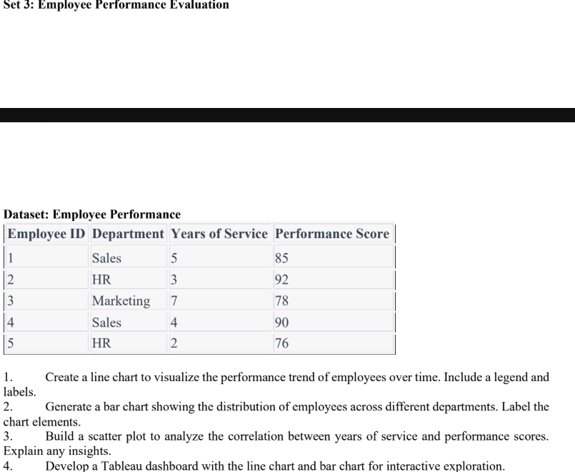
Set 3 Assignment: Employee Performance Evaluation

Dataset: Employee Performance
Employee ID | Department | Years of Service | Performance Score
1 | Sales | 5 | 85
2 | HR | 3 | 92
3 | Marketing | 7 | 78
4 | Sales | 4 | 90
5 | HR | 2 | 76

PROGRAM 1: Employee Performance Line Chart
Create a line chart to visualize the performance trend of employees. Include a legend and labels.
# Dataset
employee_id <- c(1, 2, 3, 4, 5)
performance <- c(85, 92, 78, 90, 76)
# Line Chart
plot(employee_id, performance,
type = "o",
xlab = "Employee ID",
ylab = "Performance Score",
main = "Employee Performance Trend",
col = "blue",
pch = 19)
# Legend
legend("topright",
legend = "Performance Score",
col = "blue",
lty = 1,
pch = 19)
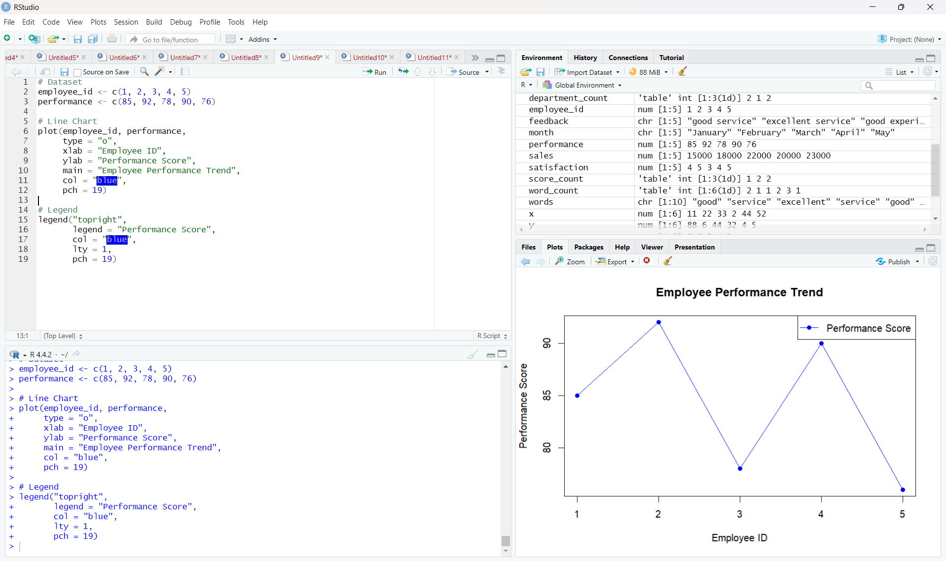
Output 1: Employee Performance Trend
Observation: Employee 2 has the highest performance score of 92, while Employee 5 has the lowest score of 76.

PROGRAM 2: Department Bar Chart
Generate a bar chart showing the distribution of employees across different departments.
# Dataset
department <- c("Sales", "HR", "Marketing", "Sales", "HR")
# Count employees in each department
department_count <- table(department)
# Bar Chart
barplot(department_count,
main = "Employees by Department",
xlab = "Department",
ylab = "Number of Employees",
col = "skyblue")
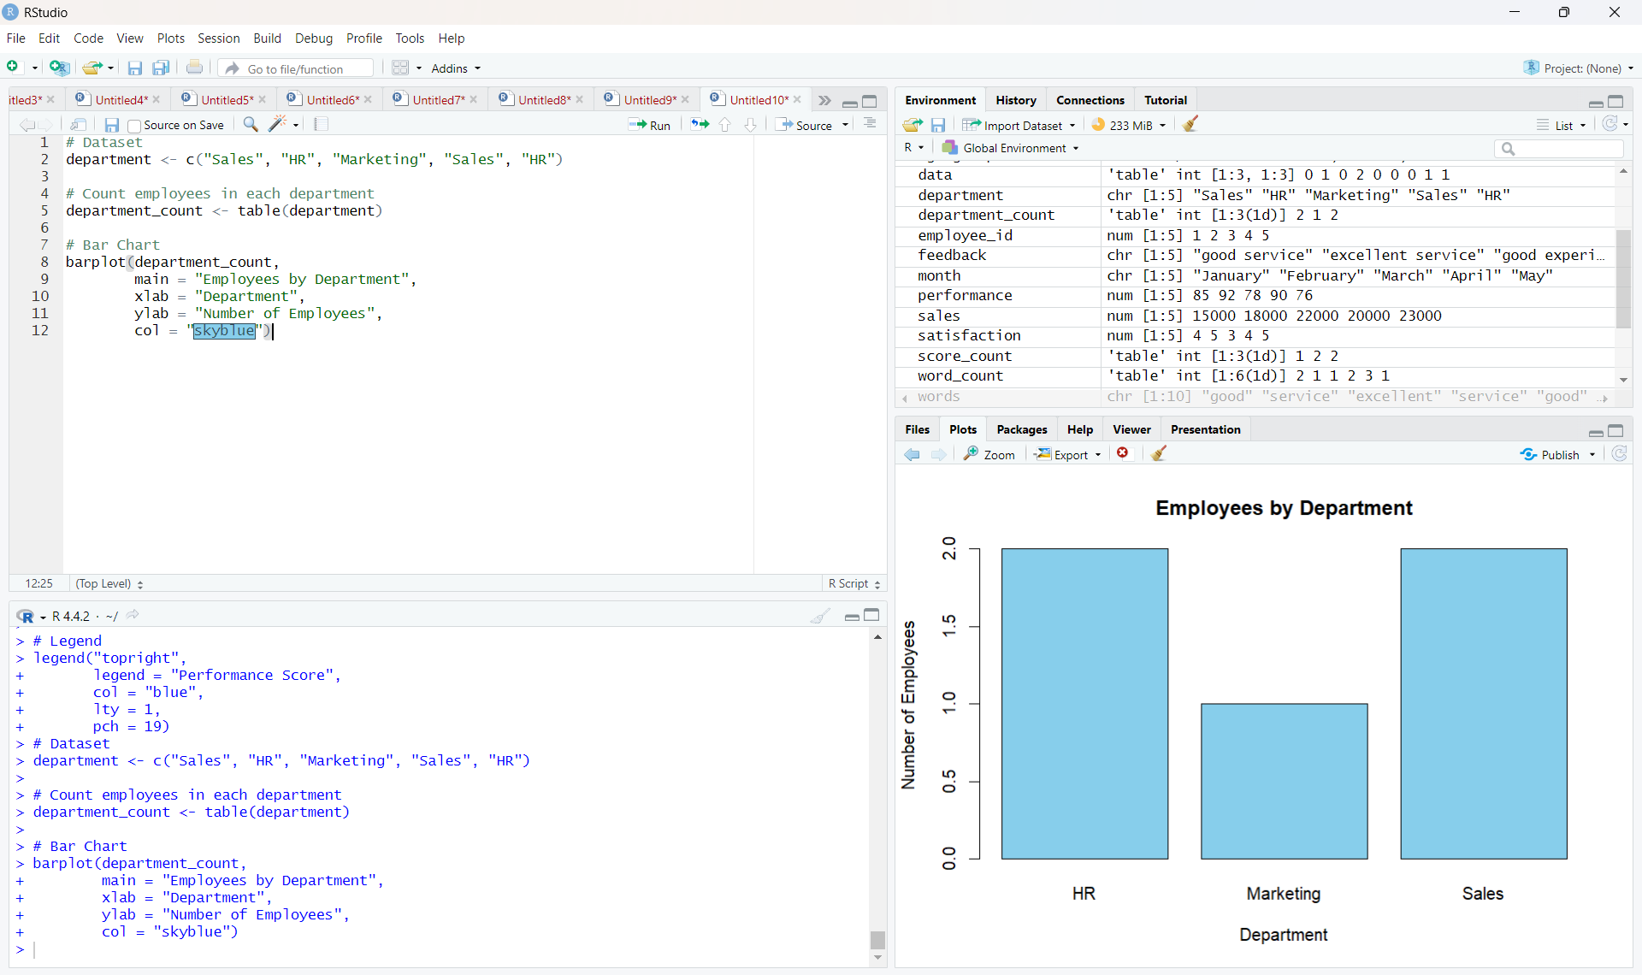
Output 2: Employees by Department
Observation: HR and Sales each have 2 employees, while Marketing has 1 employee.

PROGRAM 3: Scatter Plot and Correlation
Build a scatter plot to analyze the correlation between years of service and performance scores.
# Dataset
years <- c(5, 3, 7, 4, 2)
performance <- c(85, 92, 78, 90, 76)
# Scatter Plot
plot(years, performance,
main = "Years of Service vs Performance Score",
xlab = "Years of Service",
ylab = "Performance Score",
pch = 19,
col = "red")
# Correlation
correlation <- cor(years, performance)
print(correlation)
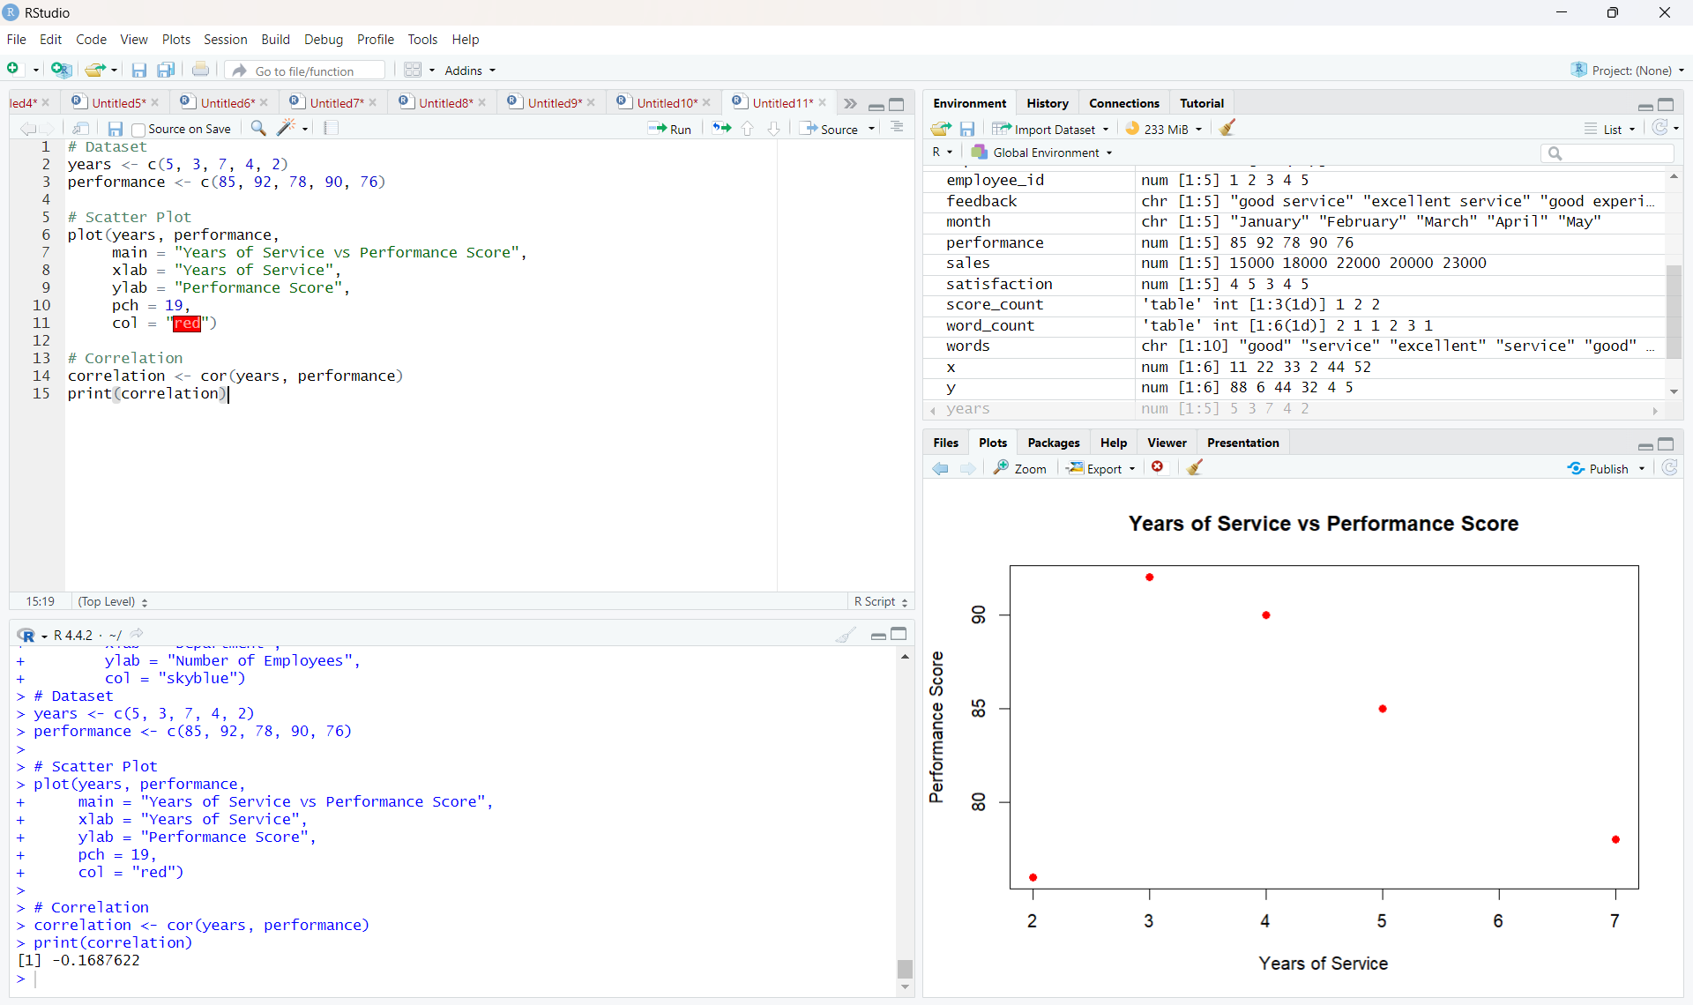
Output 3: Years of Service vs Performance Score
Observation: The calculated correlation is approximately -0.1688, indicating a weak negative linear relationship between years of service and performance score for this small dataset.

PROGRAM 4: Tableau Dashboard
Develop a Tableau dashboard combining the employee performance line chart and department bar chart for interactive exploration.
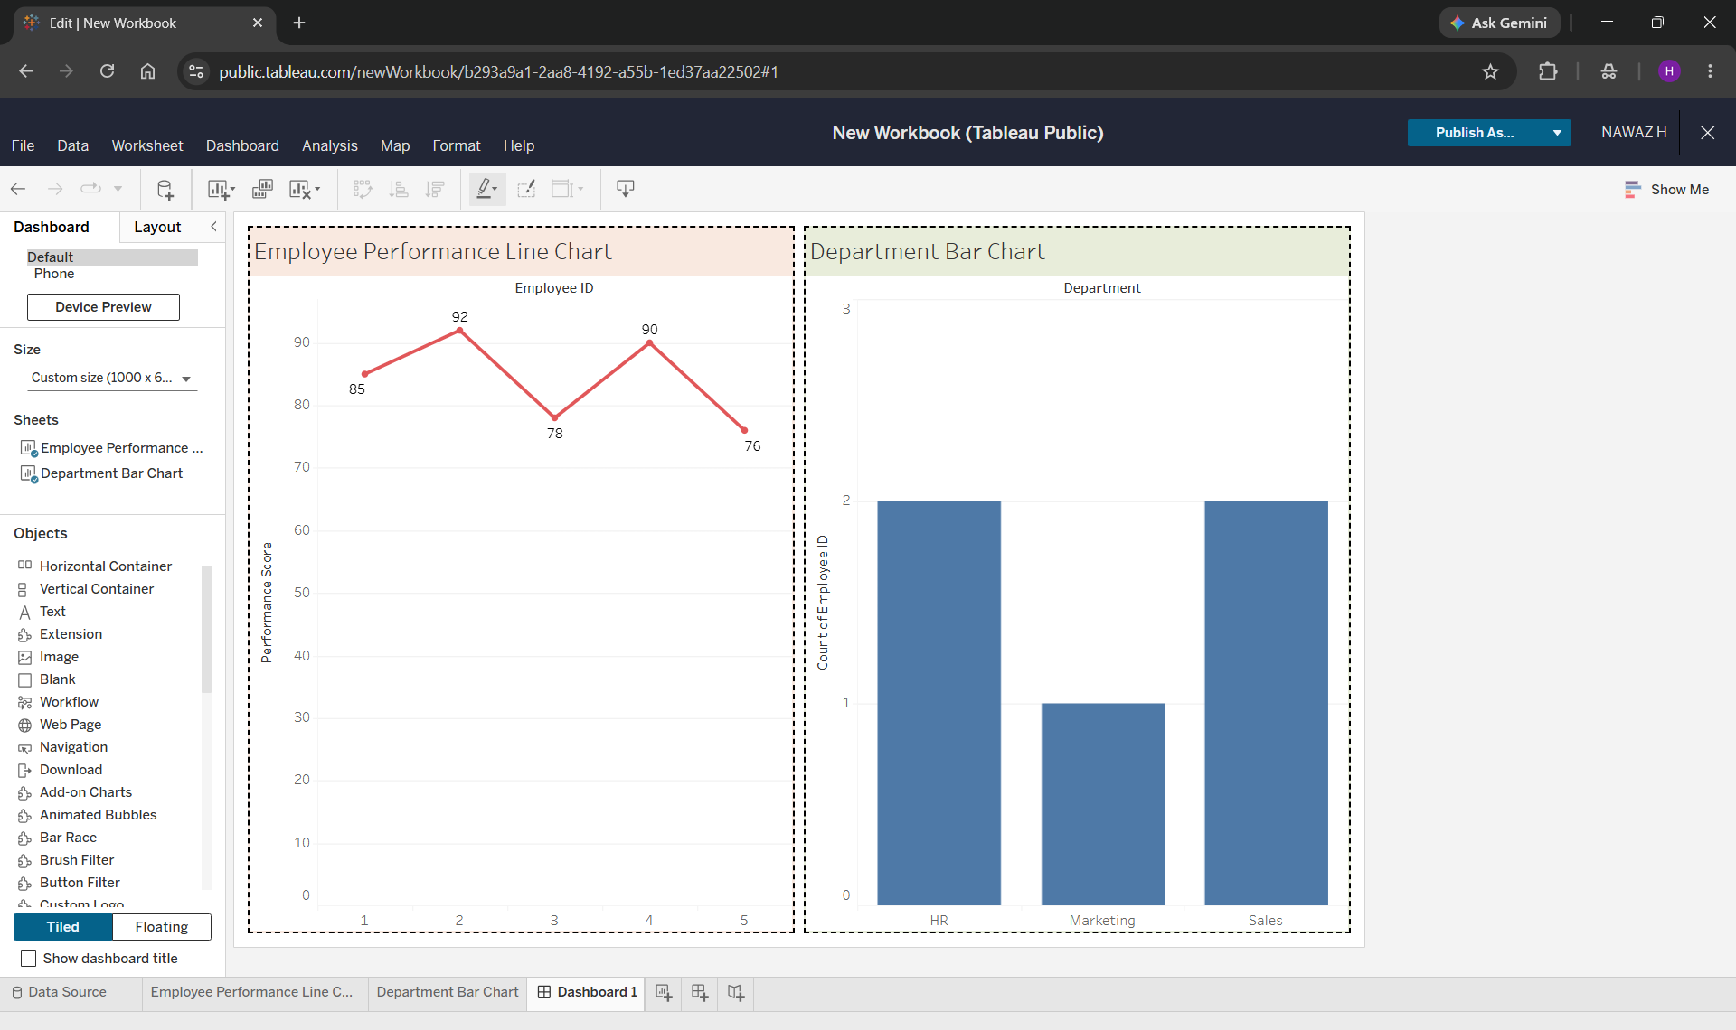
Output 4: Employee Performance Tableau Dashboard
Observation: The dashboard combines the line chart and department bar chart in one view, allowing the two visualizations to be explored together.

Procedure
- Create the Employee Performance dataset with Employee ID, Department, Years of Service, and Performance Score.
- Use R plot() to create the employee performance line chart with labels and a legend.
- Use table() and barplot() to count employees in each department and display the distribution.
- Use plot() to create the scatter plot and cor() to calculate the correlation between years of service and performance score.
- Open Tableau, create the line chart and department bar chart, and combine them in a dashboard.
- Add suitable titles, borders, labels, and formatting to make the dashboard easy to read.

Result
The Employee Performance dataset was successfully visualized using a line chart, department bar chart, and scatter plot. The correlation was calculated in R, and a Tableau dashboard was created by combining the line and bar charts.

Key Functions Used
Function / Tool | Purpose
plot() | Creates line and scatter plots in R.
legend() | Adds a legend to the line chart.
table() | Counts employees in each department.
barplot() | Creates the department bar chart.
cor() | Calculates the correlation coefficient.
Tableau Dashboard | Combines charts for interactive visual exploration.

