LAB EXPERIMENT RECORD
Set 4: Product Inventory Management
Department | AIML
Course Code / Course Name | DSA0601 / Data Handling and Visualization
Experiment | Data Visualization using R and Tableau
Name | HYDERABAD MOHAMMED NAWAZ
Register Number | 192325060
Date | 01 October 2026
Day | Wednesday
Aim
To visualize product inventory data using a bar chart, category-wise bar visualization, and scatter plot, and to develop an interactive Tableau dashboard combining the inventory charts.
Dataset: Product Inventory
Product ID | Product Name | Quantity Available
1 | Product A | 250
2 | Product B | 175
3 | Product C | 300
4 | Product D | 200
5 | Product E | 220
Additional fields used in the submitted visualizations: Product Category and Product Price. The executed R scatter plot uses prices 500, 750, 400, 900, and 600 for Products A-E respectively. The Tableau category view uses Electronics, Furniture, and Stationery to distinguish products.

PROGRAM 1: Bar Chart of Product Inventory Quantity
Create a bar chart to visualize the quantity of each product in the inventory. Label the axes and title the chart.
# Dataset
product_id <- c(1, 2, 3, 4, 5)
product_name <- c("Product A", "Product B", "Product C", "Product D", "Product E")
quantity <- c(250, 175, 300, 200, 220)
# Bar Chart
barplot(quantity,
names.arg = product_name,
main = "Product Inventory Quantity",
xlab = "Product",
ylab = "Quantity Available",
col = "skyblue")
# Add values on bars
text(x = seq_along(quantity),
y = quantity,
labels = quantity,
pos = 3)
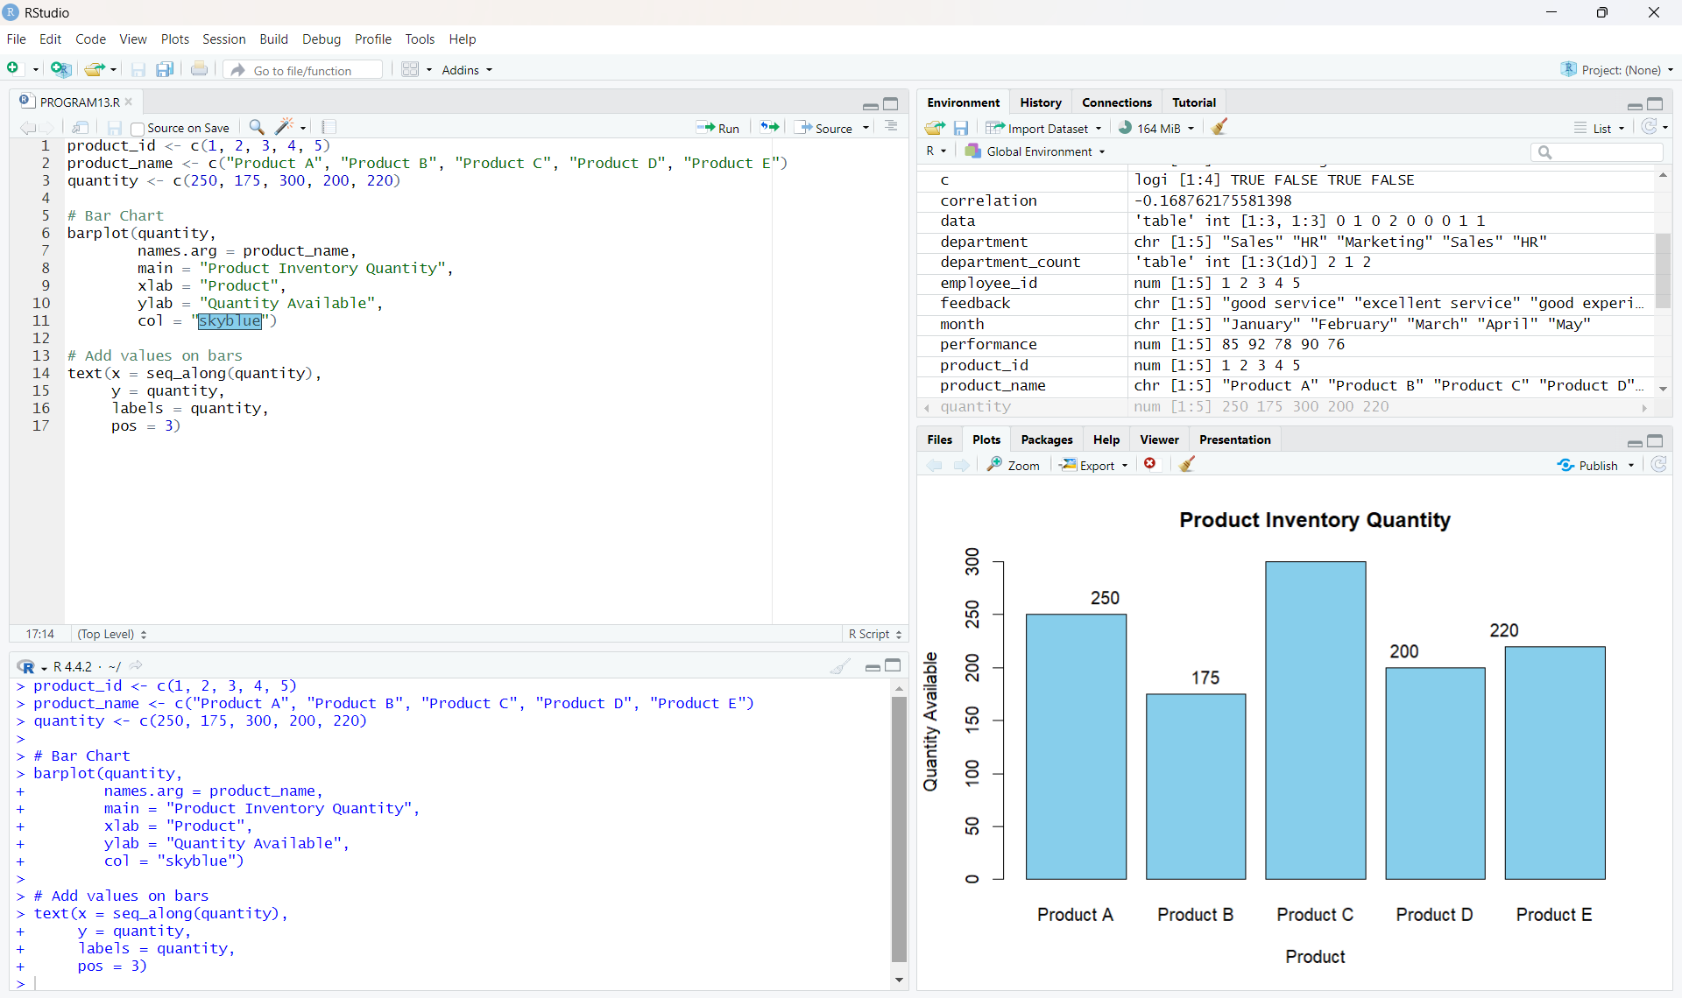
Output 1: Product Inventory Quantity Bar Chart
Observation: Product C has the highest available quantity of 300 units, while Product B has the lowest quantity of 175 units.

PROGRAM 2: Category-wise / Stacked Bar Visualization
Generate a category-wise bar visualization to show product quantities within different product categories. In the submitted Tableau view, Category is used on Color and Product Name is used on Columns.
# Product category mapping used in the Tableau visualization
Product A -> Electronics
Product B -> Electronics
Product C -> Furniture
Product D -> Furniture
Product E -> Stationery
# Tableau view
Columns: Product Name
Rows: SUM(Quantity Available)
Color: Category
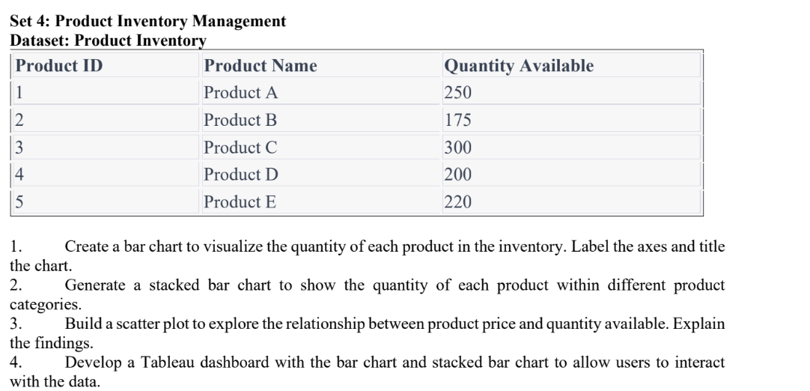
Output 2: Category-wise Inventory Visualization in Tableau
Observation: The visualization distinguishes the products by category. Product A and Product B are shown as Electronics, Product C and Product D as Furniture, and Product E as Stationery. Product C has the largest quantity among the displayed products.
Note: The submitted screenshot is a category-colored bar view rather than a single stacked bar per category. It records the Tableau visualization actually created for the experiment.

PROGRAM 3: Scatter Plot of Product Price vs Quantity Available
Build a scatter plot to explore the relationship between product price and quantity available. Explain the findings.
product_name <- c("Product A", "Product B", "Product C",
"Product D", "Product E")
quantity <- c(250, 175, 300, 200, 220)
price <- c(500, 750, 400, 900, 600)
plot(price, quantity,
main = "Product Price vs Quantity Available",
xlab = "Product Price",
ylab = "Quantity Available",
pch = 19,
col = "red")
text(price, quantity,
labels = product_name,
pos = 3)
# Correlation
correlation <- cor(price, quantity)
print(correlation)
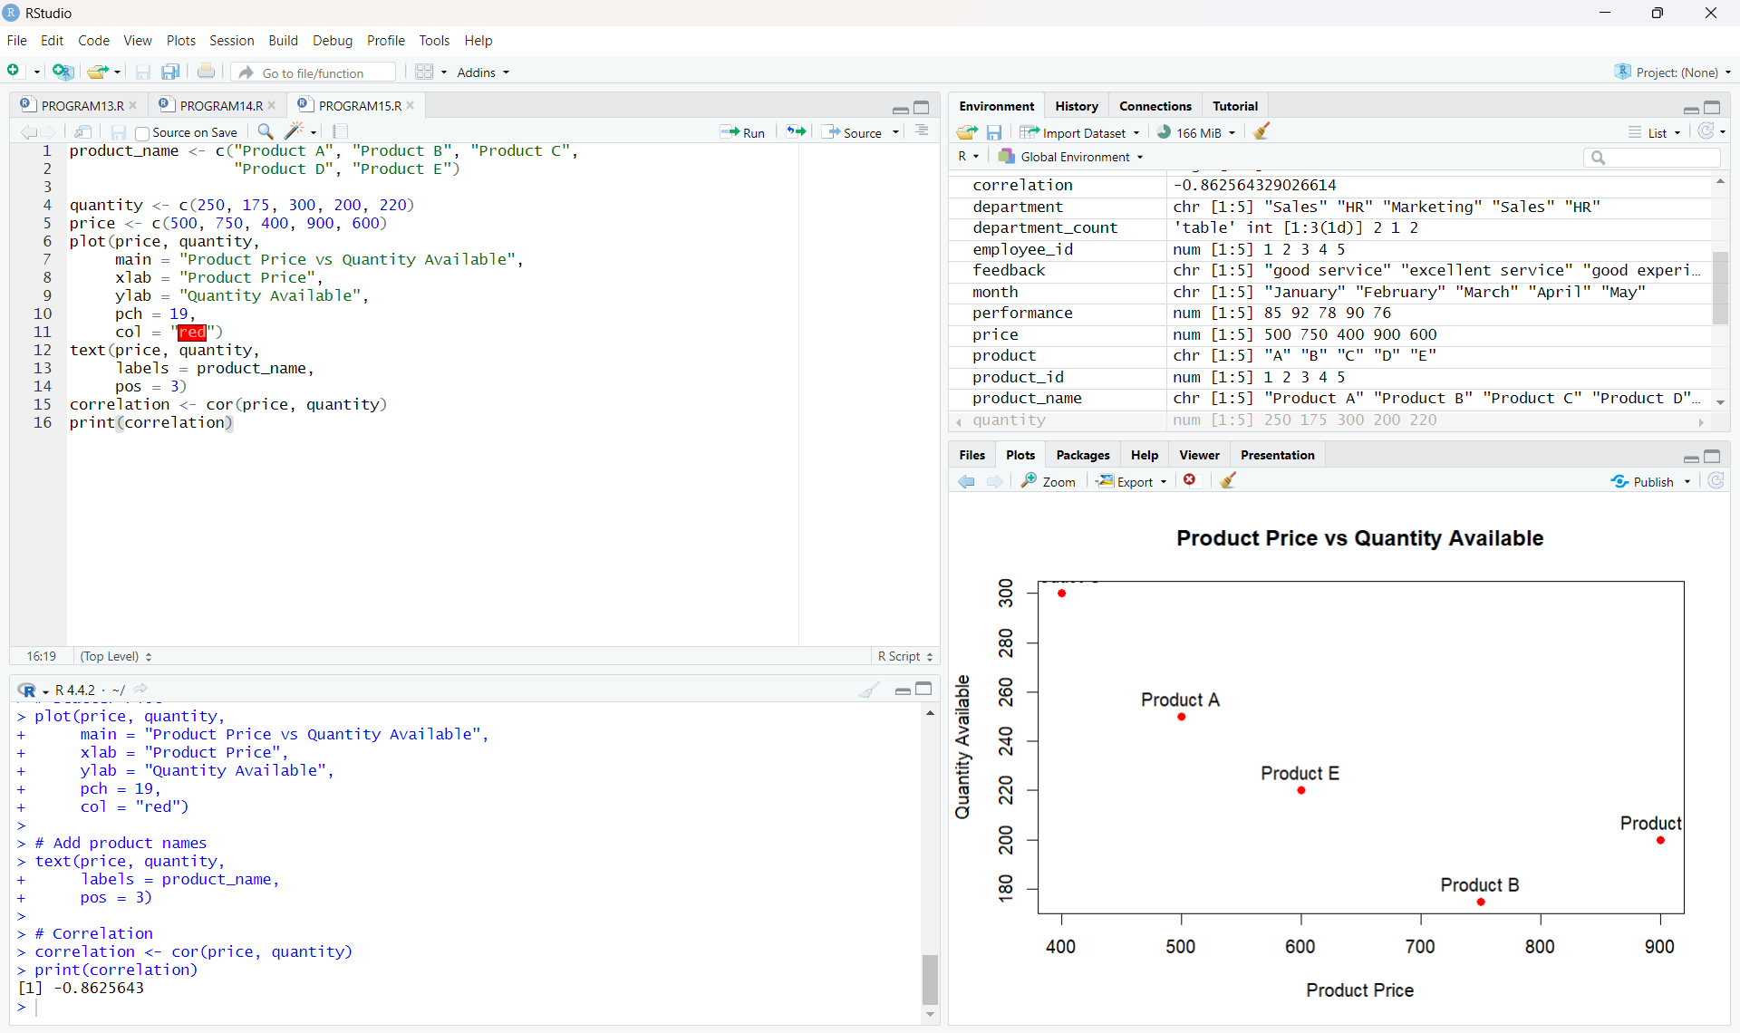
Output 3: Product Price vs Quantity Available Scatter Plot
Finding: For the five products in the dataset, the plotted points show a generally negative relationship between price and quantity available. The calculated correlation is approximately -0.8626, indicating a strong negative linear association within these five observations.

PROGRAM 4: Interactive Tableau Dashboard
Develop a Tableau dashboard with the bar chart and category-wise bar chart to allow users to interact with the data.
Tableau Dashboard Steps
1. Connect the Product Inventory dataset in Tableau Public.
2. Create a Bar Chart using Product Name on Columns and SUM(Quantity Available) on Rows.
3. Create the Category-wise Inventory view using Product Name on Columns,
SUM(Quantity Available) on Rows, and Category on Color.
4. Create a new dashboard named "Product Inventory Dashboard".
5. Place the two worksheets side by side in the dashboard.
6. Keep the Category legend visible so users can distinguish product categories.
7. Add suitable titles and labels for clear interpretation.
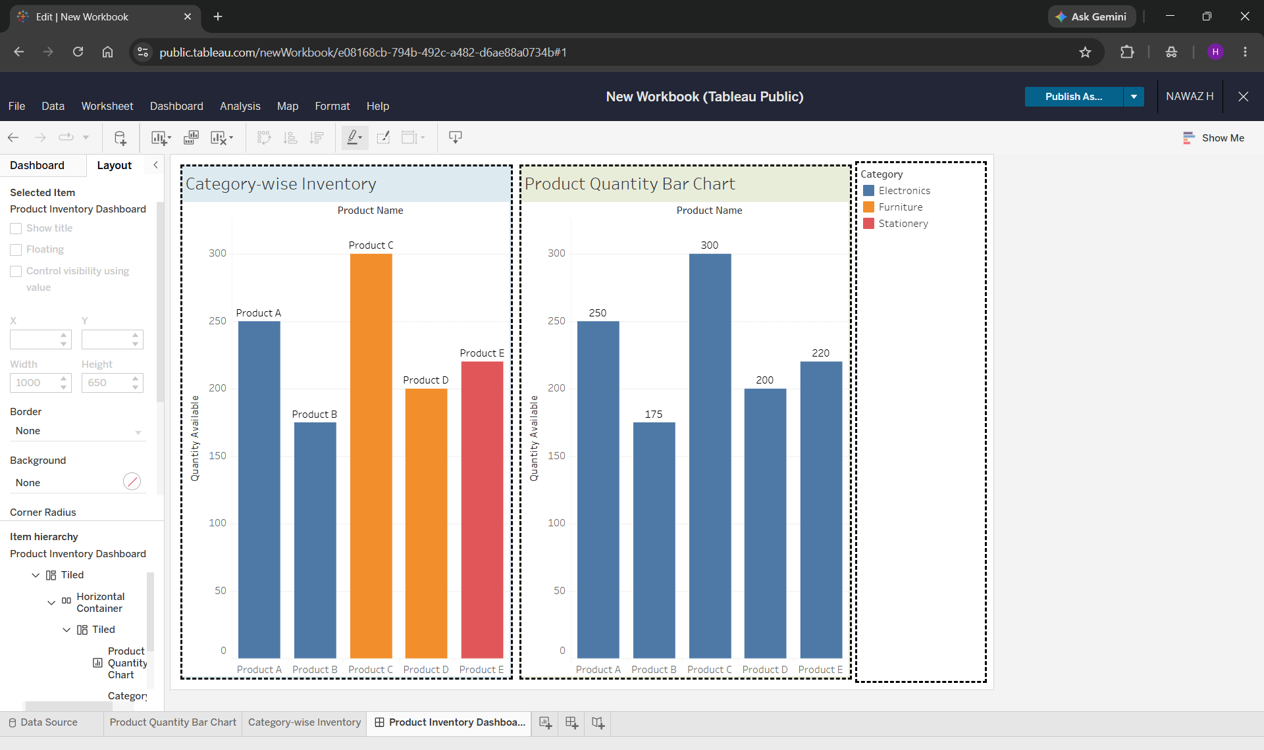
Output 4: Product Inventory Tableau Dashboard
Observation: The dashboard combines the Product Quantity Bar Chart and Category-wise Inventory visualization in one view. The Category legend allows the products to be distinguished by category.

Procedure
1. Create the Product Inventory dataset with Product ID, Product Name, and Quantity Available.
2. Use barplot() in R to visualize the quantity available for each product.
3. Use product category information in Tableau to distinguish inventory products by category.
4. Create the Product Price vs Quantity Available scatter plot in R and calculate the correlation using cor().
5. Open Tableau Public and create the Product Quantity Bar Chart and Category-wise Inventory visualization.
6. Combine both visualizations in a Tableau dashboard named Product Inventory Dashboard.
7. Add titles, labels, category legend, and suitable formatting for interactive exploration.
Result
The Product Inventory dataset was successfully visualized using a bar chart, category-wise visualization, and scatter plot. The relationship between product price and quantity available was examined using a correlation value of approximately -0.8626. A Tableau dashboard was also created by combining the product quantity bar chart and category-wise inventory visualization.
Key R Functions / Tableau Tools Used
Function / Tool | Purpose
barplot() | Creates the product quantity bar chart.
text() | Displays quantity values above the bars and product labels on the scatter plot.
plot() | Creates the scatter plot of product price and quantity.
cor() | Calculates the correlation coefficient.
Tableau Columns / Rows | Places dimensions and measures to build the charts.
Tableau Color | Distinguishes products according to their category.
Tableau Dashboard | Combines the two inventory visualizations for interactive exploration.

