SET 6
PRODUCT SALES ANALYSIS
Dataset: Monthly Product Sales
Department | AIML
Course Code / Course Name | DSA0601 / Data Handling and Visualization
Experiment | Data Visualization using R and Tableau
Name | HYDERABAD MOHAMMED NAWAZ
Register Number | 192325060
Date | 01 October 2026
Day | Wednesday

Product ID | Product Name | January Sales | February Sales | March Sales
1 | Product A | 2000 | 2200 | 2400
2 | Product B | 1500 | 1800 | 1600
3 | Product C | 1200 | 1400 | 1100

PROGRAM 1: Grouped Bar Chart
Aim: Create a grouped bar chart to visualize the sales of each product for the first quarter.
sales <- matrix(c(2000,1500,1200,
2200,1800,1400,
2400,1600,1100), nrow=3)
barplot(sales, beside=TRUE,
names.arg=c("A","B","C"),
main="Product Sales",
xlab="Product", ylab="Sales")

Output:
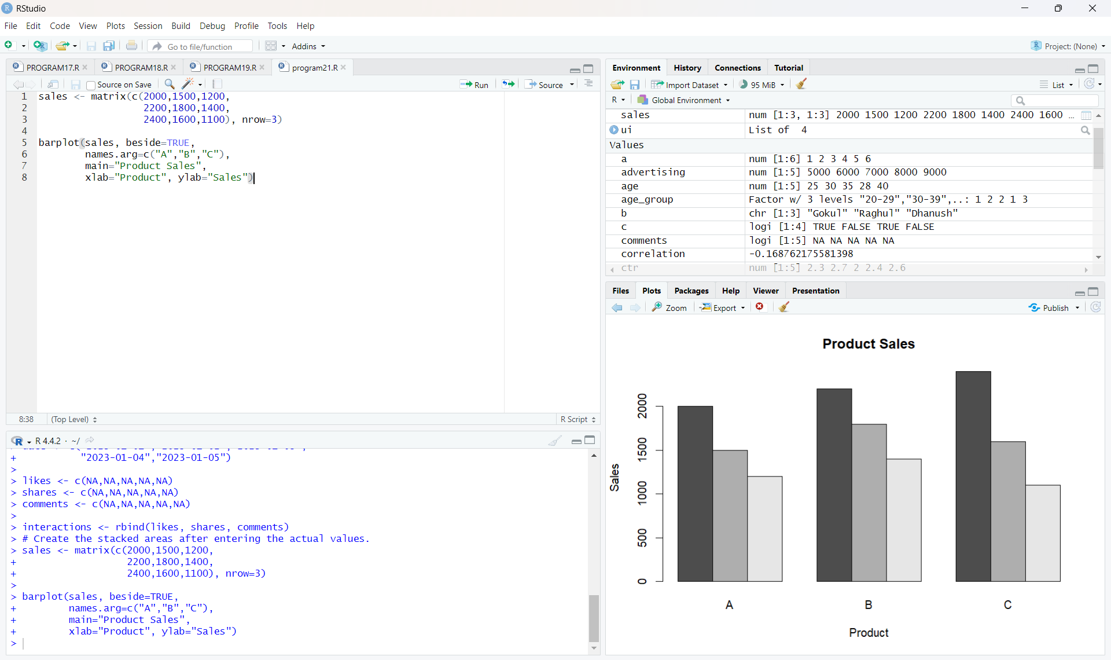
Result: The grouped bar chart displays January, February, and March sales for Products A, B, and C.
PROGRAM 2: Stacked Area Chart
Aim: Generate a stacked area chart to represent the overall sales trend for all products over the three months.
sales <- matrix(c(2000,1500,1200,
2200,1800,1400,
2400,1600,1100), nrow=3)
months <- c("January", "February", "March")
product_names <- c("Product A", "Product B", "Product C")
sales_ts <- rbind(sales[,1], sales[,2], sales[,3])
colnames(sales_ts) <- product_names
rownames(sales_ts) <- months
matplot(1:3, sales_ts, type="o", lty=1,
xlab="Month", ylab="Sales",
main="Overall Sales Trend")
axis(1, 1:3, months)
Output:
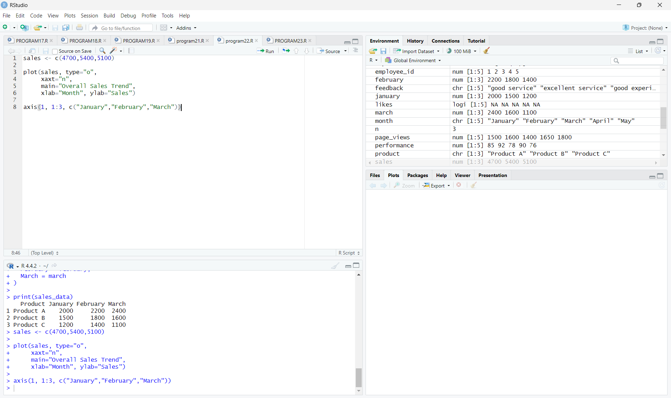
Result: The monthly sales trend is represented across January, February, and March.
PROGRAM 3: Monthly Sales Table
Aim: Build a table showing the monthly sales data for each product.
product <- c("Product A", "Product B", "Product C")
january <- c(2000, 1500, 1200)
february <- c(2200, 1800, 1400)
march <- c(2400, 1600, 1100)
sales_data <- data.frame(
Product = product,
January = january,
February = february,
March = march
)
print(sales_data)
Output:
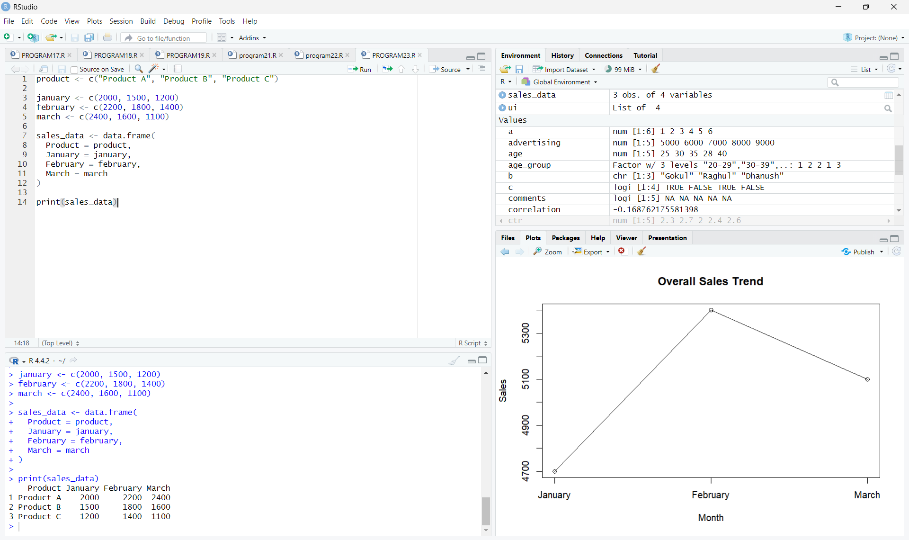
Result: The table presents the January, February, and March sales values for each product.
PROGRAM 4: Tableau Dashboard
Aim: Develop a Tableau dashboard combining the grouped bar chart, stacked area chart, and monthly sales table for interactive exploration of the sales data.
Tableau steps:
1. Connect the Monthly Product Sales dataset.
2. Create a grouped bar chart using Product Name and Sales.
3. Create a stacked area chart using Month, Sales, and Product Name.
4. Create a monthly sales table using Product Name and the three month sales fields.
5. Add all three sheets to a new dashboard.
6. Add the Product Name filter for interactive exploration.
7. Add titles and labels to the dashboard elements.
Output:
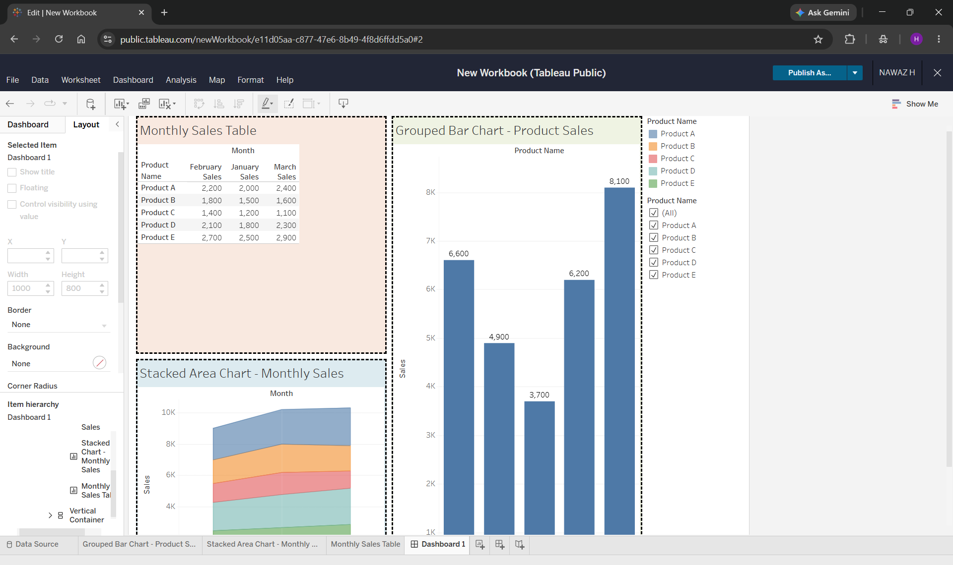
Result: The Tableau dashboard combines the required visualizations and table in one interactive dashboard.
END OF SET 6

