
PRESIDENCY SCHOOL
Bangalore/ Mangalore
Work Sheet
Subject: Social Studies
The Western Desert

Grade: IV

Name: Section: ______ Roll No: _______

I. Fill in the Blanks
- The Thar Desert is mainly located in __________.
- Large heaps of sand are called __________.
- A place with water in a desert is called an __________.
- The Thar Desert receives very __________ rainfall.
- The ship of the desert is the __________.

II. Choose the Correct Answer
- The Thar Desert is mainly found in:
☐ Rajasthan ☐ Kerala ☐ Assam
- Which is a desert plant?
☐ Cactus ☐ Lotus ☐ Banana
- Desert climate is generally:
☐ Hot and dry ☐ Cold and wet ☐ Cool and rainy

III. True or False
- Desert plants have special adaptations. ______
- Camels can walk easily on sand. ______
- Desert regions receive heavy rainfall. ______
- Some people rear sheep, goats and camels. ______
- People in deserts need to conserve water. ______

IV. Answer Briefly
- How do camels survive in the desert?

- Name two occupations of desert people.

- Why do some desert people lead a nomadic life?

V. Fill in the Blanks
- __________ help bring water to dry areas.
- People store water in __________.
- Water conservation is important in the __________ Desert.
- __________ is a famous Rajasthani folk dance.

VI. Answer Briefly
- Why is livestock important to desert people?

- Why are canals and tanks useful in desert areas?

- Name one food, dress or festival associated with Rajasthan.
___________________________________________________________________________

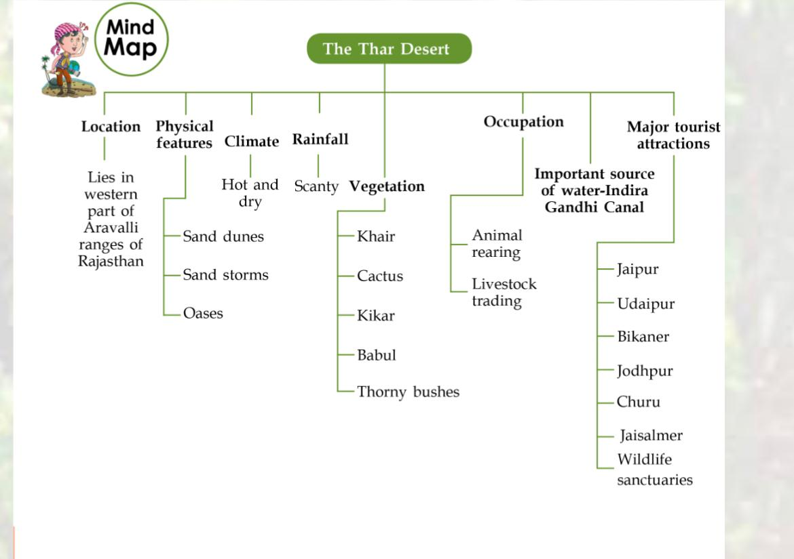

QUICK GLANCE
- The Western Desert, also known as the Thar Desert, lies in the western part of the Aravalli ranges of Rajasthan and covers a large part of Rajasthan.
- The climate of the desert is extreme. It remains hot and dry throughout the year.
- The days are hot and nights are cold in the desert.
- Plants such as cactus, kikar, khair, babul and thorny bushes are found in the desert.
- Oases are green places in the desert that have water and where trees grow.
- The camel is the only means of transport to cross vast sandy areas.
- The Indira Gandhi Canal has changed the life of the Thar Desert region.
- After Independence, the desert region is progressing rapidly.

