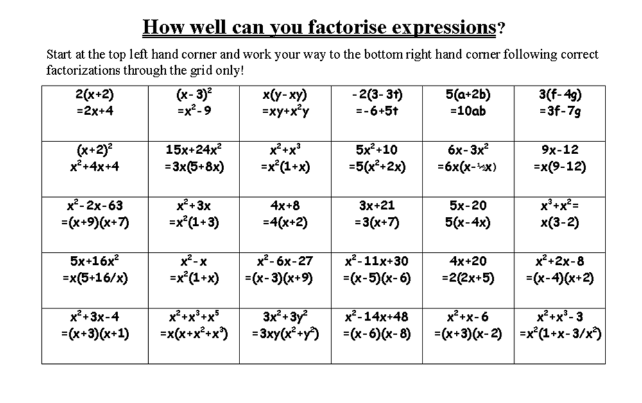
Copyright 2001, Richard Blackmore. Permission is granted to copy this page for non commercial classroom use.
www.funmaths.com

