Powers of ten cards

Six thousand | Six million | Six billion
6000 | 6000000 | 6000000000
6×1000 | 6×1000000 | 6×1000000000
6×10×10×10 | 6×10×10×10×10×10×10 | 6×10×10×10×10×10×10×10×10×10
6×10³ | 6×10⁶ | 6×10⁹
60×100 | 60×100000 | 60×100000000
60×10² | 60×10⁵ | 60×10⁸
60000×0.1 | 60000000×0.1 | 60000000000×0.1
60000÷10 | 60000000÷10 | 60000000000÷10
60000×10⁻¹ | 60000000×10⁻¹ | 60000000000×10⁻¹
6 e03 | 6 e06 | 6 e09
Six times ten to the power of three | Six times ten to the power of 6 | Six times ten to the power of nine
6÷0.0001 | 6÷0.0000001 | 6÷0.0000000001
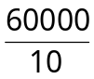 | 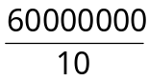 | 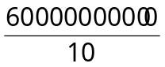

Key Questions: of the type how do you know that 6÷0.0001 is the same as 60÷0.001? How can you write that using symbols? Etc…

Algebra cards

x | 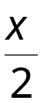 | (x - 1)² | 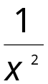
x + 6 | 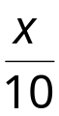 | (x + 1)(x + 2) | 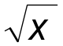
x - 6 | 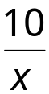 | 3(x + 2) | 3x + 6
x² | 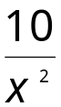 | 3(2 – x) | 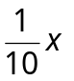
2x² | x⁻⁻¹ | -x | 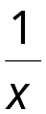
x³ | 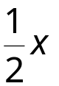 | -3x | 11
4 - x | 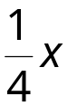 | -(x²) | 7

Key Questions: of the type
- Given that x = 5, put the cards in order
- Will the same card always be the largest whatever the value of x?
- Pick any two cards and use them to write an equation
- Pick any two cards and find a value of x that makes them equal
- Which cards are equal to each other whatever the value of x?
- If x = 0, what cards have the same value?
- Find a value of x that makes …card… the largest
- If x is a positive integer which cards can we position in order? Which cards would move if x is a negative integer

