Inequalities – squares

Find the values of x for which:

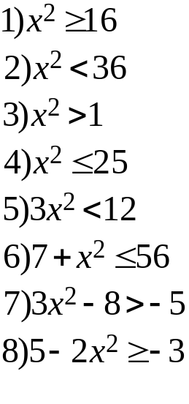
Find the values of n, given that n is an integer, when:

