Arithmagons

Task One
In an arithmagon the number in a square is the sum of the numbers in the adjoining circles. Copy and complete these six arithmagons.
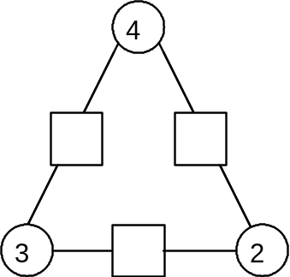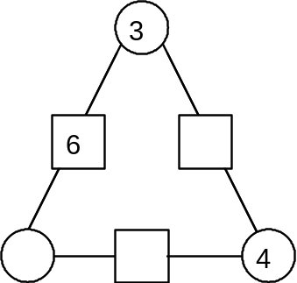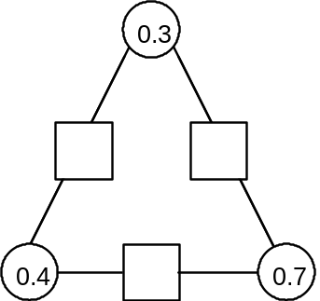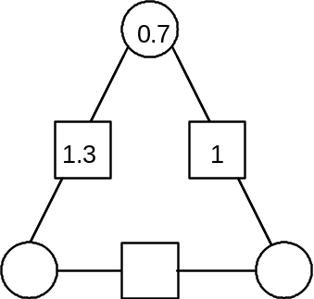

Task Two
For each of these arithmagons, (1) let x stand for the number in the top circle, (2) form expressions for the numbers in the other circles, (3) form an equation in x and solve it.

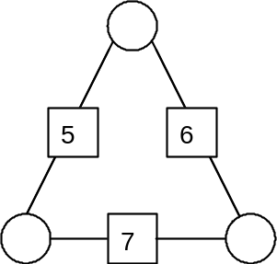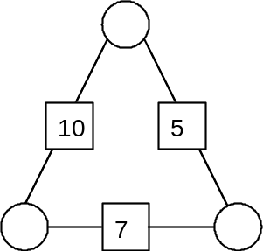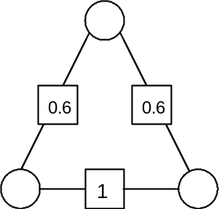

Task Three
Make up some arithmagons of your own. Leave some of the numbers missing and give them to a friend to work out. Be careful, you must have the answers first!

