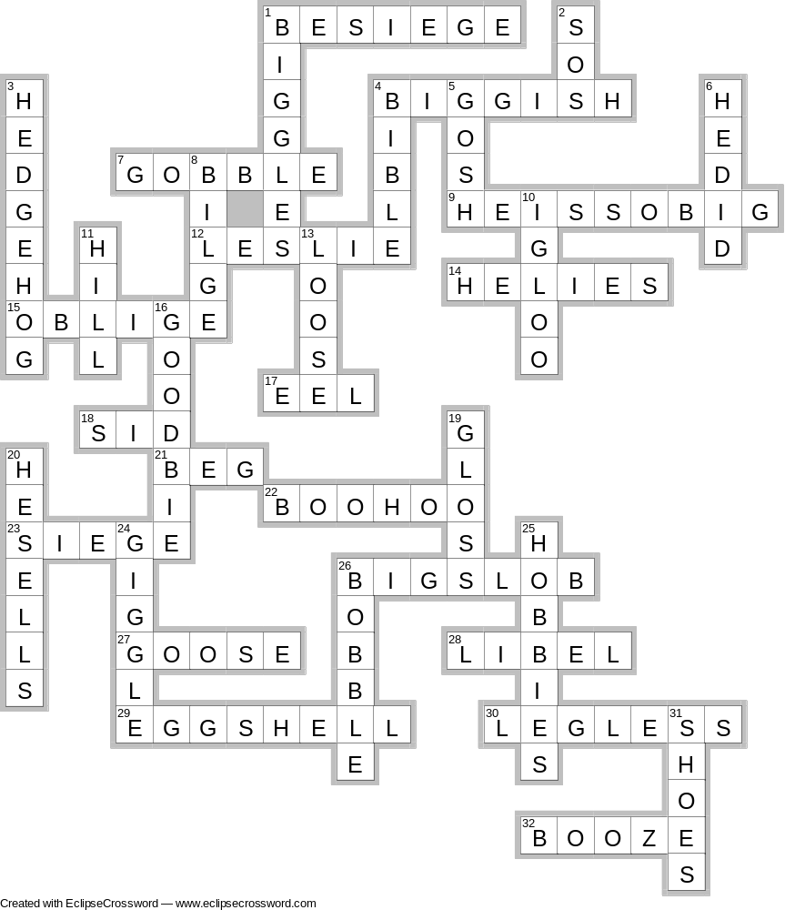

Across

1. ( 3 x 661)² – (3⁶ + 22) Pester
4. 164 x 166² +734 Almost Big
7. 566 x 711 – 23617 Bolt it down
9. (22² + 29.4) x 10; (3.03² – 0.02²) x 100² Goliath (4 words)
12. (5² – 1²)⁴ – 14239 Just a name
14. 19 x 20 x 14 – 2.66 Not an upstanding man
15. (23 x 24 x 25 x 26) + (3 x 11 x 10³) – 20 Help
17. (3³)² +2² Wriggler
18. 0.4² –0.1² Little Sidney
21. 9999 + 319 Sit up and plead
8.47 + 2.53
22. 1.25 x 0.2⁶ + 0.2² Tissue time
23. 33 x 34 x 35 + 15 x 3 Beleaguer
26. 2601 x 6 ; (401 - 78) x 5² Not a great man (2 words)
4² + 1²
27. 14 + (5 x (83² + 110)) Bigger than a duck
28. (16²+16)² - (13² - 2) Slander
29. 8794² + 25 x 342.28 + 120 x 25 Thin Skin
30. 3 x 17 x (329² + 2 x 173) Unlimited
32. (710 + (1823 x 4)) x 4 Liquor

Down

1. 6.2 x 0.987 x 1000000 – 860² +118 Flying Ace
2. (84 + 17) x 5 Dotty Message
3. 904² + 89621818 Prickly Customer
4. 14⁴ – 627 + 29 Good Book by God
5. (559 x 6) + (21 x 55) What a surprise
6. 0.32² + 0.001 Did he or didn’t he?
8. (80² + 60²) x 3 + 81² + 12² + 3013 Ship Gunge
10. 0.08 – (3² ÷ 10⁴) Ice House
11. (27 x 2000 – 2) Not quite a mountain
(0.63 ÷ 0.09)
13. (130 x 135) + (23 x 3 x 11 x 23) Wobbly
16. 2 x 3 x 53 x 10⁴ + 9 Opposite to hello, almost!)
19. 235² – (4 x 36.5) Shiny Surface
20. (177 x 179 x 182) + (85 x 86) – 82 Good Salesman
24. 615² + (7 x 242) Almost a goggle
25. 48⁴ + 102² – 4² Pursuits
26. (426 x 474) + (318 x 487) +22018 Close to a bubble
31. 230 x 230½ + 30 Fit feet

