Which chart type would you use?

For each of the following types of data choose which chart would best represent it, name each chart and state you reasons for your choice.

1.
Ice Cream Sales | Temperature
639 | 21
420 | 16
753 | 25
352 | 13
213 | 8
703 | 24

2. How do you travel to school?
Car | 12
Bus | 63
Walk | 53
Bike | 15
Helicopter | 1

3. Do you like watching television?
Yes | 126
No | 6

4.
Time | Temperature
1.00 | 19
2.00 | 20
3.00 | 21
4.00 | 22
5.00 | 21
6.00 | 20

5. How people travel to work
 | 1983 | 2003
Car | 125 | 175
Bus | 26 | 25
Walk | 69 | 20

a.

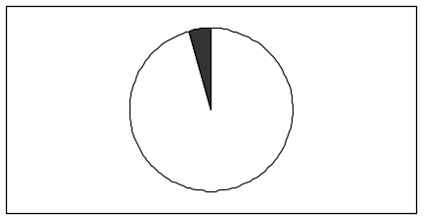

b.

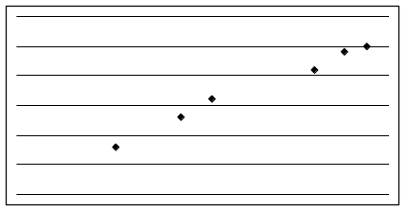

c.

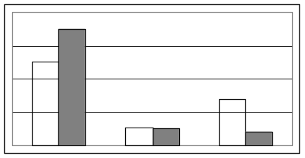

d.

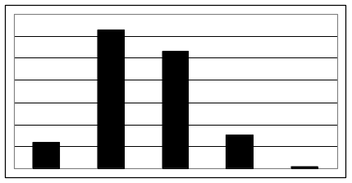

e.

