Using Autograph: Cumulative Frequency Diagrams and Box Plots

Remember the following:
- To copy an Autograph page, use ‘Ctrl+C’. To paste this page into Word use ‘Ctrl+V’
- Ensure that your name is included in the footer of any Word files that you print. Do not print direct from Autograph.
- Do not get out of your seat to get things from the printer – I will check regularly and hand them out.

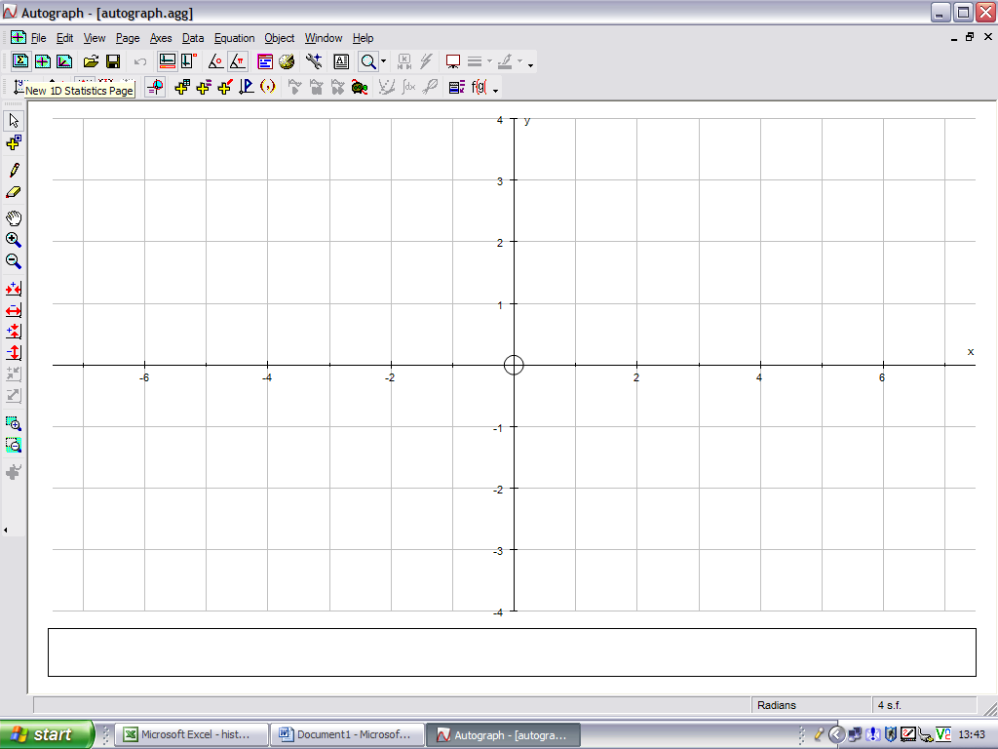
When you first open Autograph it gives you a ‘2D Graphing Page’. To use Autograph for most statistics you need to have a ‘1D Statistics Page’ open. Do this by clicking on the icon shown here:

Task One: Using Autograph to group data

The table below shows some countries of the world and their birth rate in 2005 (the number of births per 1000 of the population). You are going to use Autograph to group this data and plot some diagrams to represent it.

Afghanistan | 47.0 | Azerbaijan | 20.4 | Botswana | 23.3 | Chad | 46.0
Albania | 15.1 | Bahamas | 17.9 | Brazil | 16.8 | Chile | 15.4
Algeria | 17.1 | Bahrain | 18.1 | Brunei | 19.0 | China | 13.1
American Samoa | 23.1 | Bangladesh | 30.0 | Bulgaria | 9.7 | Colombia | 20.8
Andorra | 9.0 | Barbados | 12.8 | Burkina Faso | 44.2 | Comoros | 37.5
Angola | 44.6 | Belarus | 10.8 | Burma | 18.1 | Congo | 27.9
Anguilla | 14.3 | Belgium | 10.5 | Burundi | 39.7 | Congo, (The …) | 44.4
Antigua & Barbuda | 17.3 | Belize | 29.3 | Cambodia | 27.1 | Costa Rica | 18.6
Argentina | 16.9 | Benin | 42.0 | Cameroon | 34.7 | Côte d’Ivoire | 35.5
Armenia | 11.8 | Bermuda | 11.6 | Canada | 10.8 | Croatia | 9.6
Aruba | 11.3 | Bhutan | 34.0 | Cape Verde | 25.3 | Cuba | 12.0
Australia | 12.3 | Bolivia | 23.8 | Cayman Islands | 12.9 | Cyprus | 12.6
Austria | 8.8 | Bosnia & Herzegovina | 12.5 | Central African Republic | 35.2 | Czech Republic | 9.1
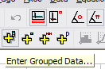

1. To enter the data into Autograph you need to click on here ‘Enter Grouped Data’

2. Choose ‘Use Raw Data’ and Click on ‘Edit’.
You can name the data
3. Type the information into the table as shown below. You can use copy and paste from a table or a spreadsheet to speed things up a bit.
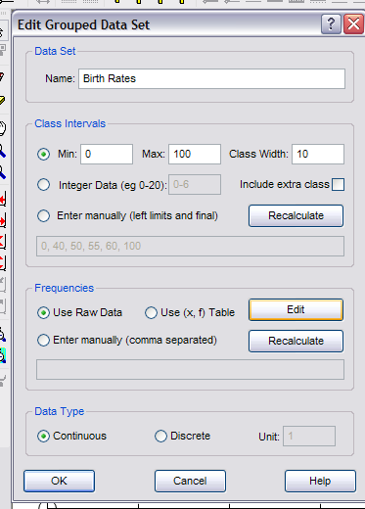

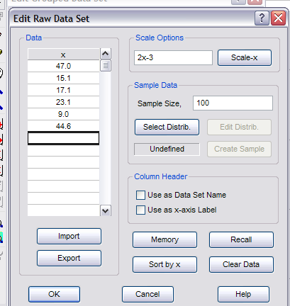

Select this …

Click on OK when you are finished – and return to the box on the left

Look here …

Remember – it is continuous data

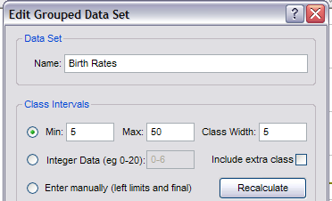
4. Now you need to tell Autograph how you want the data grouped. The data ranges from 8.8 (Austria) to 47 (Afghanistan). It makes sense to group the data into intervals of width 5, with a minimum of 5 and a maximum of 50. Do this as the diagram here shows, then click on OK.

You are now ready to construct graphs and charts, and calculate statistics for this data

Task Two: Using Autograph to construct a cumulative frequency diagram
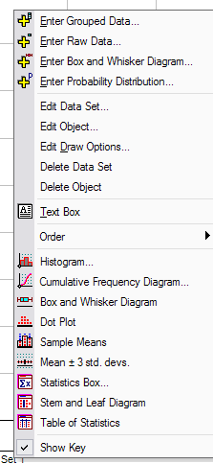
1. There is a box at the bottom left of the screen containing ‘Data Set 1’ (or whatever you chose to call the data in point 2). Right click on this to get the options shown on the left. Choose ‘Cumulative Frequency Diagram’.

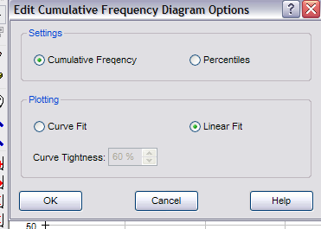
2. Select ‘Cumulative Frequency’ and ‘Linear Fit’ (this will give you a c.f. diagram rather than a c.f. curve). Click on OK to finish

3. The axes now need adjusting to make them more sensible. Go to ‘Axes’, ‘Edit Axes’ and you will get the options here. Change the ‘x’ maximum to 100, and the ‘y’ maximum to 100. You can also label the axes by selecting ‘Labels’ and typing in the relevant information (‘Birth Rate’ and ‘Cumulative Frequency’ in this case) Click on OK and you will have a much more sensible graph. Move on to the next task.

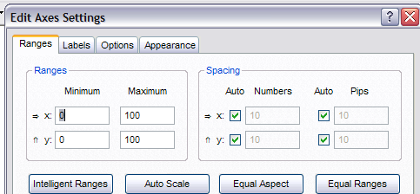

Task Three: Using Autograph to construct a box and whisker diagram (or box-plot)

Repeat step 1 of task two. Then select ‘Box and Whisker Diagram’. Leave ‘Raw Data’ selected (to get a more accurate diagram) and click on OK to finish. You can click and drag the diagram (vertically) if you need to.

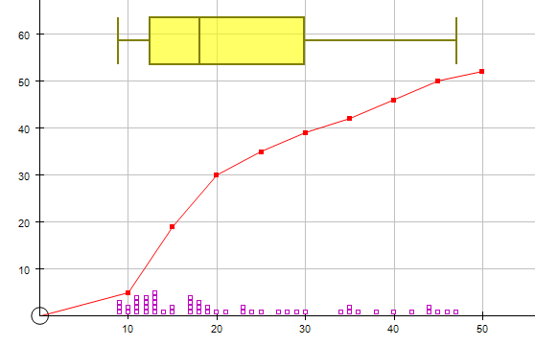
Task Four: Interpreting the data (using dot-plots to help)

1. The box and whisker diagram shows a positive skew. Thinking back to the original data, can you suggest a reason why this might be?

2. You can mark on all the individual pieces of data to help: right click on ‘Data Set 1’ and choose ‘Dot Plot’. Click on OK to get the set of diagrams as shown here.

3. You can now see clearly the pieces of data causing the skewness. Refer back to the original table and identify the countries with high birth rates. Why do you think the data is positively skewed?

Task Five: Comparing data

The tables show the number of children per family in 2004 for all countries in Europe and Asia. Enter the data into Autograph and use box and whisker diagrams to compare the information. A thorough comparison should include comments on (a) how the averages compare, (b) how the inter-quartile ranges compare, and (c) any skewness that occurs. Try to give reasons for any observations.

You will need to think about the best way in which to group the data.

Asia
Afghanistan | 5.17 | India | 5.29 | Lebanon | 4.56 | Syria | 4.88
Armenia | 3.03 | Indonesia | 3.85 | Macao | 3.42 | Taiwan | 3.23
Azerbaijan | 2.48 | Iran | 5.48 | Malaysia | 4.69 | Tajikistan | 4.57
Bahrain | 3.96 | Iraq | 5.19 | Maldives | 5.48 | Thailand | 3.63
Bangladesh | 5.90 | Israel | 3.52 | Mongolia | 4.70 | Turkey | 4.74
Bhutan | 4.56 | Japan | 2.63 | Nepal | 4.49 | Turkmenistan | 3.41
Brunei | 5.05 | Jordan | 5.67 | Oman | 3.36 | UAE | 6.41
Burma | 3.74 | Kazakstan | 3.54 | Pakistan | 7.22 | Uzbekistan | 5.77
Cambodia | 6.16 | North Korea | 5.30 | Philippines | 4.94 | Viet Nam | 3.32
China | 3.45 | South Korea | 2.76 | Qatar | 3.90 | Yemen | 4.80
Cyprus | 2.99 | Kuwait | 6.39 | Saudi Arabia | 5.91
Georgia | 3.75 | Kyrgyzstan | 5.69 | Singapore | 3.45
Hong Kong | 3.23 | Laos | 5.33 | Sri Lanka | 5.41

Europe
Albania | 2.88 | Finland | 2.16 | Liechtenstein | 2.55 | Romania | 2.95
Austria | 2.36 | France | 2.41 | Lithuania | 2.51 | Russian Federation | 2.69
Belarus | 2.50 | Germany | 2.11 | Luxembourg | 2.87 | Serbia & Montenegro | 3.22
Belgium | 2.36 | Gibraltar | 3.62 | Malta | 3.38 | Slovakia | 2.52
Bosnia & Herzegovina | 3.62 | Greece | 2.81 | Moldova | 4.38 | Slovenia | 2.88
Bulgaria | 2.67 | Hungary | 2.73 | Monaco | 2.50 | Spain | 2.71
Croatia | 3.04 | Iceland | 2.31 | Netherlands | 2.31 | Sweden | 2.14
Czech Republic | 2.69 | Ireland | 2.96 | Norway | 2.27 | Switzerland | 2.22
Denmark | 2.19 | Italy | 2.53 | Poland | 2.86 | Ukraine | 2.40
Estonia | 2.35 | Latvia | 2.94 | Portugal | 2.74 | United Kingdom | 2.36

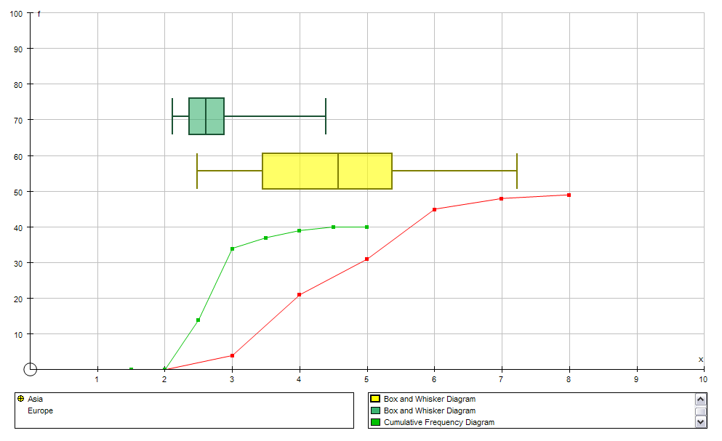

NOTE: You could investigate the ‘stem and leaf’, ‘statistics box’ and ‘results box’ capabilities to help you

