Using Autograph: Histograms and Frequency Polygons

Remember the following:
- To copy an Autograph page, use ‘Ctrl+C’. To paste this page into Word use ‘Ctrl+V’
- Ensure that your name is included in the footer of any Word files that you print. Do not print direct from Autograph.
- Do not get out of your seat to get things from the printer – I will check regularly and hand them out.

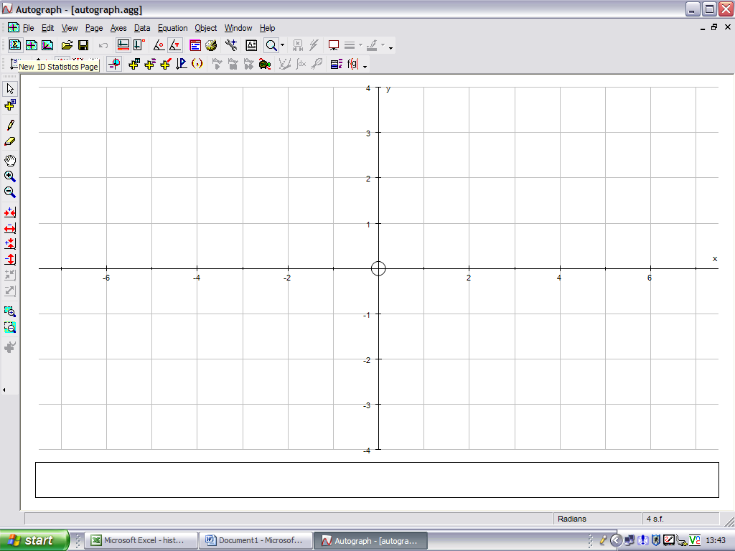
When you first open Autograph it gives you a ‘2D Graphing Page’. To use Autograph for most statistics you need to have a ‘1D Statistics Page’ open. Do this by clicking on the icon shown here:

Task One: Constructing a frequency diagram (or histogram with equal class widths)
Age (years) |  |  | Frequency
0 | ≤ y < | 20 | 36
20 | ≤ y < | 40 | 48
40 | ≤ y < | 60 | 20
60 | ≤ y < | 80 | 28
80 | ≤ y < | 100 | 15

Look at the data on the left.

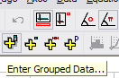
1. To enter the data into Autograph you need to click on the icon here ‘Enter Grouped Data’

2. Choose ‘Enter Manually’ in both places, and type in the relevant information. Click on OK.

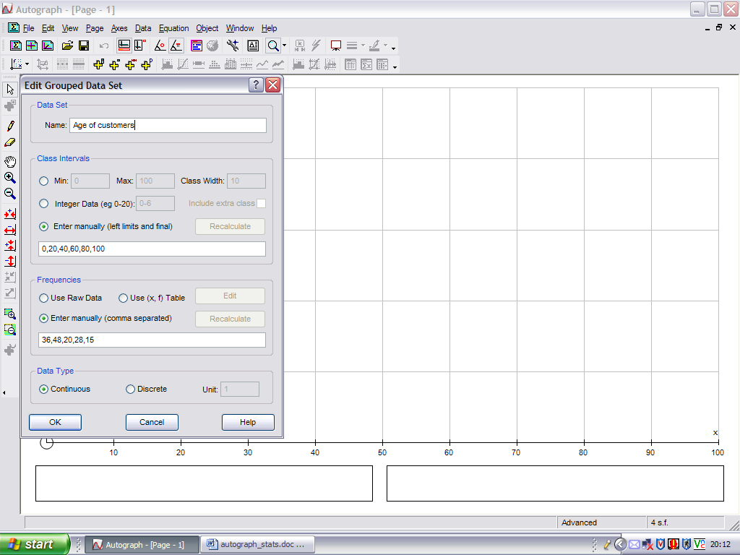
And here …
Remember – it is continuous data
It’s done already here – you just need to copy
You can name the data

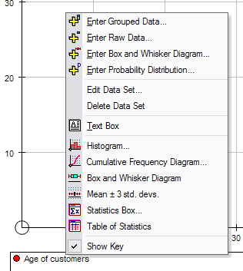

- You are now ready to construct graphs of the data. There is a box at the bottom left of the screen containing ‘Data Set 1’ (or whatever you chose to call the data in point 2). Right click on this to get the options shown on the right.
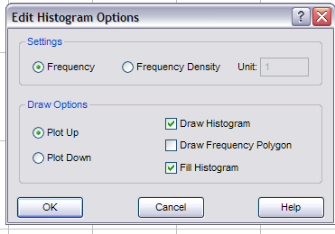
4. Choose ‘Histogram’ and select the options as shown in the box on the left. Click on OK to draw the frequency diagram.

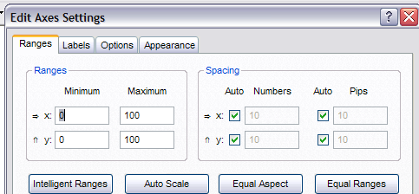
5. The axes now need adjusting to make them more sensible. Go to ‘Axes’, ‘Edit Axes’ and you will get the options here. Change the ‘x’ maximum to 120, and the ‘y’ maximum to 50. You can also label the axes by selecting ‘Labels’ and typing in the relevant information (‘Age’ and ‘Frequency’ in this case). Click on OK and you will have a much more sensible graph. Copy into Word, and move on to the next task.

Task Two: Constructing a histogram (with unequal class widths)

Using the data here, follow steps 1 to 3 as in task one. But at step 4, choose the options differently – select ‘Frequency Density’ instead. Click OK and adjust the axes to suit the graph. You should end up with a histogram that looks similar to this one.
Age (years) |  |  | Frequency
0 | ≤ y < | 20 | 28
20 | ≤ y < | 30 | 36
30 | ≤ y < | 40 | 48
40 | ≤ y < | 50 | 20
50 | ≤ y < | 70 | 30
70 | ≤ y < | 100 | 15

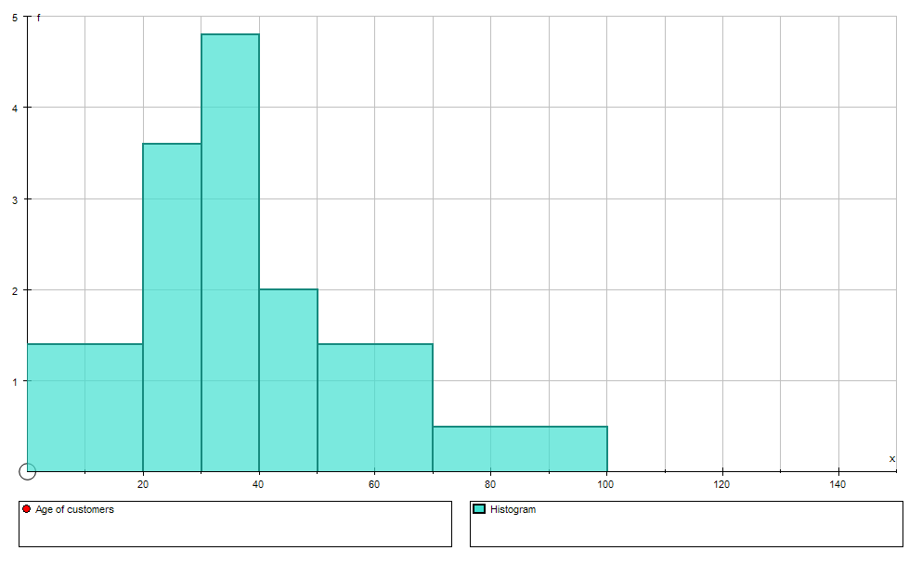

Task Three: Constructing a frequency polygon
For each of the sets of data in tasks one and two construct a frequency polygon. You will need to select the ‘Draw Frequency Polygon’ option. If you leave ‘Draw Histogram’ selected, it will draw both together.

Task Four: Investigating ‘using raw data’

Acle | 91.6 | Barton | 84.7 | Braconash | 63.1 | Burnham Mk | 63.0 | Coltishall | 87.0
Ashi | 80.8 | Bawdswell | 73.2 | Bradenham | 58.4 | Burnham Thp | 42.2 | Costessey | 74.6
Aylebridge | 74.8 | Beccles | 73.7 | Briston | 91.5 | Buxton | 85.3 | North Creake | 80.2
Aylsham | 91.4 | Besthorpe | 73.5 | Brundall | 68.6 | Carbrooke | 93.1 | Dereham | 85.8
Barney | 82.4 | Blakeney | 76.1 | Burgh Castle | 76.9 | Clenchwarton | 56.0 | Ditchingham | 70.6

Using the rainfall data above, investigate how to enter this ‘raw data’ into Autograph. Use the program to group the data into intervals of width 10. Construct a frequency diagram with superimposed frequency polygon to represent the data.

