A Slice of the Action

- These pie charts show some information about the ages of people in Greece and in Ireland.
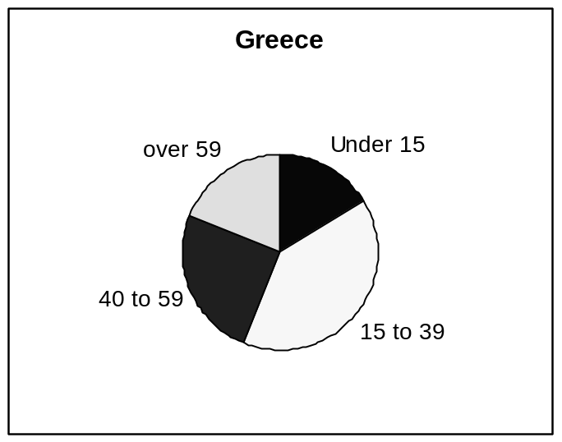

10 million people
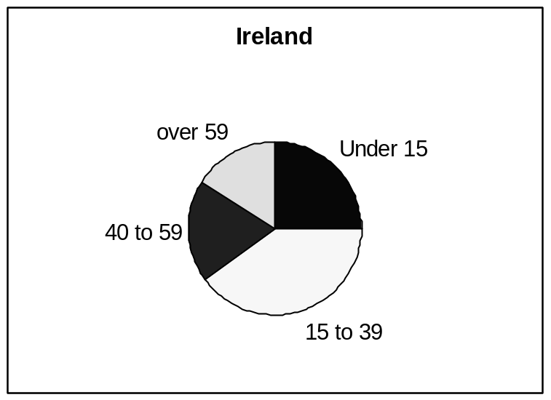

3.5 million people

- Roughly what percentage of people in Greece are aged 40-59?

- Harold says:

‘The charts show that there are more people under 15 in Ireland than in Greece.’

Harold is wrong. Explain why the charts do not show this.

