10PaperHandOuts
Some of these are whole sheets, some are cut-outs.

10Decimator

Decimators
This sheet allows you to print off an aid to multiplying or dividing by multiples of 10. Sliding a number strip inside allows you to move the place not the decimal point.
You need to cut out the shape and cut two slits either side of the decimal point.
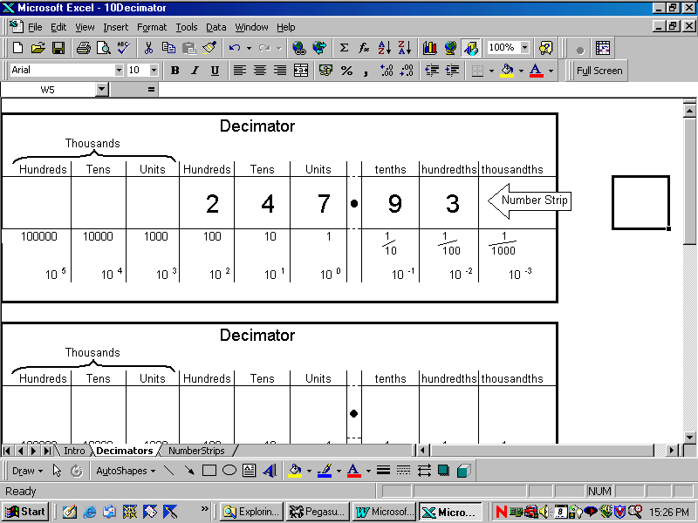

NumberStrips
These are designed to slide inside the decimator, through the slits, with the point on top. Use the strips printed or blank.

10NumberLines
This allows you to print off number lines of different scales.

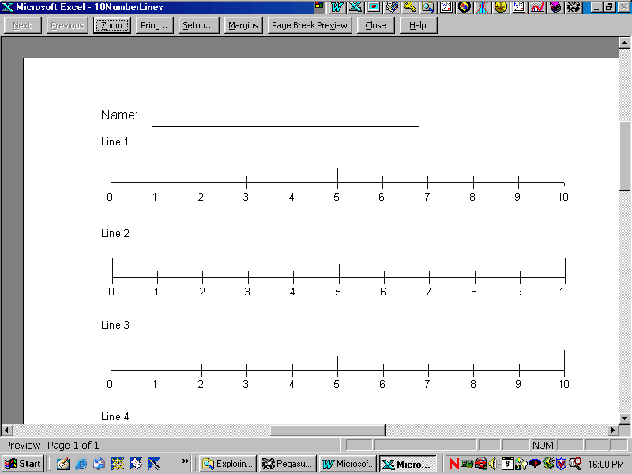Lines10
This gives you a sheet of lines from 0 to 10

Lines100
This allows you to print numbers lines from 0 to 100

Set-up and Design
Choose your own type of line, and use the macro to help you to create the correct look, copy the finished version down the page to give you a set.

10Polypedes
These are often called spider diagrams, but ours rarely have eight legs. This name allows many ‘feet’.

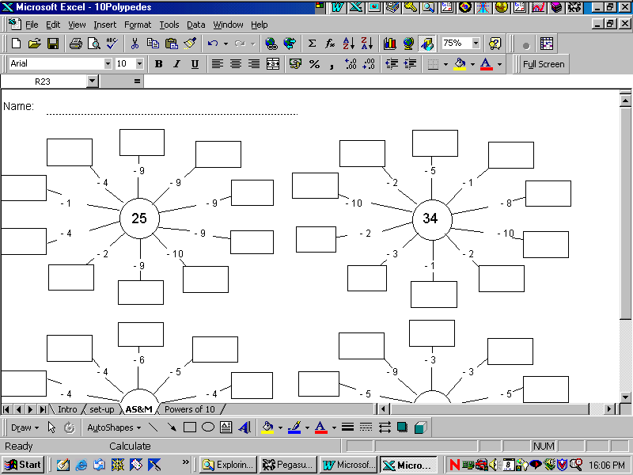AS&M
This produces random numbers, and addition, subtraction or multiplication polypedes.
The numbers lie in cells with the drawing objects drawn afterwards!

Powers of 10
This only has random numbers in the middle.

10PrintAbacusDrawings
Tools for practising aspects of place value.
This workbook illustrates ways you can draw in Excel – combining borders with drawing objects. Sometimes it is useful to use “snap to grid” in the Draw part of the drawing menu. This snaps drawing to the corners of cells. Sometimes you want more freedom.

Counter
A Counting Board - this is similar to the sand abacus, in that the spaces represent unit values for each place, whereas the lines represent fives. Relate this to Roman Numerals.
If you want to include decimals – retype the heading in the cells.

- Use the 3 columns to add, represent the two numbers in columns 1 and 2, combine them to give the result in the third.
- How do you subtract?
- What different numbers can you represent with 5 counters? Largest, smallest, even, multiples of four etc.
- Using a total of 10 counters make three numbers that are multiples of three.
- Represent 3 different numbers using a total of 12 counters so that the mean of the numbers is 22.

Spike
This allows you to print an A4 sheet showing a blank Spike Abacus and an example.

SetOfSpikes
Small versions of the spike abacus, for pupils to draw on.
This has used borders and merging cells, only using the drawing tools to add the bracket and word (in a text box).

