OCR C4 Mathematics ~ January 2006
Solutions

1 | To simplify an algebraic fraction, you factorise the top and bottom as fully as possible:  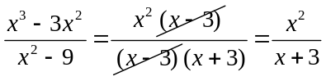
2 | 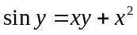  Differentiate term by term with respect to x:  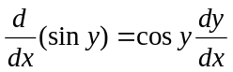  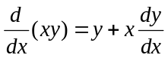 (using the product rule)  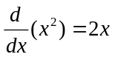  So we get: 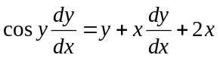  Put all 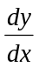 terms on the same side:  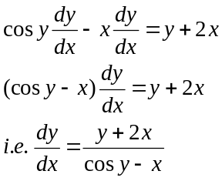
3 (i) | 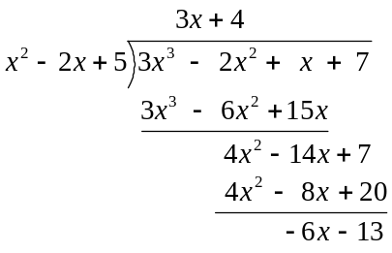  So the quotient is 3x + 4 and the remainder is -6x – 13.
(ii) | We know that  If there is to be no remainder when 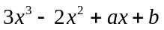 is divided by 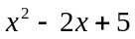, then:  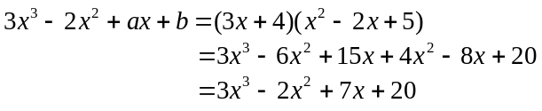  Therefore a = 7 and b = 20.
4 (i) | The formula for integration by parts is:  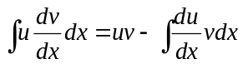  To find 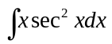, we use the above formula with 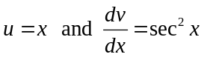.
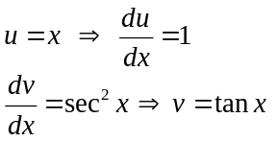
Substitute these in, we get:
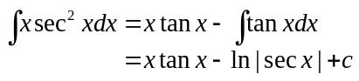
using the formula book to look up 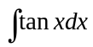.

(ii) | Recall the identity:  So,  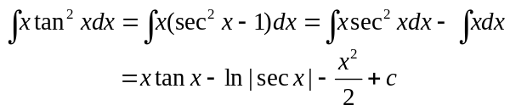
5 (i) | 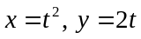  So: 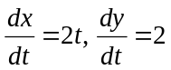  Therefore, 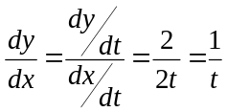
(ii) | The equation of a tangent is y = mx + c.  At the point 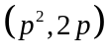, the value of the parameter is t = p and the gradient is 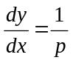  So, the equation of the tangent is 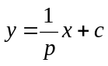.  Substitute in 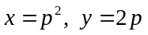, we get: 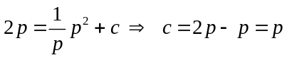  Therefore 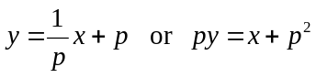
(iii) | The point (9, 6), corresponds to p = 3, so the equation of the tangent is 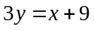.  The point (25, -10) corresponds to p = -5, so the equation of the tangent is 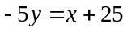  If we subtract these equations from each other to eliminate x, we get: 8y = -16  i.e. y = -2.  The corresponding x value is, x = 3y – 9 = -6 – 9 = -15.  So the tangents meet at (-15, -2).

6 (i) | Let I = 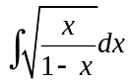 Substitute 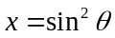  So I = 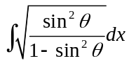 To find 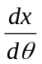 we use the chain rule.  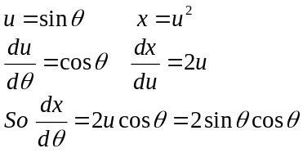 Therefore 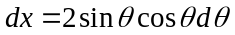  Then I = 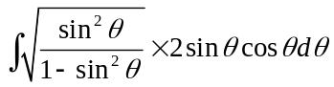  Recall that 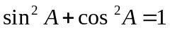, so 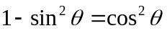.  So  I = 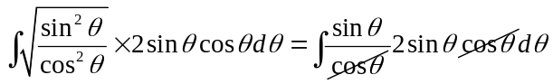  So, I = 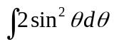 (as required)
(ii) | Let I = 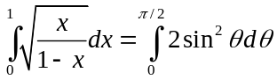 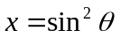  If x = 0, θ = 0  But 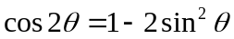 If x = 1, θ =   So, 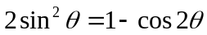  Therefore I = 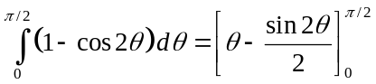  Put in the limits: I = 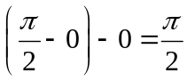
7 (i) | 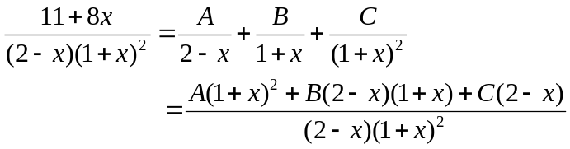  So  Put x = -1: 3 = C×3 So C = 1  Put x = 2: 27 = 9A So A = 3  Put x = 0: 11 = 3 + B×2×1 + 1×2 So B = 3  Therefore, 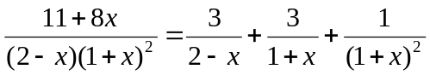
(ii) | The binomial expansion formula is 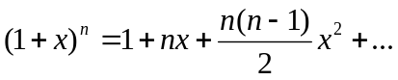  So:  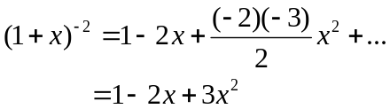  Also:  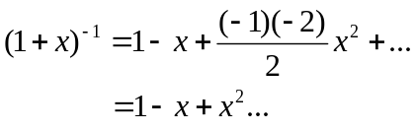  Finally  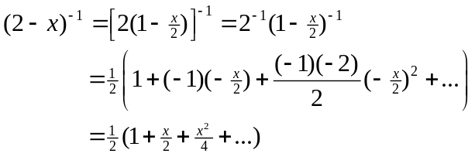  Therefore,  =  = 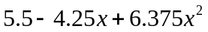+…
8 (i) | 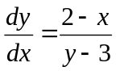  Separate out the variables so that y terms are together and x terms are together:  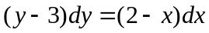  Put in the integral signs:  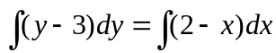  So:  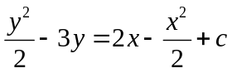  Put in y = 4 and x = 5:  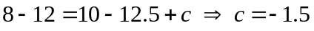  So we have:  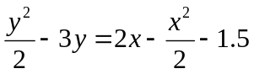
(ii) | Multiply through by 2:  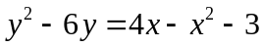  Collect x’s and y’s together on the same size:  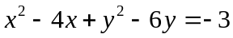  Complete the squares:  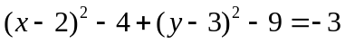  So:  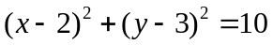.
(iii) | The solution curve is a circle, centre (2, 3) and radius 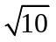.  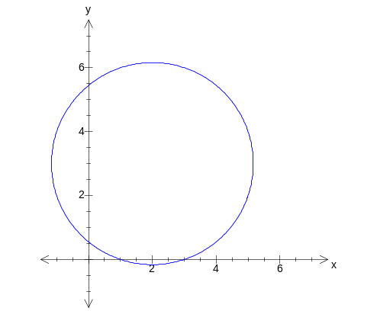
9 (i) | The angle between two lines is the angle between the two direction vectors.  The direction vectors are 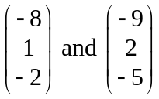.  The scalar product of the vectors is: 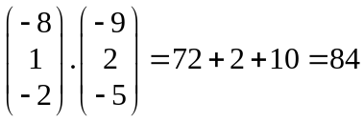  The magnitude of each vector is:  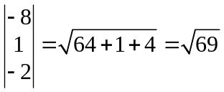  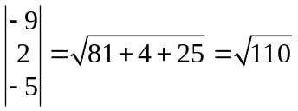  Using the formula for the scalar product we get:  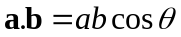  So:  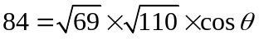  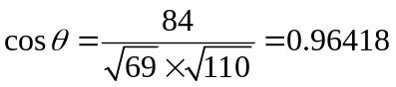  i.e. 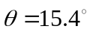
(ii) | The lines intersect so there is a solution to the equations:  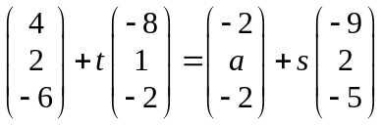  Writing these as separate equations:  4 – 8t = -2 – 9s So 8t – 9s = 6 (1)  2 + t = a + 2s So t – 2s = a – 2 (2)  -6 – 2t = -2 – 5s So 2t – 5s = -4 (3)

Solving equations (1) and (3) we get:
8t – 9s = 6 (1)
8t – 20s = -16 (3) × 4
Subtract:
11s = 22
s = 2

From equation (3): 2t = 5s – 4 = 10 – 4 = 6
So t = 3

Putting these values of s and t into equation (2):
t – 2s = a – 2
3 – 4 = a – 2
So a = 1

To find the point of intersection we use the equation of one of the lines:
