Specimen Paper C3
Solutions

1 | 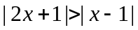  Square both sides: 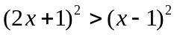  Expand brackets: 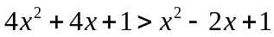  Collect terms: 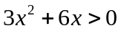  Factorise: 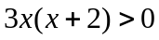  So either x > 0 or x < -2.
2 (i) | =  = 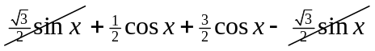  = 2cosx (as required)
(ii) | So 2cos15 = 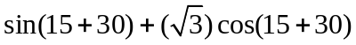 (substituting x = 15 into the above identity).  = 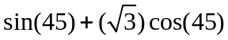  = 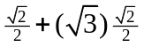  = 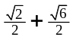  Therefore cos15 = 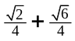  (Other correct expressions are possible)
3 (i) | 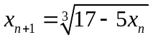  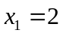  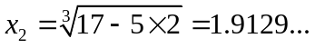  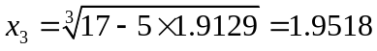  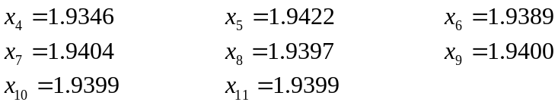  The values are converging to α = 1.94 (2 dp)
(ii) | Replace both 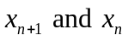 by x: 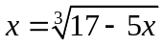  Cube both sides: 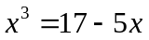  So the cubic equation is: 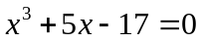
(iii) | Let 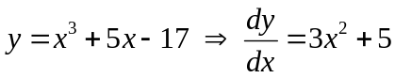.  This function has no turning points as  is never 0.  The curve therefore only crosses the x-axis in one place so there are no other real roots.

4 (i) | Area = 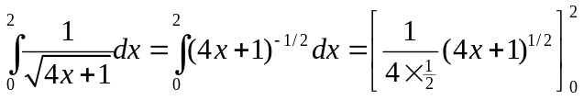  = 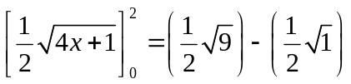  = 1.5 – 0.5  = 1 (as required)
(ii) | Formula for volume of revolution about x-axis is 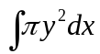 (LEARN THIS!!)  So volume = 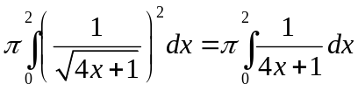  = 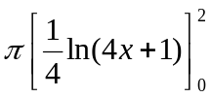  = 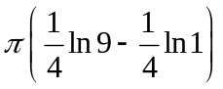  = 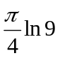.
5 (i) | As t gets larger, 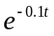 approaches 0, so the oven temperature, θ, approaches 200°C.
(ii) | 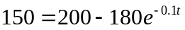 (putting θ = 150)  Therefore, 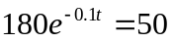  So: 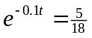  Take logs: 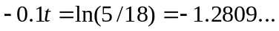  Therefore, t = 12.8 minutes.
(iii) | The rate of change of temperature is: 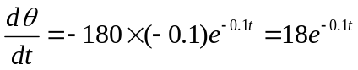  Put t = 12.8, 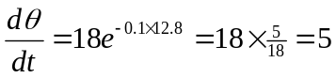°C/min.
6 (i) | The domain of f is x ≥ 0. The range of f is f(x) ≥ 1.  The range of the inverse function f⁻¹ is the same as the domain of f. So the range is f⁻¹(x) ≥ 0.  The domain of the inverse function f⁻¹ is the same as the range of f. So the domain is x ≥ 1.
(ii) | Write the function in the form y = …: 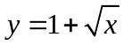  Swap over x and y: 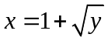  Rearrange: 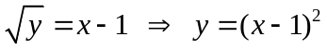
(iii) | The graph of y = f⁻¹(x) is the reflection of the graph of y = f(x) in the line y = x.  Therefore the solution to the equation f(x) = f⁻¹(x) is the same as the solution to  x = (x – 1)².  If we expand out the brackets we get: 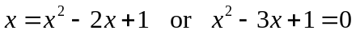.  The solution to this equation is: 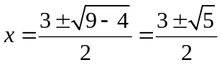.  As 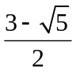 is not greater than 1, the solution must be 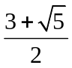
7 (i) | 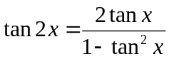 (Double angle formula for tan – LEARN!!)
(ii) | 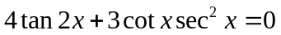  We know that 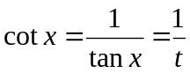 and 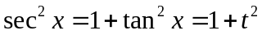.  Also, 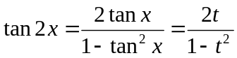  Substituting these into the equation, we get:  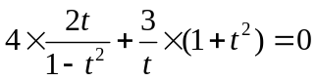  Multiply through by 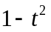: 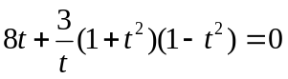  Multiply through by t: 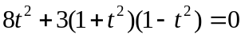  Expand out brackets: 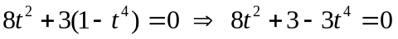  Rearranging gives: 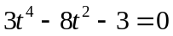 (as required)
(iii) | The equation is a quadratic in .  Using the quadratic formula: 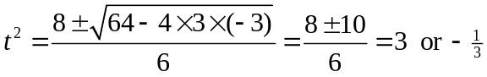  So 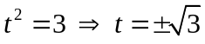  Therefore tanx = 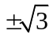 i.e. x = 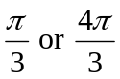 or 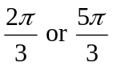
8 (i) | We use the chain rule:  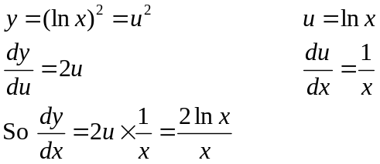  We now use the quotient rule to differentiate again:  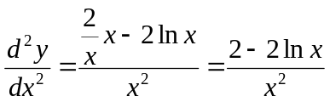
(ii) | The gradient is greatest when 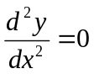. This occurs when 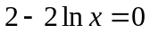, i.e. if lnx = 1.  So x = e.  The gradient at this point is given by 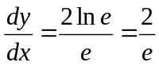. The y-coordinate of P is  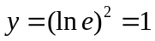  The equation of the tangent at P is: 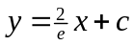  We substitute in the coordinates of P: 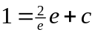 Therefore c = -1.  So the equation of the tangent is 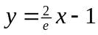. This passes through the point (0, -1).
9 (i) | a = 
(ii) | 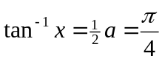  So, 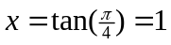
(iii) | 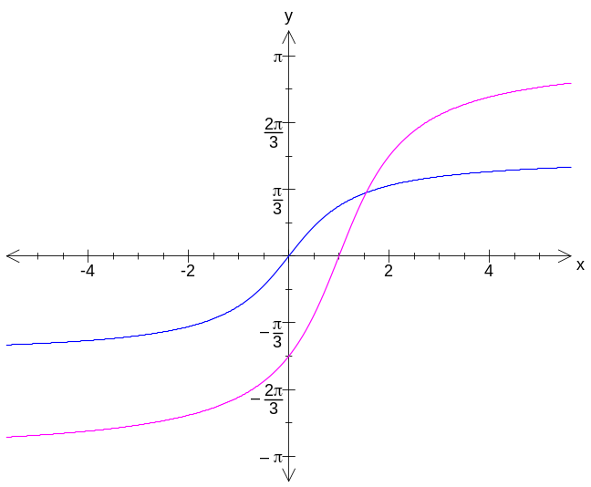  The asymptotes are now 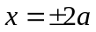
(iv) | At the point of intersection: 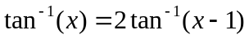 or 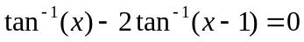.  Substitute x = 1.535: > 0.  Substitute x = 1.545: .  So the point of intersection lies between 1.535 and 1.545 i..e. it is x = 1.54 (to 2 DP).
(v) | 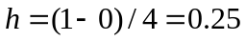  Substituting these values into the Simpson’s rule formula:  (3 SF).
  x | 0 | 0.25 | 0.5 | 0.75 | 1
  y | 0 | 0.06001 | 0.21497 | 0.41409 | 0.61685

