C4 Specimen Paper
Solutions

1 | 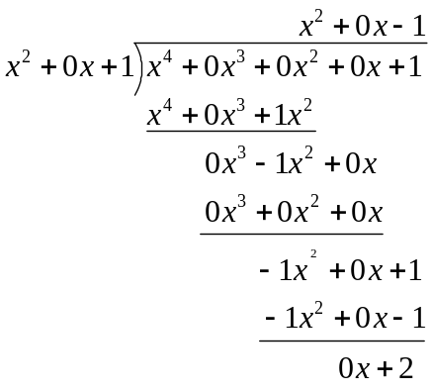  So the quotient is 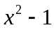 and the remainder is 2.
2 (i) | We use the formula: 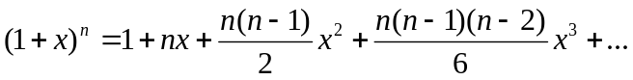  So,  = 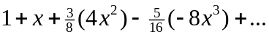  = 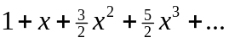
(ii) | The formula is valid if -1 < x < 1.  So our expansion is valid if -1 < -2x < 1, i.e. if -0.5 < x < 0.5.
3 | We use integration by parts with  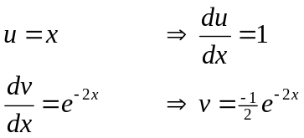  So,  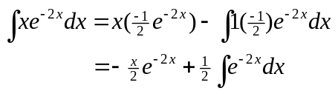  =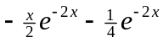  Therefore, 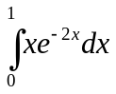 = 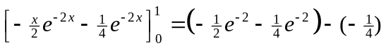  = 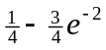

4 (i) | 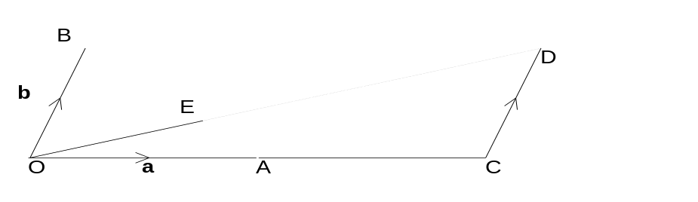
(ii) | 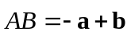  = 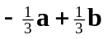  Since 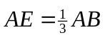, E lies one third of the way along the line joining A to B.
5 (i) | 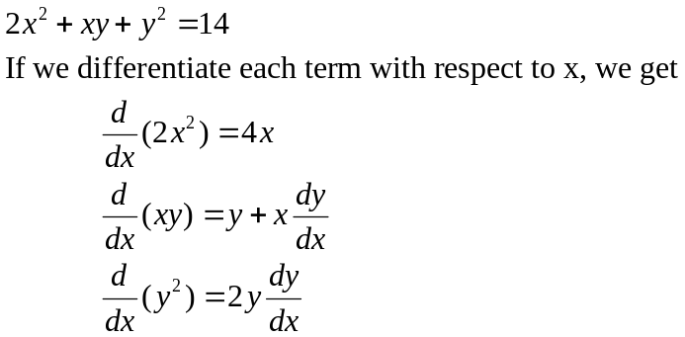  Putting this together we get:  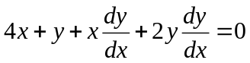  So: 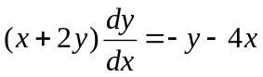  i.e. 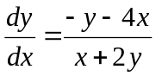
(ii) | If the tangent is parallel to the x-axis, then 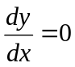. This happens when the top of the fraction (i.e. the numerator) is 0.  So we have 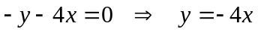  If we substitute this expression into the equation of the curve:  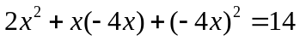  i.e. 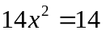  So 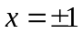  When x = 1, y = -4  When x = -1, y = 4.  So there are two points where the tangents are parallel to the x-axis. The coordinates are  (1, -4) and (-1, 4).

6 (i) | 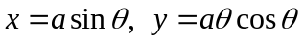  The origin corresponds to 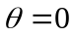 (this is the value of θ that makes the values of x and y zero).  A occurs when x = 0 and y ≠ 0. This occurs when 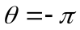, so 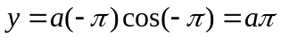. Therefore, the coordinates of A are (0, aπ).  B occurs when y = 0 and x ≠ 0. This occurs when 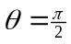, so 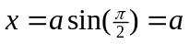. Therefore the coordinates of B are (a, 0).
(ii) | 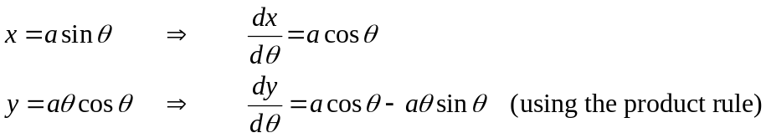  So, 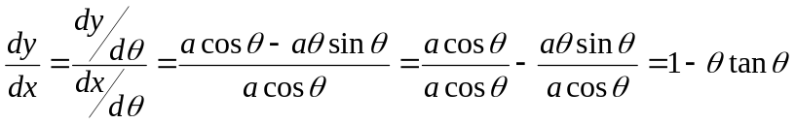 (as required)  When 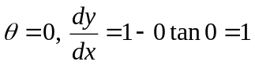.  So the equation of the tangent is y = 1x + c.  Since the tangent passes through (0, 0), c = 0. So the tangent is y = x.
7 (i) | The equation for L₁ is 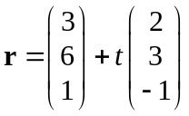  The equation for L₂ is 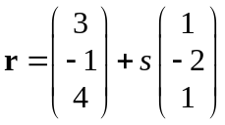  Note the need for different parameters (t and s).
(ii) | To find the point of intersection we solve: 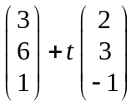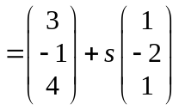  We can form 3 equations:  3 + 2t = 3 + s i.e. 2t – s = 0 (1)  6 + 3t = -1 -2s i.e. 3t + 2s = -7 (2)  1 – t = 4 + s i.e. t + s = -3 (3)  Using equations (1) and (3), we can eliminating s by adding: 3t = -3 (1) + (3)  i.e. t = -1  So from equation (1), we know s = 2t = -2.  We now show that these values work in equation (2): 3t + 2s = -3 - 4 = -7 (as required).  So the lines intersect.  The point of intersection is given by:  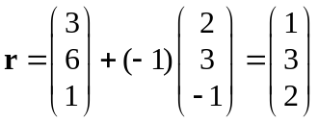.  So the point is (1, 3, 2).
(iii) | We find the angle between the direction vectors, which are 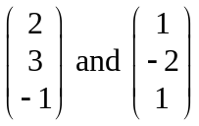.  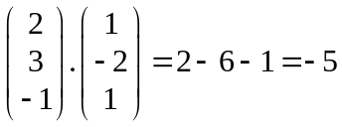  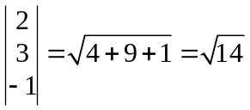  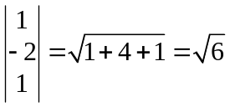  Using the formula, 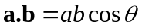, we find that 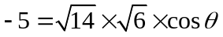.  So 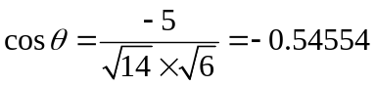 i.e. 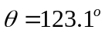.  So the acute angle is 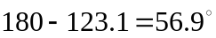.
8 (i) | 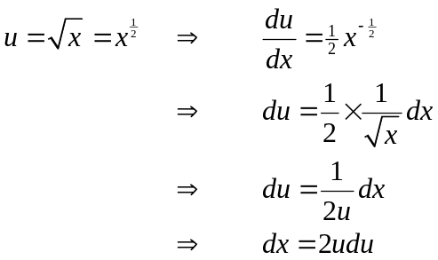  So 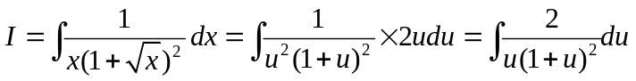
(ii) | 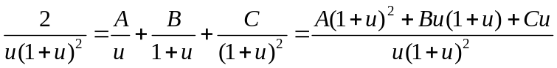  Therefore, 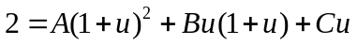  Put u = 0: 2 = A i.e. A = 2  Put u = -1: 2 = -C i.e. C = -2  Now choose any further value for u, e.g. u = 1:  2 = 4(2) + B(1)(2) – 2  2 = 8 + 2B – 2  2B = -4  B = -2  Therefore: 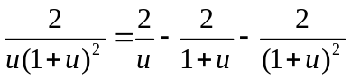
(iii) | = 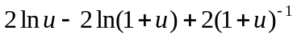  = 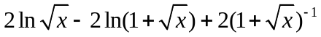+ c.  = 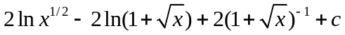  = 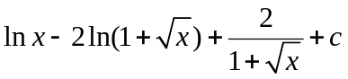
8 | When t = 0, x = 200.  We wish to find t when x = 100 and 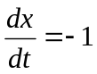  The differential equation is:  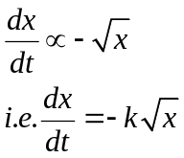  -k represents the proportionality constant  (negative as water level is falling).  The rate at which water level is dropping.  To solve this differential equation we separate the variables:  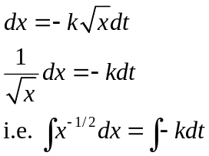  So: 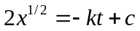  This rearranges to give: 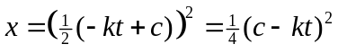  Put t = 0 and x = 200: 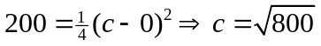  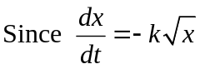 and when x = 100, we get: 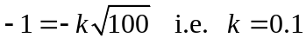  Therefore: 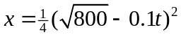  Putting x = 100: .  If we square root, we get: 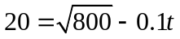  So we get: 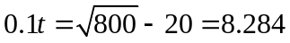.  So: t = 82.8 minutes (to 3 SF).

