January 2006 Solutions
Probability and Statistics 1

1 (i) | P(Jenny passes 1st attempt) = 2/3  P(passes 2nd attempt) = 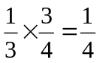  So, P(Jenny passes) = 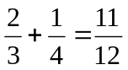
(ii) | P  2/3  P  p  F  1/3  F  1 - p  P(pass) = 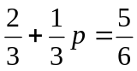. So, 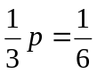  Therefore, 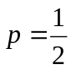
2 (i) | Let y = h – 100  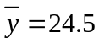 and 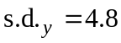  Therefore, 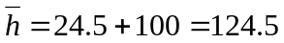  s.d._{h} = 4.8
(ii) | The 2nd group of plants are shorter on average.  The 2nd group of plants have heights that are slightly more varied.
(iii) | Total height of 150 plants =  So overall mean = 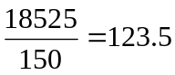
3 (i) | B  P  P  1/4  3/4  2/5  3/5  B  P  2/4  2/4  B  B  B  B  P  P  P  1/3  2/3  2/3  1/3  2/3  1/3  P(X = 3) = 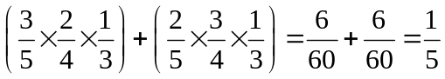  F
(ii) | 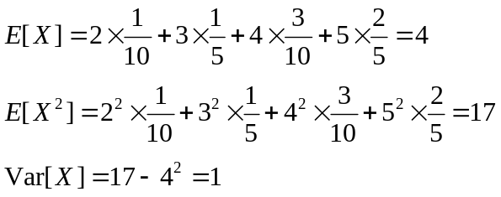
4 (i) | Each square represents 300 ÷ 60 = 5 days (there are 60 squares in the histogram).  a) Between £4000 and £6000 = 8 squares = 40 days  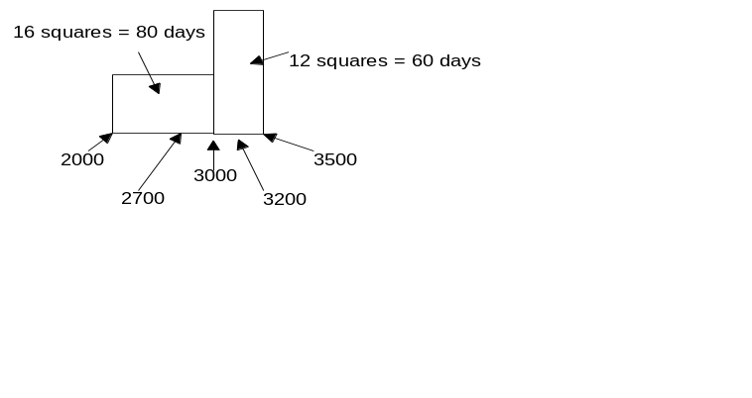  b)  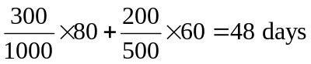
(ii) | - box-and-whisker plots are best for reading off median and quartile values  - a cumulative frequency graph is best for finding the range of the top 10% of values.
5 (i) | a) X ~ Geo(2/5)  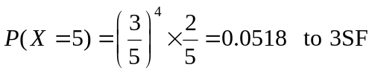  b) P(X < 5) =  = 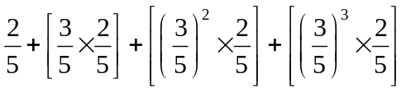  = 0.4 + 0.24 + 0.144 + 0.0864  = 0.870 (3 SF)
(ii) | a) Y ~ B95, 0.4)  P(Y = 1) = 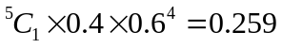 (3 SF)  b) She will score her 2nd goal on the 6th shot if she scores her 1st goal in her first 5 shots and then scores for her 2nd time on her 6th go.  So, probability = 0.2592 × 0.4 = 0.104 (3 SF)

6(i) | 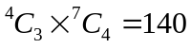
(ii) | If she chooses A1, she must choose 2 more questions out of 3 in section A. This can be achieved in 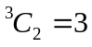 ways.  If she doesn’t choose B1, then she must choose 4 questions from 6. This can be done in 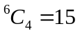 ways.  So the total number of ways for this situation is 3 × 15 = 45.  Therefore the probability is 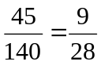.
(iii) | Case 1: Don’t answer A1: 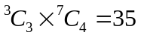  Case 2: Answer question A1: 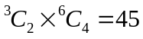  Therefore 80 ways altogether.
7 (i) | Let X = number of seeds that germinate.  X ~ B(10, 0.9)  Assumptions: seeds germinate independently of one another.  Each seed has the same probability (0.9) of germinating.
(ii) | P(X < 8) = P(X ≤ 7) = 0.0702 (from tables)
(iii) | P(X ≥ 8) = 1 – 0.0702 = 0.9298  Let Y = number of trays with at least 8 seeds germinating.  Then Y ~ B(20, 0.9298).  P(Y = 19) = 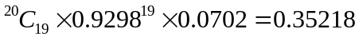  P(Y = 20) = 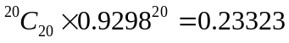  Therefore, P(Y ≥ 19) = 0.35218 + 0.23323 = 0.585 (3 SF)
8 (i) | a)  So, 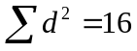  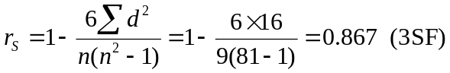  b) There is strong rank correlation between the population of a county and the population of a capital city, i.e. countries with large populations tend to have larger capital cities.
  Rank x | 1 | 2 | 3 | 4 | 5 | 6 | 7 | 8 | 9
  Rank y | 3 | 2 | 1 | 5 | 4 | 7 | 8 | 6 | 9
  d | -2 | 0 | 2 | -1 | 1 | -1 | -1 | 2 | 0
  d² | 4 | 0 | 4 | 1 | 1 | 1 | 1 | 4 | 0
(ii) | Using calculator functions, r = 0.698 (3 SF)
(iii) | The value of the PMCC would increase.
(iv) | a) We would use the regression line of x on y, since both variables are random and we wish to predict the value of x.  b) y = 1 lies within the range of values in the data but as the correlation is not very strong the estimate will not be very accurate (there is a fair degree of scatter of points about the regression line).

