1MA0/3H
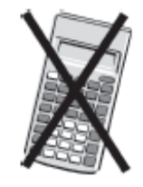
Edexcel GCSE
Mathematics (Linear) – 1MA0
Paper 3H (Non-Calculator)
Higher Tier
Mock Paper
Time: 1 hour 45 minutes

Materials required for examination Items included with question papers
Ruler graduated in centimetres and Nil
millimetres, protractor, compasses,
pen, HB pencil, eraser.
Tracing paper may be used.

Instructions
Use black ink or ball-point pen.
Fill in the boxes at the top of this page with your name, centre number and candidate number.
Answer all questions.
Answer the questions in the spaces provided – there may be more space than you need.
Calculators must not be used.

Information
The total mark for this paper is 100.
The marks for each question are shown in brackets – use this as a guide as to how much time to spend on each question.
Questions labelled with an asterisk (*) are ones where the quality of your written communication will be assessed – you should take particular care on these questions with your spelling, punctuation and grammar, as well as the clarity of expression.

Advice
Read each question carefully before you start to answer it.
Keep an eye on the time.
Try to answer every question.
Check your answers if you have time at the end.

This publication may be reproduced only in accordance with
Edexcel Limited copyright policy.
©2010 Edexcel Limited.
Printer’s Log. No. S39263A
GCSE Mathematics (Linear) 1MA0

Formulae: Higher Tier

You must not write on this formulae page.
Anything you write on this formulae page will gain NO credit.
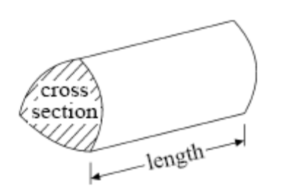

Volume of prism = area of cross section × length

Volume of sphere πr³ Volume of cone πr²h
Surface area of sphere = 4πr² Curved surface area of cone = πrl

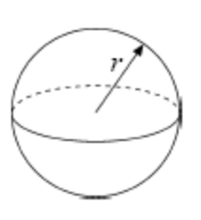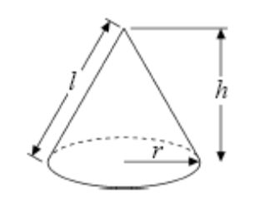

In any triangle ABC The Quadratic Equation
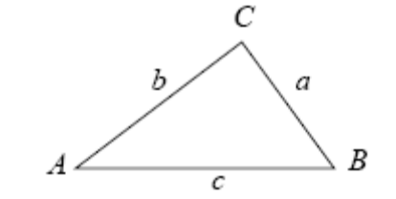
The solutions of ax2+ bx + c = 0
where a ≠ 0, are given by

x = 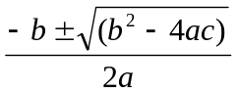

Sine Rule 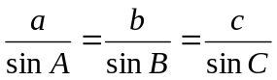

Cosine Rule a² = b²+ c²– 2bc cos A

Area of triangle = ab sin C
Answer ALL TWENTY FIVE questions.

Write your answers in the spaces provided.

You must write down all stages in your working.

1. Write 32 out of 80 as a percentage.

...................................................... %
(Total for Question 1 = 2 marks)

2. Jack sows 300 wildflower seeds.
The probability of a seed flowering is 0.7

Work out an estimate for the number of these seeds that will flower.

......................................................
(Total for Question 2 = 2 marks)

3. (a) Express 120 as a product of its prime factors.
(2)

...........................................................................

(b) Find the highest common factor (HCF) of 90 and 120
(1)

......................................................
(Total for Question 3 = 3 marks)

4. Here is a list of ingredients for making 12 small cakes.

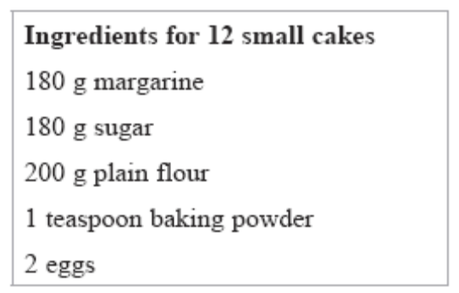

Joe is going to make 24 of the small cakes.

(a) Work out how much margarine he needs.
(2)

...................................................... g

Sharon is going to make 18 of the small cakes.

(b) Work out how much flour she needs.
(2)

...................................................... g
(Total for Question 4 = 4 marks)

5.
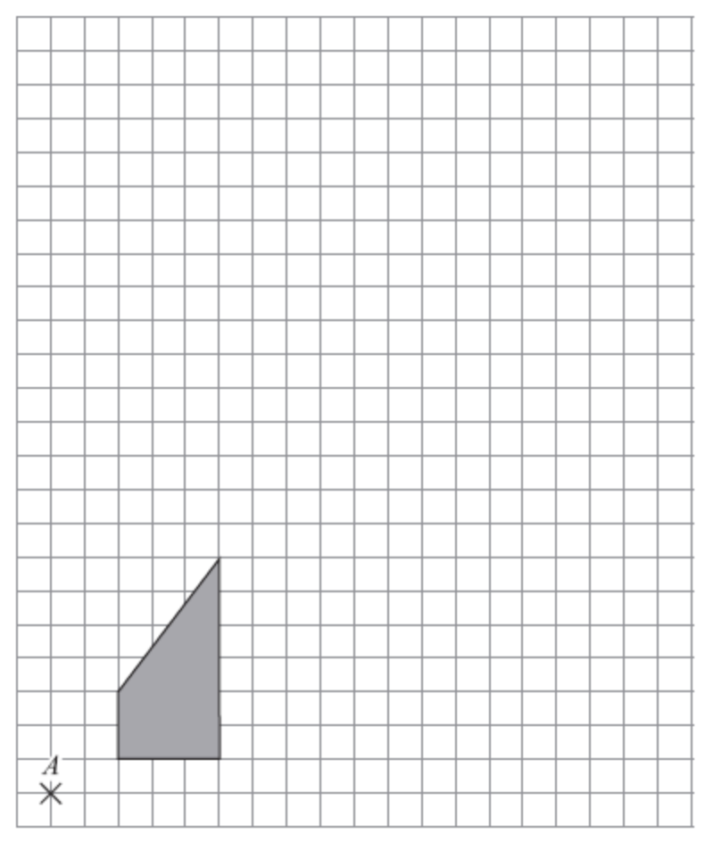

On the grid, enlarge the shaded shape by a scale factor of 3, centre A.

(Total for Question 5 = 3 marks)

6. V = 3b + 2b²

(a) Find the value of V when b = –4
(2)

......................................................

(b) Simplify m⁶ × m⁷
(1)

......................................................

(c) Simplify x⁰
(1)

......................................................

(d) Simplify 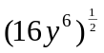
(2)

......................................................
(Total for Question 6 = 6 marks)

7. Guy wants to find out how much time people spend watching television.
He will design a questionnaire.

Design a suitable question for Guy’s questionnaire.

(Total for Question 7 = 2 marks)

8. A school canteen offers four different meal choices.
Students can choose salad or pizza or meat pie or fish.

The table shows the probability that a student will choose salad or meat pie or fish.

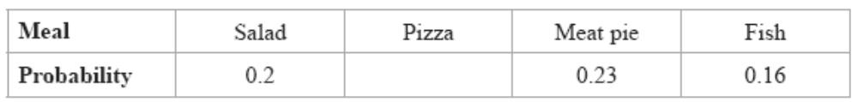

One student is chosen at random from these students who are going to use the canteen.

Work out the probability that the student

(i) chooses meat pie or fish,

......................................................

(ii) chooses pizza.

......................................................
(Total for Question 8 = 3 marks)

9. Janice asks 100 students if they like biology or chemistry or physics best.

38 of the students are girls.
21 of these girls like biology best.
18 boys like physics best.
7 out of the 23 students who like chemistry best are girls.

Work out the number of students who like biology best.

......................................................
(Total for Question 9 = 4 marks)

10. Mrs Miller is planning a party for 70 children.
She will give each child a party bag to take home.
She will put a hat and a toy in each party bag.

Party bags are sold in packs of 12
Hats are sold in packs of 8
Toys are sold in packs of 9

Mrs Miller buys the smallest possible number of packs of hats, toys and bags.

Mrs Miller can fill more party bags than she needs.
How many more?

......................................................
(Total for Question 10 = 4 marks)

11. Last year Kerry’s take home pay was £15 000
She spent 40% of her take home pay on rent.

She used the rest of her take home pay for living expenses, clothes and entertainment in the ratio 3 : 1 : 2

How much did Kerry spend on entertainment last year?

£ ......................................................
(Total for Question 11 = 4 marks)

12. (a) Expand 3(4x + y)
(2)

......................................................
(b) Expand 5p(p – 3)
(1)

......................................................
(c) Expand and simplify (y + 8)(y – 3)
(2)

......................................................
(d) Expand and simplify (2t – 3)²
(2)

......................................................
(Total for Question 12 = 7 marks)

13. Make m the subject of the formula p = h + 6m

......................................................
(Total for Question 13 = 2 marks)
14. Mary is going to put a bird bath in her garden.
The diagram shows a plan of Mary’s garden.

A B

D C

Scale 1 cm represents 1 m

There is a wall along AB.
There are hedges along the other three sides of the garden.

Mary wants to put her bird bath

at least 2 m away from the wall AB,
more than 3 m away from the tree at T,
and closer to the hedge along DC than to the hedge along CB.

Complete an accurate plan of the garden to show the region where Mary can put her bird bath.

(Total for Question 14 = 4 marks)

15. The diagram shows a trapezium.
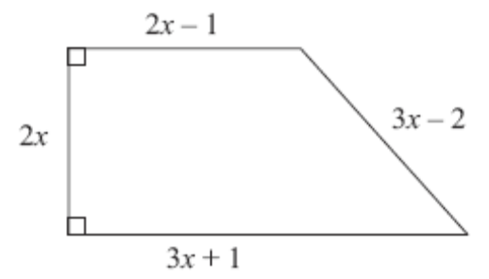

Diagram NOT
accurately drawn

In the diagram, all measurements are in centimetres.

The perimeter of the trapezium is 38 cm.

Work out the area of the trapezium.

...................................................... cm²
(Total for Question 15 = 5 marks)

16.
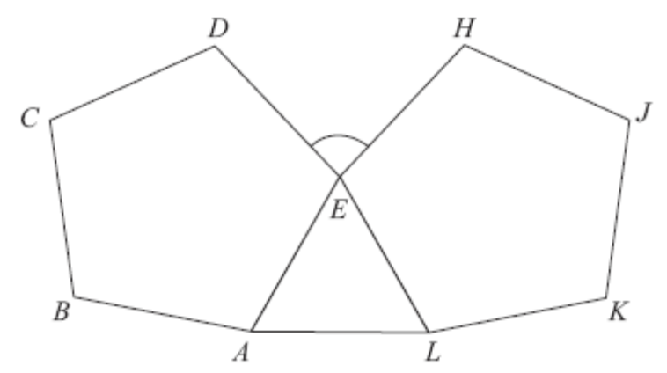

Diagram NOT
accurately drawn

ABCDE and EHJKL are regular pentagons.
AEL is an equilateral triangle.

Work out the size of angle DEH.

...................................................... °
(Total for Question 16 = 4 marks)

*17. Henry wants to invest £4000 for 2 years.
He can choose between two different banks.

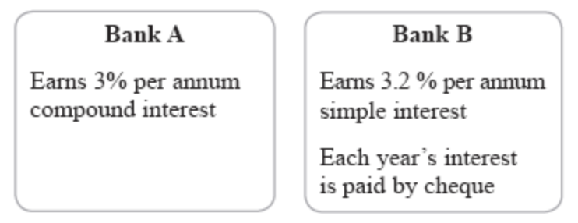

Henry wants to earn as much interest on his investment as possible.
Which bank should Henry choose?
You must show your working.

(Total for Question 17 = 5 marks)

18.
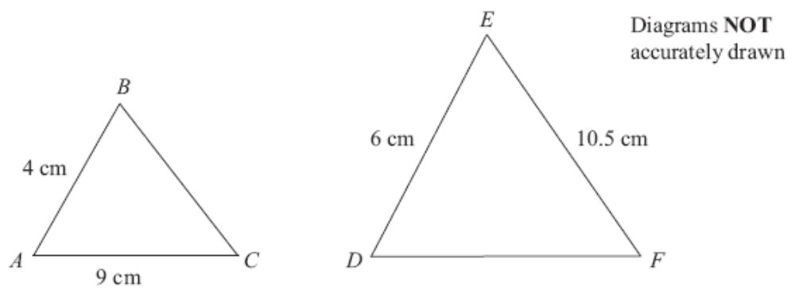

Triangles ABC and DEF are similar.

AB = 4 cm.
AC = 9 cm.
DE = 6 cm.
EF = 10.5 cm.

(a) Work out the length of DF.
(2)

...................................................... cm

(b) Work out the length of BC.
(2)

...................................................... cm
(Total for Question 18 = 4 marks)

19. Solve the simultaneous equations

5x – 2y = 13
7x + 4y = 8

x = ......................................................

y = ......................................................
(Total for Question 19 = 4 marks)

*20. 80 students took a maths exam.
The exam had two papers.

The cumulative frequency table gives information about the marks scored on Paper 1.

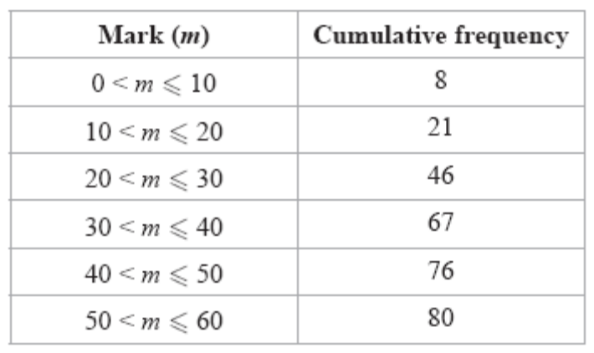

(a) On the grid opposite, draw a cumulative frequency graph for the data in the table.
(2)

The lowest mark scored on Paper 1 was 9
The highest mark scored on Paper 1 was 52

(b) In the space provided on the grid, draw a box plot for the marks scored on Paper 1.
(3)

The box plot shown has been drawn for the marks scored by the same students on Paper 2.

(c) Compare the marks scored by students on Paper 1 with the marks scored by the students on Paper 2.
(2)

............................................................................................................................................................

............................................................................................................................................................

............................................................................................................................................................

............................................................................................................................................................
(Total for Question 20 = 7 marks)

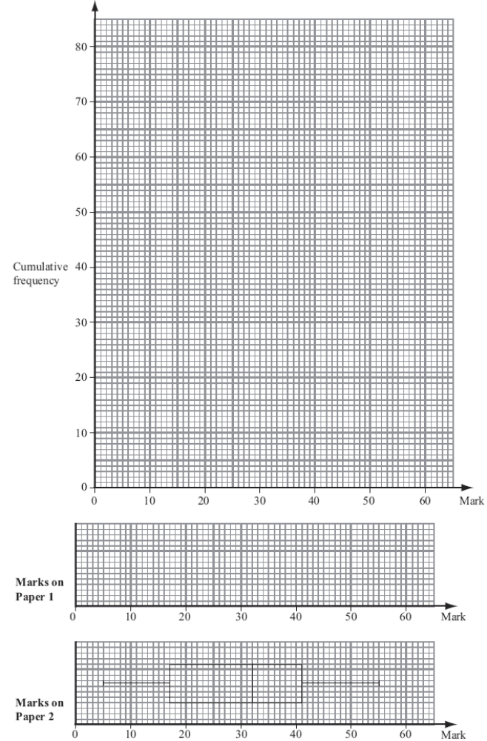
21.
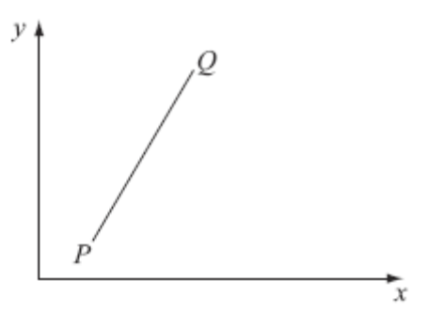

Diagram NOT
accurately drawn

O

P is the point with coordinates (2, 1).
Q is the point with coordinates (14, k).

The gradient of PQ is 

Work out the value of k.

k = ......................................................
(Total for Question 21 = 3 marks)

22.
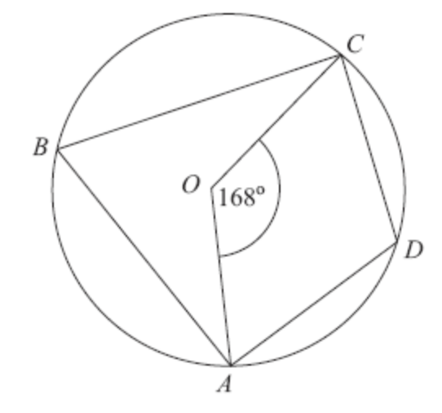

Diagram NOT
accurately drawn

A, B, C and D are points on the circumference of a circle, centre O.

Angle AOC = 168°

Work out the size of angle ADC.
You must give reasons for your working.

..................................................... °
(Total for Question 22 = 4 marks)

23. Sally has a bag of 9 sweets.

In the bag, there are

3 orange flavoured sweets,
4 strawberry flavoured sweets
and 2 lemon flavoured sweets.

Sally takes, at random, two of the sweets.
She eats the sweets.

Work out the probability that the two sweets Sally eats are not of the same flavour.

......................................................
(Total for Question 23 = 4 marks)

24. Solve 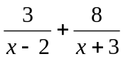 = 2

......................................................
(Total for Question 24 = 5 marks)

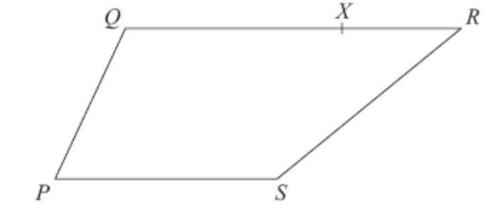
25.

Diagram NOT
accurately drawn

PQRS is a trapezium.
PS is parallel to QR.
QR = 2PS

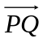 = a 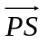 = b

X is the point on QR such that QX : XR = 3 : 1

Express in terms of a and b.

(i) 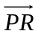
(2)

......................................................

(ii) 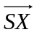
(3)

......................................................
(Total for Question 25 = 5 marks)

TOTAL FOR PAPER = 100 MARKS

