1MA0/3H
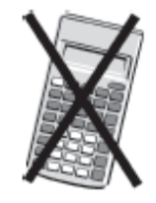
Edexcel GCSE
Mathematics (Linear) – 1MA0
Practice Paper 3H (Non-Calculator)
Set A
Higher Tier
Time: 1 hour 45 minutes

Materials required for examination Items included with question papers
Ruler graduated in centimetres and Nil
millimetres, protractor, compasses,
pen, HB pencil, eraser.
Tracing paper may be used.

Instructions
Use black ink or ball-point pen.
Fill in the boxes at the top of this page with your name, centre number and candidate number.
Answer all questions.
Answer the questions in the spaces provided – there may be more space than you need.
Calculators must not be used.

Information
The total mark for this paper is 100.
The marks for each question are shown in brackets – use this as a guide as to how much time to spend on each question.
Questions labelled with an asterisk (*) are ones where the quality of your written communication will be assessed – you should take particular care on these questions with your spelling, punctuation and grammar, as well as the clarity of expression.

Advice
Read each question carefully before you start to answer it.
Keep an eye on the time.
Try to answer every question.
Check your answers if you have time at the end.

This publication may be reproduced only in accordance with
Edexcel Limited copyright policy.
©2010 Edexcel Limited.
Printer’s Log. No. P1MA03HA
GCSE Mathematics (Linear) 1MA0

Formulae: Higher Tier

You must not write on this formulae page.
Anything you write on this formulae page will gain NO credit.
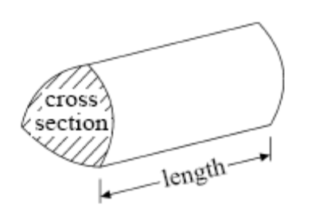

Volume of prism = area of cross section × length

Volume of sphere πr³ Volume of cone πr²h
Surface area of sphere = 4πr² Curved surface area of cone = πrl

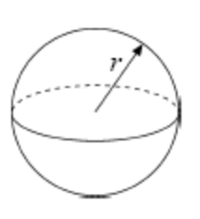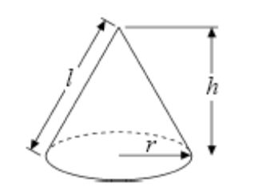

In any triangle ABC The Quadratic Equation
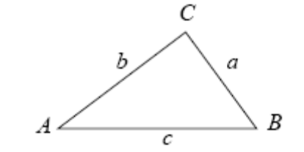
The solutions of ax2+ bx + c = 0
where a ≠ 0, are given by

x = 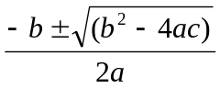

Sine Rule 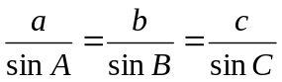

Cosine Rule a² = b²+ c²– 2bc cos A

Area of triangle = ab sin C
Answer ALL TWENTY SEVEN questions

Write your answers in the spaces provided.

You must write down all the stages in your working.

You must NOT use a calculator.

1. Simplify 5a + 4b – 2a + 3b

……………………..
(Total 2 marks)
______________________________________________________________________________
2. Using the information that

9.7 × 12.3 = 119.31

write down the value of

97 × 123

.…………………..

0.97 × 123 000

…………………..

11 931 ÷ 97

…………………..
(Total 3 marks)
______________________________________________________________________________
3. The scatter graph shows information about the height and the weight for nine students.

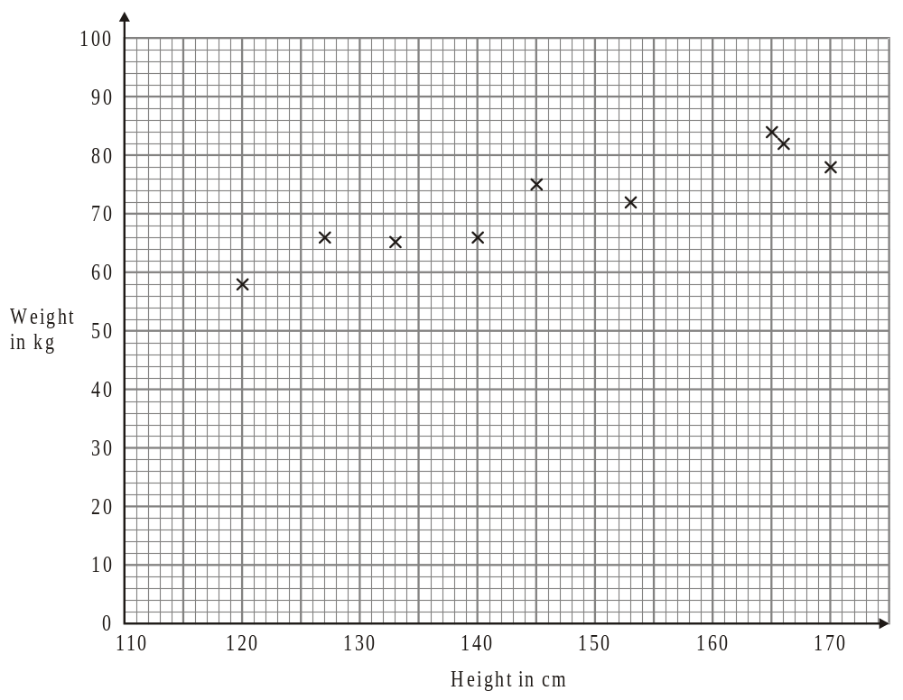
The table shows the height and the weight for three more students.

Height in cm | 135 | 155 | 170
Weight in kg | 70 | 75 | 85

(a) On the scatter graph, plot the information from the table.
(1)

(b) What type of correlation does this scatter graph show?

.....................................
(1)

(c) The weight of another student is 80 kg.

Estimate the height of this student.

.....................................cm
(2)
(Total 4 marks)
______________________________________________________________________________
4.
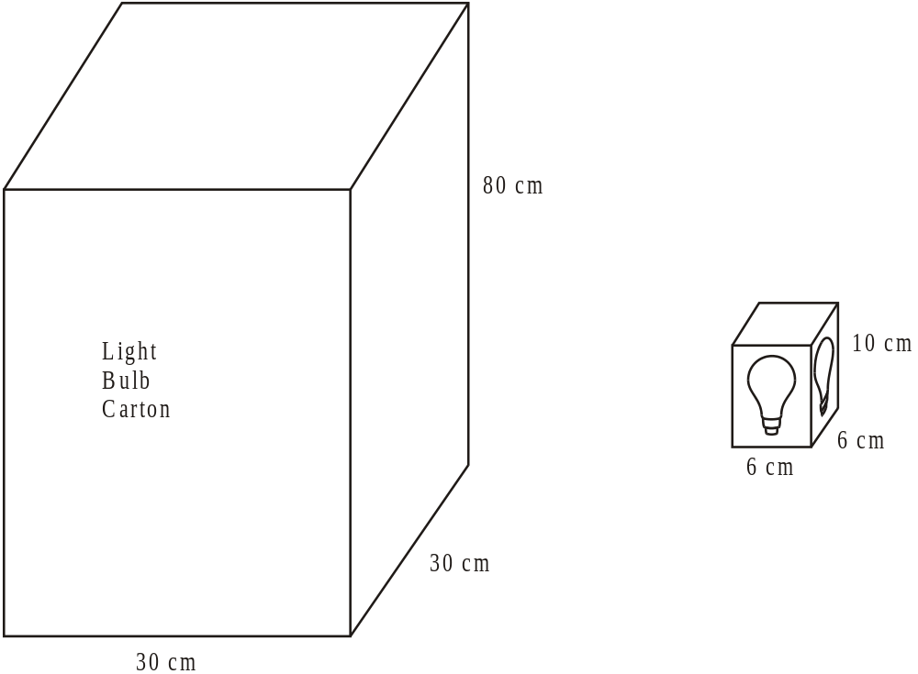
Diagrams NOT
accurately drawn

A light bulb box measures 6 cm by 6 cm by 10 cm.
Light bulb boxes are packed into cartons.
A carton measures 30 cm by 30 cm by 80 cm.

Work out the number of light bulb boxes which can completely fill one carton.

..........................
(Total 3 marks)
______________________________________________________________________________
*5. The manager of a department store has made some changes.
She wants to find out what people think of these changes.

She uses this question on a questionnaire.

“What do you think of the changes in the store?”

Excellent Very good Good

(a) Write down what is wrong about this question.

......................................................................................................................................................

......................................................................................................................................................

......................................................................................................................................................
(1)

This is another question on the questionnaire.

“How much money do you normally spend in the store?”

A lot Not much

(b) Write down one thing that is wrong with this question.

......................................................................................................................................................

......................................................................................................................................................

......................................................................................................................................................
(1)
(Total 2 marks)
______________________________________________________________________________

6. Here are the plan and front elevation of a prism.
The front elevation shows the cross section of the prism.

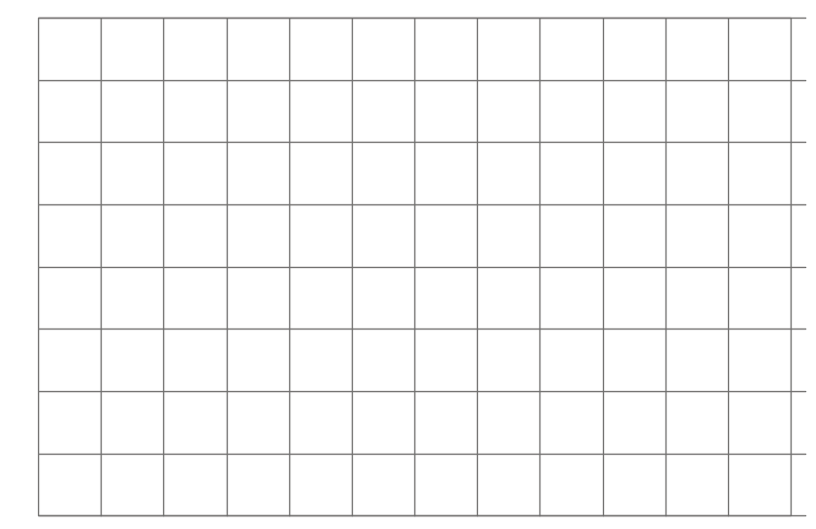
Front elevation
Plan

(a) On the grid below, draw a side elevation of the prism.
(2)

(b) In the space below, draw a 3-D sketch of the prism.

(2)
(Total 4 marks)
______________________________________________________________________________
7.
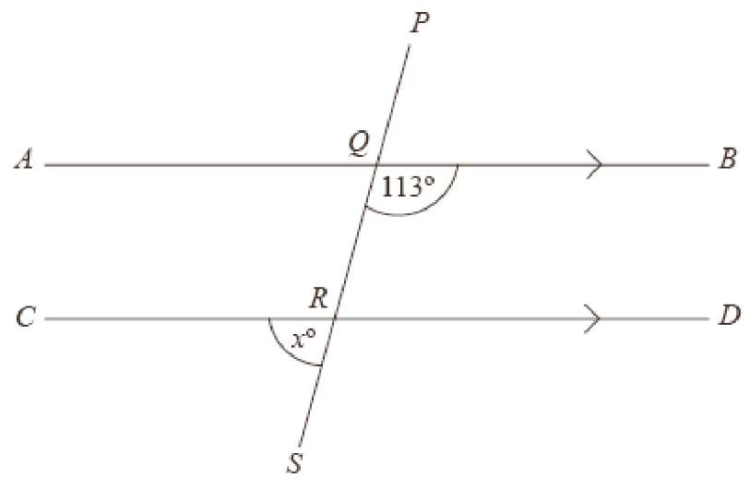

Diagram NOT
accurately drawn

AQB, CRD and PQRS are straight lines.
AB is parallel to CD.

Angle BQR = 113º.

(a) Work out the value of x.

x = ..............................

(b) Give reasons for your answer.

......................................................................................................................................................

......................................................................................................................................................

......................................................................................................................................................
(Total 4 marks)
______________________________________________________________________________
8. Some students did a French test and a German test.

Here are their results.

French test results 44 28 39 50 14
20 32 34 20 45

German test results 50 25 38 36 31
22 54 45 51 48

On the grid, draw diagrams that could be used to compare the French test results with the German test results.

(3)

*(b) Make one comparison between the French test results and the German test results.
…………………………………………………………………………………………………

…………………………………………………………………………………………………

…………………………………………………………………………………………………
(1)
(Total 4 marks)
______________________________________________________________________________

*9. Samantha wants to buy a new pair of trainers.

There are 3 shops that sell the trainers she wants.

Sports ‘4’ All |  | Edexcel Sports |  | Keef’s Sports
Trainers |  | Trainers |  | Trainers
£5 |  | off |  | £50
plus |  | usual price of |  | plus
12 payments of £4.50 |  | £70 |  | VAT at 20%

From which shop should Samantha buy her trainers to get the best deal?
You must show all of your working.

(Total 5 marks)
______________________________________________________________________________
10. A pattern is to be drawn.
It will have rotational symmetry of order 4.
The pattern has been started.

By shading six more squares, complete the pattern.

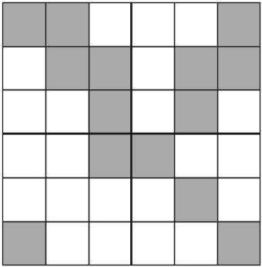

(Total 3 marks)
______________________________________________________________________________
11. Stuart and Helen play a game with red and blue cards.

Red cards are worth 4 points each.
Blue cards are worth 1 point each.

Stuart has r red cards and b blue cards.
Helen has 2 red cards and twice as many blue cards as Stuart.

The total number of points of Stuart and Helen’s cards is T.

Write down, in terms of r and b, a formula for T

………………………………………….
(Total 4 marks)
______________________________________________________________________________

12. The perimeter of a triangle is 19 cm
All the lengths on the diagram are in centimetres.

(x + 4)
(x + 3)

(x – 1)

Work out the value of x.

x = ………………….
(Total 3 marks)
______________________________________________________________________________

13. The table gives information about an estate agent’s charges for selling a house.

Value of the house | Estate agent’s charges
Up to £60 000 | 2% of the value of the house
Over £60 000 | 2% of the first £60 000  plus  1% of the remaining value of the house

Ken uses this estate agent to sell his house.
The estate agent sold Ken’s house for £80 000.

Work out the total charge that Ken will have to pay.

£................................
(Total 4 marks)
______________________________________________________________________________

14.
140°
60°
P
A
N
B

(a) Write down the bearing of A from P.

..................................°

(b) Work out the bearing of B from P.

..................................°
(Total 3 marks)
______________________________________________________________________________
15. (a) Work out 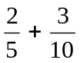

………………………
(2)

(b) Work out 5 − 2

………………………
(3)
(Total 5 marks)
______________________________________________________________________________

16. Use the ruler and compasses to construct the perpendicular to the line segment AB that passes through the point P.
You must show all construction lines.

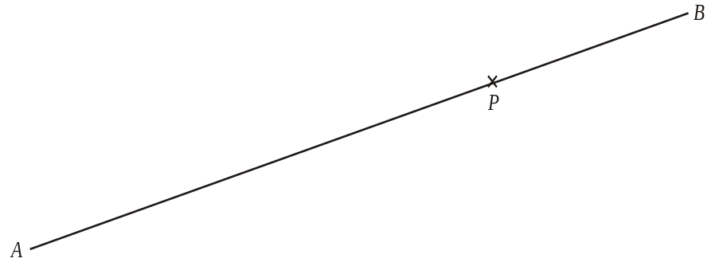

(Total 2 marks)
______________________________________________________________________________
17. 80 people work in Jenny’s factory.
The table shows some information about the annual pay of these 80 workers.

Annual pay (£x) | Number of workers
10 000 < x ≤ 14 000 | 32
14 000 < x ≤ 16 000 | 24
16 000 < x ≤ 18 000 | 16
18 000 < x ≤ 20 000 | 6
20 000 < x ≤ 40 000 | 2

(a) Write down the modal class interval.

..............................................
(1)

(b) Find the class interval that contains the median.

..............................................
(1)
(Total 2 marks)
______________________________________________________________________________

18. The point A has coordinates (–5, 1).
The point B has coordinates (7, y).

The point (x, 6) is the midpoint of the line segment AB.

Find the value of x and the value of y.

x = ..........................

y = ..........................
(Total 2 marks)
______________________________________________________________________________
19. (a) Factorise 5x – 10

..........................
(1)

(b) Factorise fully 2p² – 4pq

..........................
(2)

(c) Expand and simplify (t + 5)(t – 4)

...................................
(2)

(d) Write down the integer values of x that satisfy the inequality

–2 ≤ x < 3

..........................................................................
(2)
(Total 7 marks)
______________________________________________________________________________

20. In Holborn High School there are exactly twice as many girls as boys.
of the boys like sport.
 of the girls like sport.

What fraction of the total number of students in the school like sport?

………………………
(Total 4 marks)
______________________________________________________________________________
21. Solve 2x – 3y = 11
5x + 2y = 18

x = ...................... , y = ......................
(Total 4 marks)
______________________________________________________________________________

22. The Hawshaw Summer Fete is running a competition.
Hawshaw Summer Fete

LOSE
LOSE

You buy a scratch card with 9 squares covered up.
Under the 9 squares on each card, randomly placed
are 4 stars, 3 hearts and 2 LOSE.

Each scratch card costs £1

You scratch off two squares.
You win £1.50 if 2 stars are revealed.
You win £2 if 2 hearts are revealed.

Michelle buys a scratch card.

Work out the probability that this will be a winning scratch card.

……………………….
(3)

There are 1440 tickets sold at the Fete.
All of the proceeds go to charity.

Estimate the amount of money raised for charity

£ ……………………….
(4)
(Total 7 marks)
______________________________________________________________________________
23.
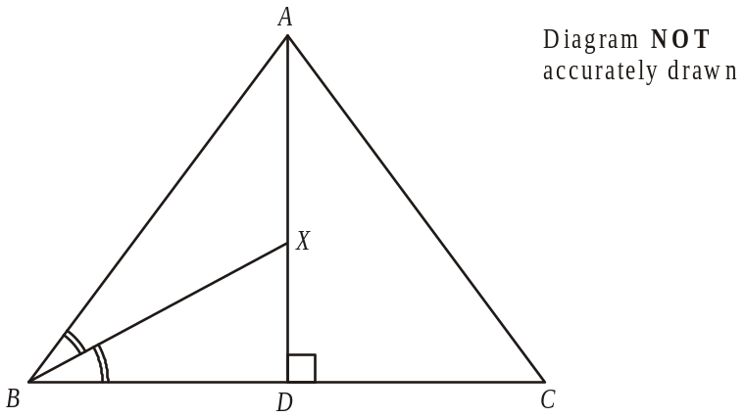

ABC is an equilateral triangle.
AD is the perpendicular bisector of BC.
BX is the angle bisector of angle ABC.
Show that triangle BXD is similar to triangle ACD

(2)

In triangle ACD,
AC = 2 cm,

(b) Show that XD = 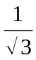 cm.

(3)
(Total 5 marks)
______________________________________________________________________________
24. Simplify 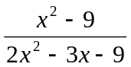

…………………………………….
(Total 3 marks)
______________________________________________________________________________

25. A rectangle has a length of 2t cm and a width of (√8 − √2) cm.
The area of the rectangle is 64 cm².

Work out the value of t.

t = ………………….
(Total 5 marks)
______________________________________________________________________________

26. Daniel has 2 bags of sweets.
One bag contains 3 green sweets and 4 red sweets.
The other bag contains 1 green sweet and 3 yellow sweets.

Daniel takes one sweet at random from each bag.

Work out the probability that Daniel will take 2 green sweets.

…………………………
(Total 3 marks)
______________________________________________________________________________

27.
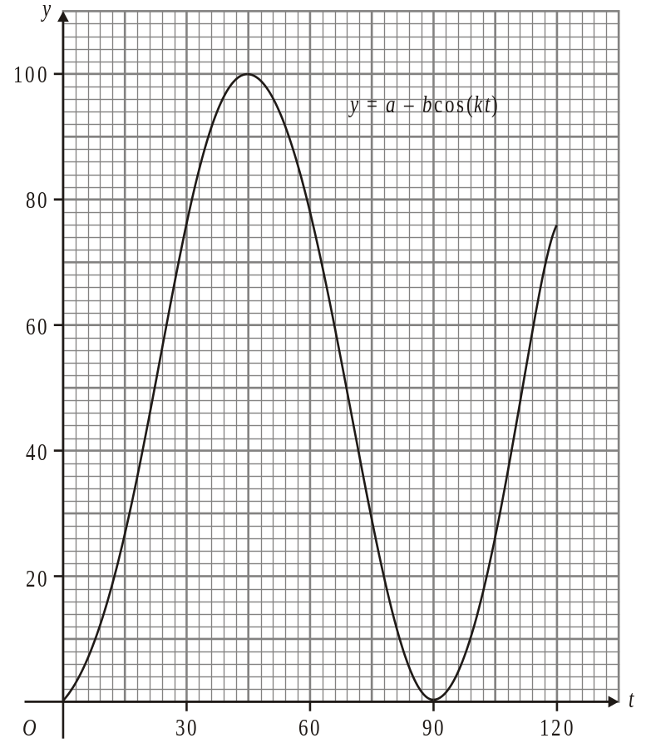

The graph of y = a – b cos (kt), for values of t between 0° and 120°, is drawn on the grid.

Use the graph to find an estimate for the value of

(i) a,

.....................................

(ii) b,

....................................

(iii) k.

....................................
(Total 3 marks)
______________________________________________________________________________
TOTAL FOR PAPER: 100 MARKS
END

