1MA0/4H
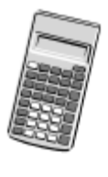
Edexcel GCSE
Mathematics (Linear) – 1MA0
Paper 4H (Calculator)
Higher Tier
Mock Paper
Time: 1 hour 45 minutes

Materials required for examination Items included with question papers
Ruler graduated in centimetres and Nil
millimetres, protractor, compasses,
pen, HB pencil, eraser.
Tracing paper may be used.

Instructions
Use black ink or ball-point pen.
Fill in the boxes at the top of this page with your name, centre number and candidate number.
Answer all questions.
Answer the questions in the spaces provided – there may be more space than you need.
Calculators may be used.

Information
The total mark for this paper is 100.
The marks for each question are shown in brackets – use this as a guide as to how much time to spend on each question.
Questions labelled with an asterisk (*) are ones where the quality of your written communication will be assessed – you should take particular care on these questions with your spelling, punctuation and grammar, as well as the clarity of expression.

Advice
Read each question carefully before you start to answer it.
Keep an eye on the time.
Try to answer every question.
Check your answers if you have time at the end.

This publication may be reproduced only in accordance with
Edexcel Limited copyright policy.
©2010 Edexcel Limited.
Printer’s Log. No. S39264A
GCSE Mathematics (Linear) 1MA0

Formulae: Higher Tier

You must not write on this formulae page.
Anything you write on this formulae page will gain NO credit.
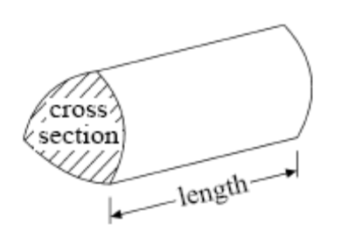

Volume of prism = area of cross section × length

Volume of sphere πr³ Volume of cone πr²h
Surface area of sphere = 4πr² Curved surface area of cone = πrl

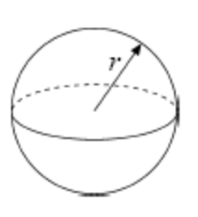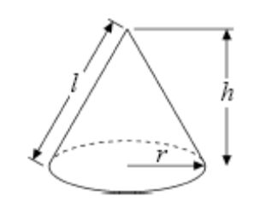

In any triangle ABC The Quadratic Equation
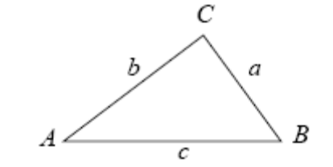
The solutions of ax2+ bx + c = 0
where a ≠ 0, are given by

x = 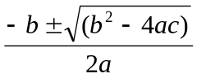

Sine Rule 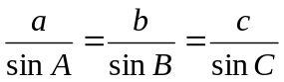

Cosine Rule a² = b²+ c²– 2bc cos A

Area of triangle = ab sin C
Answer ALL TWENTY SIX questions.

Write your answers in the spaces provided.

You must write down all stages in your working.

1. 5 kg of apples cost £7

2 kg of apples and 3 kg of bananas cost £5.65

Work out the cost of 1 kg of bananas.

...........................................................................
(Total for Question 1 = 3 marks)

2. (a) Use your calculator to work out the value of 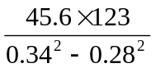

Write down all the figures on your calculator display.
(2)

...........................................................................

(b) Write your answer to part (a) correct to 3 significant figures.
(1)

...........................................................................
(Total for Question 2 = 3 marks)

3. The scatter graph shows the maths mark and the art mark for each of 15 students.
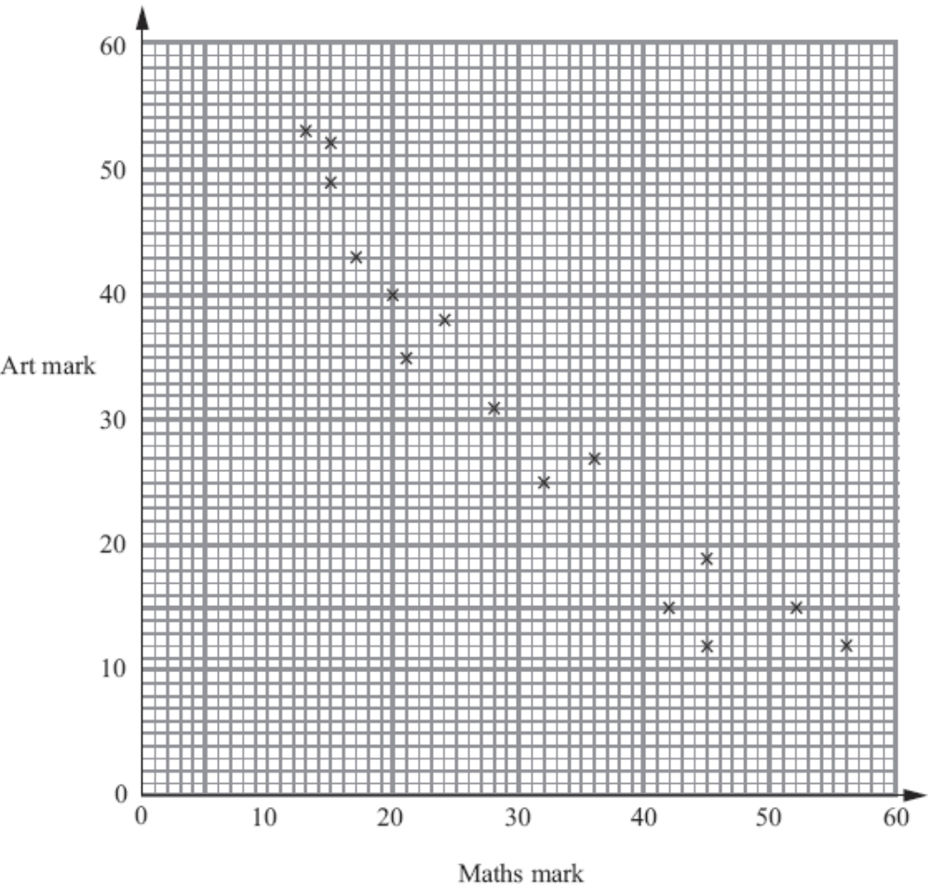

(a) What type of correlation does this scatter graph show?
(1)

...........................................................................
(b) Draw a line of best fit on the scatter graph.
(1)
Sarah has not got a maths mark.
Her art mark is 23

(c) Use your line of best fit to estimate a maths mark for Sarah.
(1)

...........................................................................
(Total for Question 3 = 3 marks)
4. Jasmin walked from her home to the park.
Here is a travel graph for Jasmin’s journey from her home to the park.

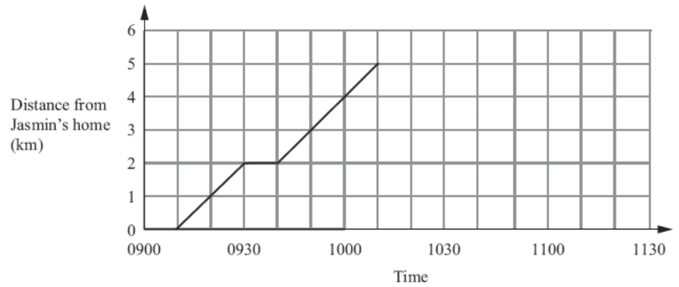

(a) For how long did she stop?
(1)

........................................................ minutes

Jasmin stayed at the park for half an hour.
She then walked home at a speed of 7.5 km/h.

(b) Complete the travel graph.
(3)

(Total for Question 4 = 4 marks)

5.
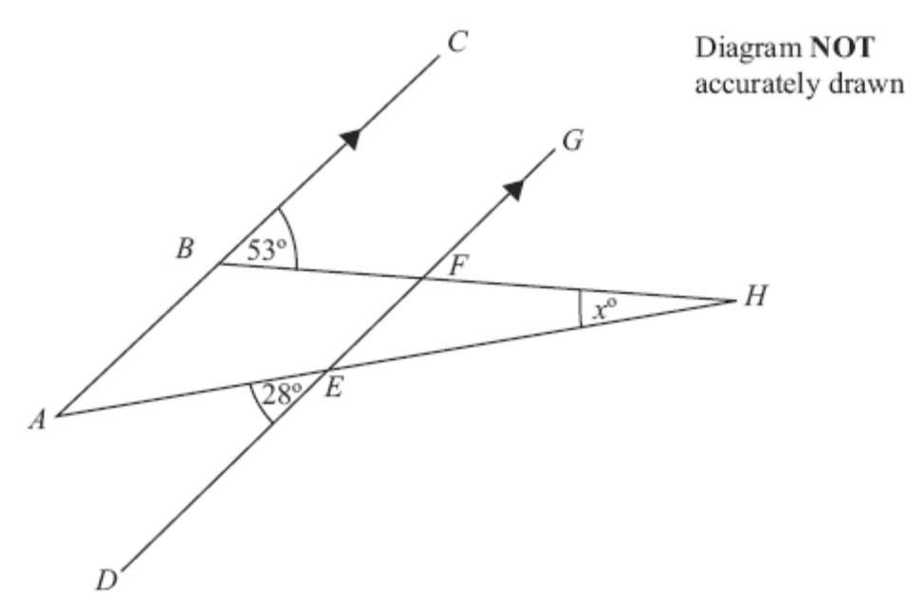

ABC and DEFG are parallel.
AEH and BFH are straight lines.
Work out the size of the angle marked x°.

.........................................................................°
(Total for Question 5 = 3 marks)

6. (a) Solve 5x + 2 = 2x + 17
(2)

x = ..................................................................

(b) Solve the inequality 3(2y + 1) > 10
(2)

...........................................................................
(Total for Question 6 = 4 marks)
7. Here are some people’s ages in years.

62 27 33 44 47

30 22 63 67 54

69 56 63 50 25

31 63 42 48 51

In the space below, draw an ordered stem and leaf diagram to show these ages.

(Total for Question 7 = 3 marks)

8. Tim is travelling home from holiday by plane.
He buys some food and drink on the plane.

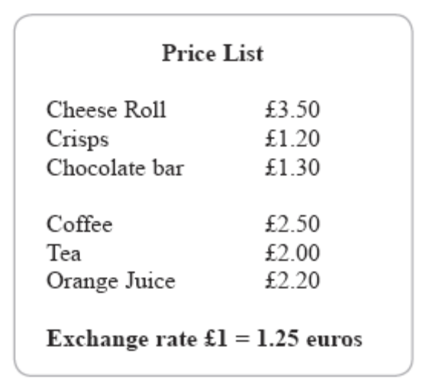

Tim buys two cheese rolls, a coffee and an orange juice.

He pays part of the cost with a 10 euro note.
He pays the rest of the cost in pounds (£).

How much does Tim pay in pounds?

£ .......................................................................
(Total for Question 8 = 4 marks)

9. (a) Factorise fully 6y² + 12y
(2)

...........................................................................
(b) Factorise k2 + 13k + 30
(2)

...........................................................................
(Total for Question 9 = 4 marks)
10. The diagram shows a cuboid.

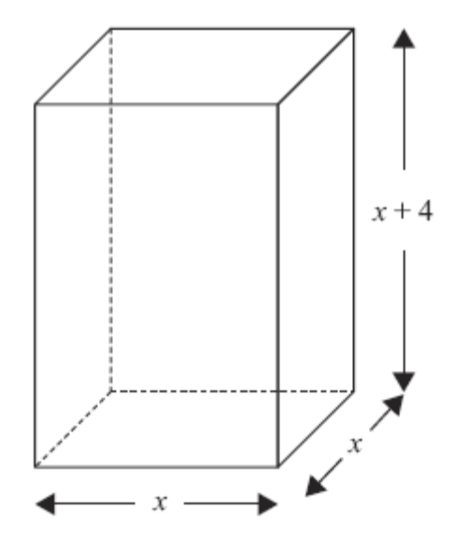

Diagram NOT
accurately drawn

A cuboid has a square base of side x cm.
The height of the cuboid is (x + 4) cm.
The volume of the cuboid is 150 cm³.

(a) Show that x³ + 4x² = 150
(2)

The equation x³ + 4x² = 150 has a solution between 4 and 5

(b) Use a trial and improvement method to find this solution.
Give your answer correct to one decimal place.
You must show ALL your working.
(4)

x= ....................................................................
(Total for Question 10 = 6 marks)
11. The table shows information about the numbers of hours 40 children watched television one evening.

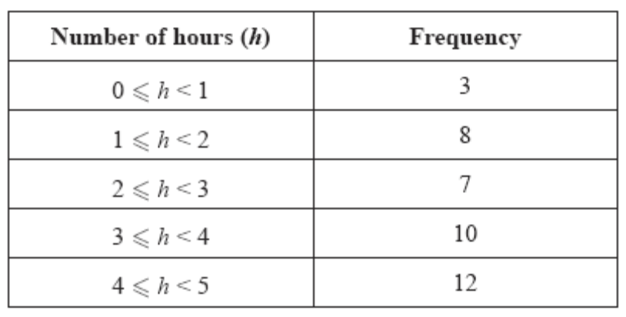

(a) Find the class interval that contains the median.
(1)

...........................................................................

(b) Work out an estimate for the mean number of hours.
(4)

.............................................................. hours
(Total for Question 11 = 5 marks)

12.
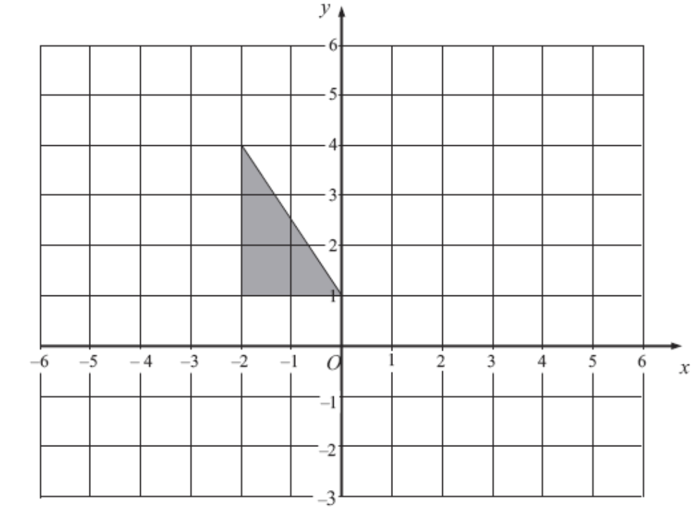

(a) Translate the triangle above by the vector 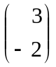
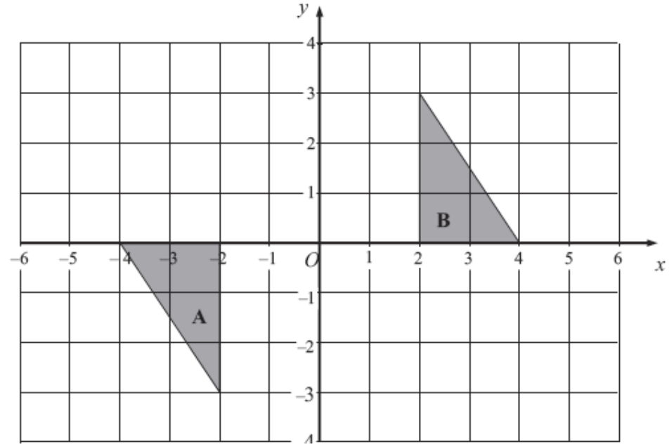
(1)
(b)

Describe fully the single transformation that maps triangle A onto triangle B.
(3)
............................................................................................................................................................

............................................................................................................................................................
(Total for Question 12 = 4 marks)

*13. Jenny fills some empty flowerpots completely with compost.
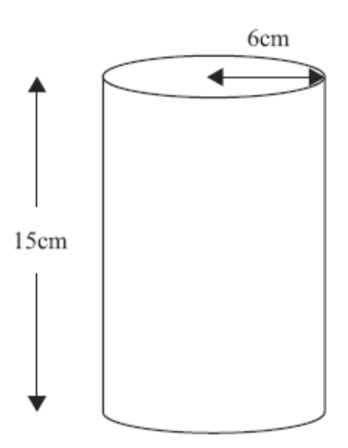

Diagram NOT
accurately drawn

Each flowerpot is in the shape of a cylinder of height 15 cm and radius 6 cm.
She has a 15 litre bag of compost.

She fills up each flowerpot completely.
How many flowerpots can she fill completely?
You must show your working.

...........................................................................
(Total for Question 13 = 4 marks)

14. A ladder is 6 m long.
The ladder is placed on horizontal ground, resting against a vertical wall.

The instructions for using the ladder say that the bottom of the ladder must not be closer than 1.5 m from the bottom of the wall.

How far up the wall can the ladder reach?
Give your answer correct to 1 decimal place.

.................................................................... m
(Total for Question 14 = 3 marks)

15. In a sale, normal prices are reduced by 20%.
The sale price of a coat is £52

Work out the normal price of the coat.

£ ......................................................................
(Total for Question 15 = 3 marks)

16.
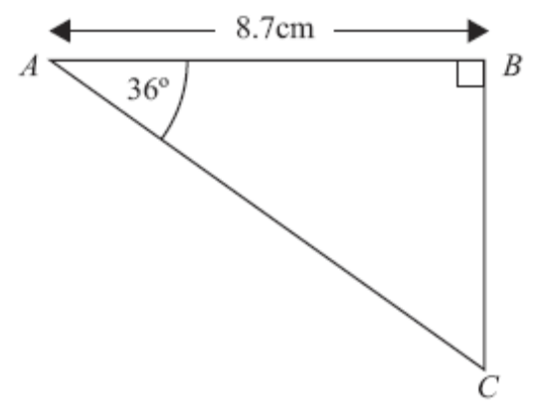

Diagram NOT
accurately drawn

ABC is a right-angled triangle.

Angle B = 90°.
Angle A = 36°.
AB = 8.7 cm.

Work out the length of BC.
Give your answer correct to 3 significant figures.

................................................................. cm
(Total for Question 16 = 3 marks)

17. (a) Complete the table of values for y = x³ – 3x – 1
(2)
x | –2 | –1.5 | –1 | –1 | –0.5 | 0.5 | 1 | 1.5 | 2
y | –3 | 0.125 |  | 0.375 |  | –2.375 | –3

(b) On the grid, draw the graph of y = x³ – 3x – 1 for –2 ≤ x ≤ 2
(2)
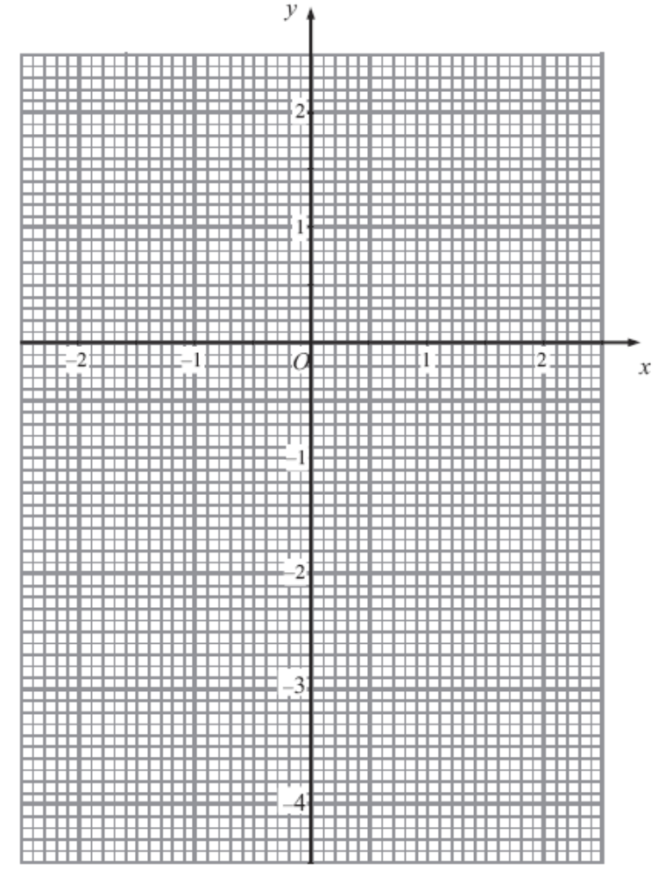

(c) Use your graph to estimate the solutions of the equation x3 – 3x – 1 = 0
(1)

...........................................................................
(Total for Question 17 = 5 marks)
18. Hannah is going to play one badminton match and one tennis match.
The probability that she will win the badminton match is 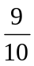
The probability that she will win the tennis match is 

(a) Complete the probability tree diagram.
(2)

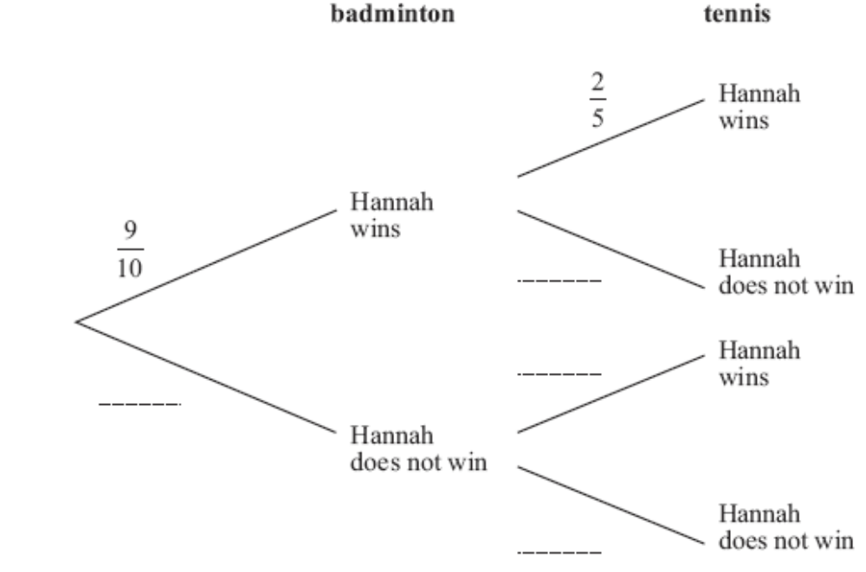

(b) Work out the probability that Hannah will win both matches.
(2)

...........................................................................
(Total for Question 18 = 4 marks)

19. On the grid, shade the region that satisfies all three of these inequalities

y > –4 x < 2 y < 2x + 1

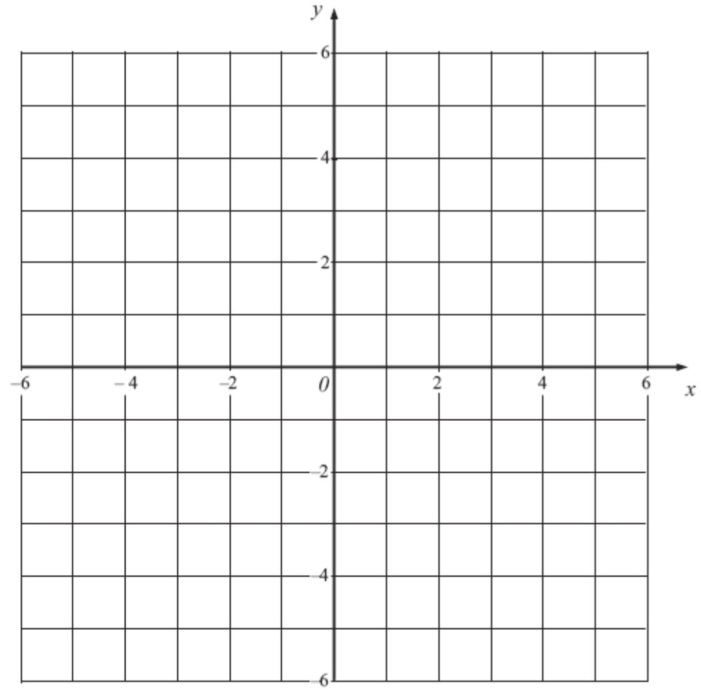

(Total for Question 19 = 4 marks)

20. (a) Write the number 0.00037 in standard form.
(1)

...........................................................................

(b) Write 8.25 × 103 as an ordinary number.
(1)

...........................................................................

(c) Work out (2.1 × 10⁸) × (6 × 10⁻⁵).
Write your answer in standard form.

(2)
...........................................................................
(Total for Question 20 = 4 marks)

21. The length of a rectangle is 30 cm, correct to 2 significant figures.
The width of a rectangle is 18 cm, correct to 2 significant figures.

(a) Write down the upper bound of the width.
(1)

................................................................. cm

(b) Calculate the upper bound for the area of the rectangle.
(2)

................................................................. cm
(Total for Question 20 = 3 marks)

22. The diagram shows a child’s toy.

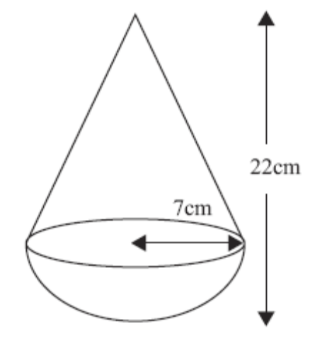
Diagram NOT
accurately drawn

The toy is made from a cone on top of a hemisphere.

The cone and hemisphere each have radius 7 cm.
The total height of the toy is 22 cm.

Work out the volume of the toy.
Give your answer correct to 3 significant figures.

............................................................... cm³
(Total for Question 22 = 3 marks)

23. The table shows information about the total times that 35 students spent using their mobile phones one week.
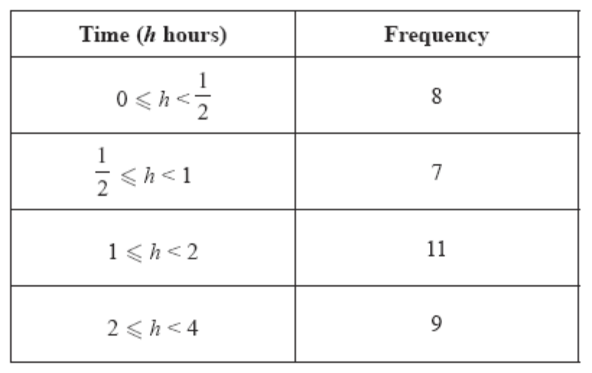
On the grid below, draw a histogram for this information.
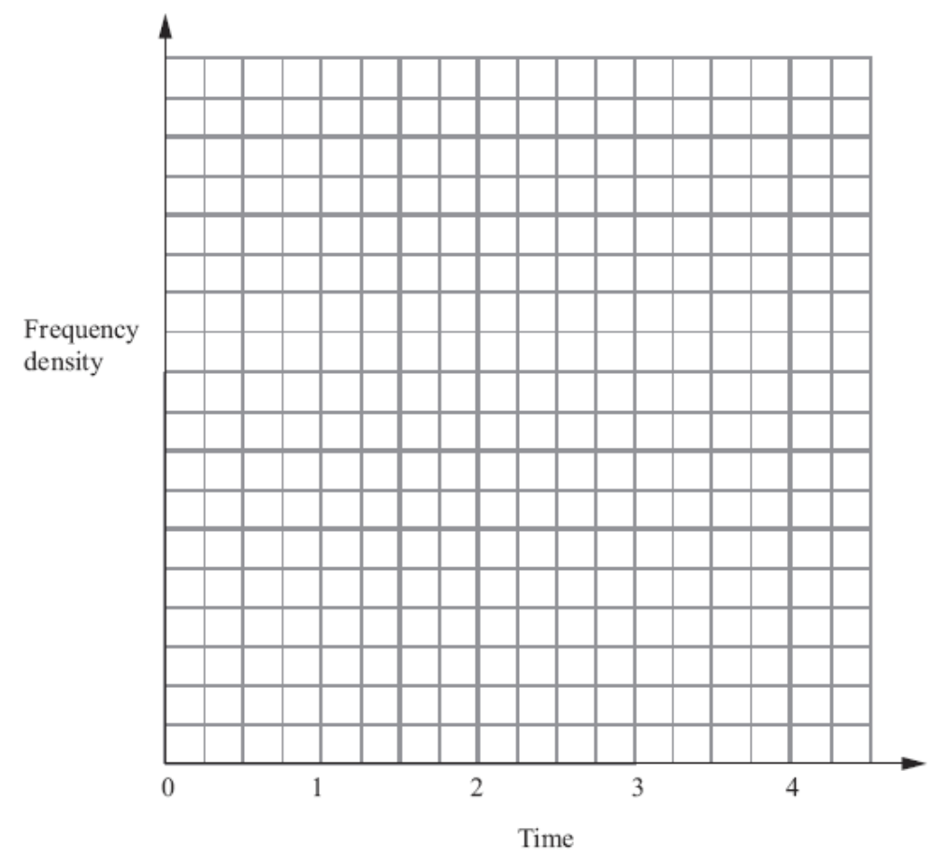
(Total for Question 23 = 3 marks)
*24. The diagram shows the plan of a field.
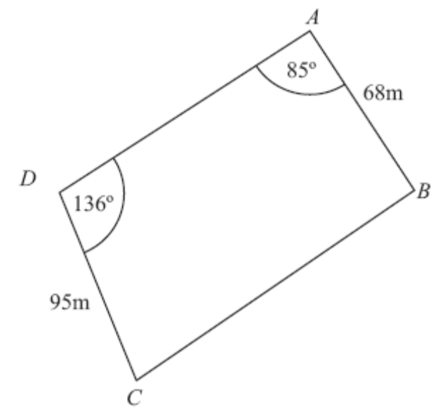

Diagram NOT
accurately drawn

AB = 68 m.
DC = 95 m.
Angle ADC = 136°.
Angle DAB = 85°.

DB = 240 m.

Work out the area of the field.
Give your answer correct to 3 significant figures.

.................................................................. m²
(Total for Question 24 = 6 marks)

25.
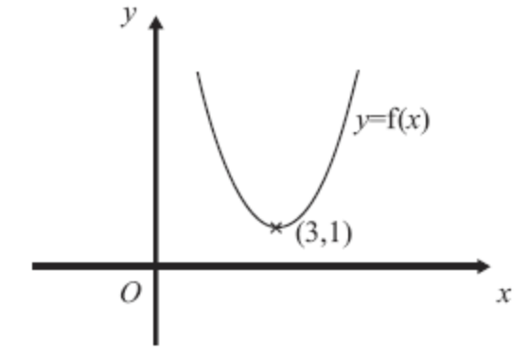

The diagram shows part of the curve with equation y = f(x).
The coordinates of the minimum point of this curve are (3, 1).

Write down the coordinates of the minimum point of the curve with equation

(a) y = f(x) + 3
(1)

(…………, …………)

(b) y = f(x – 2)
(1)

(…………, …………)

(c) y = f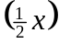
(1)

(…………, …………)
(Total for Question 25 = 3 marks)

*26. The diagram below shows a hexagon.

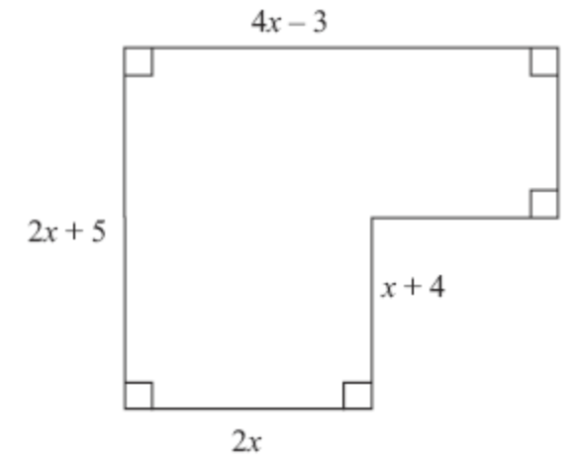

Diagram NOT
accurately drawn

All the measurements are in centimetres.

The area of this shape is 102 cm².

Work out the length of the longest side of the shape.

................................................................. cm
(Total for Question 26 = 6 marks)

TOTAL FOR PAPER = 100 MARKS

