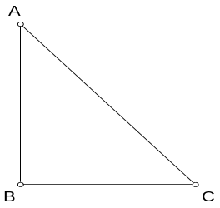 | 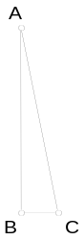 | Missing angle x is 45 º
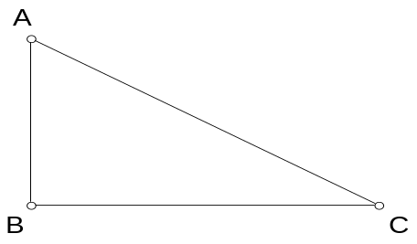 | Missing angle x is 30 º | Other angle measures 60 º
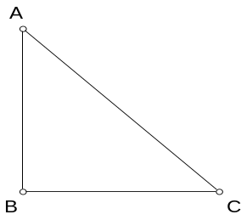 | Missing angle x is 10 º | Other angle measures 45 º
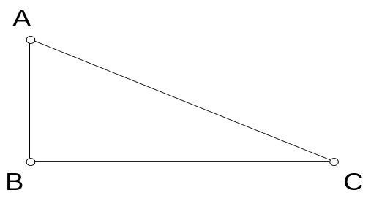 | Missing angle x is 40 º | Other angle measures 50 º
Other angle measures 80 º | Missing angle x is 25 º | Other angle measures 65 º
Ratio to use is Sin x= Opp/Hyp | Ratio to use is Sin x= Opp/Hyp | Ratio to use is Cos x= Adj/Hyp
Ratio to use is Tan x = Opp/Adj | Ratio to use is Tan x = Opp/Adj | Ratio to use is Cos x= Adj/Hyp

