An Elevated Position

Task 1

Put the multilink cubes together into some sort of shape. Place it in the middle of your table.

Task 2

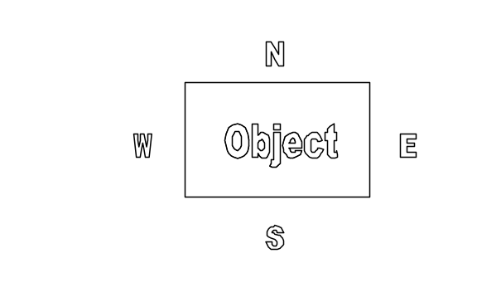Spread out round the table so that you are each looking at a different face of your shape (i.e. you are in north, south, east and west positions.)

Draw your flat view of the shape from table level. Don’t put any shading or other 3D effects onto your drawing (i.e. draw it like a silhouette.)

Task 3

Dismantle your shape.
Swap the cubes and your drawings with another table.
Try to construct their shape using their drawings.

An Elevated Position

Task 1

Put the multilink cubes together into some sort of shape. Place it in the middle of your table.

Task 2

Spread out round the table so that you are each looking at a different face of your shape i.e. you are in north, south, east and west positions.

Draw your flat view of the shape from table level. Don’t put any shading or other 3D effects onto your drawing (ie draw it like a silhouette).

Task 3

Dismantle your shape.
Swap the cubes and your drawings with another table.
Try to construct their shape using their drawings.

