Solid problems

One
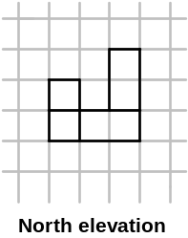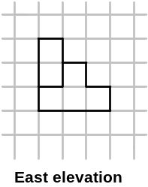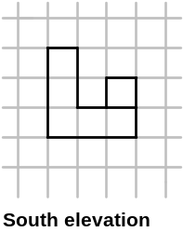The following building is made from 10 cubes. Use the four elevations, and plan, to construct the building and place it in the correct orientation on your marked paper.
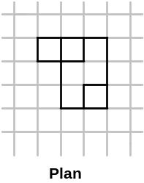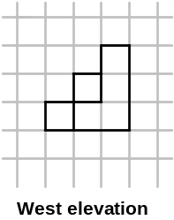

Two
The following building uses an unknown number of cubes, and this time there is no plan to help. Construct the building and place in on your marked paper. How many cubes does it use?

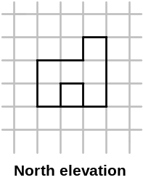
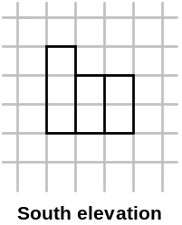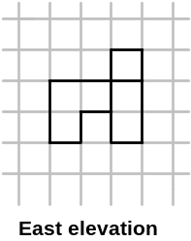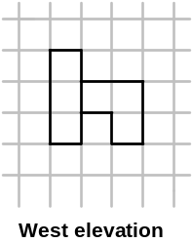

Three
Make up some similar puzzles of your own and try them out on your friends.

