WCH CH569 SerDes
Reverse Engineering

Table of Contents
1 Introduction 2
2 Hardware Setup 3
3 Software Setup 4
3.1 glscopeclient configuration 4
3.1.1 Filter Graph 5
3.1.2 Main view 5
3.1.3 Export 8b10bIBM_Hex to csv 5
4 WCH CH569W SerDes Reverse Engineering 6
4.1 SerDes Idle sequence (no data) 7
4.2 SerDes data sequence 8
4.2.1 SOF 8
4.2.2 Align 8
4.2.3 EOF 9
4.3 SerDes 180Mbps data capture and details 10
5 Appendix 11
5.1 SATA specification 11
6 Revision History 12

Introduction
The WCH CH569W is the first public MCU including a SerDes PHY (Serializer/Deserializer) which can be configured at up to 1.20Gbps officially and up to 1.38Gbps non officially.
It is a very convenient interface as it requires only 2 wires (one differential pair like CAT 5E pair) to communicate at very high speed with external world (mainly FPGA or other CH569).
It is also very interesting as this interface support network cable transfer distance of 90 meters.
Unfortunately WCH CH569W SerDes is not documented and not even present in latest examples available on github (https://github.com/openwch/ch569 on 31 July 2022).
The SerDes Example available in CH569EVT_v1_4 (or before) is not available anymore and it was using "binary blob/static library" with very basic example (not supporting any speed configuration of the SerDes link which is by default configured at 1.2Gbps).
- CH569EVT with SerDes example is available on https://github.com/SoCXin/CH569/tree/master/src/EVT/EXAM/SERDES
After lot of reverse engineering (on firmware side & analog side with oscilloscope) and with the help of multiple SerDes captures and check of data (with the help of glscopeclient and Andrew Zonenberg hints) the fact is CH569W SerDes is based on Serial ATA (SATA) specification, especially related to "SATA Primitives" used mainly for Idle Sequence and Data sequence and also related to scrambler and CRC32.
For more details with example captures and tools used in this document see following GitHub links:
- Main repository related to that document / research (including tool with source to descramble the glscopeclient csv data exported)
  - https://github.com/hydrausb3/wch-ch569-serdes
- HydraUSB3 SerDes example/code firmware (can be used with only one board too)
  - https://github.com/hydrausb3/hydrausb3_fw/tree/main/HydraUSB3_DualBoard_SerDes

Hardware Setup
All the captures are done on Development Board called HydraUSB3 V1 (available on https://hydrabus.com/shop or on Digi-Key https://www.digikey.com/en/products/detail/benjamin-vernoux/HYDRAUSB3-V1/16651677) and generated by WCH CH569W SerDes configured at 1.08Gbps & 180Mbps (SerDes firmware driver / examples released with open source license on https://github.com/hydrausb3)

The CH569W SerDes captures are done on GXP pin with a Rigol MSO5K and using original probes with ground spring (mandatory to have a good capture) then exported to bin (to an USB key) and imported with open source glscopeclient (https://github.com/glscopeclient/scopehal-apps)
- It is recommended to use glscopeclient from 30 July 2022 (commit a896eca)
  - See direct link https://github.com/glscopeclient/scopehal-apps/actions/runs/2764516663
  - There is a known issue related to recentfiles.yml (updated/corrupted when glscopeclient exit) on that version see https://github.com/glscopeclient/scopehal-apps/issues/460
    - Solution on Windows is to delete (xxx is user) C:\Users\xxx\AppData\Roaming\glscopeclient\recentfiles.yml before to start glscopeclient

Software Setup

glscopeclient configuration
The "Threshold" view & "ClockRecoveryPLL" Thresholds (Hysteresis of Threshold can be adjusted too) shall be adjusted to have best results with less error in 8b10bIBM_Hex view
To be sure the data can be recovered you shall check the signal integrity with Eye Pattern which shall have an "eye" as wide open as possible.
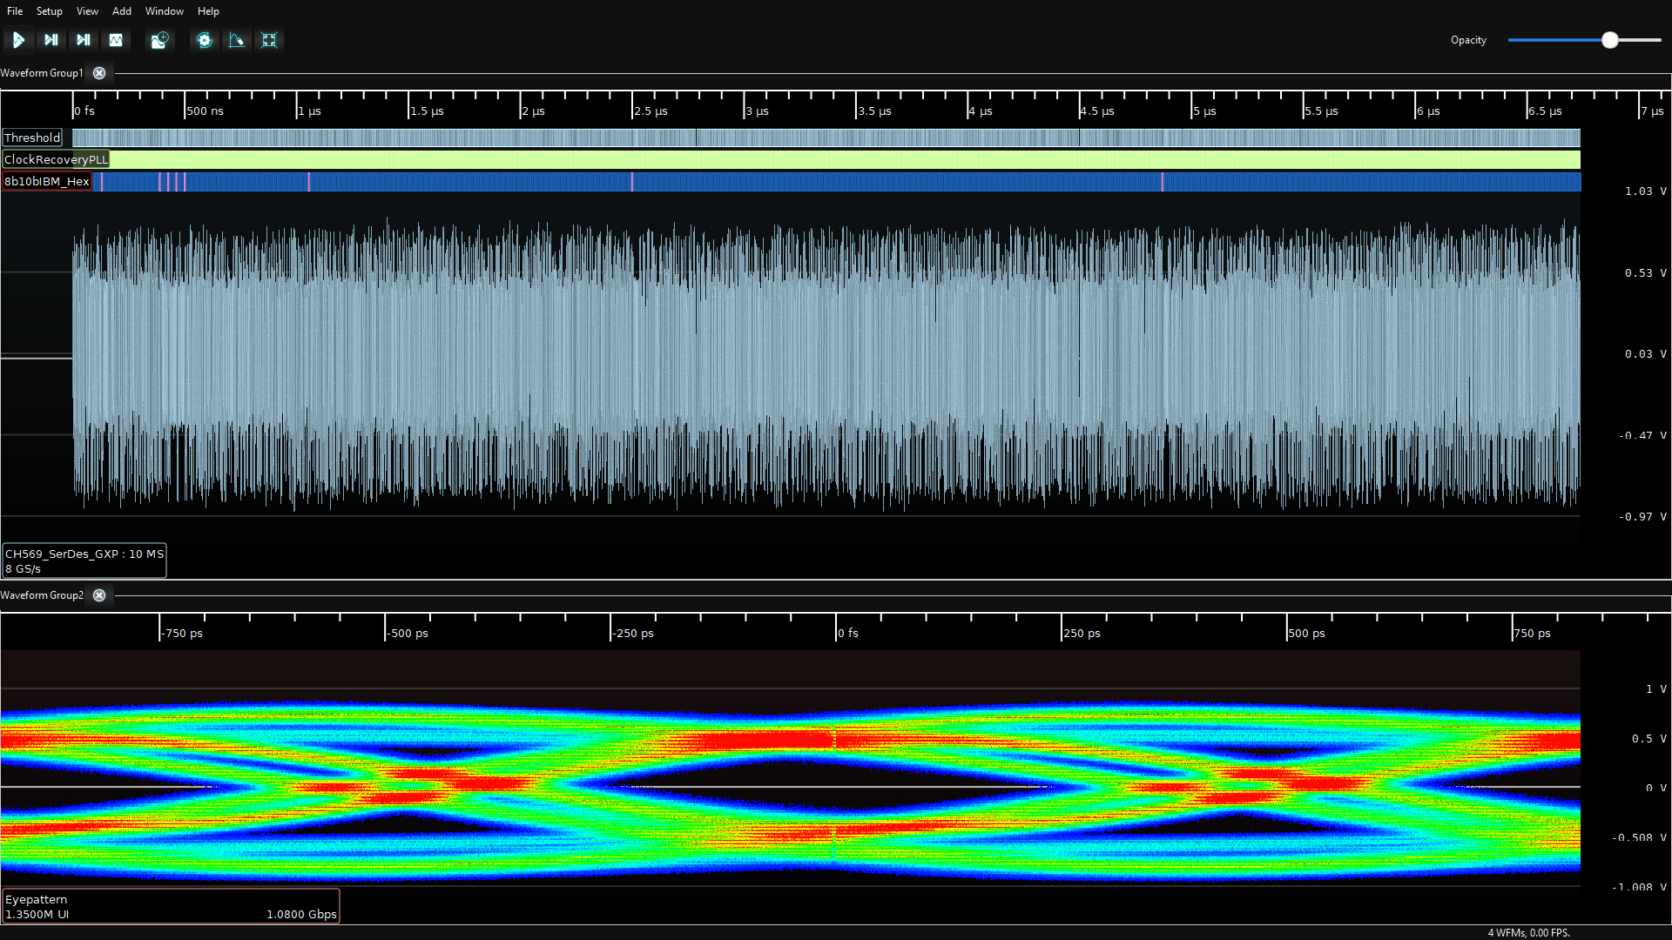
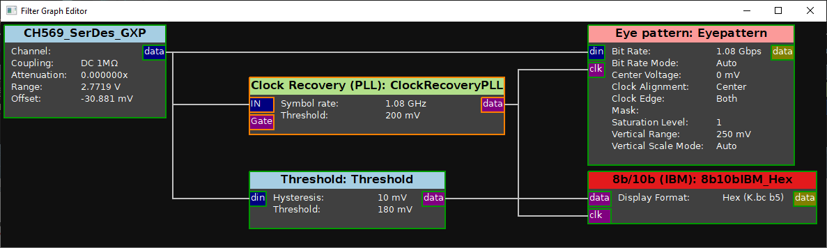

Filter Graph
Filter graph example minimal configuration to export 8b10IBM_Hex to csv
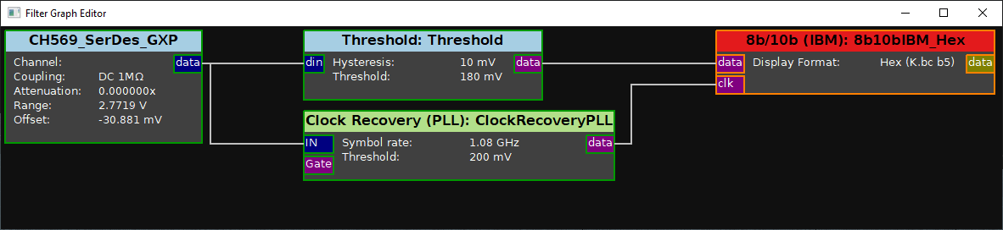

Main view
Main view example minimal filter configuration to export 8b10IBM_Hex to csv
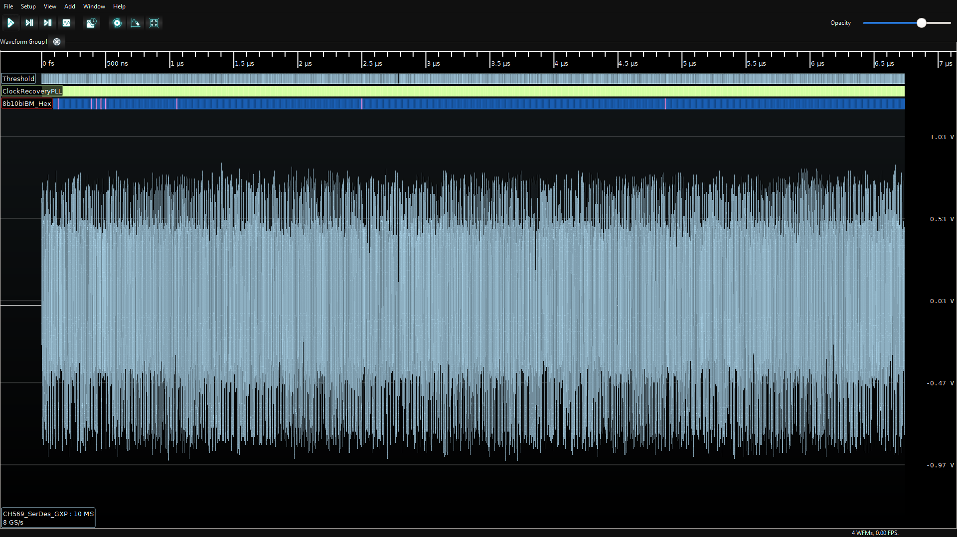

Export 8b10bIBM_Hex to csv
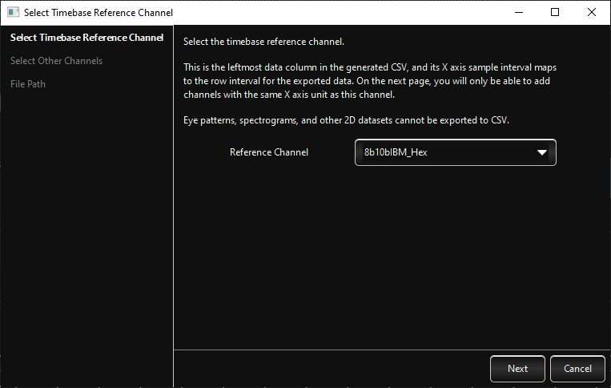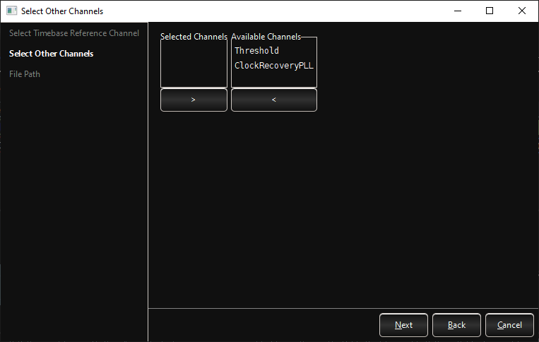
Then click next and choose a name for the csv file to export (example 8b10bIBM_Hex.csv)

WCH CH569W SerDes Reverse Engineering

This chapter describes the data format of WCH CH569W SerDes captured with glscopeclient with the help of Serial ATA specification (See Appendix for links).
The SerDes on WCH CH569W have different states:
- SerDes Idle sequence (no data) is transmitted continuously when we are not sending any data.
- SerDes data sequence is when data are transmitted.
  - The Serdes data sequence start by a SOF and finish by an EOF
Example files (CH569 SerDes at 180Mbps) available on GitHub:
- https://github.com/hydrausb3/wch-ch569-serdes/CH569_SerDes_180Mbps
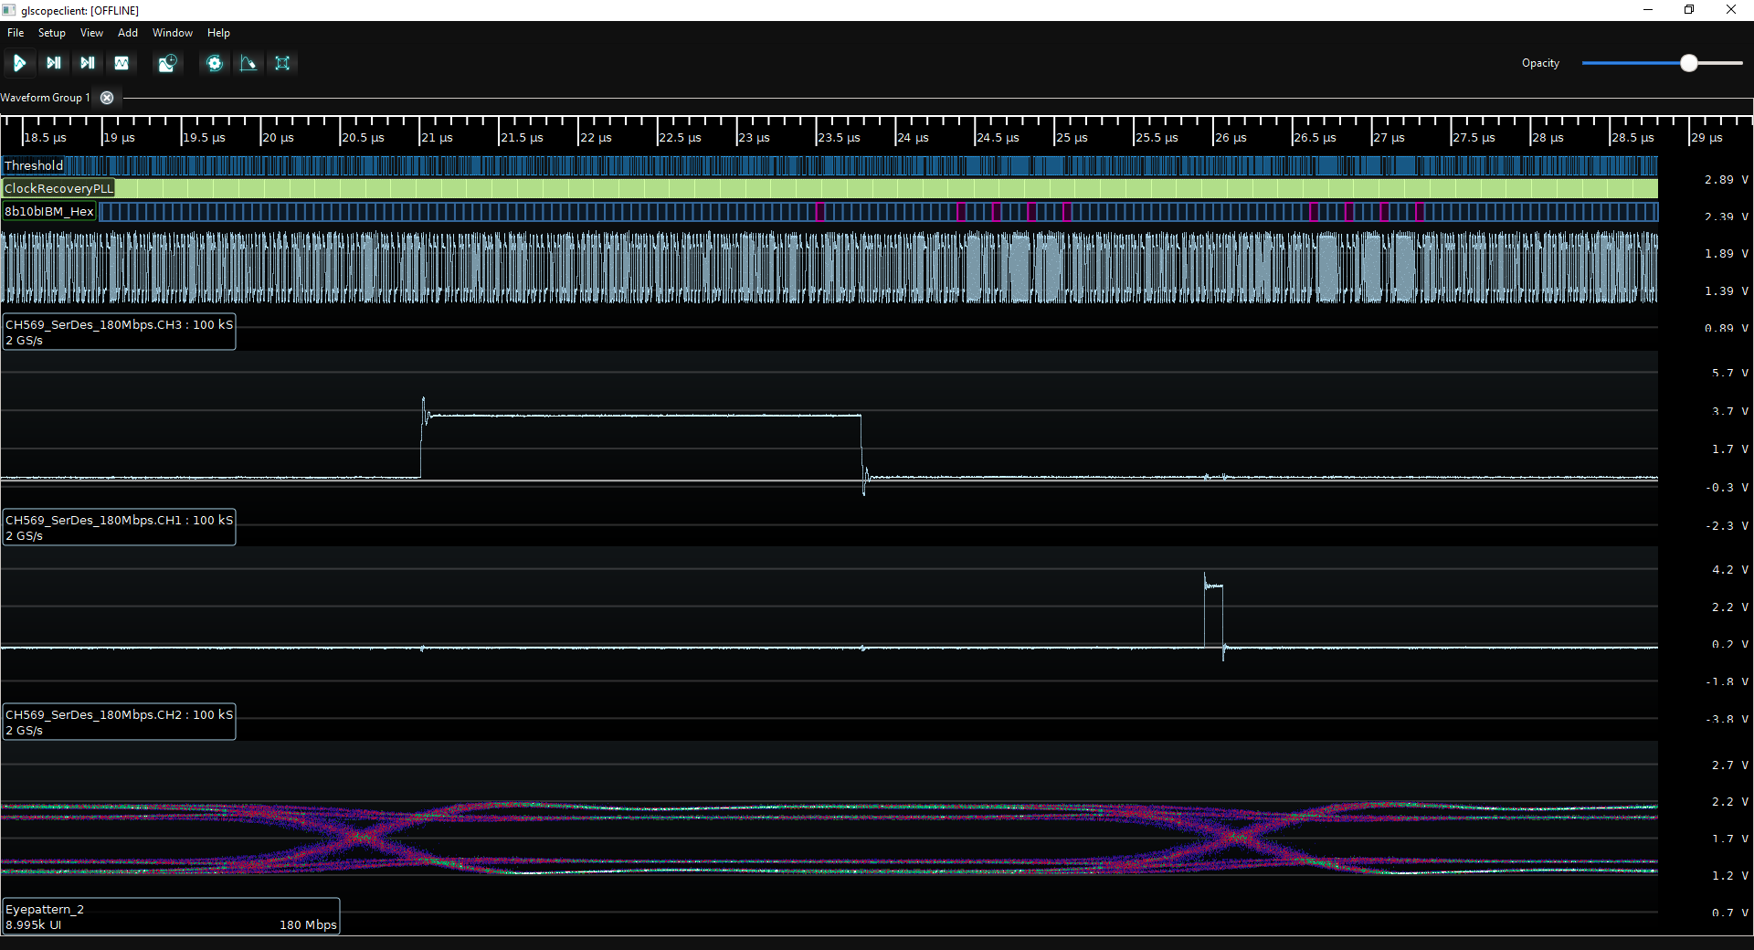

SerDes Idle sequence (no data)
  - 1x K28.5 D10.2 D10.2 D27.3 => 1xALIGN
  - 1x K.bc 4a 4a 7b
    - The Align primitives establish dword boundaries within the serial bit stream.
    - They are sent as data during OOB, and every 2048 dwords there after
    - Extract Serial ATA Specification Revision 1.0 29-August-2001
Table 20. – Description of primitives:
      - Upon receipt of an ALIGN, the physical layer readjusts internal operations as necessary to perform its functions correctly.
      - This primitive is always sent in pairs - there is no condition where an odd number of ALIGN primitives shall be sent (except as noted for retimed loopback).
  - 2x K28.3 D21.4 D21.5 D21.5 => 2xSYNC
  - 2x K.7c 95 b5 b5
    - Used when in idle to maintain bit synchronization.
    - Extract Serial ATA Specification Revision 1.0 29-August-2001
Table 20. – Description of primitives:
      - Synchronizing primitive – always idle.
  - 1x K28.3 D10.5 D25.4 D25.4 => CONT
  - 1x K.7c aa 99 99
    - Extract Serial ATA Specification Revision 1.0 29-August-2001
Table 20. – Description of primitives:
      - The CONT primitive allows long strings of repeated primitives to be eliminated.
      - The CONT primitive implies that the previously received primitive be repeated as long as another primitive is not received
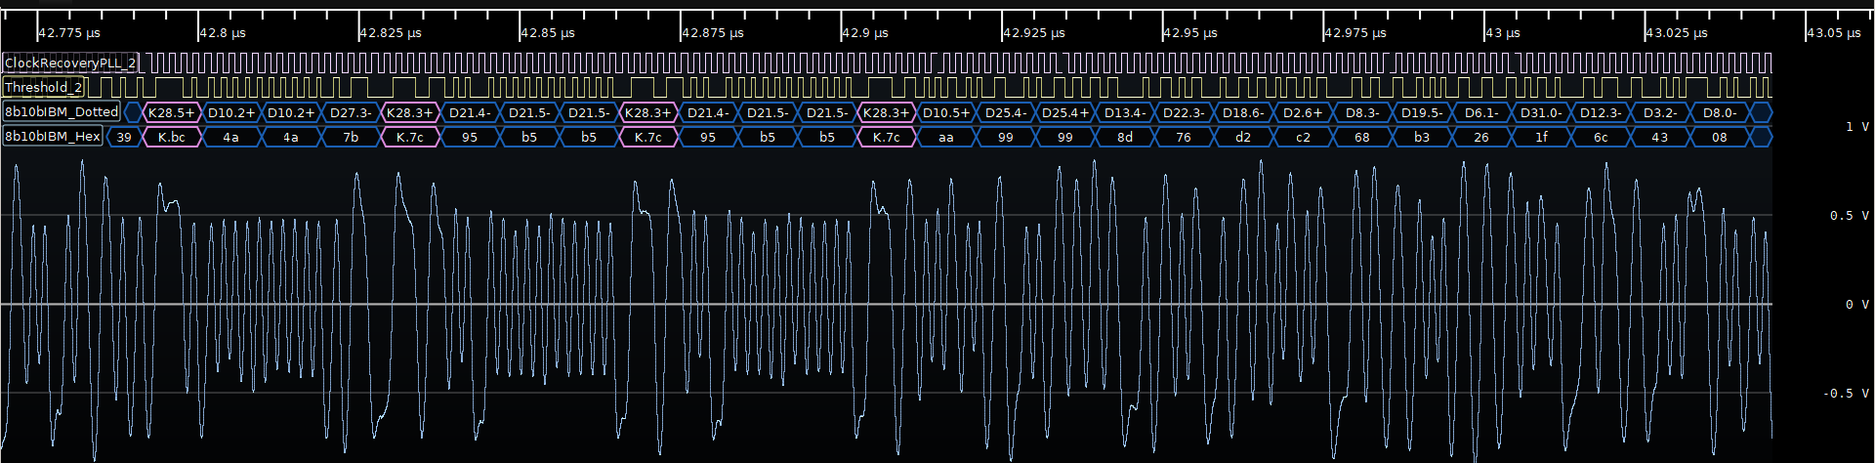
Example of multiples Idle Sequences repeated (each 2.37us):
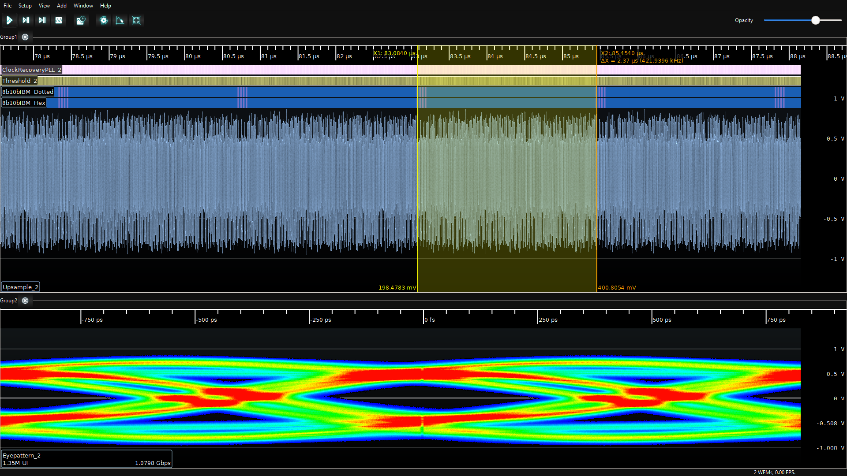

SerDes data sequence

SOF
A frame starts with a Start of Frame primitive (SOF).
The frame ends with a CRC dword and an End of Frame primitive (EOF).
In between the two primitives are dwords that make up the information content
- 1x K28.3 D21.5 D23.1 D23.1 => 1xSOF
- 1x K.7c b5 37 37
- Followed by data (until EOF) scrambled like SATA format
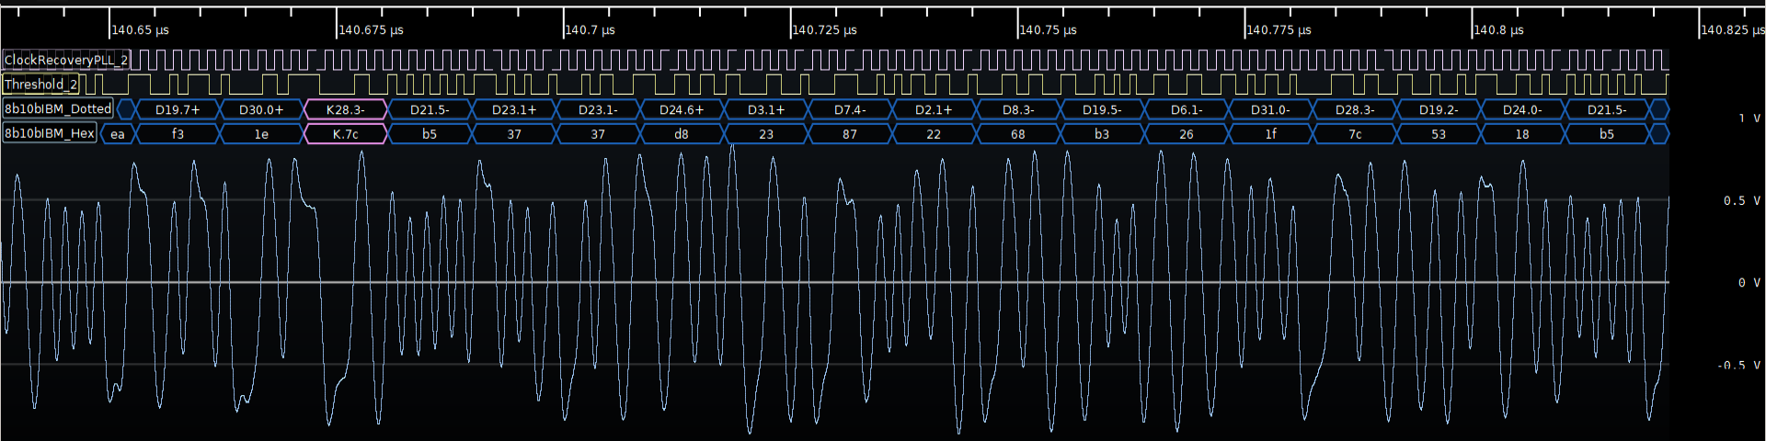

Align
Regularly (during data exchange)
- 1x K28.5 D10.2 D10.2 D27.3 => ALIGN
- 1x K.bc 4a 4a 7b
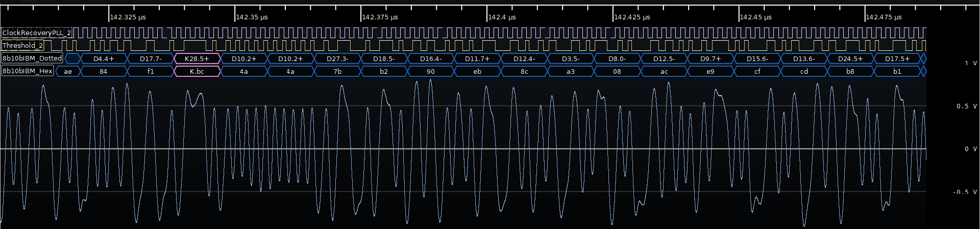
Example of multiples ALIGN repeated (each 2.37us):
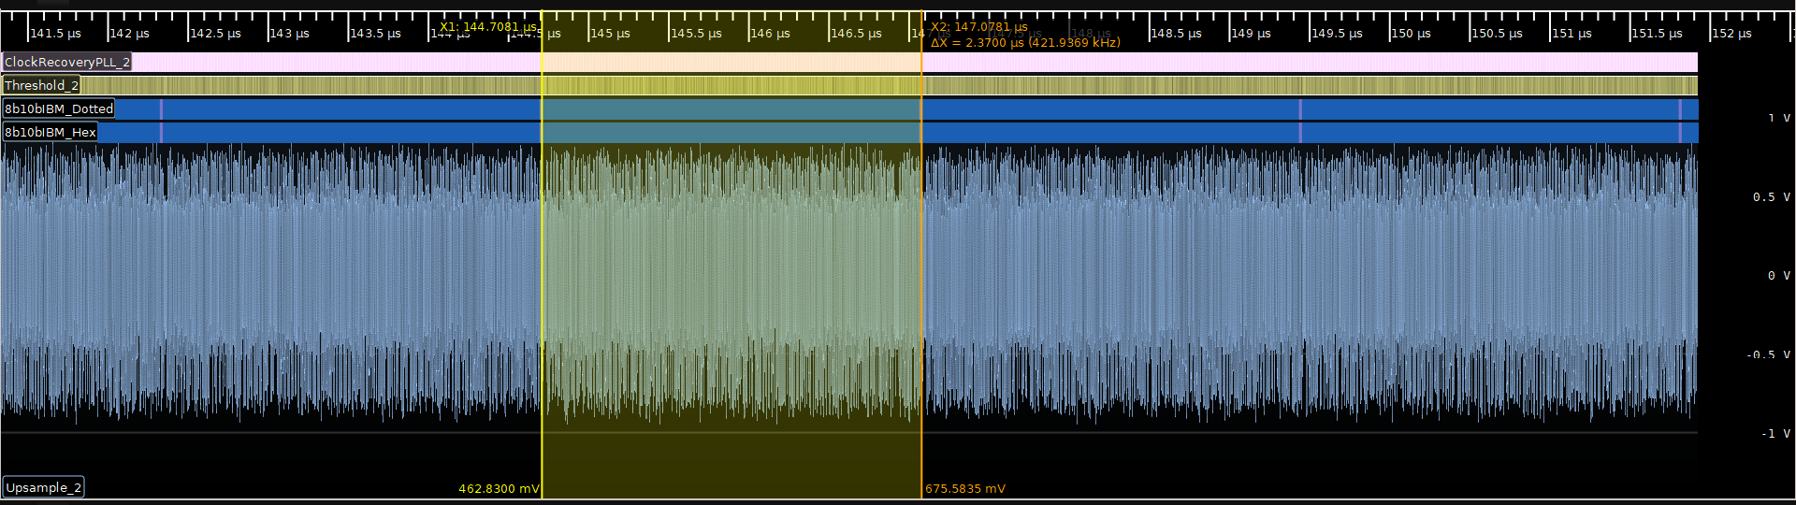

EOF
End Of Frame sequence
- 1x K28.3 D21.5 D21.6 D21.6 => 1xEOF
- 1x K7.c b5 d5 d5
  - Extract Serial ATA Specification Revision 1.0 29-August-2001
Table 20. – Description of primitives:
    - EOF marks the end of a frame. The previous non-primitive Dword is the CRC for the frame.

- 2x K28.3 D21.4 D21.5 D21.5 => 2xSYNC
- 2x K.7c 95 b5 b5
- K28.3 D10.5 D25.4 D25.4 => CONT
- K.7c aa 99 99
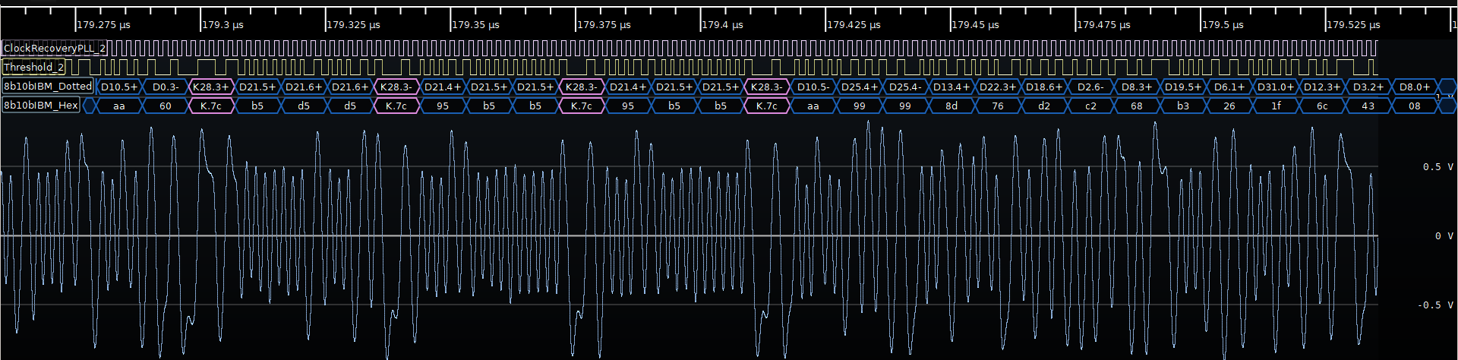

SerDes 180Mbps data capture and details
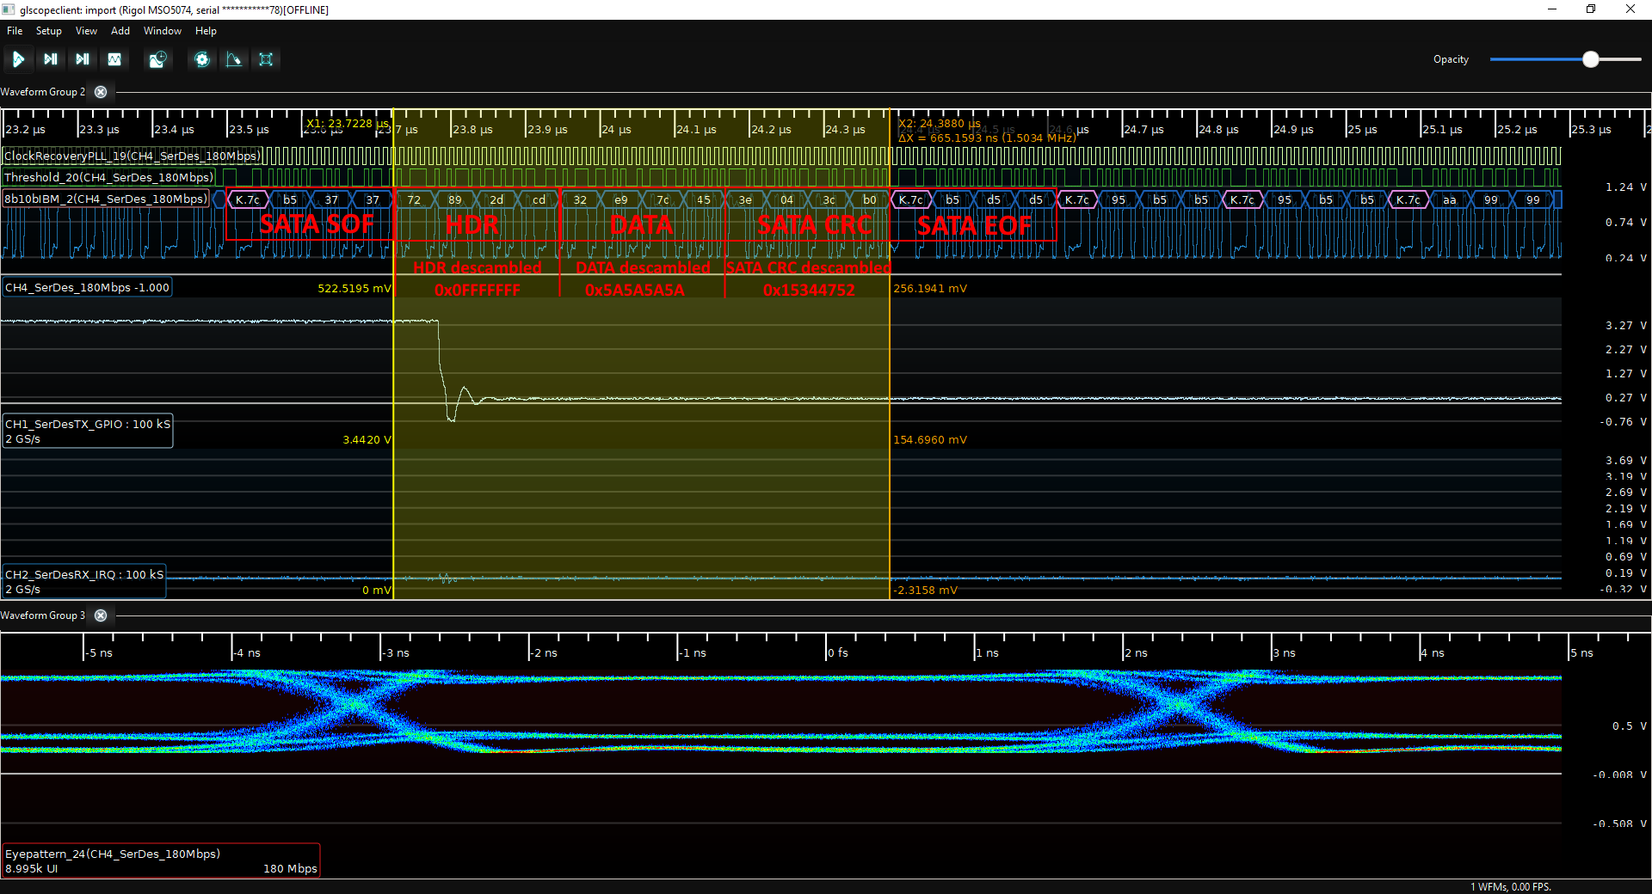
Details:
- SerDes SATA SOF (compliant with SATA CRC32 spec) start at 23.50us
  - SATA SOF => Hex: 7C B5 37 37
- SerDes DATA (HDR / PAYLOAD DATA / CRC32)
  - HDR / Header (specific to WCH CH569W) start at 23.723us
    - Scrambled data => Hex: 72 89 2D CD
    - Descrambled data => Hex: 0F FF FF FF
      - 4bits = Packet Number (incremented after each packet transmitted, start from 0x0 up to 0xF then restart to 0x0 and so on)
      - 28bits = Packet Identifier configured with CH569W SerDes Register
  - PAYLOAD data start at 23.945us
    - Scrambled data => Hex: 32 E9 7C 45
    - Descrambled data => Hex: 5A 5A 5A 5A
  - CRC32 checked as OK(compliant with SATA CRC32 spec) start at 24.168us
    - Scrambled data => Hex: 3E 04 3C B0
    - Descrambled data => Hex: 15 34 47 52
- SerDes SATA EOF (compliant with SATA CRC32 spec) start at 24.39us
  - SATA EOF => Hex: 7C B5 D5 D5

Appendix

SATA specification
See https://www.seagate.com/support/disc/manuals/sata/sata_im.pdf
Most interesting chapter for CH569 SerDes are:
- § 7.4 Primitives (mainly related to SOF/EOF)
- § 7.5 CRC calculation and scrambling of FIS contents
- APPENDIX A. SAMPLE CODE FOR CRC AND SCRAMBLING
See extract of § 7.4.3 Primitive encoding
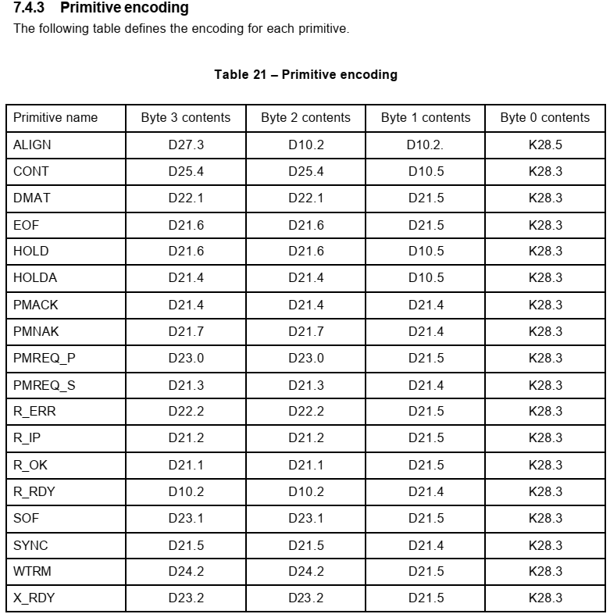

Revision History

Date | Revision | Changes
31-July-2022 | V1.0 | Initial release (written by Benjamin VERNOUX).

