Jonathon Moore

CST-310

Professor Citro

5/29/2024

Topic 4 Lab Question 2

Texture mapping is the process of taking a two dimensional image, and applying it to a three dimensional object to add detail and color to the object. Within the texture mapping there are two dimensional coordinates that will specify how the texture should map to the surface of the three dimensional object.

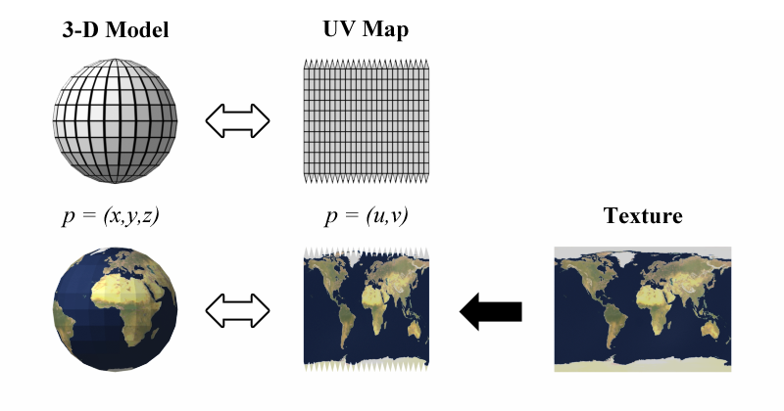

In this picture we have a 3D sphere that is broken into segments along its body, those are then unraveled into a two dimensional map. To get the 2D texture onto the sphere we first take the texture and map it into the coordinates given by the unfolded model, and then finally apply the mapping back to the three dimensional sphere, with the texture applied to the sphere. Similarly, bump mapping is the process of applying bumps and wrinkles to the surface of the three dimensional object without actually changing the model itself. This is done by perturbing the surface normal of the object based on the given texture bump mapping.

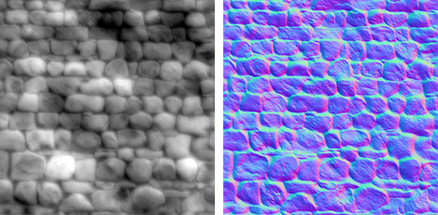

For example we have the two dimensional texture on the left of some bricks. Alone it would just wrap around the sphere and still be flat. With the bump map on the right we can see the light areas, which would be the low areas, and the darker areas being the higher areas. From here you can specify how strong the bump map would be leaving you with higher differences between the highs and lows of the ending texture. Finally we have environment mapping which is a technique to simulate reflections and refractions of the surrounding environment on the surface of an object. There are quite a few versions including cube mapping and spherical mapping.

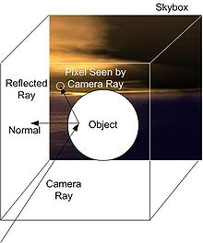

Here you can see this is achieved by sending a ray to the object and seeing where the reflected ray would end up. Wherever that ends up will be what is displayed on the three dimensional object. Giving the illusion of reflection.