Project 8: 3D Animation

Jonathon Moore

CST-310

College of Engineering: Software Engineering

Professor Citro

GitHub Link: <https://github.com/hydrenoid/CST-310>

Project 8: 3D Animation

1. Screenshots

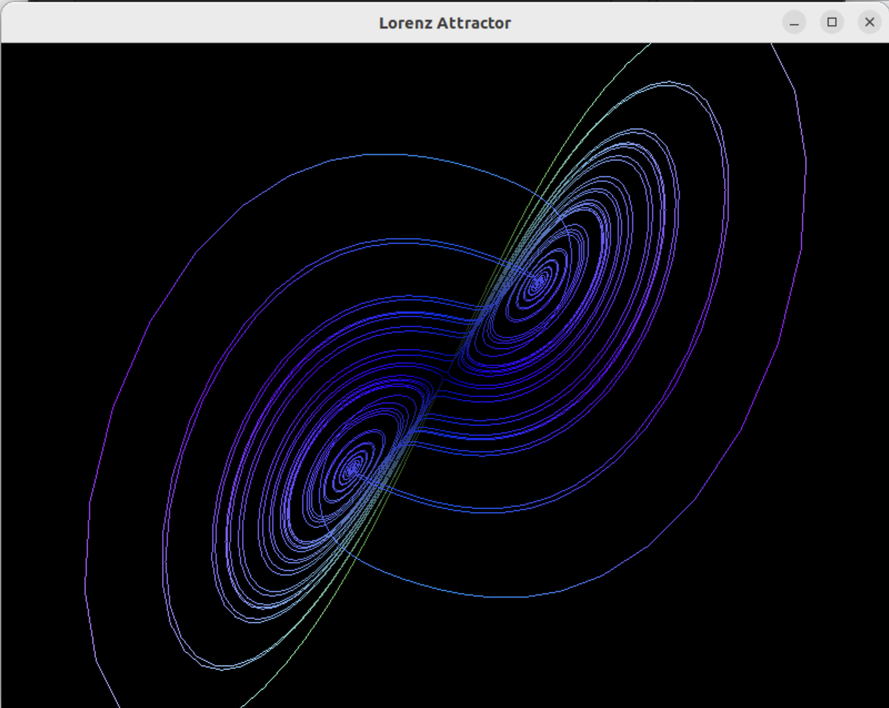

1. Why is it interesting to watch?

The program creates an animation of two Lorenz attractors in three-dimensional space. The attractors exhibit chaotic behavior, which means their trajectories are highly sensitive to initial conditions. This sensitivity results in complex, non-repeating patterns that are visually captivating and intriguing to watch.

1. Why is it challenging to design?

Designing the program is challenging because it involves understanding and implementing the mathematical equations that govern the Lorenz attractor. Additionally, creating a visually appealing and smooth animation requires careful consideration of rendering techniques and user interaction.

1. Why is it tricky to program?

Programming the Lorenz attractor involves managing a lot of dynamic data, such as the position of the attractors in three-dimensional space over time. Ensuring that the animation runs smoothly and efficiently while also responding to user input for rotation and resetting adds complexity to the programming task.

1. Theoretical background

The Lorenz attractor is a mathematical model that describes a chaotic system of three differential equations. It was introduced by Edward Lorenz in 1963 as a simplified model of atmospheric convection, but it has since been used to study a wide range of complex systems in physics, biology, and other fields.

1. Main idea

The main idea of the program is to visualize the behavior of the Lorenz attractor in a three-dimensional space. By plotting the trajectories of two attractors with slightly different initial conditions, the program demonstrates the sensitive dependence on initial conditions characteristic of chaotic systems.

1. Various components

The program includes components for updating the positions of the attractors based on the Lorenz equations, rendering the attractors as line strips in OpenGL, processing user input for rotation and resetting, and managing the OpenGL context using GLFW and GLEW.

1. Concepts

The program demonstrates concepts related to chaos theory, including sensitive dependence on initial conditions, deterministic chaos, and the visualization of complex, non-repeating patterns.

1. Relationships

The program relates to mathematics, physics, and computer graphics. It uses mathematical equations to model the behavior of the Lorenz attractor, physics concepts to understand the underlying dynamics, and computer graphics techniques to render the attractors in three-dimensional space.

1. Intended effect

The intended effect of the program is to provide a visual representation of a chaotic system that is both aesthetically pleasing and intellectually stimulating. By allowing users to interact with the animation, the program aims to enhance understanding of chaos theory and its implications for complex systems.

1. Short video

<https://youtu.be/QpDdsLd6Ko8>

1. Mathematical concepts

The program is based on the Lorenz attractor, which is described by a set of three nonlinear differential equations. These equations are:

Here, x, y, and z represent the state variables of the system, and t represents time. The parameters σ, ρ, and β are constants that determine the behavior of the system. The Lorenz attractor exhibits chaotic behavior, with trajectories that are highly sensitive to initial conditions.

In the program, 3D transformations are used to position and orient the attractors in the OpenGL scene. These transformations include translation, rotation, and scaling operations, which are applied to the vertices of the attractors to animate their movement and orientation.

1. Flowchart

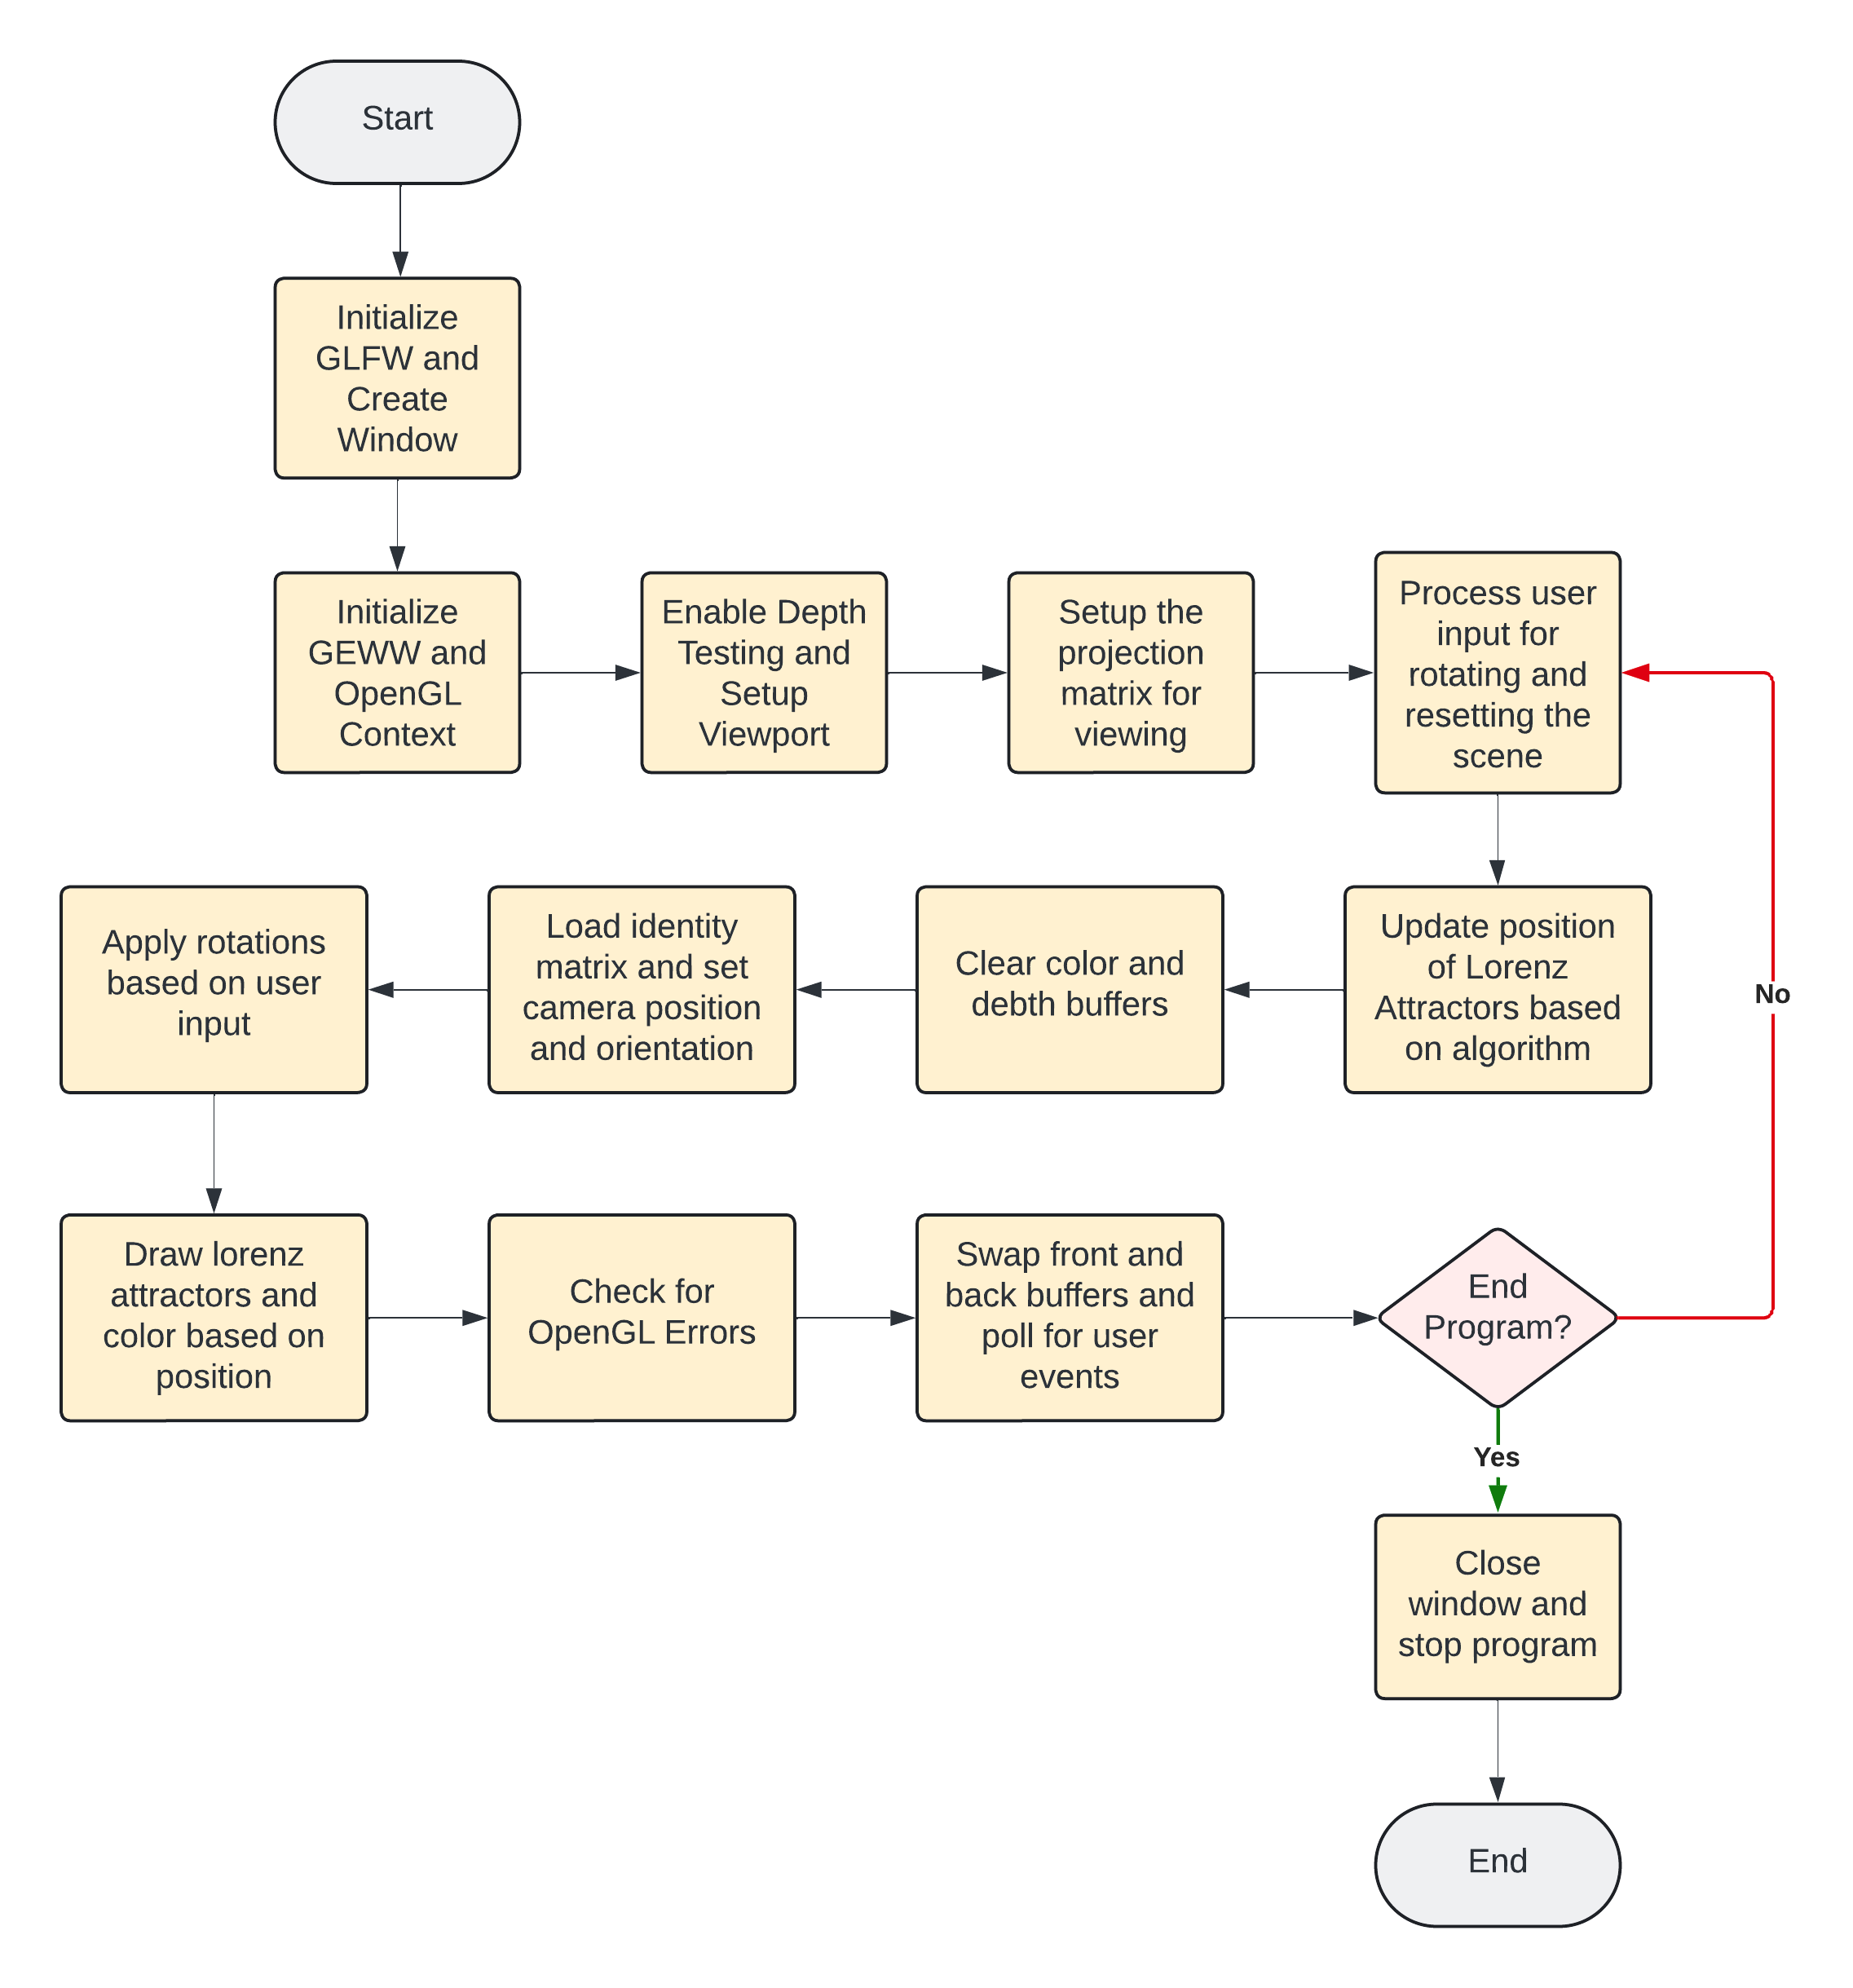

References

Weisstein, E. W. (n.d.). Lorenz Attractor. In *MathWorld - A Wolfram Web Resource*. Retrieved from <http://mathworld.wolfram.com/LorenzAttractor.html>

GLFW. (n.d.). *GLFW: An OpenGL library*. Retrieved from <https://www.glfw.org/>

GLEW. (n.d.). *The OpenGL Extension Wrangler Library*. Retrieved from http://glew.sourceforge.net/