Project 9: Advanced Shaders

Jonathon Moore

CST-310

College of Engineering: Software Engineering

Professor Citro

GitHub Link: <https://github.com/hydrenoid/CST-310>

Project 9: Advanced Shaders

1. Theoretical Background

The project focuses on creating a 3D scene in OpenGL, implementing shaders for various mapping effects, and enabling user interaction for camera control to inspect these effects. The main components include a checkerboard ground plane as a reference, creation of three objects (a sphere, cube, and cylinder) with different mapping techniques applied to each, and user controls for camera movement. Shaders are small programs running on the GPU that control rendering. The checkerboard texture shader creates a grid of alternating black and white squares for orientation, while the sphere mapping shader applies a texture that simulates a real sphere's curvature. The cube mapping shader maps textures onto each face of the cube, and the cylinder mapping shader wraps textures around the cylindrical surface. The project aims to demonstrate the versatility and power of shaders in rendering realistic textures and effects on 3D objects, showcasing fundamental concepts in 3D graphics and shader programming.

1. Mathematical Concepts

In this project, several mathematical functions and models are employed to create textures and enable camera movement within a 3D scene. The checkerboard pattern is generated by iterating over each texel (texture pixel) and assigning it a color based on its position, using the model

$$bw=(\left(i\&texelsPerSquareSide\right)==0)⨁(\left(j\&texelsPerSquareSide\right)==0)$$

where i and j are the texel coordinates. Sphere mapping projects a 2D texture onto a spherical surface with the coordinates

$$\left(u,v\right)=(\frac{1}{2}+\frac{arctan2(z,x)}{2π},\frac{1}{2}-\frac{\arcsin\left(y\right)}{π})$$

Cube mapping assigns a texture to each face of a cube, using the major axis to determine the face and mapping coordinates

$$\left(u,v\right)=(\frac{xface}{\left|major_{axis}\right|},\frac{yface}{\left|major_{axis}\right|})$$

Cylinder mapping wraps a texture around a cylindrical surface, with texture coordinates

$$\left(u,v\right)=(\frac{arctan2(x,z)}{2π}+0.5,y)$$

Camera movement is controlled by user inputs, allowing translation and rotation within the scene, defined by the

$$ViewMatrix=LookAt(eye,center,up)$$

and the

$$ProjectionMatrix=Perspective(fovy,aspect,zNear,zFar)$$

These models and functions define how textures are mapped onto 3D objects and how the camera interacts with the scene, enhancing realism and interactivity. The checkerboard pattern provides a visual reference for orientation and scale, aiding in the inspection of textures generated by the mapping models.

1. Short Video

<https://youtu.be/UaUFNZXcj6A>

1. Screenshots

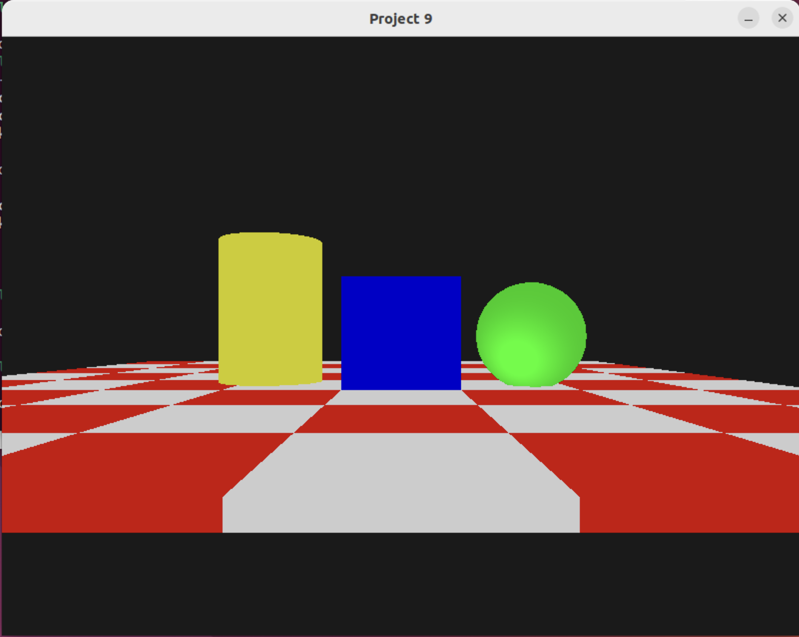

References

GLFW. (n.d.). *GLFW: An OpenGL library*. Retrieved from <https://www.glfw.org/>

*Textures*. LearnOpenGL. (n.d.). https://learnopengl.com/Getting-started/Textures

Wikimedia Foundation. (2024, March 17). *Cube mapping*. Wikipedia. https://en.wikipedia.org/wiki/Cube_mapping