**CST-320 Technical Report Template**

**Period** (Mon-Sun dates): T-TH 11AM

**Student Name**: Jonathon Moore, Ryan Woodward

**Faculty Name**: Isaac Artzi

**Project Topic**: CLC - Software and Foundational Tools Readiness

**Current task(s)** (refer to the tasks listed in LoudCloud and/or instructor directions; detailed bullet list):

* Extract the application you focused on from the 4-app example
* Modify it in 3 meaningful ways:
  + add or modify assets
  + add or modify an interaction
  + add or modify a special effect

**Activities performed this week** (bullet points with explanations):

Johnny:

* Fixed the landing pad and positioning of separate balls so they land at the same time on the y axis.
* Added a separate display to the Canvas to display the x displacement of the second ball
* Calculated velocity for both balls and displayed them on the canvas
* Added a slider to change the scale of one ball

Ryan:

* Adjusted the growth script so the rate is half of the normal rate
* added Mondrian painting to the floor
* recolored the tree
* added a new rock material for the cylinder
* adjusted the direction and color of the particle stream

**Overall progress** (describe new knowledge acquired, successes, ideas generated, etc.):

* Learned how to navigate the Unity UI and setup scenes
* Connecting game objects with scripts
* Moving around the 3D world and positioning objects
* Learning how objects interact with each other, specifically collisions
* Attaching scripts to game objects

**Issues that need to be resolved** (bullet list):

* Could add a trigger on the wall that will execute the timer instead of having to click it so that it gets an accurate reading of how long it took for the ball to hit the wall
* Add a slider to increase the gravity coefficient (mass does not affect fall speed)

**Next steps** (how will you mitigate the issues listed above; bullet list):

* Add a script to the wall for collision detection that will execute the button script
* Connect a slider to the gravity value

**Other comments**:

* Seems that the scale does not affect the velocity at all
* Could not find where the gravity was being calculated

**Representative screenshot or diagram:**

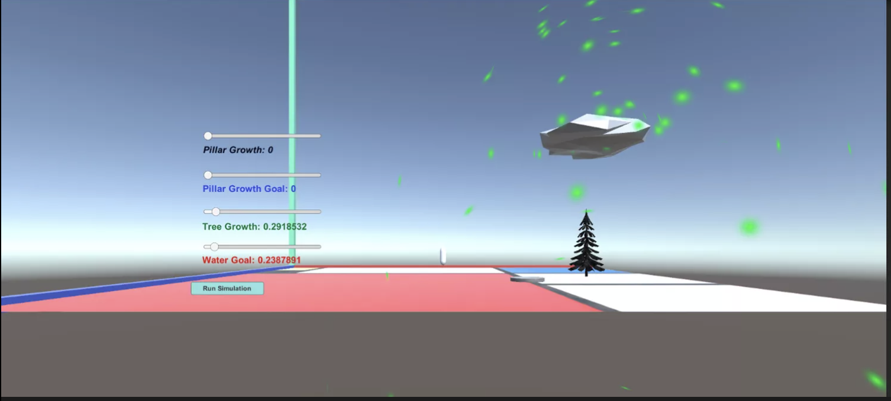

Link to Screencast and Github Repo:

<https://github.com/hydrenoid/CST-320.git>

Link to Ryan’s Screencast:

https://youtu.be/kK-QZiZBusM