Created in the cloud with Aspose.Words for Cloud. http://www.aspose.com/cloud/word-api.aspx

# Understanding the Risks in Geo Tagging

Published Date : October 27, 2016  
Author : tayo

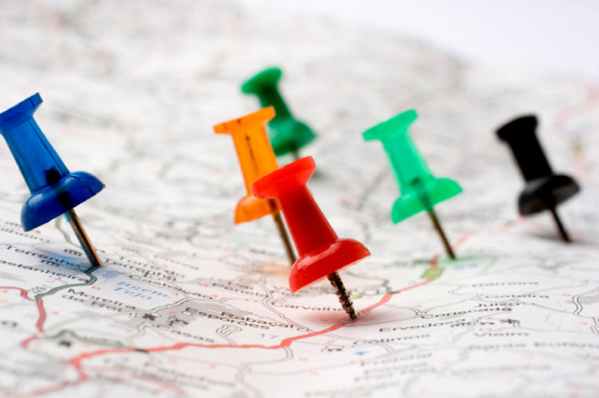

The Geo tagging feature is, an awesome way of letting people know where you had that delightful lunch with your family, or the beautiful view from your room during a holiday trip. It just makes it easier for you to arrange photos and let friends know where they might be able to replicate some enjoyable experience you had.

With its interesting capabilities, there is also risk to consider when using the Geo tag feature.

The primary risk with geo tag is the risk of “**social surveillance.**”  If you’ve any social media platform, be it Facebook? Twitter or Instagram. You must have come across social stalkers.  These modern creepers make use of the information you publish on social media pages in order to track your movement, your habits, and your associations.  Stalkers can make use of public geo tagging information to pinpoint your present location, find out where you live, and even how and where you spend your time with very little effort.

The follow points are best ways to keep you safe while geo tagging.

1. **Take the time to note your default privacy settings:**This applies both to your smart phone or mobile device and the social media networks you access through your device.   Sometimes tagging a location maybe a default setting on your phone or on the social network you’re using.  It is important to be aware of these settings so you can consciously decide when and where you geo tag, and who the information will be available to.
2. **Understand the Risk:**Realize that geo tagging information gives anyone who views it the opportunity to know your exact whereabouts, particularly in instances where you’ve posted your location to multiple sites (e.g. Twitter, Facebook, and Instagram).  A check-in at the airport with the message “vacation for the next week!” for example lets anyone who might care to look know that you’ll be out of town for a week.
3. **Know How to Disable the Geo Tagging Feature:**Every smartphone has a geo tag feature, and many of them will be automatically set up to function without you consciously choosing to have it do so. It’s a much better idea to consciously decide to geo tag each time you post rather than having to remember to opt out of geo tagging each time you post

**How To Disable Geo Tagging Feature**

**For iPhones**:

Go to the “settings” page of the geo-tagging program.  Go to “settings” then “general” and then “location services.”  Disable those applications that automatically make use of your GPS tracking data.

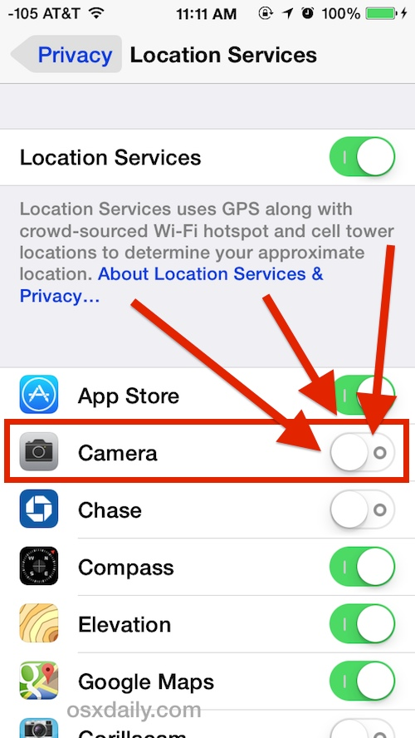

**For Android Platforms:**

Start the camera application.  Open the menu and go to “settings.”  Turn off “geo tagging” or “location storage” (depending on the type of Android).

For digital cameras, be sure to consult the user manual.  Not all digital cameras come with a geo tagging feature, but it’s important you know how your particular camera operates in relation to location tracking.

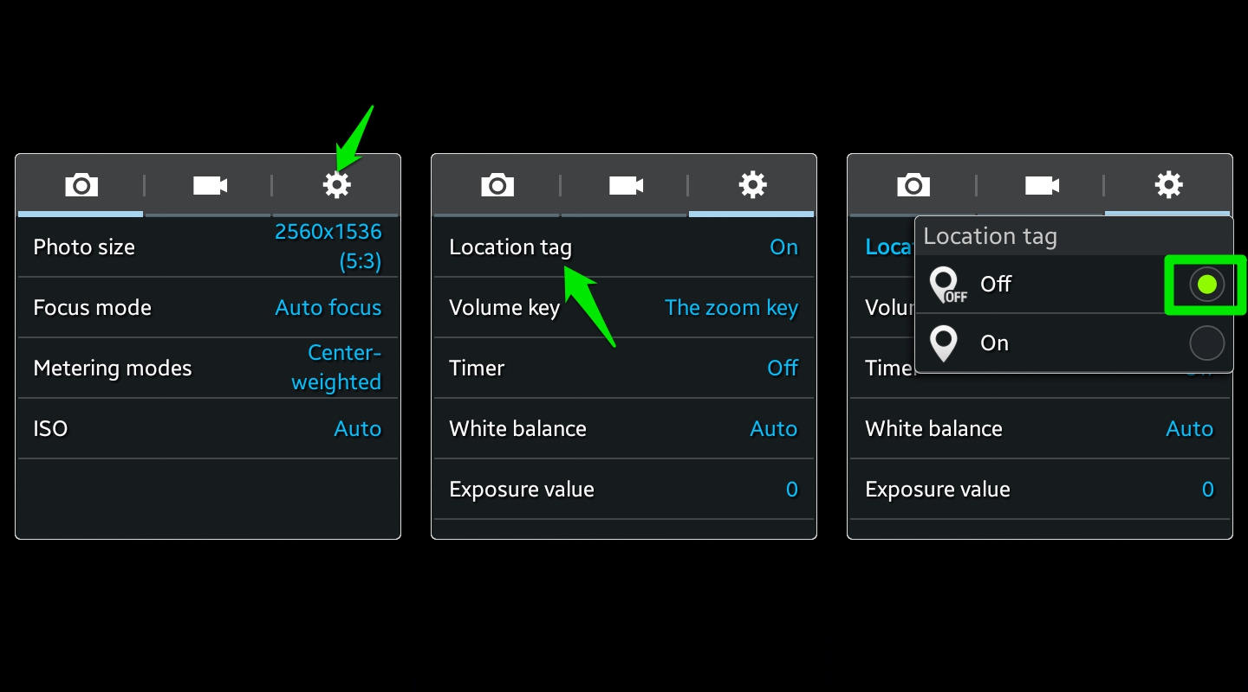

### Comments