Created in the cloud with Aspose.Words for Cloud. http://www.aspose.com/cloud/word-api.aspx

# Understanding Privacy Policies

Published Date : September 7, 2016  
Author : tayo

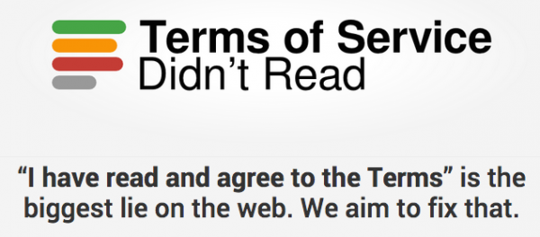

**Privacy policy** is the statement or a legal document that discloses how customer data is managed and used. It can be hard to understand, seeming to be meaningful to just the writers or someone in the advertising industry. Many people do not actually read privacy policy either because it is too long or they don’t just care.

The major challenge lies in helping people to realize why the privacy of their data is important to them, and then enabling techniques on assisting them to understand the unending data policy.

Several issues contribute to confusion over privacy policies, beginning with the assumptions users make about what it means to have a privacy policy in the first place. Many people don’t actually read privacy policies; they simply look at the label. And the intuitive understanding — the cultural understanding — of the label is that when something says privacy policy, it protects your privacy .

Users don’t fully understand the scope of the data that is being collected on them — or how small amounts of data can be used to create a much more detailed portrait when matched with information from third-party sites that collect and share various types of customer information with each other. The general sense among marketers is that people understand that their data is being used, but people don’t truly understand how data mining works. They may realize that one or two pieces of their information are being given out; what they don’t realize is that those one or two data points can be linked with other sources to uncover information they would have never given out in the first place.

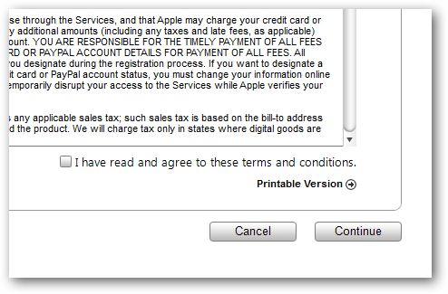

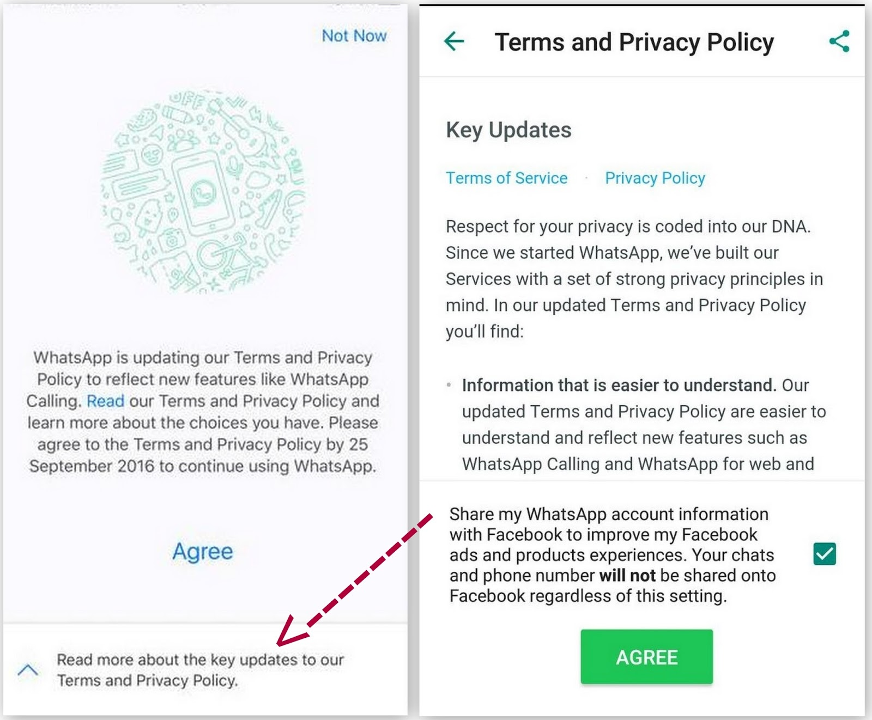

**Approach to Understanding**Endeavour to Read the End User License Agreement and Privacy Policy or Data Use Policy carefully, this will let you understand how your content and personal data are going to be treated, with whom will they be shared. The sort of service that you are signing up to can give a general idea of what kind of personal data will be collected from you and if you will be to ok to have such data shared with a third party entity other than the service provider you are transacting with. In fact, it has been reported that if you actually bothered to read all the privacy policies you encounter on a daily basis, it would take you 250 working hours per year — or about 30 workdays.

For a useful add-on tool which helps users to understand the Terms of Service of many popular sites, visit https://tosdr.org/index.html . It is a browser add-on that rates and labels website term and privacy policies. It uses a ‘class’ rating that will let users understand their rights on line by rating the privacy agreement of the web service they are using.

### Comments

# 10 things to know about Nigeria’s Cybercrime Act

Published Date : July 27, 2016  
Author : tayo

Nasir and Dolapo are working together to track the activities of AGA on social media. They need to build up a case so law enforcement agencies can clamp down on AGA. How do they go about this, without contravening the Nigerian Cybercrime Act 2015

10 things to know about Nigeria’s Cybercrime Act 2015. There you go:

**1**. Any person convicted of **child pornography** convictions will be receive 10 years in prison and/ or a N20 million fine, depending on the nature of the offence. Child pornography includes producing, procuring, distributing, and possession such images.

**2**. Anyone convicted of identity theft will receive result in 3 years’ imprisonment and/ or a N7 million fine.

**3**. The Act also outlaws **cyber-stalking** and **cyber-bullying**. Anyone convicted of these could receive a N2 million minimum fine and/or at least 1 year in prison. More severe offences could attract a penalty as high as a N25 million minimum fine and/or up to 10 years’ imprisonment, depending on the severity of the offence.

**4**.If hackers are found guilty of unlawfully accessing a computer system or network, they could be fined up to N10 million, imprisoned for 5 years, or both, depending on the purpose of the hack. The same applies to **Internet fraudsters** who commit cybercrimes by sending electronic messages, or accessing and using data on computer systems.

**5**. The president may decide that certain systems, networks and information infrastructure are vital to Nigeria’s national security or its citizens’ economic and social well-being. Therefore, the president may term them Critical National Information Infrastructure, and may implement procedures and guidelines for their use, and may conduct audits to make sure they are functioning as they’re supposed to. For example, the transportation, communications, banking sectors are critical national infrastructure.

**6**. A conviction for any offence committed against any part of Nigeria’s critical national infrastructure that results in someone’s death attracts the death penalty (and there are other punishments for lesser crimes).

**7**. The Act prohibits[cybersquatting](https://en.wikipedia.org/wiki/Cybersquatting) and anyone convicted of this faces at least 2 years’ imprisonment, and/or a minimum N5 million fine.

**8**. The distribution of **racially or ethnically prejudicial or violent material through a computer system** or network is prohibited. Convictions attract at least 5 year’s imprisonment and/or a minimum N10million fine.

**9**. Internet service providers (ISPs) are required to **keep records of users’ Internet traffic and their subscriber data**, and must safeguard this information so that the users’ constitutional right to privacy is respected.

**10**. Lastly, the Act allows **electronic communication to be intercepted**, but only with a court order based on reasonable grounds to suspect that the information is required for a criminal investigation or proceedings.

You can read or download the whole Act here:[CyberCrime (Prohibition,Prevention,etc) Act, 2015](https://cert.gov.ng/images/uploads/CyberCrime_%28Prohibition,Prevention,etc%29_Act,_2015.pdf)

### Comments