Here is an example.

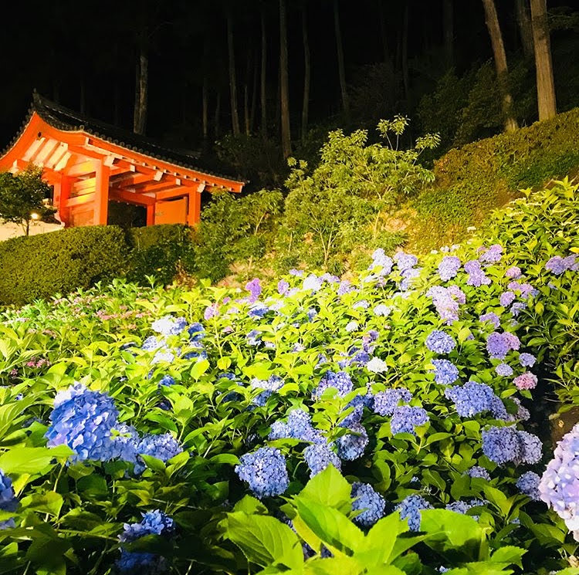

Takuya Miyashita

Doctoral student, Kyoto University

<https://hydrocoast.jp>

miyashita(at mark)hydrocoast.jp

2018.07