Distributional thermal change and the components of increasing dry–hot concurrence across Iran, 1991–2024
Running title: Thermal extremes and dry–hot concurrence in Iran

Abstract
Changes in thermal extremes and compound dry–hot occurrence depend on both climate behavior and event construction. We analyzed daily observations from 124 Iranian stations during 1991–2024, using a fixed 108-station network for annual thermal-count quantile trends. Six controlled index constructions evaluated reference period, percentile window, quantile convention and in-base estimation correction. A complementary analysis classified dry–hot years using 1991–2007 precipitation and temperature quartiles and partitioned joint-frequency change into dry-frequency, hot-frequency and excess-joint components. Warm-day point slopes ranged from 9.52 to 22.37 days decade⁻¹ across the 0.10–0.90 quantiles, but their contrast had a 95% interval of −5.76 to 19.66; thermal asymmetry and day–night differences remained unresolved. In-base correction reduced fixed-reference warm-day/warm-night increases from 37.17/29.26 to 32.71/25.94 days per year on identical stations. All evaluated constructions retained warming-consistent period-change directions. Annual dry–hot frequency increased from 9.16% to 29.81% on 104 balanced stations; June–September frequency increased from 5.54% to 18.39% on 103 stations. The summer increase of 12.85 percentage points partitioned into 2.89 from dry-frequency change, 9.91 from hot-frequency change and 0.06 from excess joint occurrence. Synchronized year-block intervals supported increased concurrence but did not resolve an excess-joint change. Excluding 28 zero-cutoff summer stations simply rescales the point change to 17.65 and provides no independent robustness evidence. Matched-station tie comparisons substantially altered climate-regime patterns. The findings separate directional change from unresolved asymmetry and definition-driven contrasts; inference remains conditional on short reference samples, observed stations and unhomogenized daily records.
Keywords: quantile regression; temperature extremes; compound events; fixed thresholds; block bootstrap; Iran

1. Introduction
Climate change can alter both the center and shape of a temperature distribution, so a mean trend alone does not describe the behavior of extremes (Katz and Brown, 1992). Changes in the annual frequency of warm and cool days are particularly useful observational indicators because they translate daily temperature departures into interpretable counts (Alexander et al., 2006; Zhang et al., 2011; Dunn et al., 2020). Nevertheless, their annual distributions may change unevenly: years containing many warm days can exhibit a different trend from years containing relatively few. Distinguishing these responses requires an explicit distributional estimand rather than an assumption that the whole distribution follows its mean.
Quantile regression provides that distinction by estimating conditional trends across the response distribution (Koenker and Bassett, 1978; Koenker, 2005). Barbosa et al. (2011) combined quantile trends, bootstrap uncertainty, and clustering for European temperatures, while Fan (2014) examined quantile-dependent annual temperature-extreme counts in China. These studies establish the methodological precedent for the present thermal analysis. Our question concerns the regional expression of those distributional changes and their relationship to a separately defined compound hydroclimatic signal.
Concurrent low precipitation and high temperature create a second interpretive challenge. Their joint frequency depends on the frequencies of the individual conditions and on their concurrence. Greater joint occurrence can therefore accompany more frequent heat without requiring stronger dependence between temperature and precipitation (Zscheischler and Seneviratne, 2017). Alizadeh et al. (2020) used a century-scale United States archive to investigate joint rarity, spatial extent, and changing event composition. Bevacqua et al. (2022) highlighted the importance of precipitation changes and sampling uncertainty for compound hot–dry occurrence, and Schmutz et al. (2026) examined marginal and dependence contributions to emerging European events. Separating these statistical components is therefore an established scientific question, rather than a new method introduced here.
Event definition matters when applying that question to a short archive. An observation may have a small empirical joint survival probability because one variable is unusual, even when the other is not beyond a marginal extreme threshold. A joint-rarity classification and an explicit low-precipitation/high-temperature AND classification consequently describe different sets of years. In arid environments, the distinction is complicated further by zero precipitation and tied observations. Transparent definitions are necessary before changes in joint frequency can be interpreted as changes in concurrent dryness and heat.
Iran provides a heterogeneous setting for evaluating these distinctions. Its station network spans Caspian lowlands, the Alborz and Zagros mountains, interior plateaus, deserts, and southern coasts. Previous work documented regional changes in temperature and precipitation extremes (Zhang et al., 2005a; Soltani et al., 2016). More recently, Ghasemi (2026) combined PCA and quantile regression for monthly and seasonal Iranian temperatures, while Jamali et al. (2026) examined changes in station climate classifications. Quantile analysis and climatic regionalization therefore already have direct Iranian precedents.
The unresolved empirical question is whether distributionally uneven thermal-count changes coexist with increasing explicit dry–hot concurrence in this Iranian archive, and how the interpretation of that concurrence depends on marginal frequencies and zero precipitation across climate settings. The studies compared in Table 5 establish the individual analytical approaches, but their reported temperature-intensity trends, event-count trends, compound-probability changes and climate-type transitions do not answer this combined question for the same Iranian archive. Recent work also decomposes compound-event probability changes using temperature and precipitation distribution parameters (Zhao and Xiong, 2026), reinforcing the need to identify the added observational evidence precisely.
We address three objectives: quantify distributional thermal change and its climate-regime contrasts across the 124-station archive; determine whether explicit fixed-baseline dry–hot concurrence increased on stable observing networks; and partition the period difference into changes associated with marginal event frequencies and excess joint occurrence, both nationally and within climate regimes. The contribution has three parts. First, fixed-network annual-count quantile profiles and paired contrast intervals distinguish supported thermal directions from unresolved distributional asymmetry, and permit qualified comparison with count-based precedents. Second, a station-first partition with synchronized resampling and threshold re-estimation quantifies the components of observed concurrence while accounting for a short reference sample. Third, fixed climate groups expose where zero precipitation makes a relative dry-event definition structurally restrictive. We assess sensitivity to screening, thresholds, coverage, block length and precipitation ties. These analyses provide complementary evidence; they do not estimate a causal or predictive relationship between a station's thermal quantile trend and its compound-frequency change.

2. Data and methods

2.1. Observations, coverage, and quality diagnostics
The archive contains daily minimum, maximum, and mean temperature and precipitation from 124 Iranian stations during 1991–2024 (Fig. 1), supplied by the Iran Meteorological Organization (IRIMO). Coordinates and elevation are supplied in the station metadata. The original measurement units, acquisition procedure, and redistribution conditions require author confirmation: [UNITS, ACCESS AND LICENSE REQUIRED].
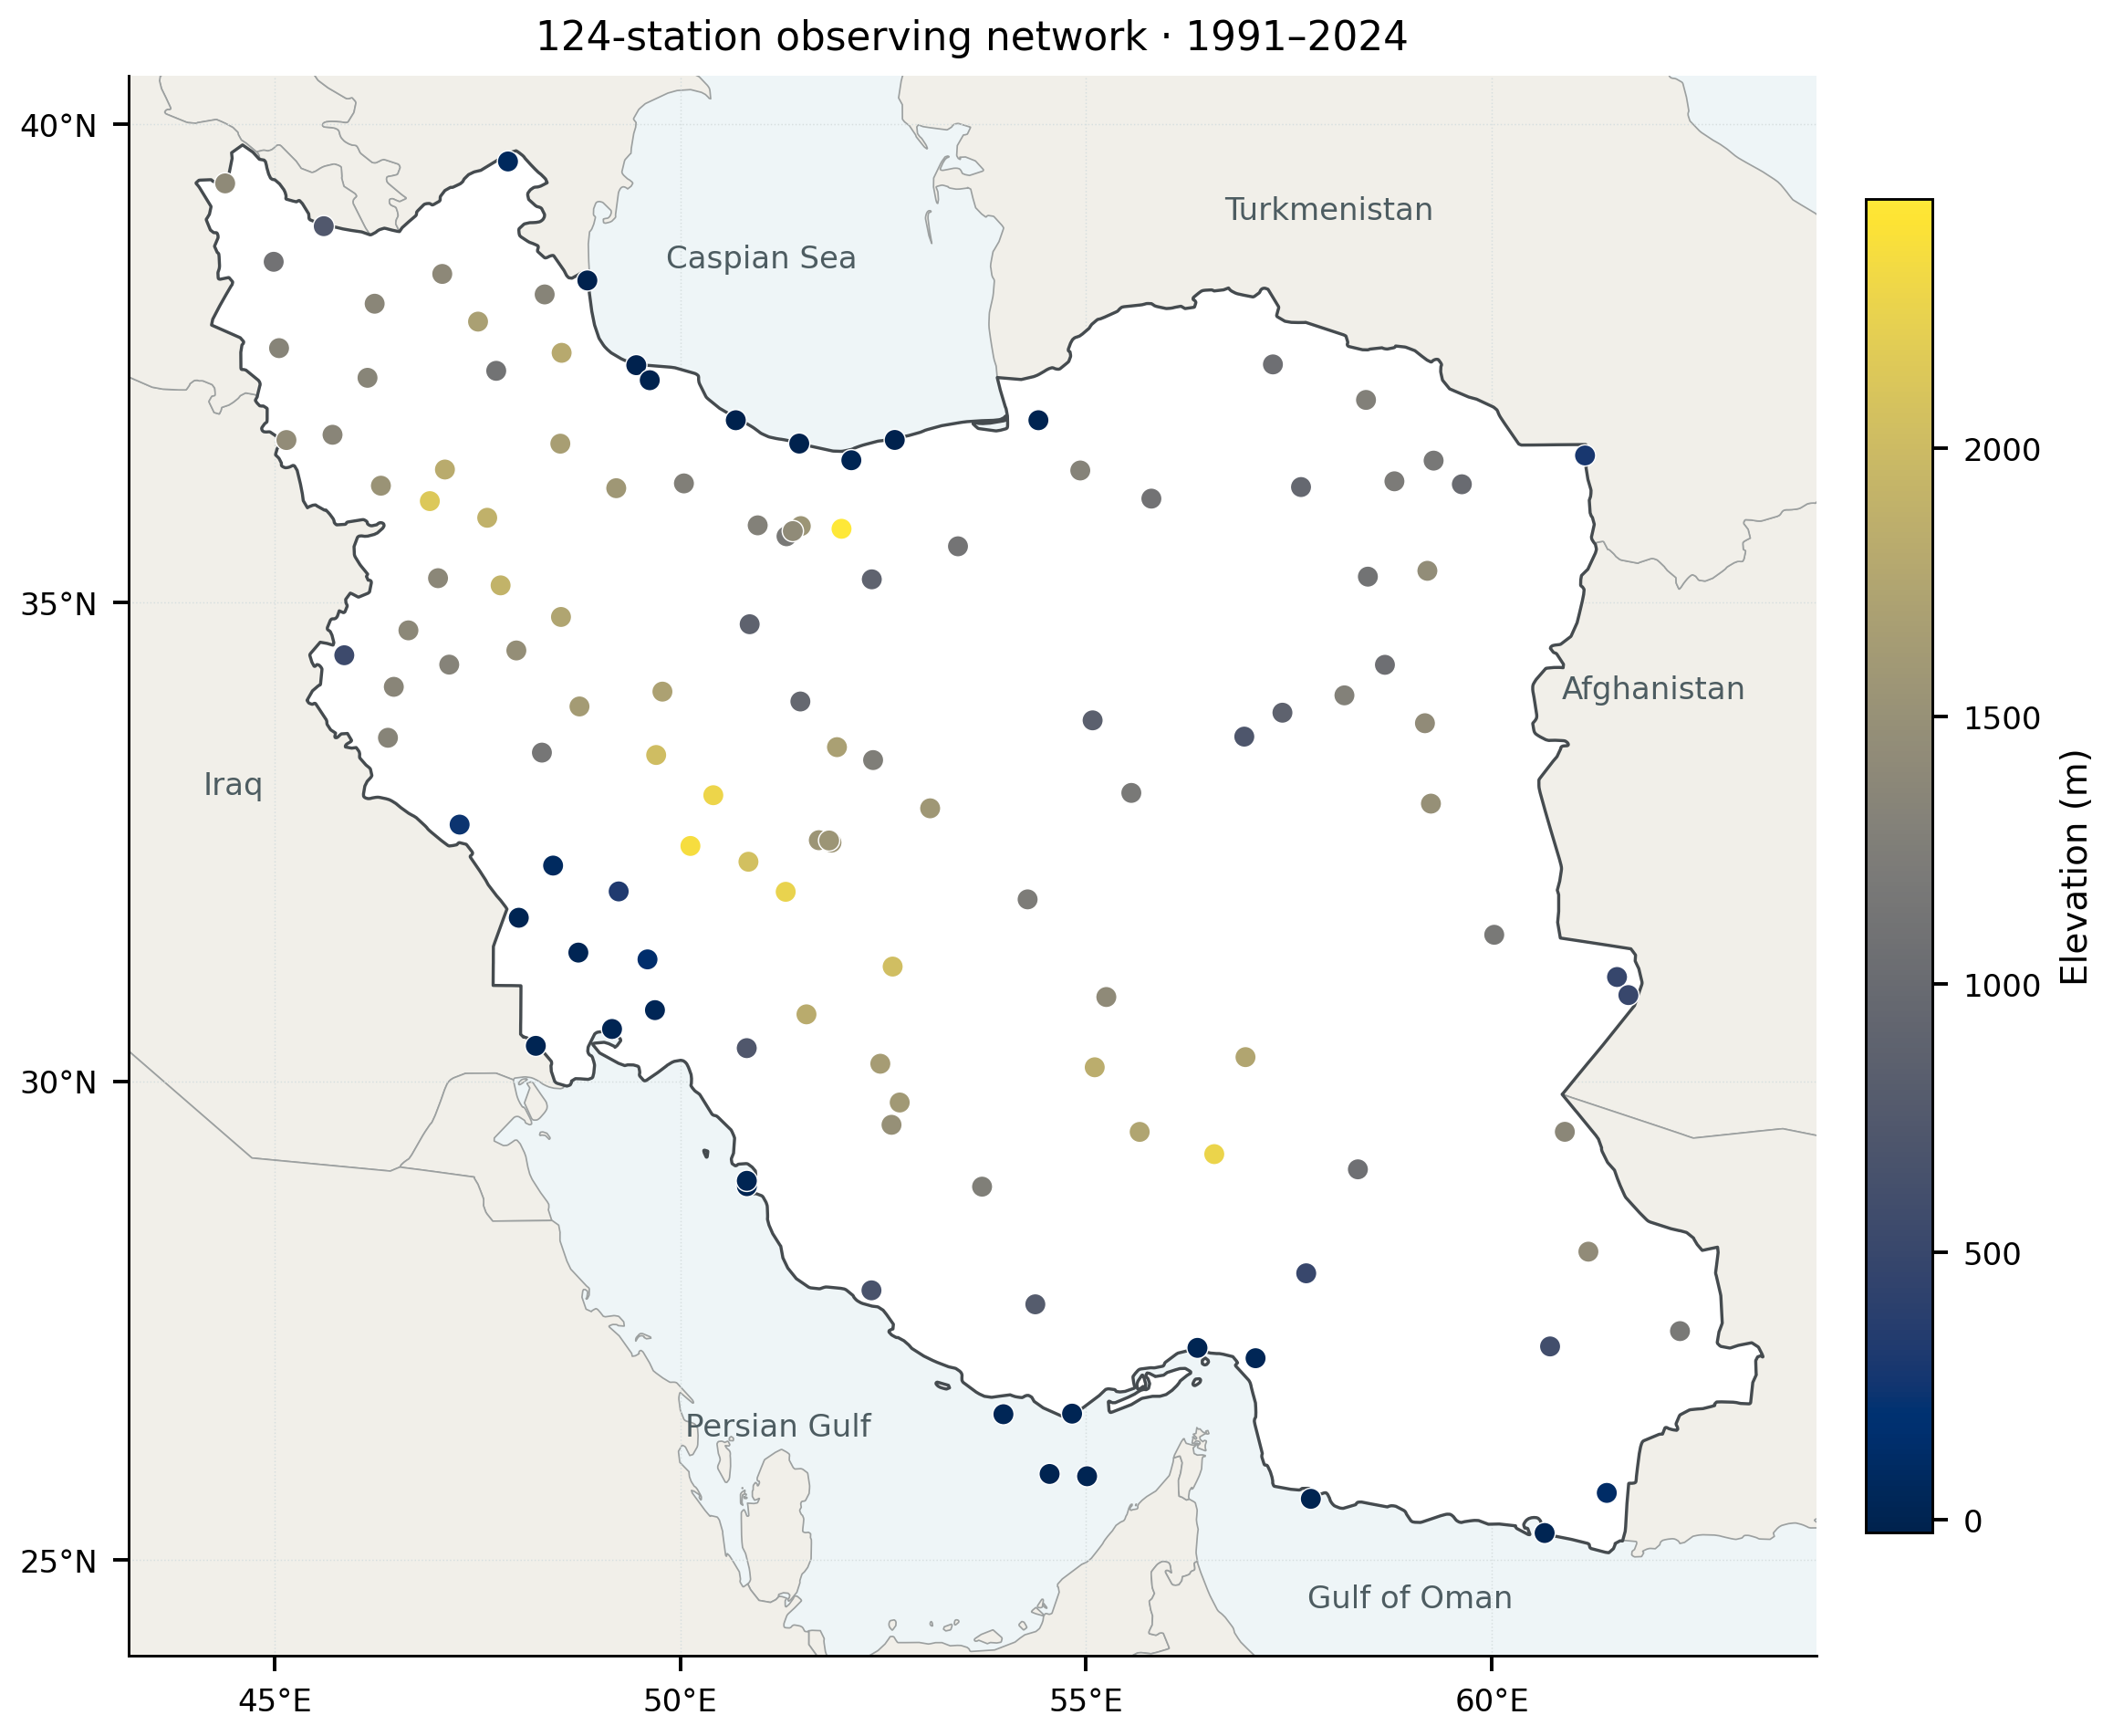
Figure 1. Locations of the 124 stations in the 1991–2024 thermal archive. Color denotes station elevation. Coordinates are displayed in WGS84 longitude and latitude with latitude-adjusted aspect. Boundaries provide geographical context; symbols represent individual observations rather than a spatially continuous sample. Primary network thermal trends use the common 108-station subset in Section 2.3; compound analyses use the balanced subsets described in Section 2.4.
There were 1,539,956 station-day records and no duplicate station dates. Median completeness was 98.96% for minimum temperature, 99.42% for maximum temperature, 99.35% for mean temperature, and 98.94% for precipitation. Internal checks found 45 records at 32 stations with minimum temperature exceeding maximum temperature. After excluding those overlapping conflicts, a further 2,165 records at 61 stations had mean temperature outside the minimum–maximum interval. Historical thermal estimates use the supplied observations, with a separate consistency-screened sensitivity. The new compound analysis masks all three temperatures on minimum–maximum conflict days and masks only mean temperature for the second category. Negative precipitation, if present, is treated as missing; source files are never changed.
Pettitt, standard normal homogeneity, and Buishand-type tests applied to annual mean temperature flagged 119 raw and 39 detrended station series under at least one diagnostic (Pettitt, 1979; Buishand, 1982; Alexandersson, 1986). These screens do not constitute daily homogenization. We retain historical exclusion sensitivity for the 39 detrended flags, because station histories and reference-network information are insufficient to support automatic adjustments.

2.2. Annual thermal indices and baseline sensitivity
Day-of-year 10th- and 90th-percentile thresholds were estimated from the 1991–2024 record using an 11-day circular window, comprising each calendar day and five days on either side. Leap days were omitted. When a local reference sample contained fewer than 15 observations, the station-wide reference sample was used. Warm days and nights are strict exceedances of the upper maximum- and minimum-temperature thresholds; cool days and nights are strict departures below the corresponding lower thresholds. Annual values are counts of observed qualifying days, set to missing below 80% valid coverage. Primary counts are not annualized to compensate for missing days, so residual coverage differences remain a limitation. A separate 365-day-equivalent sensitivity assesses this issue (Section 2.3).
We evaluated six controlled constructions on the same common 108-station network, keeping raw temperature input, calendar, station selection and annual coverage unchanged (Table S12). The historical construction uses the full 1991–2024 reference, an 11-day window and linearly interpolated Hyndman–Fan type-7 quantiles (numpy method linear). A 5-day full-reference variant isolates window width. For the fixed 1991–2007 reference, we compare the uncorrected 11-day/type-7 series with corrected 11-day/type-7, corrected 5-day/type-7 and corrected 5-day/type-8 (median_unbiased) series. This sequence separates reference, in-base estimation, window and quantile-convention effects without searching all possible combinations.
Following the in-base replacement principle of Zhang et al. (2005b), each baseline target year is excluded from threshold estimation and replaced, in turn, by a second copy of each of the other 16 years. Thresholds are calculated from each resulting 17-year reference sample; target-year counts are evaluated separately for all 16 replacements and then averaged. Averaging the thresholds instead would define a different index. Corrected baseline counts can therefore be fractional. Years 2008–2024 retain thresholds fitted to the original 17-year reference; only in-base counts are corrected. The circular calendar-day window and percentile interpolation are applied identically in each replacement. All audited windows met the minimum 15-observation requirement, including donor replacements.
We compare late-minus-early station mean counts and percentages of valid observed days, then average the differences with equal station weights. The common network and identical daily masks isolate construction effects from changes in membership or observation opportunity. The 5-day/type-8 correction follows percentile conventions used in climdex implementations, but the 17-year reference and annual 80% coverage rule differ from standard baseline and monthly-completeness conventions; these outputs are not labeled fully standard ETCCDI indices (Zhang et al., 2011). The replacement procedure corrects a specific in-base/out-of-base estimation mismatch; it neither homogenizes observations nor eliminates uncertainty from a short, trending baseline. It is distinct from uncertainty resampling, and the thermal sensitivity intervals described below condition on each completed index series.

2.3. Quantile trends and spatial summaries
For annual count (Y) and time (t), measured in decades, we fitted
Qᵧ(τ | t) = β₀(τ) + β₁(τ)t.$
The quantile coefficient minimizes the sum of check losses (\rho_\tau(u)=u[\tau-\mathbf{1}(u<0)]). Primary profiles were fitted at quantiles 0.10–0.90 in steps of 0.01, with 0.10, 0.50, and 0.90 as focal summaries. Construction sensitivities refit those three focal quantiles and OLS. Ordinary least squares (OLS) provides a mean-trend comparison. We distinguish regression of the annual network-mean series from averaging individual-station regression coefficients; these operations generally yield different values. The asymmetry metric is
Δ₁ = β̂₁(0.90) − β̂₁(0.10).$
It describes differences in slopes across annual count quantiles, not a change in daily temperature intensity. For declining cool indices, a negative value denotes a more negative slope at the upper count quantile.
The primary network series is the equal-station mean on the intersection of stations with nonmissing annual counts for all four indices in every year: 108 stations over 34 years. Each index separately has 109 complete stations, but those sets differ. This common subset holds membership constant across time and between day and night. We compare it with the annually available network (115–124 stations for daytime and 114–124 for nighttime indices) and each index-specific fixed set. A further diagnostic uses 365 times each common station's observed count divided by its valid-day count, before network averaging. This 365-day-equivalent series assumes missing days are representative within a station-year; it is a coverage sensitivity, not imputation or a substitute for the observed-count estimand. Membership and annual coverage are archived.
Network uncertainty uses 4,999 circular moving-block pairs replicates of the 34 annual observations, with four-year blocks and two- and six-year sensitivities (Künsch, 1989; Fitzenberger, 1998). Each sampled pair retains its original calendar-year covariate together with the full response field. The same sampled year positions are used across all four indices and compared networks, preserving their observed within-year dependence; stations are not resampled independently. Intercept-and-time quantile fits minimize the weighted check loss over observation-pair line intersections. For nonunique optima, the midpoint of the extreme optimal slopes is used. An independent linear-programming solver checks this implementation. Daily percentile thresholds and selected station sets are held fixed; these conditional intervals do not include threshold-estimation or network-selection uncertainty. Block resampling in a short trending record provides approximate inference, without a finite-sample coverage guarantee.
We calculate every slope contrast within its paired replicate: (\Delta_{1,i}^{}=\beta_{1,i}^{}(0.90)-\beta_{1,i}^{}(0.10)), and (C_{w}^{}=\Delta_{1,\mathrm{warm\ days}}^{}-\Delta_{1,\mathrm{warm\ nights}}^{}), with an analogous signed cool-index contrast. Thus, contrast intervals account for covariance between fitted slopes and indices. The cool contrast compares signed asymmetries, not their absolute magnitudes. Table 1 reports pointwise 95% percentile intervals for OLS, focal quantiles and (\Delta_1); Figure 2 shows pointwise bands across the quantile grid, not a simultaneous band. Table S10 additionally reports nominal Bonferroni intervals using quantiles 0.004167 and 0.995833 for six primary contrasts: four (\Delta_1) values and the two day-minus-night contrasts. This six-contrast family is separate from the eight compound quantities in Section 2.6. We also omit each year in turn to assess point-estimate sensitivity.
Historical station uncertainty used 200 moving-block bootstrap replicates, with (\lceil n^{1/3}\rceil) years per block, bounded between two and eight; the 34-year series therefore used four-year blocks. A 400-replicate calculation and a maximum-entropy alternative provide sensitivity checks (Künsch, 1989; Vinod, 2006). Tail intervals are pointwise percentile intervals. At the median, analytic station probabilities were adjusted separately within each index using Benjamini–Hochberg FDR at 0.05 (Benjamini and Hochberg, 1995). These retained counts are local tests after multiplicity adjustment; they are not a separate test of field significance, and FDR does not repair misspecification of the underlying probabilities.
Station maps display the observed estimates without interpolation. Historical Moran diagnostics used five-nearest-neighbor weights and 499 label permutations; their nominal probabilities are exploratory across the 12 fields. Hierarchical clustering was examined through feature and algorithm sensitivities. Climate-regime stratification, described in Section 2.7, uses a separately established classification rather than clusters fitted to the same trends being compared.

2.4. Explicit dry–hot events on a balanced network
The compound analysis uses annual precipitation totals with annual mean temperature, and June–September precipitation totals with the seasonal mean of daily maximum temperature. Coverage is computed against the number of calendar days, including missing daily rows, separately for precipitation and temperature. A year requires at least 80% coverage for both variables. To keep the comparison independent of changes in station membership, a station must meet these conditions in all 34 years; this yields 104 annual and 103 warm-season stations. Precipitation totals are not scaled for missing days. A 90% coverage sensitivity tests the influence of this choice, without assuming that missing precipitation is zero.
For station (s), define dry and hot indicators
Dₛᵧ = 𝟙(Pₛᵧ < qᴾₛ,₀.₂₅), Hₛᵧ = 𝟙(Tₛᵧ > qᵀₛ,₀.₇₅), Jₛᵧ = DₛᵧHₛᵧ,$
where both thresholds use the 17 baseline years, 1991–2007, with linearly interpolated sample quantiles. Quartiles provide a less sparse primary classification than more extreme cutoffs in this short baseline; these events are relative dry–hot conditions, not rare design hazards. Fixed thresholds are applied to both periods. Period frequencies are first calculated at each station and then averaged with equal station weights. Annual network extent is the percentage of those same stations with (J=1).
Strict inequalities prevent equality to a tied threshold from automatically qualifying as an extreme. In particular, a zero lower precipitation threshold permits no strictly drier year. We retain these stations in the primary network summary but report their number and examine both inclusive inequalities and exclusion of zero-threshold stations. Additional sensitivities use 20th/80th and 30th/70th percentiles, stricter coverage, and the intersection of annual and warm-season station sets.
To separate sample composition from event definition, we classify the original balanced stations by whether their observed baseline precipitation quartile is zero or positive. These strata are held fixed in subsequent resampling. Under strict inequalities and nonnegative precipitation, every zero-cutoff station has zero dry and joint frequency in both periods. Consequently, for each network or climate group,
Δĵₐₗₗ = (N₊/N)Δĵ₊,$
where (N_+) is the number of positive-cutoff stations. The same point identity holds for each partition component. Removing zero-cutoff stations therefore changes the population and denominator; its larger point estimate is not independent evidence of robustness. We report both populations and their sizes.
Within each original station set, three rules separate equality effects: strict (P<q_{25},T>q_{75}); dry-inclusive only (P\leq q_{25},T>q_{75}); and both-inclusive (P\leq q_{25},T\geq q_{75}). Paired differences isolate the dry-equality effect and the additional hot-equality effect. Including zero precipitation at a zero cutoff changes the climatic meaning of “dry”; it does not recover an unobserved below-cutoff condition. All three rules are evaluated within climate regimes and observed-zero/positive strata using shared year draws, with both fixed and refitted thresholds. Fixed-threshold strict draws obey the same zero-dilution identity as the point estimates. Refitting can give positive cutoffs to originally zero-cutoff stations, so their bootstrap contributions need not remain zero and interval endpoints cannot simply be rescaled.

2.5. Exact partition of the joint-frequency difference
Let (d_k), (h_k), and (j_k) denote a station's dry, hot, and joint frequencies in period (k), with (k=0) for 1991–2007 and (k=1) for 2008–2024. Write (c_k=j_k-d_kh_k), the excess joint frequency relative to the product of the two marginal frequencies. The exact identity
j₁ − j₀ = (d₁ − d₀)(h₁ + h₀)/2 [Aᴅ] + (h₁ − h₀)(d₁ + d₀)/2 [Aʜ] + (c₁ − c₀) [Aᴄ]$
allocates the change in the marginal-frequency product symmetrically between dry and hot frequencies. The three terms sum exactly to the joint-frequency difference at every station and in their equally weighted network mean. Multiplication by 100 expresses the terms in percentage points.
This is an accounting identity, not a causal model. In particular, (c) is covariance between binary threshold indicators; its change does not isolate copula change. Indicator covariance may vary with marginal frequencies even under an unchanged copula. We therefore call (A_C) the excess-joint term, and interpret (A_D) and (A_H) as frequency components rather than fractions of externally forced change.

2.6. Resampling, multiplicity, and reproducibility
For the new partition we generated 4,999 circular moving-block bootstrap replicates, separately within each 17-year period. Four-year blocks were sampled with replacement and truncated to the original period length. Within each period, the same sampled years were used for every station and both variables, retaining observed within-year spatial and cross-variable dependence. The two periods were resampled independently. Baseline thresholds were re-estimated in every replicate before evaluating both period samples, so the intervals include variation in the estimated thresholds. A conditional-threshold sensitivity holds the original cutoffs fixed; two- and six-year blocks assess the resampling choice.
We report 95% percentile intervals and wider, nominal Bonferroni intervals using quantiles 0.003125 and 0.996875 for eight primary quantities: four partition terms under two event definitions. These are approximate intervals from short, discretized samples, not exact simultaneous coverage guarantees. Numerical resampling choices assess interval sensitivity; threshold and station-set changes assess different estimands. Neither category supplies independent replication, and zero-cutoff exclusion is identified separately as algebraic reweighting at the point-estimate level. No local significance symbols are placed on the new station maps. Resampling assumes that blocks represent variability within each period and does not model secular nonstationarity inside the periods or dependence across their boundary.
The extension is controlled by publication_config.yaml and index_definition_config.yaml and reproduced with python run_publication.py. Input hashes, package versions, station membership, thresholds, bootstrap network draws, summary tables, and vector figures are archived under outputs/publication_v2. python run_thermal_network.py reproduces the thermal network extension alone, and python validate_thermal_network.py independently checks membership, weighted quantile fits, paired contrasts and saved intervals. python validate_publication.py checks the probability identity and calendar coverage and rebuilds both historical thermal index sets from daily observations. python run_index_definition.py reproduces the corrected index sensitivity, python run_zero_threshold.py reproduces the structural-zero and paired tie analyses, and python validate_index_zero.py independently checks count construction, dilution identities and intervals. A separate output audit reran station quantile fits and clustering and reconstructed historical bootstrap summaries from saved draws. Historical bootstrap ensembles were not regenerated; the supplementary audit records the verification scope.

2.7. Climate classification and stratified analysis
We assigned station coordinates to the 1-km present-climate Köppen–Geiger raster of Beck et al. (2018), representing 1980–2016. The six reporting groups are BWh hot desert (36 stations), BWk cold desert (18), BSh hot steppe (10), BSk cold steppe (35), temperate Csa/Cfa (15), and Dsa cold dry-summer (10). The temperate group combines 13 Csa and two Cfa stations for reporting; this aggregation does not imply climatic equivalence. One station required a nearest-valid raster cell, as recorded with classification confidence in the station table. These are fixed climate labels, not an analysis of climate-type transitions. The newer map collection of Beck et al. (2023) provides a relevant alternative baseline, but its classes were not substituted for the archived 2018 assignments.
For each group we summarized station-specific thermal slopes and fixed-baseline changes. Historical label-permutation tests compared the maximum minus minimum group mean across six regimes, using 999 permutations and FDR across 32 prespecified index–metric combinations. Their exchangeability assumption is limited by spatial dependence; we therefore use these results as supporting diagnostics. Of the 32 combinations, 16 concern time trends, four fixed-baseline changes, and 12 responses to a regional temperature anomaly. These are omnibus tests of between-group variation, not 32 pairwise comparisons.
For the compound analysis, climate groups are intersected with the balanced annual or summer station set. We calculate group means of each probability-partition term and obtain exploratory 95% within-group intervals from the same synchronized 4,999 bootstrap fields used for the network analysis. Group-specific replication therefore preserves cross-station and cross-group covariance. These intervals are not multiplicity-adjusted between-regime tests, and their overlap or separation is not used to declare one climate regime more affected than another. Counts of zero dry thresholds are reported alongside the summer results.

3. Results

3.1. Fixed-network thermal trends and unresolved asymmetry
On the common 108-station network, warm-count slopes were positive and cool-count slopes negative at all three focal quantiles, with primary pointwise 95% intervals excluding zero (Fig. 2; Table 1). Warm-day point slopes were 9.52, 15.72 and 22.37 days decade⁻¹ at q10, q50 and q90; corresponding warm-night slopes were 10.07, 12.34 and 12.78. Cool-day estimates ranged from −5.45 at q10 to −15.70 at q90, and cool-night estimates from −5.91 to −12.27. These coefficients support a warming-consistent direction within the fixed observing network, conditional on the index construction and resampling assumptions.
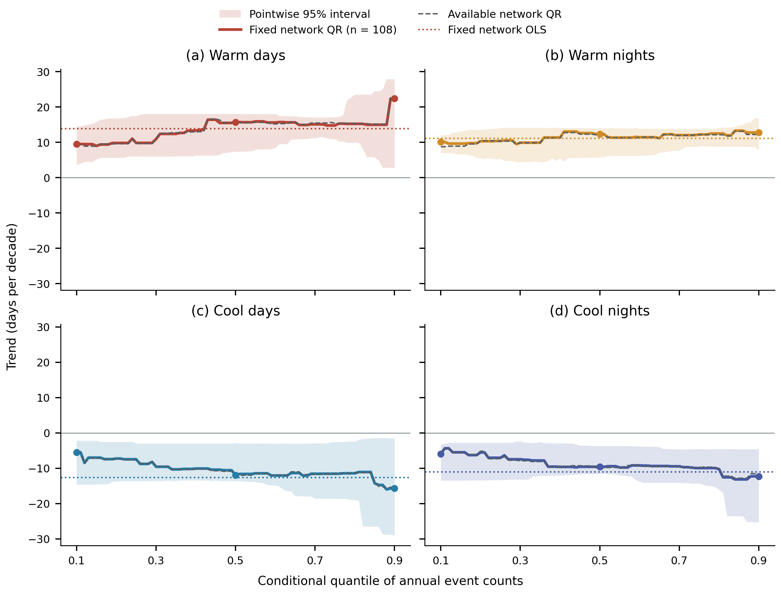
Figure 2. Quantile slopes of annual mean counts on the common 108-station network (solid colored lines), with pointwise 95% percentile bands from 4,999 synchronized circular year-pairs block replicates of length four. Colored dotted lines show fixed-network OLS slopes; gray dashed curves show the annually available network for comparison. Points identify q10, q50 and q90. Shading quantifies uncertainty in the network slope, not between-station spread or simultaneous coverage across quantiles. The response is an annual count, not daily temperature intensity. Contrast uncertainty is calculated from paired replicates and reported separately in Table 1 and Table S10.
Table 1. Thermal trends and paired upper-minus-lower contrasts on the common 108-station network.
Index | OLS [95% interval] | q10 [95% interval] | q50 [95% interval] | q90 [95% interval] | Δ₁ [95% interval]
Warm days | 13.95 [8.64, 17.08] | 9.52 [3.56, 14.55] | 15.72 [7.34, 18.04] | 22.37 [2.81, 27.90] | 12.85 [-5.76, 19.66]
Warm nights | 11.14 [8.09, 12.92] | 10.07 [6.94, 11.97] | 12.34 [5.76, 14.03] | 12.78 [7.87, 16.91] | 2.71 [-2.24, 7.00]
Cool days | -12.61 [-18.39, -4.55] | -5.45 [-14.62, -2.18] | -11.95 [-13.62, -2.83] | -15.70 [-29.00, -1.56] | -10.24 [-22.23, 3.28]
Cool nights | -10.97 [-15.73, -4.55] | -5.91 [-13.47, -3.24] | -9.60 [-11.50, -3.67] | -12.27 [-25.24, -4.57] | -6.37 [-19.30, 3.11]
All coefficients and intervals are in days decade⁻¹. Brackets contain pointwise 95% intervals from 4,999 synchronized four-year block replicates. Δ₁ = q90 slope − q10 slope, calculated before rounding within each replicate. The four Δ₁ intervals include zero; the wider six-contrast family intervals are provided in Table S10. Historical local station FDR screening is a different estimand and appears in Table S5.
The apparent quantile ordering was not resolved as a nonzero network asymmetry. Warm-day Δ₁ was 12.85 [−5.76, 19.66] days decade⁻¹, compared with 2.71 [−2.24, 7.00] for warm nights; cool-day and cool-night values were −10.24 [−22.23, 3.28] and −6.37 [−19.30, 3.11]. The paired warm-day minus warm-night asymmetry was 10.14 [−5.99, 14.24], and the signed cool-day minus cool-night contrast was −3.88 [−8.05, 5.09] days decade⁻¹. All six pointwise and family intervals included zero (Table S10). The evidence therefore supports directional thermal change more strongly than unequal quantile slopes or a day–night difference in asymmetry; inclusion of zero does not establish equality.
Changing station membership had a small effect on the point profiles relative to these interval widths. Available-network Δ₁ estimates were 13.06, 3.47, −9.77 and −6.16 days decade⁻¹, versus 12.85, 2.71, −10.24 and −6.37 on the common subset (Table S9; Fig. S12). Index-specific fixed networks gave similar point patterns. The coverage-equivalent diagnostic retained the signs, with Δ₁ of 12.92, 2.74, −10.37 and −7.34; it addresses a different, assumption-dependent annualized count. Two- and six-year blocks also left all six asymmetry contrasts unresolved (Fig. S13). Omitting individual years yielded warm-day Δ₁ from 2.32 to 13.39 days decade⁻¹ (Table S11), illustrating sensitivity in magnitude despite stable point-estimate signs.

3.2. Spatial heterogeneity and index-construction sensitivity
Station asymmetry maps retain the full 124-station archive and show substantial variation in point-estimate magnitude (Fig. 3); their station-level estimand differs from the fixed-network regressions in Section 3.1. Positive warm-day Δ₁ occurred at 118 stations and negative cool-day Δ₁ at all 124. The maps retain individual-station values; they do not imply a continuous trend surface. Historical Moran diagnostics gave the most consistent spatial organization for cool-day slopes, while clustering was sensitive enough to remain a supplementary description.
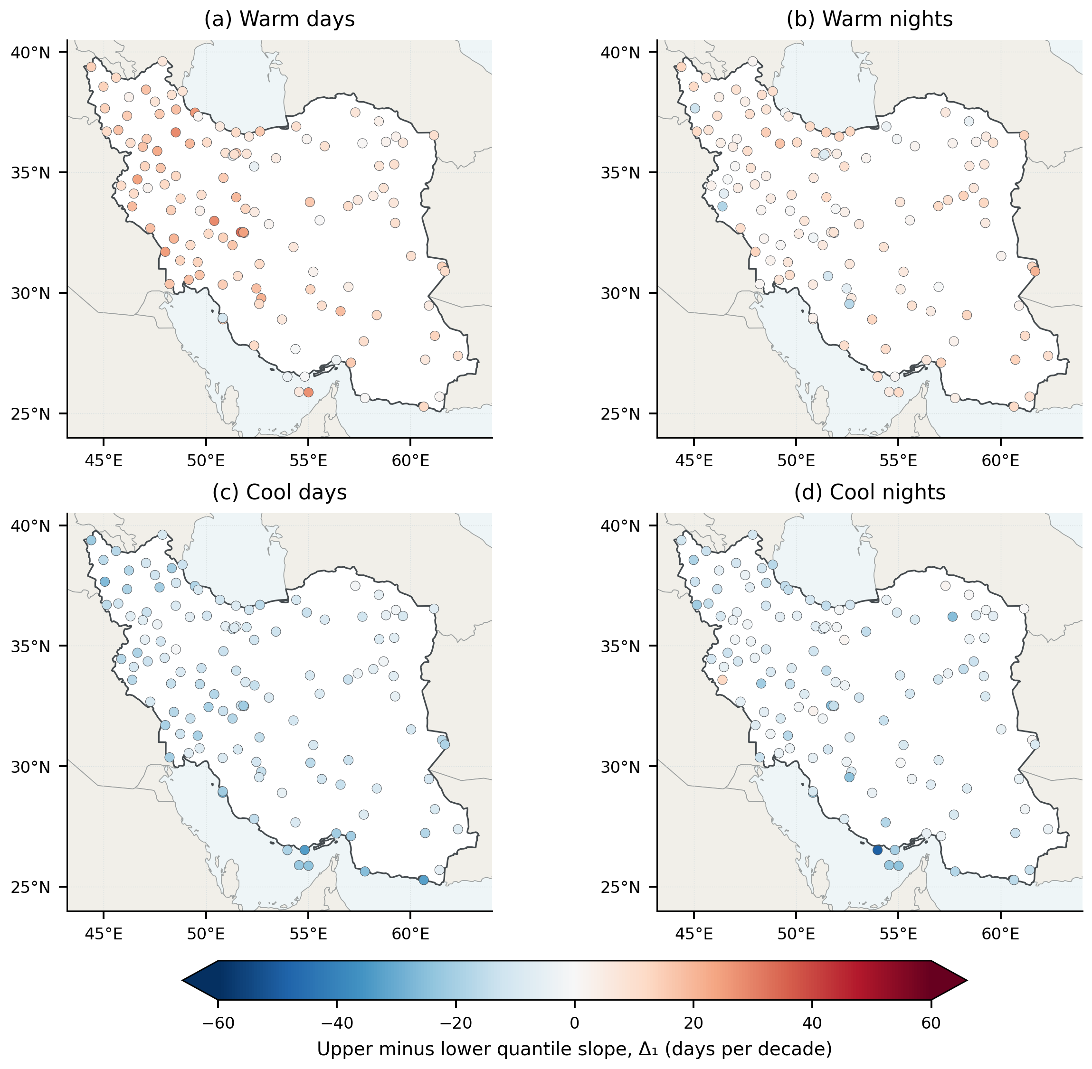
Figure 3. Station-specific Δ₁ for the four annual thermal indices. All panels use the same zero-centered color scale in days decade⁻¹. Positive values indicate a larger upper-quantile slope; negative values indicate a more negative upper-quantile slope. Colors encode point estimates without local significance claims or spatial interpolation.
Index construction affected the magnitude of fixed-reference period changes while preserving their warming-consistent directions (Fig. 4; Tables S12–S13). On the same 108 stations, uncorrected 11-day/type-7 thresholds gave +37.17 warm days and +29.26 warm nights per year in 2008–2024 relative to 1991–2007. In-base correction reduced these differences to +32.71 and +25.94: reductions of 4.46 and 3.32 days per year. Cool-day and cool-night differences became more negative, from −10.78/−8.24 to −14.93/−12.13. The correction changes the baseline counts while leaving the late-period counts unchanged. Earlier 124-station uncorrected estimates of +36.78/+28.41 concern a different population and are not used to quantify the correction effect.
Using corrected 5-day/type-7 thresholds gave +33.43/+26.46 warm days/nights per year; switching that construction to type 8 gave +32.64/+25.71. Valid-day percentages retained the same directions: corrected 11-day/type-7 differences were +8.95, +6.97, −4.15 and −3.55 percentage points for warm days, warm nights, cool days and cool nights. A full-record reference gave different count changes (+23.00/+18.04 for the historical 11-day construction), underscoring that reference climate is part of the estimand. These comparisons use identical stations and daily observation masks; they are not independent observations of the signal.
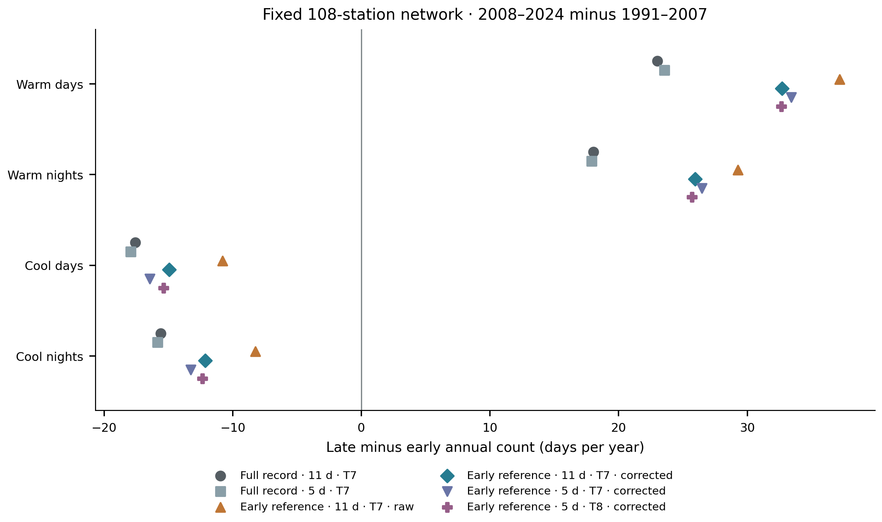
Figure 4. Equal-station mean annual-count differences between 2008–2024 and 1991–2007 on the same 108 stations under six index constructions. Full record denotes the 1991–2024 reference and early reference denotes 1991–2007; 5 d and 11 d are total calendar-day window widths. T7 and T8 denote linear and median-unbiased sample quantiles. Corrected variants average in-base target-year counts over 16 donor-year replacements; out-of-base thresholds are unchanged. Symbols are sensitivity point estimates, not independent replications or confidence intervals. Table S13 also reports changes in percentages of valid days and conditional trend uncertainty.
The unresolved-asymmetry conclusion was also retained: every Δ₁ sensitivity interval included zero (Fig. S14). For example, corrected 11-day/type-7 warm-day Δ₁ was 10.29 [−10.11, 22.69] days decade⁻¹, compared with 12.85 [−5.76, 19.66] for the historical full-record construction. Thus, the stable directional count change does not establish a precise invariant magnitude or a detected distributional asymmetry. Supplementary Figures S1–S8 retain the historical quality, spatial and clustering diagnostics with their original scope.
Historical available-network checks provide additional descriptive sensitivities (Fig. S2); they are not reanalyses of the primary common 108-station network. Excluding 39 detrended-homogeneity-flagged stations changed network Δ₁ from 13.06 to 13.05 days decade⁻¹ for warm days and from 3.47 to 3.45 for warm nights; cool-day and cool-night contrasts changed from −9.77 to −10.39 and from −6.16 to −4.87. Masking inconsistent temperatures changed the focal network slopes by at most 0.026 days decade⁻¹. Bootstrap means were stable when increasing replication from 200 to 400, although upper-quantile results were more sensitive to the resampling method. These historical station summaries do not test the new network-level contrasts; their uncertainty is evaluated directly in Section 3.1.

3.3. Climate regimes organize the spatial contrasts
All six climate groups had positive mean upper-quantile warm-day and warm-night slopes and negative mean cool-day and cool-night slopes (Fig. 5; Table 2). In these historical full-reference station estimates, the strongest mean upper-quantile warm-day trends occurred in BSh hot steppe (23.85 days decade⁻¹) and Dsa cold dry-summer settings (22.23), whereas BWh hot desert had a smaller warm-day slope (15.84) but the largest warm-night slope (16.64). Thus, the descriptive network-wide daytime point contrast did not describe every climate setting: hot-desert stations exhibited comparatively strong nighttime change.
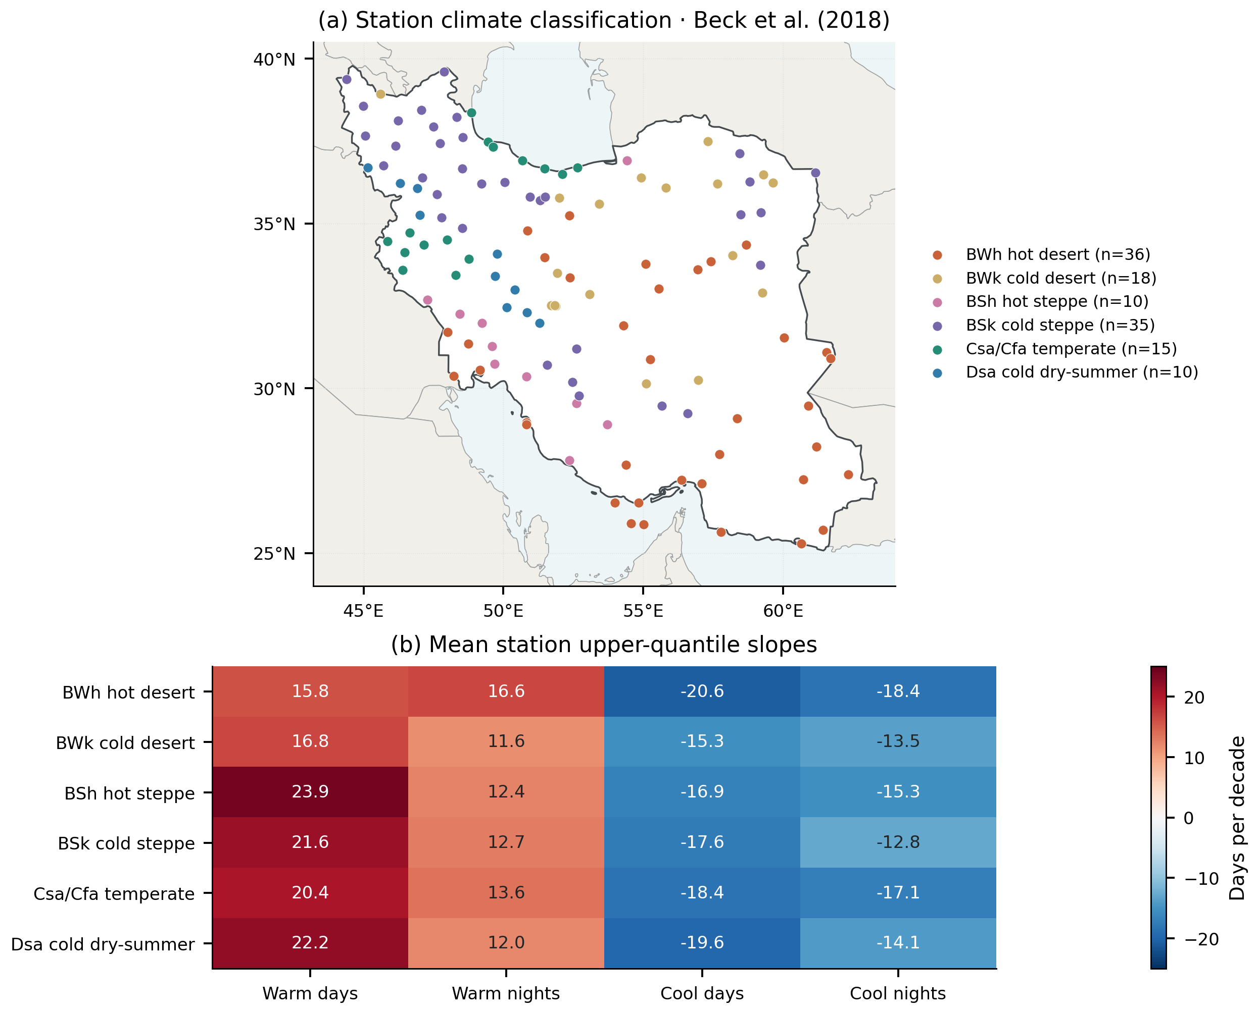
Figure 5. (a) Station membership in six fixed Köppen–Geiger reporting groups, using the Beck et al. (2018) 1980–2016 climate raster. The 15-station temperate group pools Csa and Cfa for reporting. (b) Group means of station-specific 0.90-quantile slopes for annual thermal-event counts, with a common zero-centered scale. These are descriptive means, not slopes fitted to group-average series, classification-change estimates, or proof of between-group significance.
Table 2. Climate-regime composition and mean station upper-quantile thermal slopes.
Regime | N | Mean elevation (m) | Warm days | Warm nights | Cool days | Cool nights
BWh hot desert | 36 | 575.05 | 15.84 | 16.64 | -20.59 | -18.36
BWk cold desert | 18 | 1401.71 | 16.75 | 11.62 | -15.28 | -13.48
BSh hot steppe | 10 | 495.39 | 23.85 | 12.36 | -16.85 | -15.34
BSk cold steppe | 35 | 1442.13 | 21.62 | 12.72 | -17.56 | -12.82
Csa/Cfa temperate | 15 | 671.57 | 20.44 | 13.64 | -18.37 | -17.09
Dsa cold dry-summer | 10 | 1917.11 | 22.23 | 11.99 | -19.62 | -14.09
Elevation is the group mean in meters; all four slopes are in days decade⁻¹. Station counts refer to the complete thermal network. Compound analyses use smaller balanced subsets (Table 4). These summaries do not identify the climatic cause of a trend.
BWh stations also had the most negative mean upper-quantile cool-day slope (−20.59 days decade⁻¹), compared with −15.28 in BWk cold desert. These contrasts describe the data but are less decisive inferentially: no time-trend or fixed-baseline regime statistic survived FDR across the historical 32-metric family. The two retained statistics (q = 0.048 each) concerned thermal-index responses to the internally derived regional temperature anomaly, not trends per decade. Consequently, the climate classification improves geographical interpretation without establishing six statistically distinct trend populations.

3.4. Explicit dry–hot concurrence increased on stable station sets
With both marginal thresholds required, annual dry–hot frequency increased from 9.16% to 29.81% between periods, a change of 20.64 percentage points across 104 stations (95% interval 9.22–40.84). June–September frequency increased from 5.54% to 18.39%, or 12.85 percentage points across 103 stations (7.20–27.18; Fig. 6). The wider primary-family intervals also remained above zero. These frequencies describe equal-weight station networks, not percentages of Iranian land area.
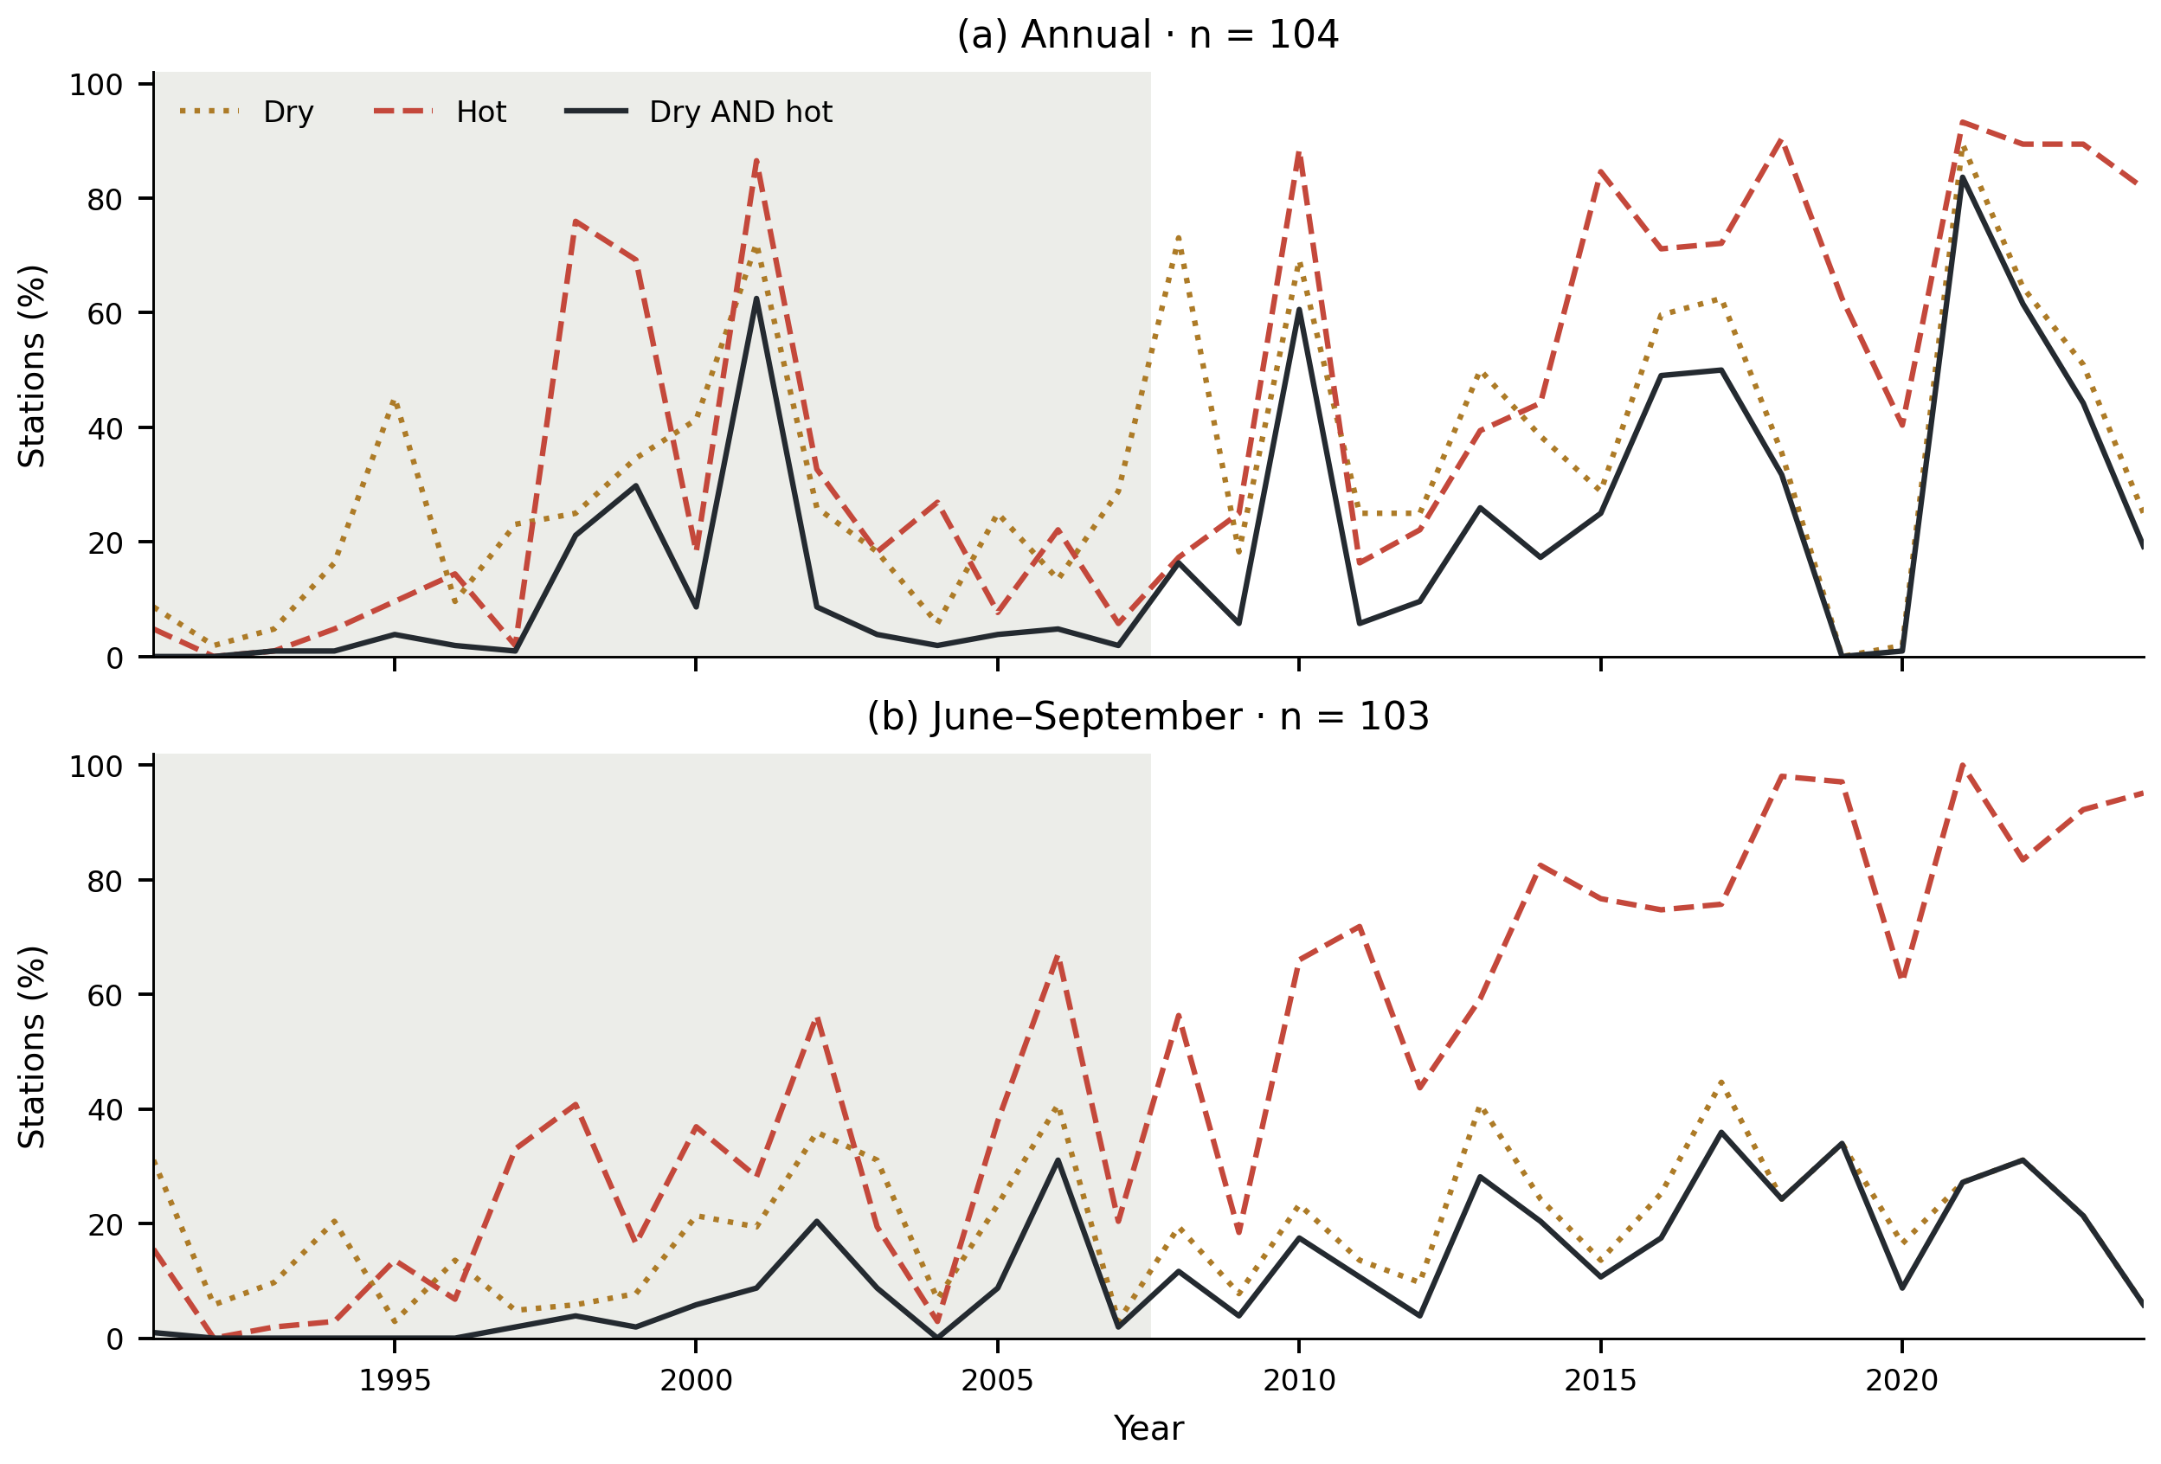
Figure 6. Percentage of balanced-network stations classified as dry, hot, or simultaneously dry AND hot in each year. Annual and June–September definitions use separate station sets and their own fixed 1991–2007 precipitation and temperature quartiles. Shading identifies the baseline period. Strict inequalities are used; joint-event extent cannot exceed either marginal extent. Counts are based on screened daily observations and calendar-day coverage.
Summer dryness classification was constrained by precipitation zeros: 28 of the 103 stations had a baseline lower quartile of zero. Such stations cannot satisfy the strict dry inequality and contribute zero joint frequency in the primary classification. No annual station had a zero lower quartile. Sensitivities changing the tie convention and station inclusion are therefore necessary for interpreting the seasonal difference; the primary annual and summer magnitudes should not be read as a controlled comparison of identical event populations.

3.5. The hot-frequency term accounts for most of the summer point change
The exact partition attributes the summer point difference to +2.89 percentage points in the dry-frequency term, +9.91 in the hot-frequency term, and +0.06 in the excess-joint term (Fig. 7; Table 3). The corresponding annual components were +8.18, +12.48, and −0.02 percentage points. These components sum to the observed joint changes before rounding. The hot-frequency term had the larger point estimate under both definitions, but the overlapping component intervals do not by themselves constitute a paired test that it exceeds the dry-frequency term.
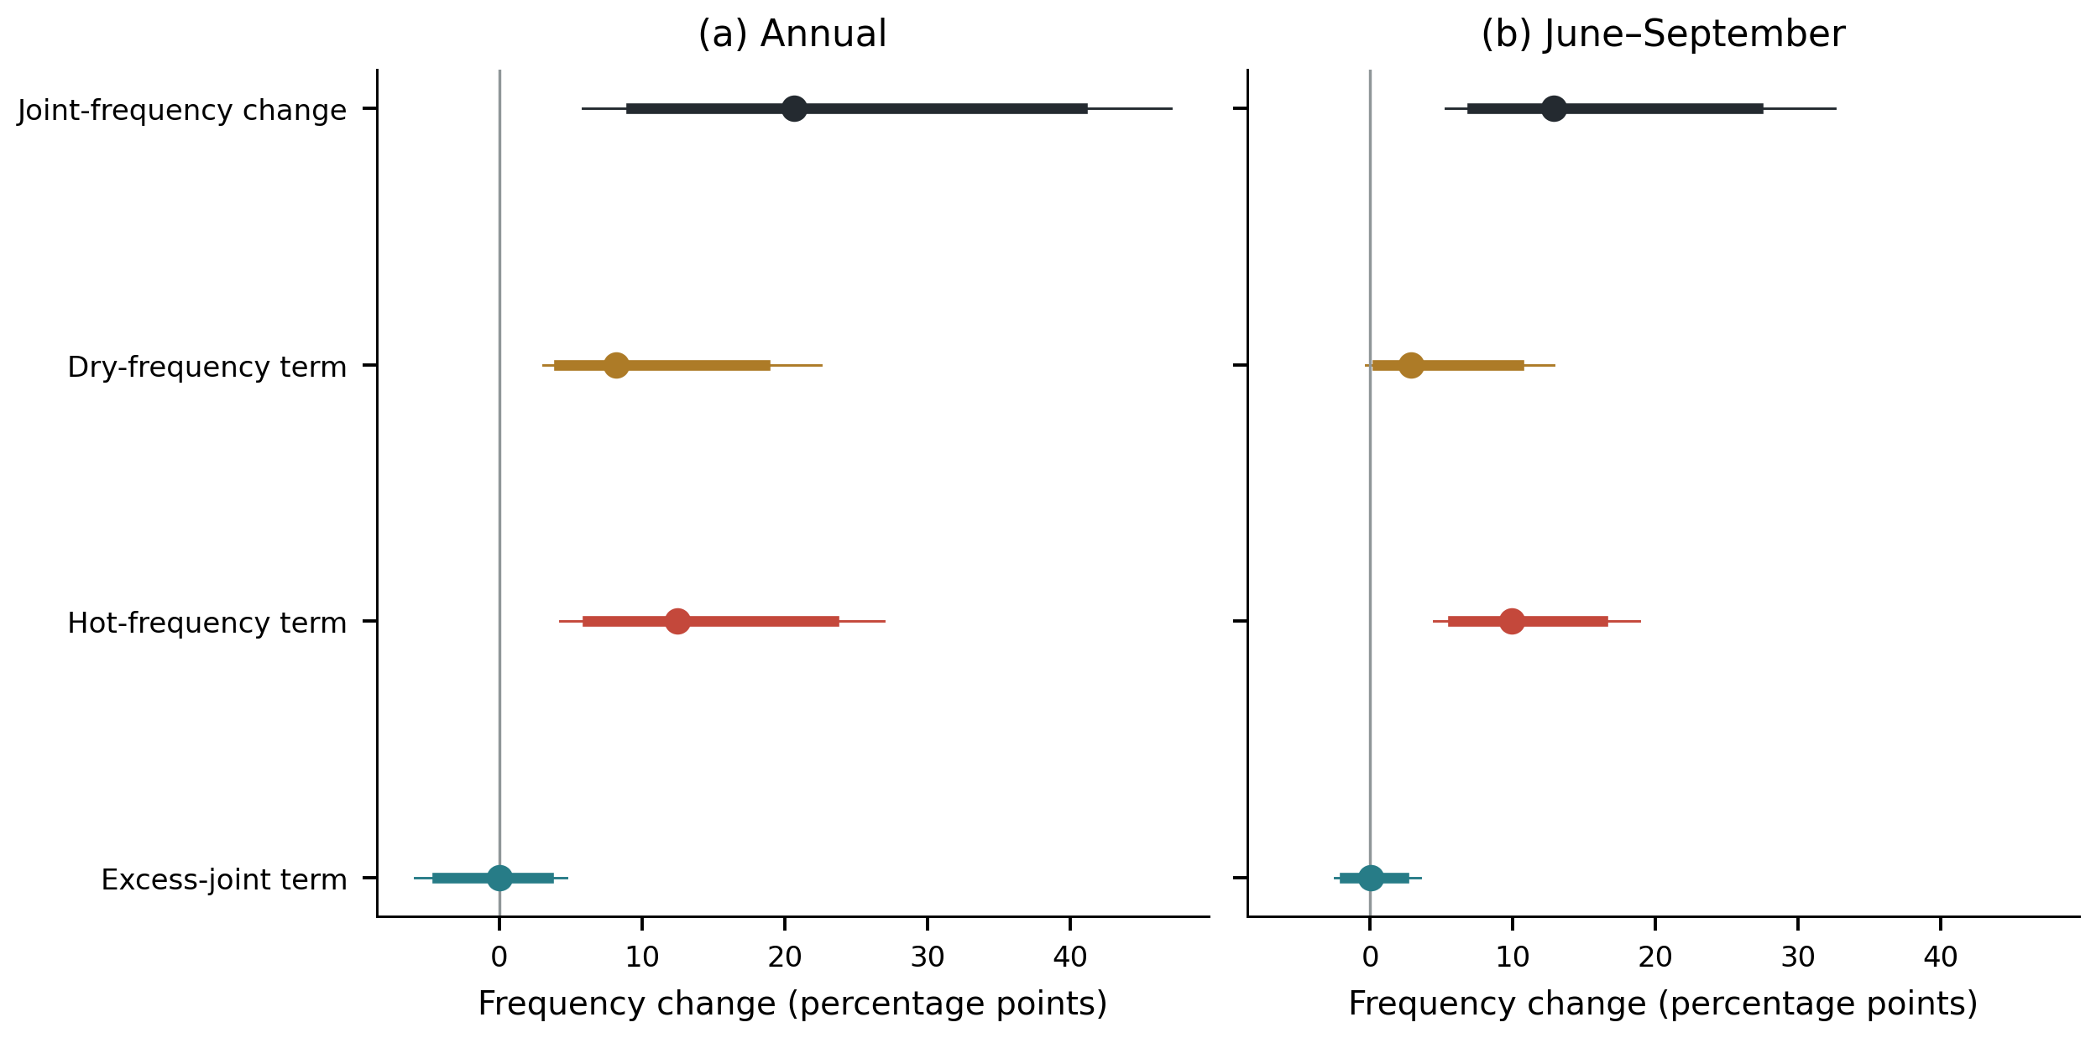
Figure 7. Partition of the late-minus-early joint-frequency difference. Points are equal-station estimates; thick intervals are 95% percentile intervals and thin intervals are nominal Bonferroni intervals across eight primary quantities. The 4,999 synchronized circular year-block replicates re-estimate baseline thresholds. The three colored component estimates sum exactly to the total change. The excess-joint term is a covariance difference between binary indicators, not a causal or copula-isolated contribution.
Table 3. Compound-frequency differences and partition terms, in percentage points.
Definition | Stations | Joint change [95% interval] | Dry-frequency term [95% interval] | Hot-frequency term [95% interval] | Excess-joint term [95% interval]
Annual | 104 | 20.64 [9.22, 40.84] | 8.18 [4.18, 18.61] | 12.48 [6.16, 23.44] | −0.02 [−4.35, 3.42]
June–September | 103 | 12.85 [7.20, 27.18] | 2.89 [0.53, 10.43] | 9.91 [5.79, 16.29] | 0.06 [−1.79, 2.37]
Intervals include baseline-threshold re-estimation and synchronized resampling within each period. The wider nominal primary-family intervals are archived in compound_partition_primary.csv and drawn in Fig. 7. In particular, the summer dry-frequency term does not exclude zero under that wider interval. No component is interpreted as a physical attribution fraction.
The excess-joint intervals included zero under both definitions, providing no resolved network-wide change in this term. This differs from claiming that temperature and precipitation are independent, or that their dependence structure is unchanged. Station components varied spatially (Fig. 8), while the network average could conceal compensating local patterns. These short station records do not justify local significance claims from inspection of the mapped colors.
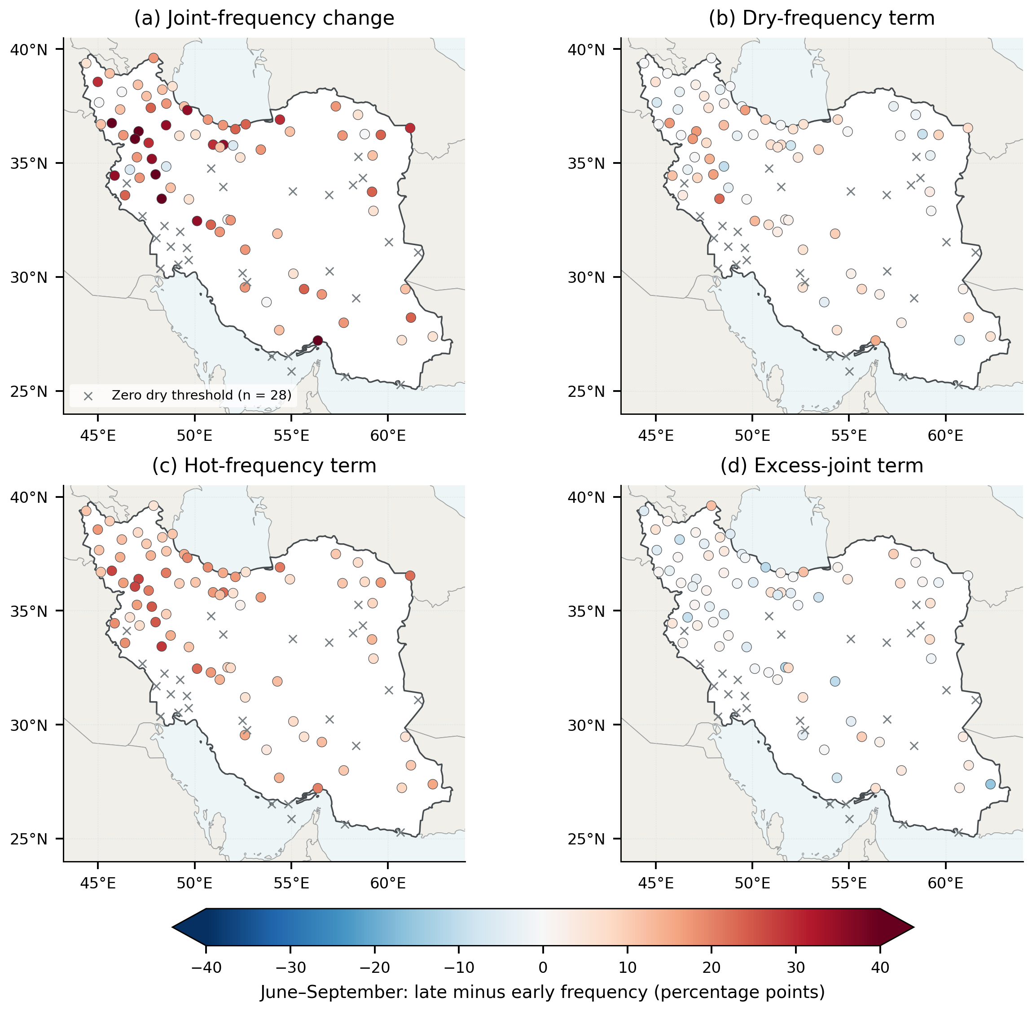
Figure 8. June–September station estimates of the joint-frequency difference and its three partition terms for the 103-station balanced network. All panels share a symmetric color scale in percentage points. Gray crosses identify the 28 stations with zero baseline precipitation thresholds, which cannot satisfy the strict dry definition; their zero-valued contributions are retained in network means. Colored circles show the remaining station estimates without interpolation or significance symbols. Threshold values and flags are supplied in the station table.

3.6. Compound-frequency changes within climate regimes
The annual joint-frequency point difference was positive in every climate group, ranging from 16.86 percentage points in the temperate group to 36.13 in BSh hot steppe (Fig. 9). Summer point differences ranged from 5.20 in BWh hot desert to 21.32 in Dsa cold dry-summer settings; the temperate and BSk cold-steppe groups had changes of 20.78 and 16.22 percentage points, respectively (Table 4). These patterns extend the climate-regime interpretation from individual thermal indices to explicit compound concurrence.
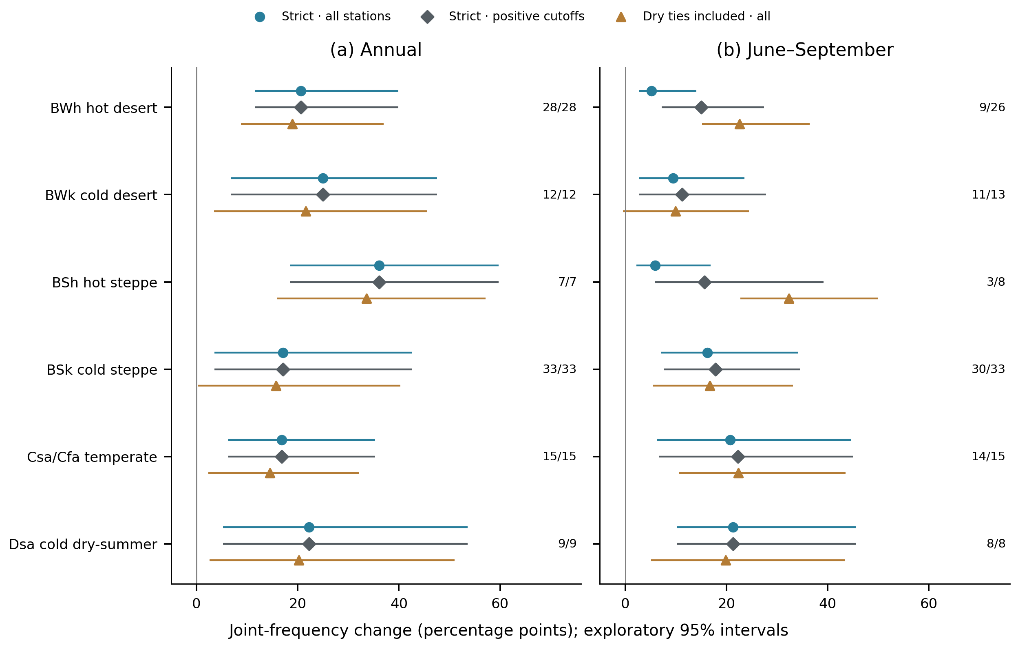
Figure 9. Climate-regime joint-frequency changes under strict rules on all original balanced stations, strict rules on the observed-positive-cutoff subset, and dry-inclusive rules on all original stations. The hot condition remains strict in all three displayed comparisons. Numbers give positive-cutoff/all station counts. Points and exploratory 95% intervals use synchronized four-year blocks with threshold refitting; observed strata remain fixed. The larger positive-subset point estimate is algebraic reweighting, not independent robustness evidence. Within-group intervals are not tests comparing climate groups. Both-inclusive results and paired rule effects are in Table S14 and Fig. S15.
Table 4. Summer compound-frequency change and its components by climate regime.
Regime | N | N₀ | Joint change [95% interval] | Dry-frequency term | Hot-frequency term | Excess-joint term
BWh hot desert | 26 | 17 | 5.20 [2.71, 14.03] | 1.87 | 3.85 | -0.52
BWk cold desert | 13 | 2 | 9.50 [2.69, 23.53] | 1.06 | 8.54 | -0.11
BSh hot steppe | 8 | 5 | 5.88 [2.21, 16.91] | 1.08 | 5.06 | -0.26
BSk cold steppe | 33 | 3 | 16.22 [7.13, 34.22] | 2.78 | 12.46 | 0.99
Csa/Cfa temperate | 15 | 1 | 20.78 [6.27, 44.71] | 6.32 | 14.74 | -0.28
Dsa cold dry-summer | 8 | 0 | 21.32 [10.29, 45.59] | 4.95 | 17.06 | -0.69
All changes and components are percentage points. N₀ denotes stations with zero baseline precipitation quartiles. The joint-change interval is an exploratory 95% within-group interval. Component point estimates sum to the joint change before rounding; complete intervals for every component and both seasons are in the supplementary tables.
The hot-frequency point term exceeded the dry-frequency term in all six summer groups, while every group-specific excess-joint interval included zero. However, lower summer changes in hot-arid groups partly reflect the strict precipitation definition: zero dry thresholds occurred at 17 of 26 balanced BWh stations and five of eight BSh stations, compared with none of the eight Dsa stations. Under the strict rule, removing these structural zeros changes BWh from 5.20 to 15.03 percentage points (9/26 stations) and BSh from 5.88 to 15.69 (3/8); Dsa remains 21.32 (8/8). These are exactly the corresponding changes of denominator. On the original station sets, including dry ties only instead gives 22.62 for BWh, 32.35 for BSh and 19.85 for Dsa (Fig. 9; Table S14). The resulting change in point ordering is definition-driven and cannot rank absolute heat exposure or drought hazard. Small groups, especially the three-station positive-cutoff BSh subset, and broad intervals further limit ranking the regimes.

3.7. Numerical sensitivity, structural-zero dilution and tie effects
The evaluated scenarios retained positive network joint-frequency point changes under both definitions (Fig. 10), but they assess different questions and are not independent evidence of robustness. Using the 20th/80th or 30th/70th percentile thresholds changed the annual estimate to 17.76 or 20.36 percentage points and the summer estimate to 10.97 or 14.45. Raising daily coverage to 90% retained 86 annual and 101 summer stations and yielded changes of 22.09 and 12.93 percentage points. Two- and six-year blocks altered interval endpoints without changing the observed point estimates.
Threshold uncertainty materially widened some intervals. Holding thresholds fixed gave a summer interval of 6.17–19.59 percentage points, compared with 7.20–27.18 when thresholds were re-estimated. The common 101-station network gave annual and summer changes of 20.62 and 13.10 percentage points. These checks describe the sensitivity of magnitude and precision to specific analysis choices.
Zero-cutoff exclusion has a different interpretation. The 28 summer zero-cutoff stations contribute exactly zero under the observed strict thresholds, giving the point identity 12.849800 = (75/103) × 17.647059. Consequently, the increase from 12.85 to 17.65 after their exclusion supplies no additional evidence that the underlying signal is robust. The identity holds within each climate group and for all partition components (Table S14). With fixed cutoffs it also holds in every bootstrap replicate. With threshold refitting, the observed-zero subgroup has a zero point change but a 95% interval of −0.21 to 11.55 percentage points: some resampled precipitation cutoffs become positive. The refitted full-network interval therefore cannot be obtained by multiplying the positive-subset interval by 75/103.
Tie effects were evaluated on identical station sets. Including precipitation equality alone changed the summer estimate from 12.85 to 19.65 percentage points; subsequently including temperature equality changed it to 17.36. The paired dry-equality effect was +6.80 [3.03, 9.82] percentage points, while the additional hot-equality point effect was −2.28 (Fig. S15). These are exploratory definition effects, not physical changes between datasets. In particular, including dry equality at zero reclassifies zero-precipitation seasons; it does not detect seasons below a zero baseline. Some discrete paired bootstrap distributions are shifted relative to their observed estimates, so their percentile intervals are reported as conditional diagnostics rather than calibrated confirmatory tests. Table S14 separates these effects from changing the station population.
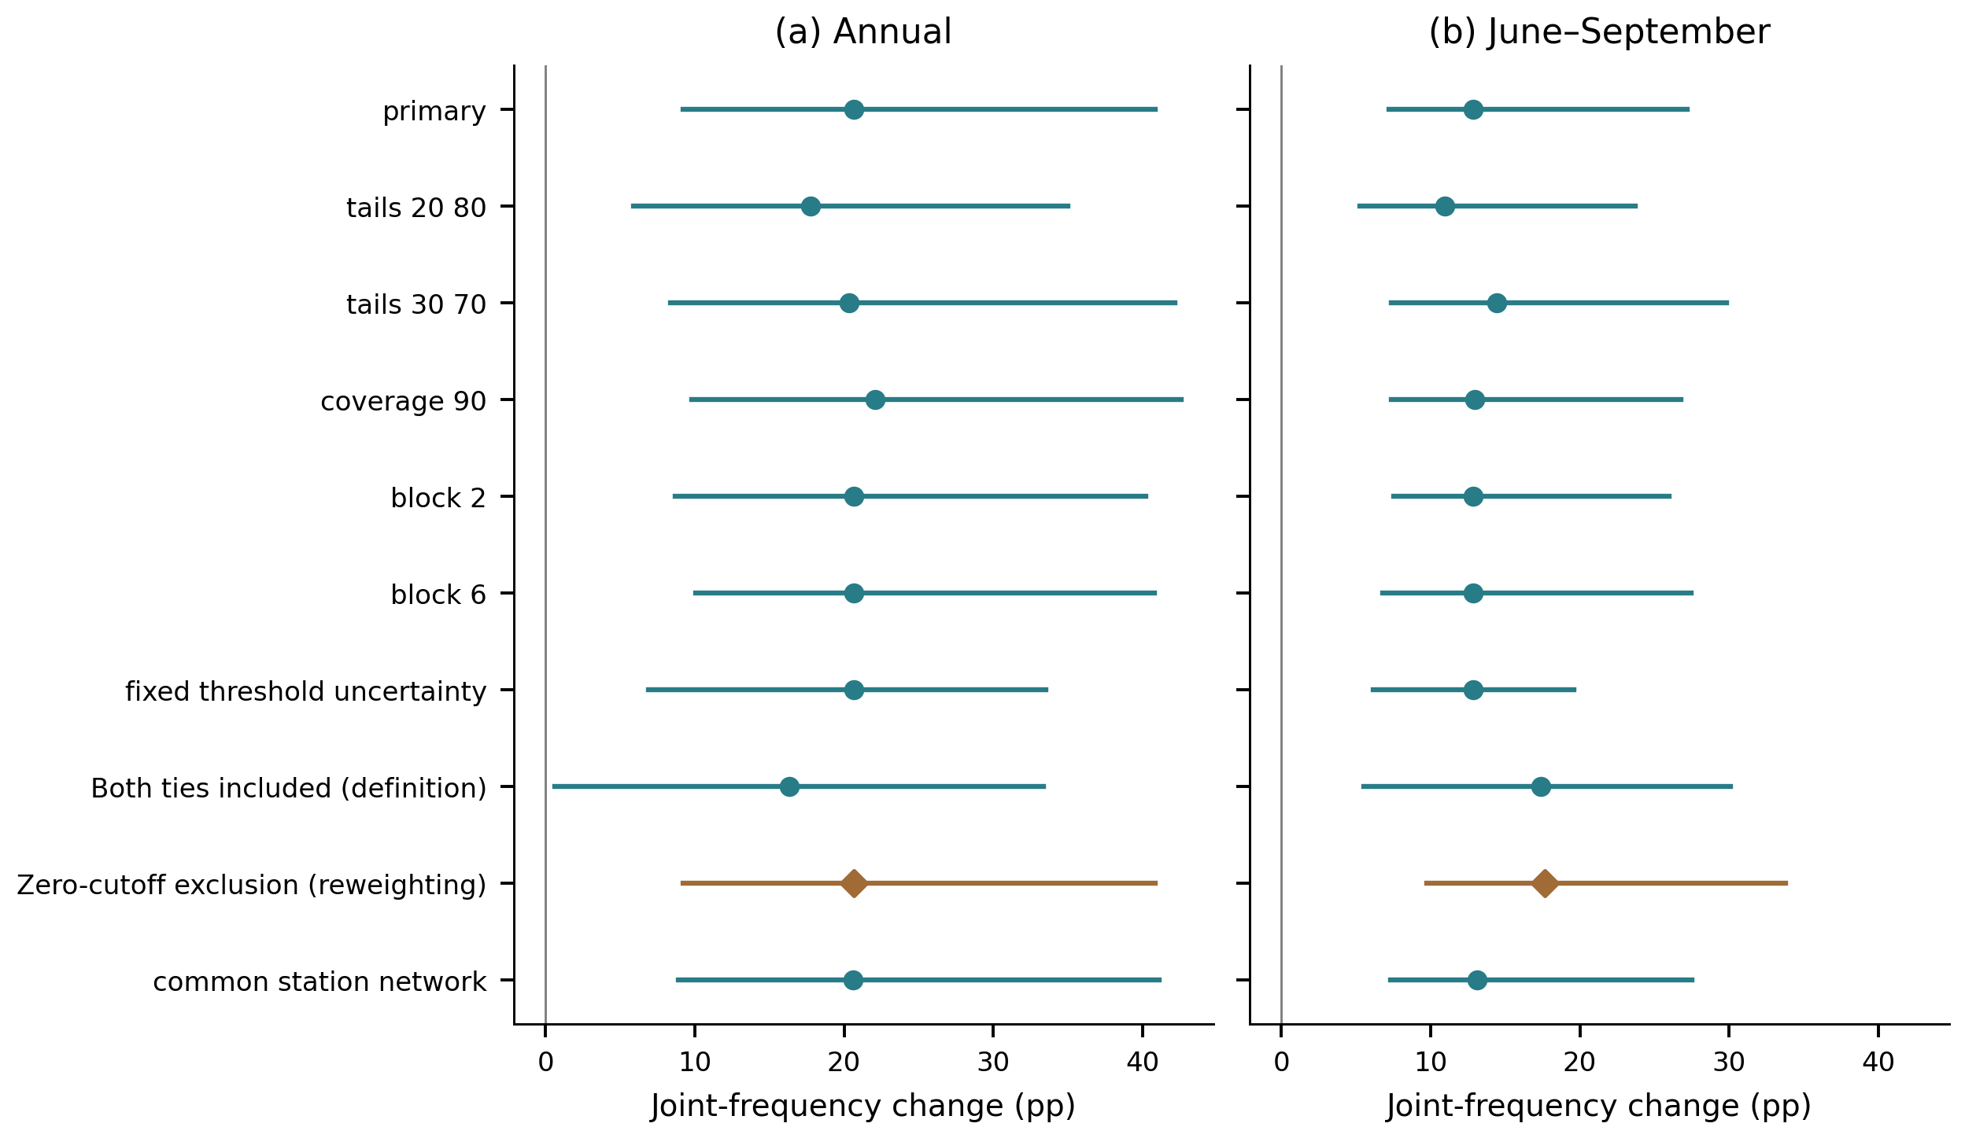
Figure 10. Joint-frequency changes and exploratory 95% synchronized-block intervals under ten scenarios. Block length and threshold refitting assess numerical uncertainty; threshold, tie and coverage/network choices change the estimand. Zero-cutoff exclusion, marked by a diamond, is algebraic reweighting of the observed strict point estimate and supplies no independent robustness evidence. Its refitted-threshold interval is not a scaled copy of the full-network interval. The historical inclusive-ties scenario changes both precipitation and temperature equality; their separate paired effects are shown in Fig. S15.

4. Discussion

4.1. Thermal changes in relation to earlier observational studies
The thermal and compound analyses describe related but distinct aspects of recent change. On the fixed network, annual warm-day point slopes were larger at the upper than lower quantile, but the paired interval for their difference included zero. This pattern is consistent with the motivation for quantile analysis in Barbosa et al. (2011) and Fan (2014): reporting only OLS or median trends can conceal potential differences between high- and low-count years. Here, explicit contrast intervals prevent that motivation from being mistaken for a detected change in distributional shape. It does not mean that the annual quantile itself has become more probable; a fixed conditional quantile retains its probability definition while its count value changes with time.
Fan (2014) offers a particularly useful comparison because both studies model annual extreme-temperature counts. Across 549 Chinese stations during 1960–2008, the reported national warm-night slopes were 4.63, 8.15, and 8.83 days decade⁻¹ at the 0.10, 0.50, and 0.90 quantiles. Our corresponding fixed-network estimates are 10.07, 12.34, and 12.78 days decade⁻¹ (Table 1). Both point profiles are ordered toward larger upper-quantile slopes, although our warm-night slope contrast remains unresolved. A more distinct difference concerns cool days: Fan reported little evidence of change at the lower and upper quantiles, with slopes of +0.19 and +0.07 days decade⁻¹, whereas our corresponding point estimates are −5.45 and −15.70. The Iranian pattern therefore includes declining cool-day counts at both focal tails and a more negative upper-tail point slope, extending beyond agreement on increasing warm events; the difference between our two tail slopes is not statistically resolved. Our controlled index sensitivities also show that the magnitude of thermal change depends on percentile construction and reference period (Table S13). Cross-study differences cannot establish regional climate sensitivity or acceleration without harmonizing these choices, station weighting and preprocessing. Fan used a 1961–1990 reference and homogenized records, whereas our primary count thresholds use 1991–2024 and our daily archive has not undergone metadata-supported homogenization. Barbosa et al. (2011) analyzed daily mean temperature itself; their temperature-unit slopes provide a conceptual precedent for distributional heterogeneity.
Within Iran, Soltani et al. (2016) examined 50 stations over 1975–2010 and reported warm-day and warm-night increases of 12 and 14 days decade⁻¹ for the 1995–2010 subperiod, alongside decreases of 4 and 3 days decade⁻¹ in cold days and nights. Our historical full-reference 1991–2024 OLS estimates are 13.95, 11.14, −12.61, and −10.97 days decade⁻¹, respectively. The common directions support consistency in the broad thermal signal, while the day–night ordering and cooling-index magnitudes differ. These are comparisons across different periods and index implementations, not formal evidence of acceleration or a reversal of physical controls.
The more recent Iranian analysis of Ghasemi (2026) used 78 stations with monthly records spanning 1955–2024 and reported warming of 0.54 °C decade⁻¹ at the cold minimum-temperature tail and 0.34 °C decade⁻¹ at the hot maximum-temperature tail. That stronger cold-tail temperature change does not contradict our larger warm-day point contrast, whose day–night difference remains unresolved: monthly temperature quantiles and quantiles of annual threshold-exceedance counts measure different responses. A small temperature shift can produce a large count change where many daily observations lie near the threshold. This precedent also narrows our contribution: applying quantile regression in Iran is already established; linking annual count distributions, explicit compound occurrence, and climate-stratified component estimates is the focus here.
Table 5. Prior findings, present evidence and the specific contribution relative to each study.
Study | Prior scope and finding | Present evidence and added value | Interpretation of the comparison
Barbosa et al. (2011) | Daily-temperature quantile trends and clustering in Central Europe | Annual thermal-count profiles are evaluated alongside explicit precipitation–temperature concurrence in Iran (Figs. 2, 6–7). | Extension of the scientific question; quantile regression and clustering are established methods. Temperature and count slopes have different units.
Fan (2014) | Chinese annual counts, 1960–2008: warm nights increase; cool-day q10/q90 slopes are +0.19/+0.07 days decade⁻¹, without clear tail trends. | Iranian fixed-network cool-day q10/q90 slopes are −5.45/−15.70 days decade⁻¹; warm-night slopes also increase (Table 1). | Agreement for warm nights; a different cool-day tail pattern. Periods, baselines and homogenization differ; no formal between-study test.
Soltani et al. (2016) | Iranian warm-day/warm-night increases of 12/14 days decade⁻¹ in 1995–2010 | Fixed-network OLS count slopes are 13.95/11.14 days decade⁻¹ for 1991–2024; quantile contrasts add distributional detail (Table 1). | Signs agree, but the day–night ordering differs. Unequal periods and index implementations preclude an acceleration claim.
Ghasemi (2026) | Iranian monthly temperature tails: cold Tmin changes by 0.54 and hot Tmax by 0.34 °C decade⁻¹. | Fixed-network Δ₁ point estimates are 12.85 for warm days and 2.71 for warm nights (days decade⁻¹); both intervals and their paired difference interval include zero (Tables 1, S10). | Complementary intensity and frequency responses; our point ordering is uncertain and does not establish a contradictory day–night response.
Alizadeh et al. (2020) | US joint-rarity extent and event composition over 1896–2017 | Explicit AND-event increases are 20.64 annual and 12.85 summer percentage points on balanced Iranian networks; component intervals are reported (Table 3). | Qualitative agreement in increasing occurrence. Fixed marginal concurrence supplies a different event definition; magnitudes and spatial extent are not interchangeable.
Bevacqua et al. (2022) | Precipitation trends shape projected compound hot–dry occurrence in climate-model ensembles. | The observed summer hot-frequency point term is 9.91, versus 2.89 percentage points for the dry-frequency term (Table 3). | Different experimental setting and decomposition; the component ordering does not refute the projected precipitation result.
Schmutz et al. (2026) | ERA5 Europe/North Africa: marginal changes and copula dependence affect compound probabilities and their emergence. | Summer excess-joint change is 0.06 [−1.79, 2.37] percentage points; synchronized uncertainty accompanies a binary-frequency partition (Table 3). | An unresolved indicator-covariance change does not establish unchanged copula dependence or supply an emergence date.
Zhao and Xiong (2026) | CMIP6 probability-ratio decomposition separates temperature/precipitation means, variances and correlation. | Observed station-frequency differences are partitioned without fitting those distribution parameters; ties and baseline uncertainty are examined (Figs. 7, 10). | Related component question with a different estimand and model structure; no claim to invent probability decomposition.
Jamali et al. (2026) | Iranian climate-type transitions toward arid conditions in record-length subsets | Fixed classes expose zero-cutoff dilution: strict summer BWh change is 5.20 on 26 stations and 15.03 on the 9 positive-cutoff stations; dry-inclusive change on all 26 is 22.62 (Table S14). | Separates exact sample reweighting from paired definition effects; neither establishes climate-zone migration or ranks absolute hazard.
q10 and q90 denote conditional quantiles 0.10 and 0.90 of annual counts; Δ₁ is q90 minus q10 trend slope. Present estimates use 1991–2024 unless a period contrast is specified. Bracketed intervals are pointwise 95% synchronized-block intervals. Thermal network estimates use the common 108-station subset; day–night asymmetry differences remain unresolved. Numerical differences are descriptive comparisons of published estimates, not statistically established differences between regions or periods. Table 5 is a targeted comparison, not an exhaustive novelty search; source checks are documented in the reference audit.
Warm-night trends were also widespread. Their smaller point contrast suggests a possible difference from warm days, but the paired interval does not distinguish that contrast from zero. Temperature minima and maxima respond to radiation, moisture availability, boundary-layer processes, and circulation in different ways. Those processes provide hypotheses for subsequent work, not mechanisms identified by these regressions. The absence of humidity, soil moisture, radiation, or circulation observations prevents testing mechanisms for the suggested daytime–nighttime pattern. Annual event counts also do not resolve the duration, intensity, or persistence of individual heatwaves.
The fixed-threshold compound analysis adds a hydroclimatic condition: high seasonal or annual temperature must coincide with precipitation below a baseline cutoff. Its increase on balanced station sets indicates that changing data availability alone does not account for the estimated expansion. Yet the magnitudes remain conditional on the reference climate and observing locations. Relative quartile events are useful for comparing occurrence through time at each site; they are not equivalent to an absolute heat-stress threshold, a soil-moisture drought, or a societal impact.

4.2. More joint events do not require a resolved excess-joint increase
The summer partition identifies a large positive hot-frequency term and an excess-joint term close to zero at network scale. The interpretation is statistical: an increase in the marginal frequency of hot seasons can contribute substantially to more frequent dry–hot seasons without a detectable increase in excess concurrence beyond the marginal product. This is compatible with established compound-event theory, which distinguishes marginal changes from the dependence that joins them (Zscheischler and Seneviratne, 2017). The present binary partition is deliberately simpler than the full distributional decomposition in Schmutz et al. (2026); it does not estimate a copula or separate dependence changes from all marginal effects on indicator covariance.
The annual dry-frequency term was also positive, and the summer estimate should not lead to the general claim that precipitation is unimportant. Bevacqua et al. (2022) showed why precipitation change and internal variability can be central to compound-event occurrence. Differences in time scale, baseline, station population, and threshold position matter when comparing such findings. Here, the annual analysis integrates precipitation through the year, whereas the summer classification encounters frequent zero totals at the lower threshold. A smaller summer dry term can therefore reflect the statistical definition as well as the behavior of precipitation.
Zhao and Xiong (2026) further distinguish contributions from temperature and precipitation means, variances and their correlation in projected probability ratios. Our observed period-frequency difference answers a narrower question and does not identify those distributional contributions separately. Likewise, Schmutz et al. (2026) found that dependence could affect emergence timing even where it was not the leading probability-change component. Our unresolved excess-joint estimate cannot exclude such an effect. The added result here is a quantified increase in explicit concurrence with uncertainty on its station-frequency components, together with evidence of how precipitation ties constrain its interpretation in arid climate groups.
Alizadeh et al. (2020) provides the closest supplied precedent for examining changes in compound-event extent and composition. However, their much longer archive supports a different temporal perspective. The present 34-year record cannot supply stable estimates of rare return periods or distinguish recent change from all modes of multidecadal variability. The historical joint-rarity outputs are retained as complementary descriptive evidence, while the revised main analysis asks the more explicit question of how often both marginal thresholds were crossed. An apparent difference in relative annual and summer expansion between the two definitions is therefore informative about the estimand, rather than evidence that one set of calculations must be numerically wrong.
Specifically, Alizadeh et al. used United States climate divisions during 1896–2017, with October–September annual and March–August warm-season windows. Their increasing compound extent and greater heat contribution are qualitatively consistent with our growing joint occurrence and large summer hot-frequency term. However, their empirical joint-rarity classes are not our fixed marginal AND events, and their warm season is not June–September. A numerical ratio between the reported changes would combine differences in temporal aggregation, spatial support, record length, and event definition. The comparison supports the scientific relevance of separating event composition, while leaving the Iranian magnitudes conditional on this study's design.

4.3. What climate classification adds to the interpretation
The Köppen–Geiger grouping connects the station results to recognizable temperature–moisture environments. It is useful even when a formal difference between groups is not resolved: the joint-change estimates, sample sizes, and zero-precipitation thresholds can be inspected together rather than hidden inside one national mean. In summer, the relatively small BWh and BSh joint changes coexist with many structurally zero dry-event classifications. Conversely, larger point changes in temperate and Dsa groups describe departures from their own reference climates, not larger absolute aridity. The within-regime zero-stratum identities and matched-station tie comparisons quantify that interpretation problem: smaller strict-rule averages can reflect structural-zero dilution, while inclusive definitions can reverse point ordering. This is an accounting and classification effect, not evidence of a different physical response generated by excluding stations.
Jamali et al. (2026) analyzed 279 Iranian stations grouped by record availability and reported shifts toward arid types at 27% of long-record and 18% of mid-record stations. Their time-varying classifications address climate transitions, whereas our Beck et al. (2018) assignments hold the geographical stratification fixed. The results are complementary, but our maps cannot establish that stations crossed climate boundaries or attribute the observed compound-frequency components to aridification. Beck et al. (2023) provides updated historical classification periods that could support a future assignment-sensitivity analysis; that newer product was not substituted for the raster actually used here.
The current classification also has statistical limits. None of the 16 historical time-trend group comparisons survived the specified FDR family, and the new compound intervals are within-group uncertainty summaries rather than adjusted contrasts between groups. Sparse classes and spatial dependence limit the power and interpretation of regime rankings. The defensible result is heterogeneous point estimates within a common warming-consistent pattern, not a set of statistically distinct climate responses. Keeping the classification in the main analysis makes those limits visible and provides a reproducible basis for testing them with longer records.

4.4. Uncertainty and spatial interpretation
For thermal trends, retaining the same 108 stations removes changing membership from the primary estimand; it does not correct nonrandom missing days within valid years or make the subset area-representative. Paired year-field resampling quantifies uncertainty in the exact slope differences of interest. All asymmetry intervals include zero, including the day–night contrasts, so point ordering alone cannot establish stronger daytime asymmetry. The 34-year record offers limited tail information, and conditional percentile bands may be sensitive to nonstationarity and block choice.
For compound frequencies, resampling whole annual station fields is important because treating stations as independent replicates would overstate the information in a spatially coherent climate signal. Our synchronized blocks preserve the observed spatial arrangement within sampled years, and re-estimation of baseline thresholds acknowledges that those cutoffs were estimated from only 17 observations. The resulting intervals are appreciably wider than some conditional-threshold intervals. Their asymmetry also reflects discrete event counts and threshold variability; reporting only a bootstrap standard deviation would obscure this behavior.
The bootstrap nevertheless has limits. Four-year blocks leave few effective blocks in each period, and circular resampling treats the period boundary as adjacent for sampling purposes. Within-period trends challenge the approximate stationarity assumption. The Bonferroni intervals address multiplicity in the primary family only to the extent that the marginal bootstrap intervals have adequate coverage; they cannot correct the short record or make sensitivity analyses confirmatory. Failure to resolve an excess-joint change is consequently absence of clear evidence at this scale, rather than proof of stable dependence.
Point maps and equal-station summaries also describe a monitoring network rather than the whole land surface. Dense station clusters have more influence than sparsely sampled terrain of equal area. Spatially opposing components can cancel in network averages, while a small set of local colors cannot establish coherent regional change. The maps therefore use common scales and avoid interpolated surfaces or significance markers. Area-weighted products, independent gridded observations, and explicit spatial models would be needed to estimate physical affected area and formally evaluate regional contrasts.

4.5. Specific contribution, transferability, and next steps
Taken together, the comparisons in Table 5 identify an empirical and interpretive contribution. The cool-day tail pattern differs from Fan's reported Chinese pattern, while the warm-event direction agrees with earlier Iranian work. The compound analysis quantifies increased concurrence without resolving an excess-joint increase. Climate stratification then reveals why an apparently smaller relative compound change in hot-desert stations can coexist with a dry threshold that cannot be crossed. These findings show which conclusions follow from the observations and which depend on how the event is defined. Merely combining established methods would not establish methodological novelty; the contribution rests on these specific results and the transparent evaluation of their uncertainty.
The transferable procedure is to define marginal thresholds, retain a stable sampling network, calculate station-first probabilities, partition their difference with synchronized uncertainty estimation, and report the prevalence of zero thresholds within climate groups. This makes the distinction between increased occurrence and altered concurrence assessable in other arid station archives. A direct statistical link between thermal quantile asymmetry and compound-frequency change remains a separate hypothesis requiring matched station sets and explicit control of shared trends and spatial dependence.
Several limitations remain before the work can support stronger conclusions. Daily observations have not undergone metadata-supported homogenization, precipitation totals remain sensitive to nonrandom missing days, and the baseline is shorter than a conventional 30-year climatology. The balanced subsets improve comparability but exclude stations with poorer coverage, potentially changing geographical representation. Existing thermal median probabilities are analytic and their FDR screening does not fully resolve temporal and spatial dependence concerns. The extensions add conditional uncertainty for thermal slopes and paired contrasts, quantify in-base index corrections, and separate structural-zero dilution from tie definitions. Historical station-level inference retains its separate limitations. The correction does not make the short reference climate independent or remove missing-day and homogenization concerns.
The most useful next extensions would add independent evidence: longer homogenized records, gridded data for area-weighted comparison, or soil-moisture and evaporative-demand measurements for process-oriented definitions. A copula-based counterfactual decomposition would address a different and more demanding dependence question, requiring adequate sample size and model diagnostics. Daily heatwave duration and simultaneous warm-day/warm-night persistence would also complement the annual-frequency estimands. These analyses should be evaluated against explicit questions rather than added simply to increase methodological complexity.

5. Conclusions
This study jointly evaluated changes in annual thermal-event count distributions and explicitly defined dry–hot concurrence across the Iranian observing network during 1991–2024. Relative to the studies compared in Table 5, the added evidence comprises a different cool-day tail pattern from the reported Chinese count analysis, an uncertainty-qualified partition of increasing Iranian concurrence, and identification of climate-specific constraints imposed by zero precipitation thresholds. These findings contribute to interpreting observed change across arid and non-arid settings while keeping thermal-count asymmetry, compound occurrence and dependence as distinct statistical quantities.
On the common 108-station network, the thermal response was warming-consistent across the focal count quantiles. Warm-day point slopes ranged from 9.52 to 22.37 days decade⁻¹ and warm-night slopes from 10.07 to 12.78. However, the warm-day upper-minus-lower contrast of 12.85 days decade⁻¹ had a 95% interval of −5.76 to 19.66. All four asymmetry intervals and both paired day–night intervals included zero. Stable membership preserved the broad point patterns, but neither thermal asymmetry nor stronger daytime asymmetry is established by these data and conditional intervals. After correcting in-base estimation on the same 108 stations, the fixed-reference differences were 32.71 additional warm days and 25.94 warm nights per year, reduced from the matched uncorrected values of 37.17 and 29.26. Window and quantile-convention sensitivities preserved these directions, with construction-dependent magnitudes. These are changes in annual event frequency, with separate implications from the intensity or duration of individual heatwaves.
Explicit dry–hot occurrence increased on balanced station networks. Annual frequency rose from 9.16% to 29.81%, and June–September frequency from 5.54% to 18.39%. The summer increase of 12.85 percentage points had a 95% synchronized-block interval of 7.20–27.18 points. Its statistical partition comprised a 9.91-point hot-frequency term, a 2.89-point dry-frequency term, and a 0.06-point excess-joint term whose interval included zero. Increasing compound occurrence can therefore be described without claiming a detected strengthening of dependence or physical coupling. The positive annual dry-frequency term also prevents generalizing the summer balance into a claim that precipitation change is unimportant.
Climate classification adds spatial and methodological context. All six groups had positive joint-frequency point differences, while the summer changes and prevalence of zero dry thresholds varied substantially among groups. The larger temperate and Dsa estimates describe relative changes against local baselines, not greater absolute hazard than in desert environments. Group contrasts remain exploratory: historical thermal differences did not survive the specified time-trend multiplicity screening, and the new intervals do not formally test differences between climate groups. The classification is consequently useful for identifying where event definitions and sample composition affect interpretation.
Positive network compound-frequency point changes persisted across the evaluated definitions, but these correlated analyses are not independent confirmations. In summer, excluding the 28 zero-cutoff stations simply rescales the strict point estimate by 103/75. Matched-station tie comparisons instead show that accepting precipitation equality materially changes the event and its climate-regime pattern. Structural-zero dilution and alternative definitions must therefore be reported separately from numerical uncertainty sensitivity. Inference remains restricted by the 34-year record, 17-year reference period, unequal spatial sampling, precipitation missingness, and absence of metadata-supported daily homogenization. Longer homogenized observations, independent spatial products, and soil-moisture or evaporative-demand measurements would be the most informative next steps. They would enable stronger tests of regional contrasts and process explanations while retaining the central distinction between more frequent joint events and changes in their dependence structure.

Data and code availability
Daily observations were supplied by the Iran Meteorological Organization (IRIMO). [AUTHOR TO CONFIRM ACCESS CONDITIONS AND REDISTRIBUTION LICENSE.] The reproducible implementation comprises the original thermal pipeline and the separate publication extension. [INSERT PERMANENT CODE/DATA ARCHIVE DOI OR PUBLIC REPOSITORY RELEASE.] Input hashes and package versions are included with the extension outputs.

Author declarations
[INSERT AUTHORS AND AFFILIATIONS, CONTRIBUTIONS, FUNDING, COMPETING INTERESTS, AND ACKNOWLEDGEMENTS.]

Supplementary material
The supplementary index provides complete component intervals, all sensitivity scenarios, station thresholds and membership, bootstrap draws, fifteen supporting figures, fourteen tables, validation scope, and a catalog of retained numerical evidence. Figures S12–S13 and Tables S9–S11 document thermal network composition, paired contrast uncertainty, block sensitivity and leave-one-year-out diagnostics. Figures S14–S15 and Tables S12–S14 add controlled index construction, in-base correction and matched-station zero/tie analyses. Supplementary Figures S9–S11 provide explicitly exploratory warming associations, historical joint-rarity sensitivity and geographical associations.

References
Alexander LV, Zhang X, Peterson TC, Caesar J, Gleason B, Klein Tank AMG, Haylock M, Collins D, Trewin B, Rahimzadeh F, Tagipour A, Rupa Kumar K, Revadekar J, Griffiths G, Vincent L, Stephenson DB, Burn J, Aguilar E, Brunet M, Taylor M, New M, Zhai P, Rusticucci M, Vazquez-Aguirre JL (2006). Global observed changes in daily climate extremes of temperature and precipitation. Journal of Geophysical Research: Atmospheres 111:D05109. https://doi.org/10.1029/2005JD006290
Alexandersson H (1986). A homogeneity test applied to precipitation data. Journal of Climatology 6:661–675. https://doi.org/10.1002/joc.3370060607
Alizadeh MR, Adamowski J, Nikoo MR, AghaKouchak A, Dennison P, Sadegh M (2020). A century of observations reveals increasing likelihood of continental-scale compound dry-hot extremes. Science Advances 6:eaaz4571. https://doi.org/10.1126/sciadv.aaz4571
Barbosa SM, Scotto MG, Alonso AM (2011). Summarising changes in air temperature over Central Europe by quantile regression and clustering. Natural Hazards and Earth System Sciences 11:3227–3233. https://doi.org/10.5194/nhess-11-3227-2011
Beck HE, McVicar TR, Vergopolan N, Berg A, Lutsko NJ, Dufour A, Zeng Z, Jiang X, van Dijk AIJM, Miralles DG (2023). High-resolution (1 km) Köppen-Geiger maps for 1901–2099 based on constrained CMIP6 projections. Scientific Data 10:724. https://doi.org/10.1038/s41597-023-02549-6
Beck HE, Zimmermann NE, McVicar TR, Vergopolan N, Berg A, Wood EF (2018). Present and future Köppen–Geiger climate classification maps at 1-km resolution. Scientific Data 5:180214. https://doi.org/10.1038/sdata.2018.214
Benjamini Y, Hochberg Y (1995). Controlling the false discovery rate: a practical and powerful approach to multiple testing. Journal of the Royal Statistical Society: Series B 57:289–300. https://doi.org/10.1111/j.2517-6161.1995.tb02031.x
Bevacqua E, Zappa G, Lehner F, Zscheischler J (2022). Precipitation trends determine future occurrences of compound hot–dry events. Nature Climate Change 12:350–355. https://doi.org/10.1038/s41558-022-01309-5
Buishand TA (1982). Some methods for testing the homogeneity of rainfall records. Journal of Hydrology 58:11–27. https://doi.org/10.1016/0022-1694(82)90066-X
Dunn RJH, Alexander LV, Donat MG, Zhang X, Bador M, Herold N, Lippmann T, Allan R, Aguilar E, Barry AA, Brunet M, Caesar J, Chagnaud G, Cheng V, Cinco T, Durre I, de Guzman R, Htay TM, Wan Ibadullah WM, Bin Ibrahim MKI, Khoshkam M, Kruger A, Kubota H, Leng TW, Lim G, Li‐Sha L, Marengo J, Mbatha S, McGree S, Menne M, de los Milagros Skansi M, Ngwenya S, Nkrumah F, Oonariya C, Pabon‐Caicedo JD, Panthou G, Pham C, Rahimzadeh F, Ramos A, Salgado E, Salinger J, Sané Y, Sopaheluwakan A, Srivastava A, Sun Y, Timbal B, Trachow N, Trewin B, van der Schrier G, Vazquez‐Aguirre J, Vasquez R, Villarroel C, Vincent L, Vischel T, Vose R, Bin Hj Yussof MN (2020). Development of an updated global land in situ-based dataset of temperature and precipitation extremes: HadEX3. Journal of Geophysical Research: Atmospheres 125:e2019JD032263. https://doi.org/10.1029/2019JD032263
Fan LJ (2014). Quantile trends in temperature extremes in China. Atmospheric and Oceanic Science Letters 7:304–308. https://doi.org/10.3878/j.issn.1674-2834.13.0102
Fitzenberger B (1998). The moving blocks bootstrap and robust inference for linear least squares and quantile regressions. Journal of Econometrics 82:235–287. https://doi.org/10.1016/S0304-4076(97)00058-4
Ghasemi AR (2026). Analyzing spatiotemporal patterns of extreme temperatures in Iran using principal component analysis and quantile regression. Earth and Space Science 13:e2025EA004860. https://doi.org/10.1029/2025EA004860
Jamali M, Eslamian S, Shayannejad M, Gohari A (2026). Observed warming–driven aridification and climate-type transitions across Iran. Journal of Arid Environments 235:105606. https://doi.org/10.1016/j.jaridenv.2026.105606
Katz RW, Brown BG (1992). Extreme events in a changing climate: variability is more important than averages. Climatic Change 21:289–302. https://doi.org/10.1007/BF00139728
Koenker R (2005). Quantile Regression. Cambridge University Press, Cambridge. https://doi.org/10.1017/CBO9780511754098
Koenker R, Bassett G Jr (1978). Regression quantiles. Econometrica 46:33–50. https://doi.org/10.2307/1913643
Künsch HR (1989). The jackknife and the bootstrap for general stationary observations. The Annals of Statistics 17:1217–1241. https://doi.org/10.1214/aos/1176347265
Pettitt AN (1979). A non-parametric approach to the change-point problem. Applied Statistics 28:126–135. https://doi.org/10.2307/2346729
Schmutz J, Vrac M, François B, Bulut B (2026). Spatial structures of emerging hot and dry compound events over Europe from 1950 to 2023. Natural Hazards and Earth System Sciences 26:881–900. https://doi.org/10.5194/nhess-26-881-2026
Soltani M, Laux P, Kunstmann H, Stan K, Sohrabi MM, Molanejad M, Sabziparvar AA, Ranjbar SaadatAbadi A, Ranjbar F, Rousta I, Zawar-Reza P, Khoshakhlagh F, Soltanzadeh I, Babu CA, Azizi GH, Martin MV (2016). Assessment of climate variations in temperature and precipitation extreme events over Iran. Theoretical and Applied Climatology 126:775–795. https://doi.org/10.1007/s00704-015-1609-5
Vinod HD (2006). Maximum entropy ensembles for time series inference in economics. Journal of Asian Economics 17:955–978. https://doi.org/10.1016/j.asieco.2006.09.001
Zhang X, Aguilar E, Sensoy S, Melkonyan H, Tagiyeva U, Ahmed N, Kutaladze N, Rahimzadeh F, Taghipour A, Hantosh TH, Albert P, Semawi M, Karam Ali M, Al-Shabibi MHS, Al-Oulan Z, Zatari T, Al Dean Khelet I, Hamoud S, Sagir R, Demircan M, Eken M, Adiguzel M, Alexander LV, Peterson TC, Wallis T (2005a). Trends in Middle East climate extreme indices from 1950 to 2003. Journal of Geophysical Research: Atmospheres 110:D22104. https://doi.org/10.1029/2005JD006181
Zhang X, Alexander L, Hegerl GC, Jones P, Klein Tank AMG, Peterson TC, Trewin B, Zwiers FW (2011). Indices for monitoring changes in extremes based on daily temperature and precipitation data. WIREs Climate Change 2:851–870. https://doi.org/10.1002/wcc.147
Zhang X, Hegerl G, Zwiers FW, Kenyon J (2005b). Avoiding inhomogeneity in percentile-based indices of temperature extremes. Journal of Climate 18:1641–1651. https://doi.org/10.1175/JCLI3366.1
Zhao T, Xiong S (2026). How Do Precipitation Changes Affect Compound Dry and Hot Events Amidst Global Warming? International Journal of Climatology 46:e70324. https://doi.org/10.1002/joc.70324
Zscheischler J, Seneviratne SI (2017). Dependence of drivers affects risks associated with compound events. Science Advances 3:e1700263. https://doi.org/10.1126/sciadv.1700263

