Introduction
Evaluating hydrologic models at continental scales requires robust metrics and strategies that go beyond simple time-series statistics like Nash–Sutcliffe Efficiency (NSE) or Kling–Gupta Efficiency (KGE). A multifaceted evaluation is needed, tailored to each hydrologic component (snow, streamflow, groundwater). This ensures that models capture not only overall fit but also critical hydrologic signatures (timing of snowmelt, magnitude of peak flows, seasonal groundwater fluctuation, etc.). We distinguish metrics established in peer-reviewed literature from those used in practice but not yet formalized. For each component, we also discuss when to evaluate (key periods of the hydrologic year) to obtain meaningful, unbiased assessments. Finally, we note observational challenges – such as data gaps or measurement biases – and how they constrain or inform the evaluation in critical windows.

Snow Component Evaluation

Performance metrics for snow
Snow model performance is often judged on the model’s ability to simulate snowpack accumulation and melt timing rather than just raw time-series error. Key metrics beyond NSE/KGE include:
- Peak Snow Water Equivalent Bias (Peak SWE Bias): This metric quantifies error in the magnitude of the maximum snowpack amount. It can be defined as the relative difference between simulated and observed peak SWE each year. A value of 0% is ideal (no bias), positive indicates overestimation of peak snow, and negative indicates underestimation. This is a common practical check by modelers to ensure snowpack volume is right. This type of comparison is usually called “same-day comparison”, where modeled SWE is compared to observed SWE on the observed peak SWE date. To support this comparison, the total precipitation accumulated from October 1 (the start of the water year) to that date for each dataset can be evaluated, helping to determine whether any mismatch in SWE may be attributed to differences in precipitation inputs.

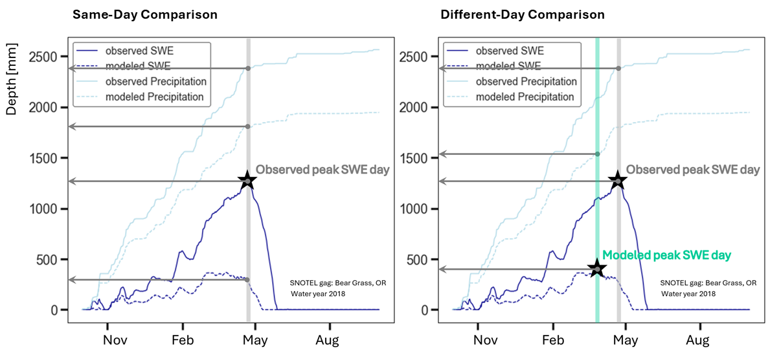
Fig. Observed data is from the Bear Grass, OR SNOTEL station, representing Water Year 2018. Modeled data is from the retrospective run of NWM version 2. In the same-day comparison, modeled SWE and accumulated precipitation are extracted for the date of maximum observed SWE, allowing a direct comparison on the same calendar day.

- Peak SWE Timing Error: This metric measures whether the model predicts the peak snow accumulation on the correct date. Although not always reported in journals, experts routinely examine this (e.g. noting if a model’s snowpack peaks too early or late). Larger timing errors indicate the model may misrepresent snow energy or melt processes.

Fig. Observed data is from the Bear Grass, OR SNOTEL station, representing Water Year 2018. Modeled data is from the retrospective run of NWM version 2. The different-day comparison uses the peak SWE value and date for each dataset individually, regardless of whether they occur on the same day.

- Melt Timing: Determining exactly when snowmelt begins can be tricky. One reason is that the snowpack does not always melt in a sharp way. For example, the peak SWE can be flat or noisy, making it hard to pinpoint the start of melting. While some researchers have defined the start of snowmelt as the first 5-day period when SWE drops by more than 2.5 cm, this can still be affected by other factors like sublimation, which also reduces SWE slightly. To make this comparison easier, a more reliable and common approach is to use what's called the half-melt date. This is simply the date when the snowpack has melted down to half of its peak SWE value (Fig below).
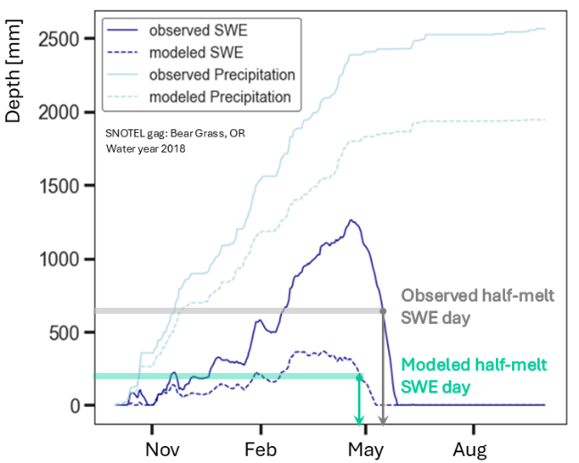
Fig. Comparison of modeled and observed half-melt dates. Observed data is from the Bear Grass, OR SNOTEL station for Water Year 2018, and modeled data is from the retrospective run of NWM version 2. The comparison highlights the timing difference between modeled and observed snowmelt. In this example, the half-melt date for the modeled dataset occurs earlier than the observed, indicating a model early scenario.

- Snow Cover Area Accuracy: Binary or fractional snow cover comparisons use classification metrics:
  - Probability of detection (POD): fraction of observed snow events the model correctly simulates
  - False alarm ratio (FAR): fraction of model-simulated snow that was not truly there
  - Critical success index (CSI): a single measure that balances hits, misses, and false alarms
- Snow Cover Duration Error: the difference in the duration of seasonal snow cover. This can be expressed in days. A positive bias means the model’s snow lasts too long into the melt season (or starts too early). This metric is essentially an integration of snow cover errors over time, highlighting if the model’s snowpack persistence is off. It is often evaluated qualitatively (e.g. via plots of snow presence) or by comparing the modeled snow-off date to observations (such as the last day with snow). In literature on climate trends, snow cover duration is a monitored variable.
- Snow Seasonality/Runoff Contribution Metrics: the center-of-mass of snowfall or snowmelt contribution to runoff. For example, a snowmelt runoff index might measure the timing of when snowmelt-driven streamflow occurs. These are less standard, but practitioners sometimes examine whether the model releases the correct fraction of annual flow in the spring (indicating snowmelt contribution) as observed.

Seasonal focus for snow evaluation
Snow models should be evaluated during the portions of the year when snow processes are active; using an improper period can bias or render metrics meaningless. Important evaluation periods and events include:
- Monthly Snapshot Comparisons: One simple way to assess seasonal performance is by comparing monthly total precipitation and SWE on the first day of each month. This provides a coarse but informative picture of how much of the monthly precipitation is contributing to snowpack and how modeled snow accumulation (usually from November to February) and melt (usually March to June) tracks with observations throughout the snow season. It can help identify months or phases where the model consistently over- or under-performs.
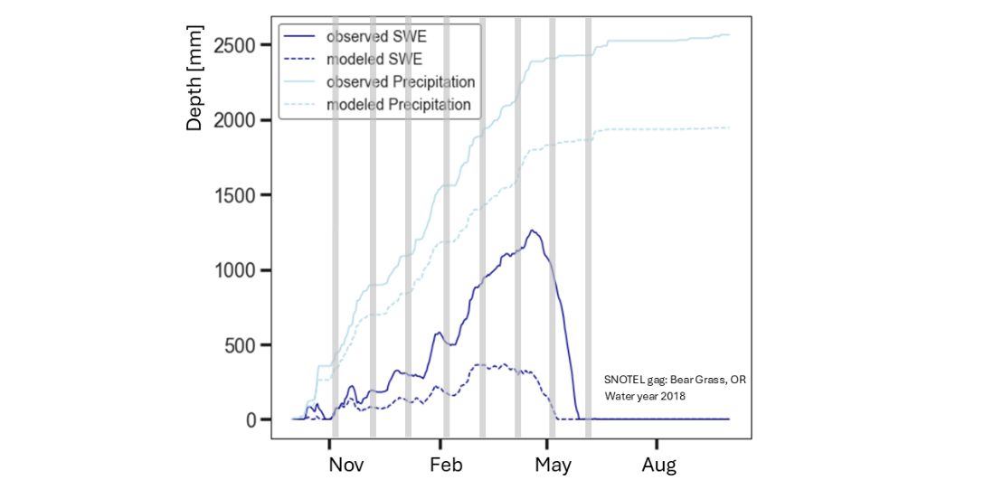
Fig. Monthly comparison of modeled and observed SWE on the first day of each month from November to June, along with the corresponding cumulative precipitation from the start of the water year to each date. Modeled SWE and cumulative precipitation are shown as dotted lines, while observed SWE and cumulative precipitation are shown as solid lines. Observed data is from the Bear Grass, OR SNOTEL station, representing Water Year 2018. Modeled data is from the retrospective run of NWM version 2.

- Peak Accumulation (Winter late-season): Evaluating model performance at this peak ensures the model gets the winter accumulation right. Metrics like Peak SWE bias and timing (described above) should be computed at this peak or over the accumulation season. For example, one might compute bias only on the date of observed peak each year to avoid diluting it with other times. This focuses the evaluation on whether the model’s snowpack builds up correctly by end of winter. An unbiased evaluation here means comparing model vs observed SWE around the peak (when values are largest and most consequential for water supply). If one evaluated SWE in midsummer (when it should be zero for both), one could get misleadingly perfect statistics despite failures in winter; thus winter/early-spring focus is essential.
- Melt Season (Spring transition): Metrics like snow cover duration error or melt-out date error should be assessed in spring. For instance, you might evaluate the day when SWE goes to zero (snow disappearance) in the model vs observations for each basin or pixel. Additionally, time-series metrics on SWE can be restricted to the melt season to see if the model’s melt rate matches observations. Focusing on spring avoids “unfair” averaging with summer (when both model and observations have no snow); it highlights biases in melt dynamics.
- Off-Season (Summer/Fall): Check for spurious snowfall events or residual snow. For example, a model might erroneously simulate snow in summer at high elevations – this would show up as false positives in snow cover (high FAR). Thus, a targeted check in summer could be to ensure no false snow: e.g. the FAR metric computed over summer months should ideally be zero (any false snow then is clearly wrong). In practice, modelers ensure the model’s snow states fully reset in summer (no leftover snowpack).
- Multi-year Trends: Evaluating many winters. If evaluating a long-term simulation, one might examine whether the model captures interannual variability in snow (e.g. does it produce the big snow year in 2017 that was observed?). Often, one will compute the above metrics (peak SWE bias, timing, etc.) each year and then summarize their distribution over many years to see if the model consistently lags or biases. Ensuring unbiased model performance over wet snow years and dry snow separately can also be insightful.
Meaningful snow model evaluation should occur during winter/spring when snow exists, focusing on peak and melt periods. This ensures metrics are sensitive to differences. For example, evaluating snow cover accuracy should exclude times/regions with no snow; instead, compute it only when some snow is expected. By slicing the hydrologic year in this way, we get an unbiased view of model skill in snow. Metrics like peak SWE timing are inherently tied to a specific time (peak day) and should be evaluated on an annual basis (each year’s timing). Likewise, snow duration error is best looked at on a yearly or seasonal basis rather than averaged over a full year. These practices ensure the evaluation fairly tests the model when and where it matters for snow.

