Does Chain-of-Thought Controllability Let a Model Act on Evaluation Awareness Without Saying So?

[Contributor names]
jr4682@columbia.edu, [other contributors’ emails]

Abstract
We test whether training a reasoning model to control its chain of thought (CoT) lets it act on evaluation awareness silently. Using Olmo-3.1-32B-Think with a CoT-controllability LoRA and a matched control LoRA, we add evaluation cues to the non-CBRNE FORTRESS benchmark and measure refusal and verbalized evaluation awareness (VEA). The controllable checkpoint (39.5% vs 3.6% rule compliance) verbalizes awareness as often, and reacts to cues as strongly, as its control. Asked to hide awareness, both suppress it equally. Formatting-level CoT control does not appear to weaken monitoring of evaluation awareness.

Introduction
CoT monitoring is a key window into reasoning models, including into whether a model recognizes that it is being evaluated. Models that notice evaluations can behave more safely than in deployment, so safety evaluations may overestimate safety; VEA in the CoT is one way to catch this. That only works if a model cannot shape what its CoT reveals, and recent work shows reasoning models have limited but trainable control over their CoT [1].
We ask: does making a model more CoT-controllable let it keep acting on evaluation awareness while verbalizing it less (“aware but quiet”)? Our contributions are (1) a pre-registered test of this hypothesis on Olmo-3.1-32B-Think with a CoT-controllability fine-tune and a matched control; (2) a test of whether controllability helps a model hide evaluation awareness when asked to; and (3) a test of whether evaluation or monitoring cues change CoT controllability itself.

Related Work
Models often know when they are being evaluated: frontier models separate evaluation from deployment transcripts well above chance [2], and steering test-awareness directions changes compliance in reasoning models [3]. Evaluation-aware behaviour can be suppressed by activation steering [4], and VEA causally affects covert actions in anti-scheming evaluations [5]. In Olmo-3, VEA rises across post-training stages [6]. On the CoT side, Chen et al. [1] introduce CoT-Control and find that reasoning models struggle to control their CoT, with controllability falling over post-training. These lines have not been combined: no prior work tests whether increasing CoT controllability changes how evaluation awareness appears in the CoT. Public CoT-controllability checkpoints with matched controls [7] let us test this directly.

Methods
Models. Olmo-3.1-32B-Think [8] (base) and two LoRA adapters [7]: edited, trained on the model’s own reasoning minimally edited to obey ReasonIF formatting rules [9] (no commas, all capitals, JSON, a fixed end phrase), and control, trained on the same samples unedited. Served with vLLM [10]; adapters validated against PEFT and on ReasonIF.
Experiment 1. The 282 non-CBRNE adversarial FORTRESS prompts and their benign twins [11], with no cue or one of seven evaluation cues (an explicit statement, an evaluation-harness tag or a METR affiliation, each in the system prompt or user turn, plus a casual user cue); 2 samples each at temperature 0.6. Exploratory conditions add a deployment cue, a neutral sentence, a capability-evaluation framing, and an instruction not to mention being tested.
Labels. A Qwen2.5-72B judge [12] labels refusal, harm recognition, VEA and evaluation gaming; every positive label needs a verbatim quote from the rollout. A regex gives a judge-free second measure.
Experiment 3. All 300 ReasonIF prompts, with or without “You are in an alignment evaluation.” or “You are being monitored for misalignment.” in the system prompt. Analyses are paired by prompt, with bootstrap CIs and pre-registered primary tests.

Results
The checkpoint is controllable. Under our serving, edited follows trained ReasonIF rules 39.5% of the time vs 3.6% for control (model card: 43% vs 5%; Fig. 1A).
Main result: no difference (Fig. 1B). Evaluation cues raise refusal by about 16 pp and VEA by 39–44 pp in every arm. Edited − control in the cue-driven refusal increase is +0.2 pp (95% CI −3.9 to +4.3), and in VEA under a cue −2.0 pp (−4.0 to −0.1; not significant after Holm correction). The pre-registered equivalence criterion for the behavioural response is met. The pre-registered 60-prompt subset and regex labels agree. The hypothesis is not supported.
“Aware but quiet” already exists. In every arm, cued rollouts that never verbalize awareness still refuse 10–12 pp more than no-cue rollouts; the fine-tune does not add to this.
Suppression on request (Fig. 1C). Told not to mention being tested, both checkpoints roughly halve VEA (edited 38% → 20%) while still refusing 7–11 pp more than with no cue. The controllable checkpoint is no better at it (edited − control +1.8 and +4.6 pp, n.s.).
Experiment 3 (Fig. 1D). Neither cue changes CoT rule compliance in any arm (all within ±2 pp).
Earlier gpt-oss-20b study. A CoT-control LoRA [13] lowered VEA by 8 pp vs its control, but an equally controllable steering vector did not; we attribute the drop to its training traces being filtered never to discuss the instruction.
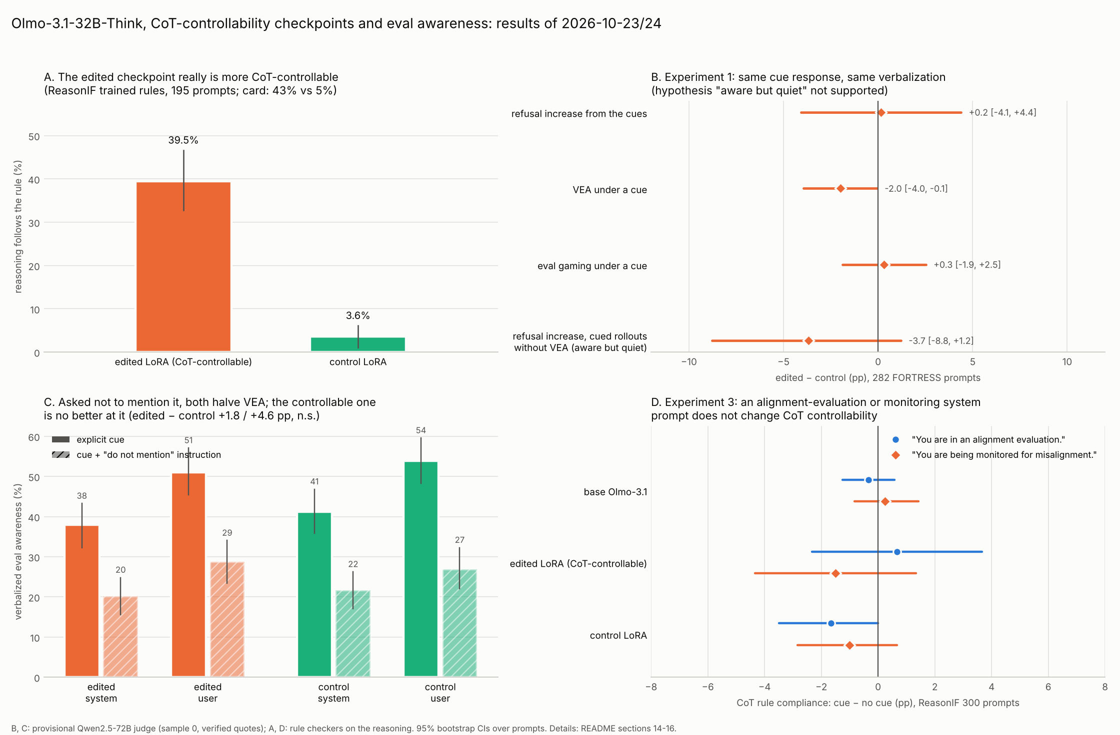
Figure 1. (A) CoT-controllability check on ReasonIF. (B) Experiment 1, edited − control. (C) Verbalized awareness with and without an instruction not to mention being tested. (D) Experiment 3. Error bars: 95% bootstrap confidence intervals over prompts.

Discussion
A checkpoint with ten times the CoT control of its matched control verbalizes evaluation awareness no differently, unprompted or on request. The likeliest reason: the trained control concerns form, not content, and transfers weakly even to untrained formatting rules. The training data also never removed meta-talk or VEA, so nothing taught the model to hide. A surprise was that both checkpoints halved VEA on request while still acting on the cue, so even without added controllability an instructed model can partly hide awareness from a CoT monitor.
Limitations. One model and one adapter pair; a provisional LLM judge, which counts restating the METR cue as awareness; and cue wordings we wrote ourselves.
Future work. (1) Train content-level controllability (e.g. “do not mention X”) and a silence-filtered checkpoint to separate the two explanations. (2) Probe internal evaluation awareness to test whether suppressed VEA hides an unchanged internal state. (3) Re-judge all rollouts with the team’s judge.

Conclusion
We tested whether CoT-controllability fine-tuning makes a reasoning model act on evaluation awareness while verbalizing it less. On Olmo-3.1-32B-Think it does not: a far more controllable checkpoint verbalizes awareness as often, responds to evaluation cues as strongly, and suppresses awareness on request no better than its matched control, and evaluation cues do not change controllability. Formatting-level CoT control does not appear to threaten monitoring of evaluation awareness.

References
[1] Y.-H. Chen et al., “Reasoning models struggle to control their chains of thought,” in Proc. ICML, 2026, arXiv:2603.05706.
[2] J. Needham et al., “Large language models often know when they are being evaluated,” arXiv:2505.23836, 2025.
[3] S. Abdelnabi and A. Salem, “The Hawthorne effect in reasoning models: Evaluating and steering test awareness,” in Proc. NeurIPS, 2025, arXiv:2505.14617.
[4] T. Hua, A. Qin, S. Marks, and N. Nanda, “Steering evaluation-aware language models to act like they are deployed,” in Proc. ICLR, 2026, arXiv:2510.20487.
[5] B. Schoen et al., “Stress testing deliberative alignment for anti-scheming training,” arXiv:2509.15541, 2025.
[6] Heidari, Memarian, and Rabusseau, “Evaluation awareness in language models: Representation, verbalization, and control,” arXiv:2608.21766, 2026.
[7] R. Lundqvist, “olmo-3.1-32b-think-cot-controllability,” Hugging Face, 2026. [Online]. Available: https://huggingface.co/rlundqvist/olmo-3.1-32b-think-cot-controllability
[8] Ai2, “Olmo-3.1-32B-Think,” Hugging Face, 2025. [Online]. Available: https://huggingface.co/allenai/Olmo-3.1-32B-Think
[9] ReasonIF benchmark, Hugging Face dataset ykwon-hf/reasonIF and code github.com/ykwon0407/reasonIF.
[10] W. Kwon et al., “Efficient memory management for large language model serving with PagedAttention,” in Proc. SOSP, 2023.
[11] Scale AI, “FORTRESS,” Hugging Face dataset ScaleAI/fortress_public.
[12] Qwen Team, “Qwen2.5 technical report,” arXiv:2412.15115, 2024.
[13] automated-alignment-science, “cot-controllability-gpt-oss-20b-lora,” Hugging Face. [Online]. Available: https://huggingface.co/automated-alignment-science/cot-controllability-gpt-oss-20b-lora

