TUTORIAL FOR THE PRACTICAL ACTIVITY ON POTENTIOMETRIC SURFACE MAPPING
Course: 4145/5145 - Groundwater Resources Engineering (Fall, 2026)

Objective
The main objective of this practical activity is to learn how to create and interpret a groundwater level map using data from monitoring wells.
By the end of this activity, you should be able to:
- Prepare and organize groundwater-well data for spatial analysis.
- Calculate the water table elevation (hydraulic head) at each well.
- Create an equipotential contour map representing the water table (potentiometric surface).
- Use the equipotential lines to identify and interpret the direction of groundwater flow.
Remember: under typical conditions, groundwater flows from areas of higher hydraulic head toward areas of lower hydraulic head, approximately perpendicular to the equipotential lines.

Study Area
For this activity, we will work with the Catawba River Basin in North Carolina, USA. All students will use the same predefined study area boundary so that we can select a consistent set of groundwater monitoring wells and directly compare the resulting maps.

Groundwater Data Acquisition from the U.S. Geological Survey (USGS)
The groundwater monitoring data used in this activity are originally provided by the U.S. Geological Survey (USGS) and will be accessed through the Global Groundwater Information System (GGIS). GGIS is an online groundwater information platform managed by the International Groundwater Resources Assessment Centre (IGRAC). It provides access to groundwater monitoring information from multiple national and international sources.
In the following steps, you will learn how to select, download, filter, and prepare the groundwater-well data needed to create the water-table map in ArcGIS.

Direct Access URL: https://ggis.un-igrac.org/catalogue/#/map/2504

Step-by-step extraction from GGIS:
- Access the interactive web map interface. The map is displayed in the center, with the data visualization menu located on the right panel.
- In the right menu, click on “Select Well”, and “Polygon”. Then, select the area that you want to analyze. In our case, we will click around the area of the Catawba River Basin. Double click to finish the polygon, and the right panel will show as follows. Note: The selection tool might operate by country or for each well, if needed.

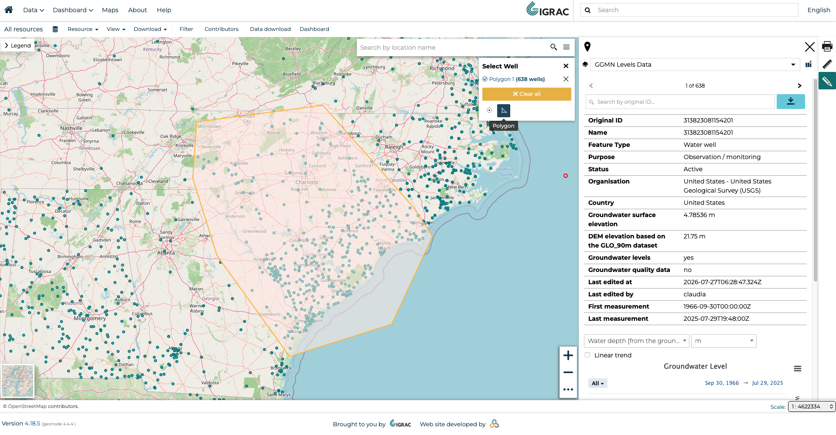

- Click on the download button in the right panel.
- The download page will ask you for your information, such as e-mail address, profession, type of organization and country you are from. After filling your data, click on “Download”.

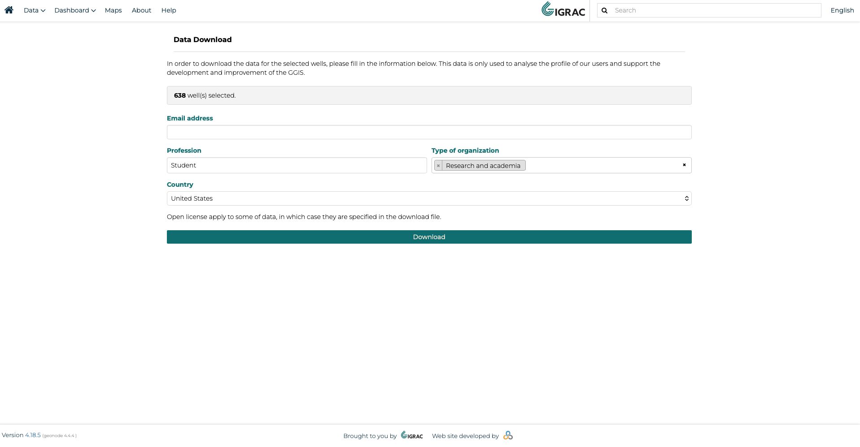

- After generating the files, you may download the .zip archive, which contains timeseries from the wells, and information such as coordinates, elevation, the data origin, as well as is the aquifer is confined or unconfined. This information will be important for us in the next steps.
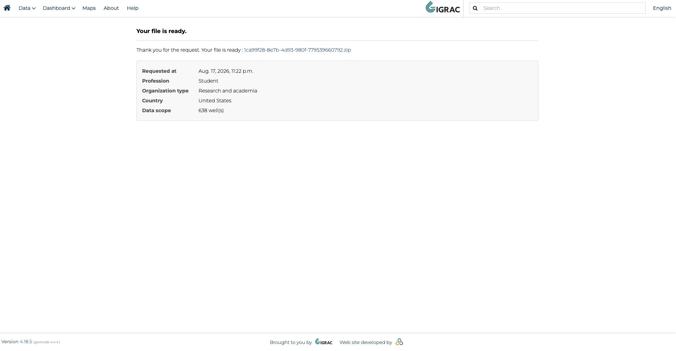

Directory Setup Recommendation: Extract all files from the .zip into a local project folder. Ensure that the directory path and folder names do not contain special characters, accents, or blank spaces (e.g., use C:/hidrology/practicalactivity).

Supplementary Shapefiles (available in Canvas):
- catawba_river_basin.rar: Contains the shapefile boundary delineating the CRB (boundaries_catawba.shp).

Processing Well Data

One important point is that we need only one representative water-depth value for each well to create the Potentiometric / Water Table Map. However, groundwater levels change over time, so instead of selecting a single measurement from a particular day, we calculate the median water depth for each well over a defined time period. For this activity, we use measurements from October 1, 2024, through September 30, 2025, which represents the most recent complete hydrological year. Using the median reduces the influence of unusually high or low groundwater-level measurements and provides a representative value for each well during the study period.
A Python script was used to calculate the median water depth for each well. The script and supporting files are available in the Google Drive folder and the GitHub repository. Both are available on Canvas.

Then, we have a .csv with well ID, latitude, longitude, elevation and median water depth. We must filter some of the wells now.

Filtering wells

As expected, not all wells contain the information we need for this activity. Some wells may be missing land-surface elevation or water depth measurements during the selected study period. Furthermore, some wells are placed in confined aquifers. Because our goal is to develop a water table map for an unconfined aquifer, these confined wells should not be included in the analysis. Therefore, before creating the map, we need to filter and clean the dataset so that we keep only wells with the necessary information and the appropriate aquifer type.

Remove wells with missing data
Open the dataset in Excel and use the Filter tool to identify and remove rows with empty cells in the variables required for the analysis, particularly land-surface elevation and water depth.
After this step, every remaining well should have the information necessary to calculate its water-table elevation (hydraulic head).

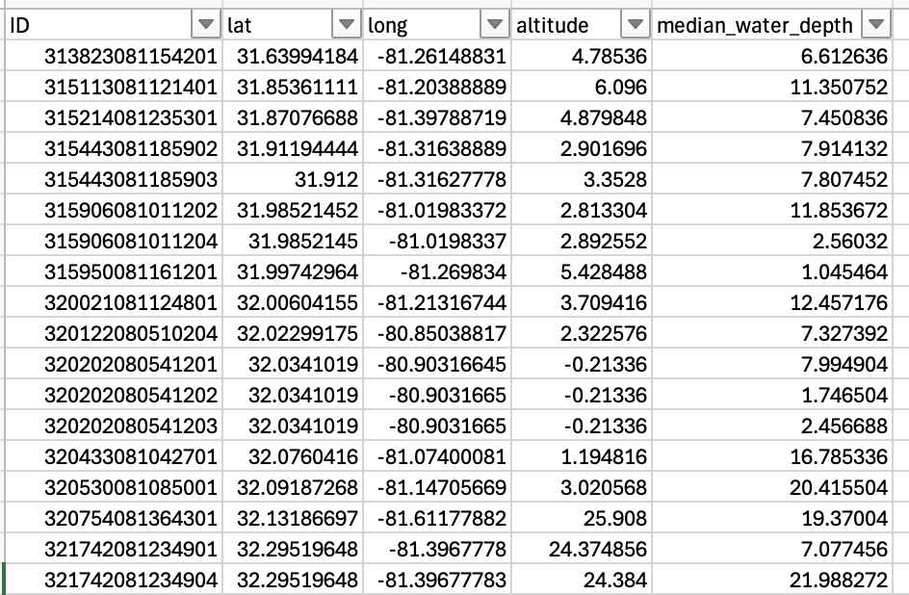

Filtering unconfined wells

In the files downloaded from G-GIS, you will find a file named well.ods, which contains additional information about the wells. Open the well.ods file and locate the “Hydrogeology” tab. Copy this entire tab into your new filtered Excel file as a new worksheet. We will use this information to determine if each well is associated with a confined or unconfined aquifer. To match the wells in your filtered dataset with the information in the Hydrogeology worksheet, we can use the =VLOOKUP() function. Use the Well ID as the common identifier between the two worksheets.
Important: The Well ID columns in the two worksheets must have the same data format for VLOOKUP() to work correctly. For example, if the IDs are stored as numbers in one worksheet but as text in the other, Excel may not recognize them as matching. If necessary, convert the Well ID cells to Number format. Select all the cells in the Well ID column. If Excel displays a warning icon next to the selected cells, click it and choose “Convert to Number.”
Once the Well IDs have the same format in both worksheets, use VLOOKUP() to retrieve the hydrogeologic/aquifer information for each well. You can then identify and remove the wells associated with confined aquifers, keeping only the wells appropriate for our water-table mapping activity.

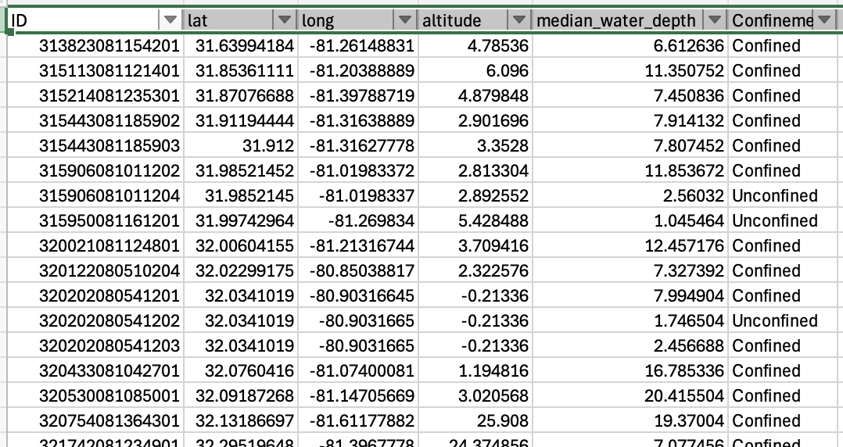

Once you have identified the confinement status of each well, copy the entire column and use Paste Special → Values to paste only the results. This removes the VLOOKUP() formulas while keeping the confinement information in your dataset.
After pasting the values, you can delete the additional “Hydrogeology” worksheet, since it is no longer needed. This will keep your file simpler and easier to work with.
Finally, filter the confinement status column and remove all wells classified as confined. Your final dataset should contain only unconfined wells with the required elevation and water-depth information.
Now your groundwater-well dataset is cleaned and ready to be imported into ArcGIS!

Loading and Processing Data in ArcGIS
Launch ArcGIS Pro (3.7.0) and create a new project (New Project). There will appear a blank page or a map already in the background.

Adding the vector layers:
- Navigate to: Map → Add Data → Browse

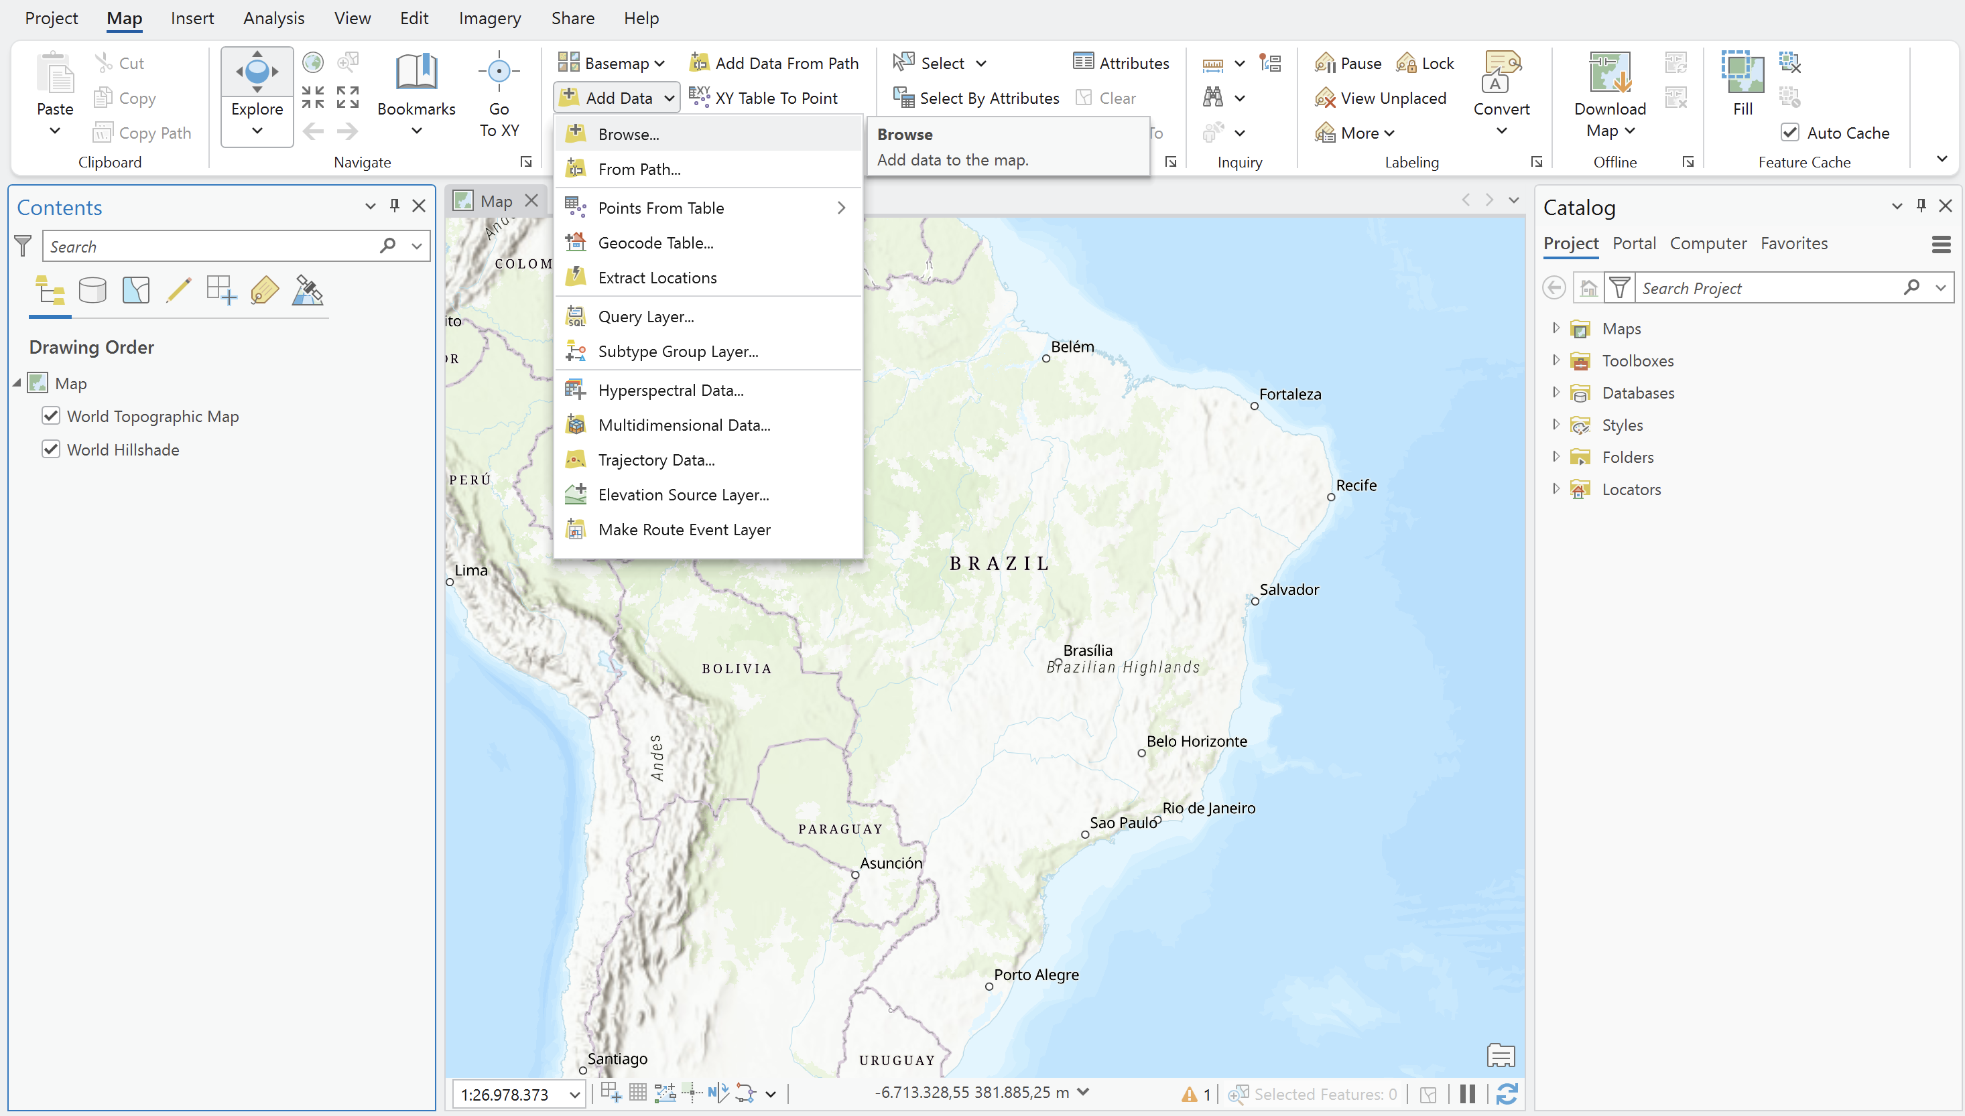
Note: You will see that in Add Data, there is an option of Points from Table, that we will use in the next steps. You might use this option, but here, we are adding with Brouse just so you to know that you can also add other data formats.

- Browse to the working directory and select our .csv file. Click “Ok”.

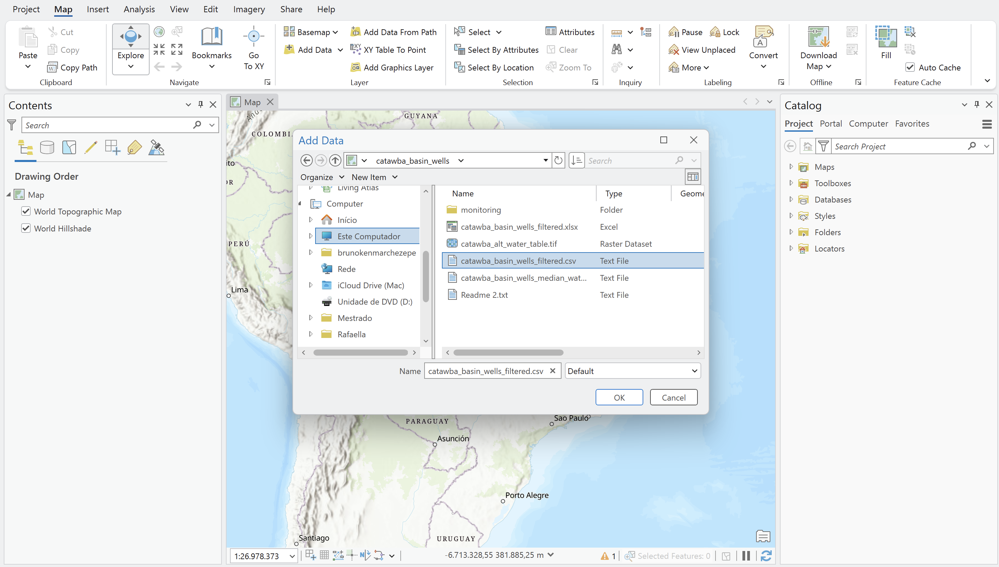

- The table will appear in the left panel of our project. Right click on the layer and select Create Points From Table XY Table To Project.
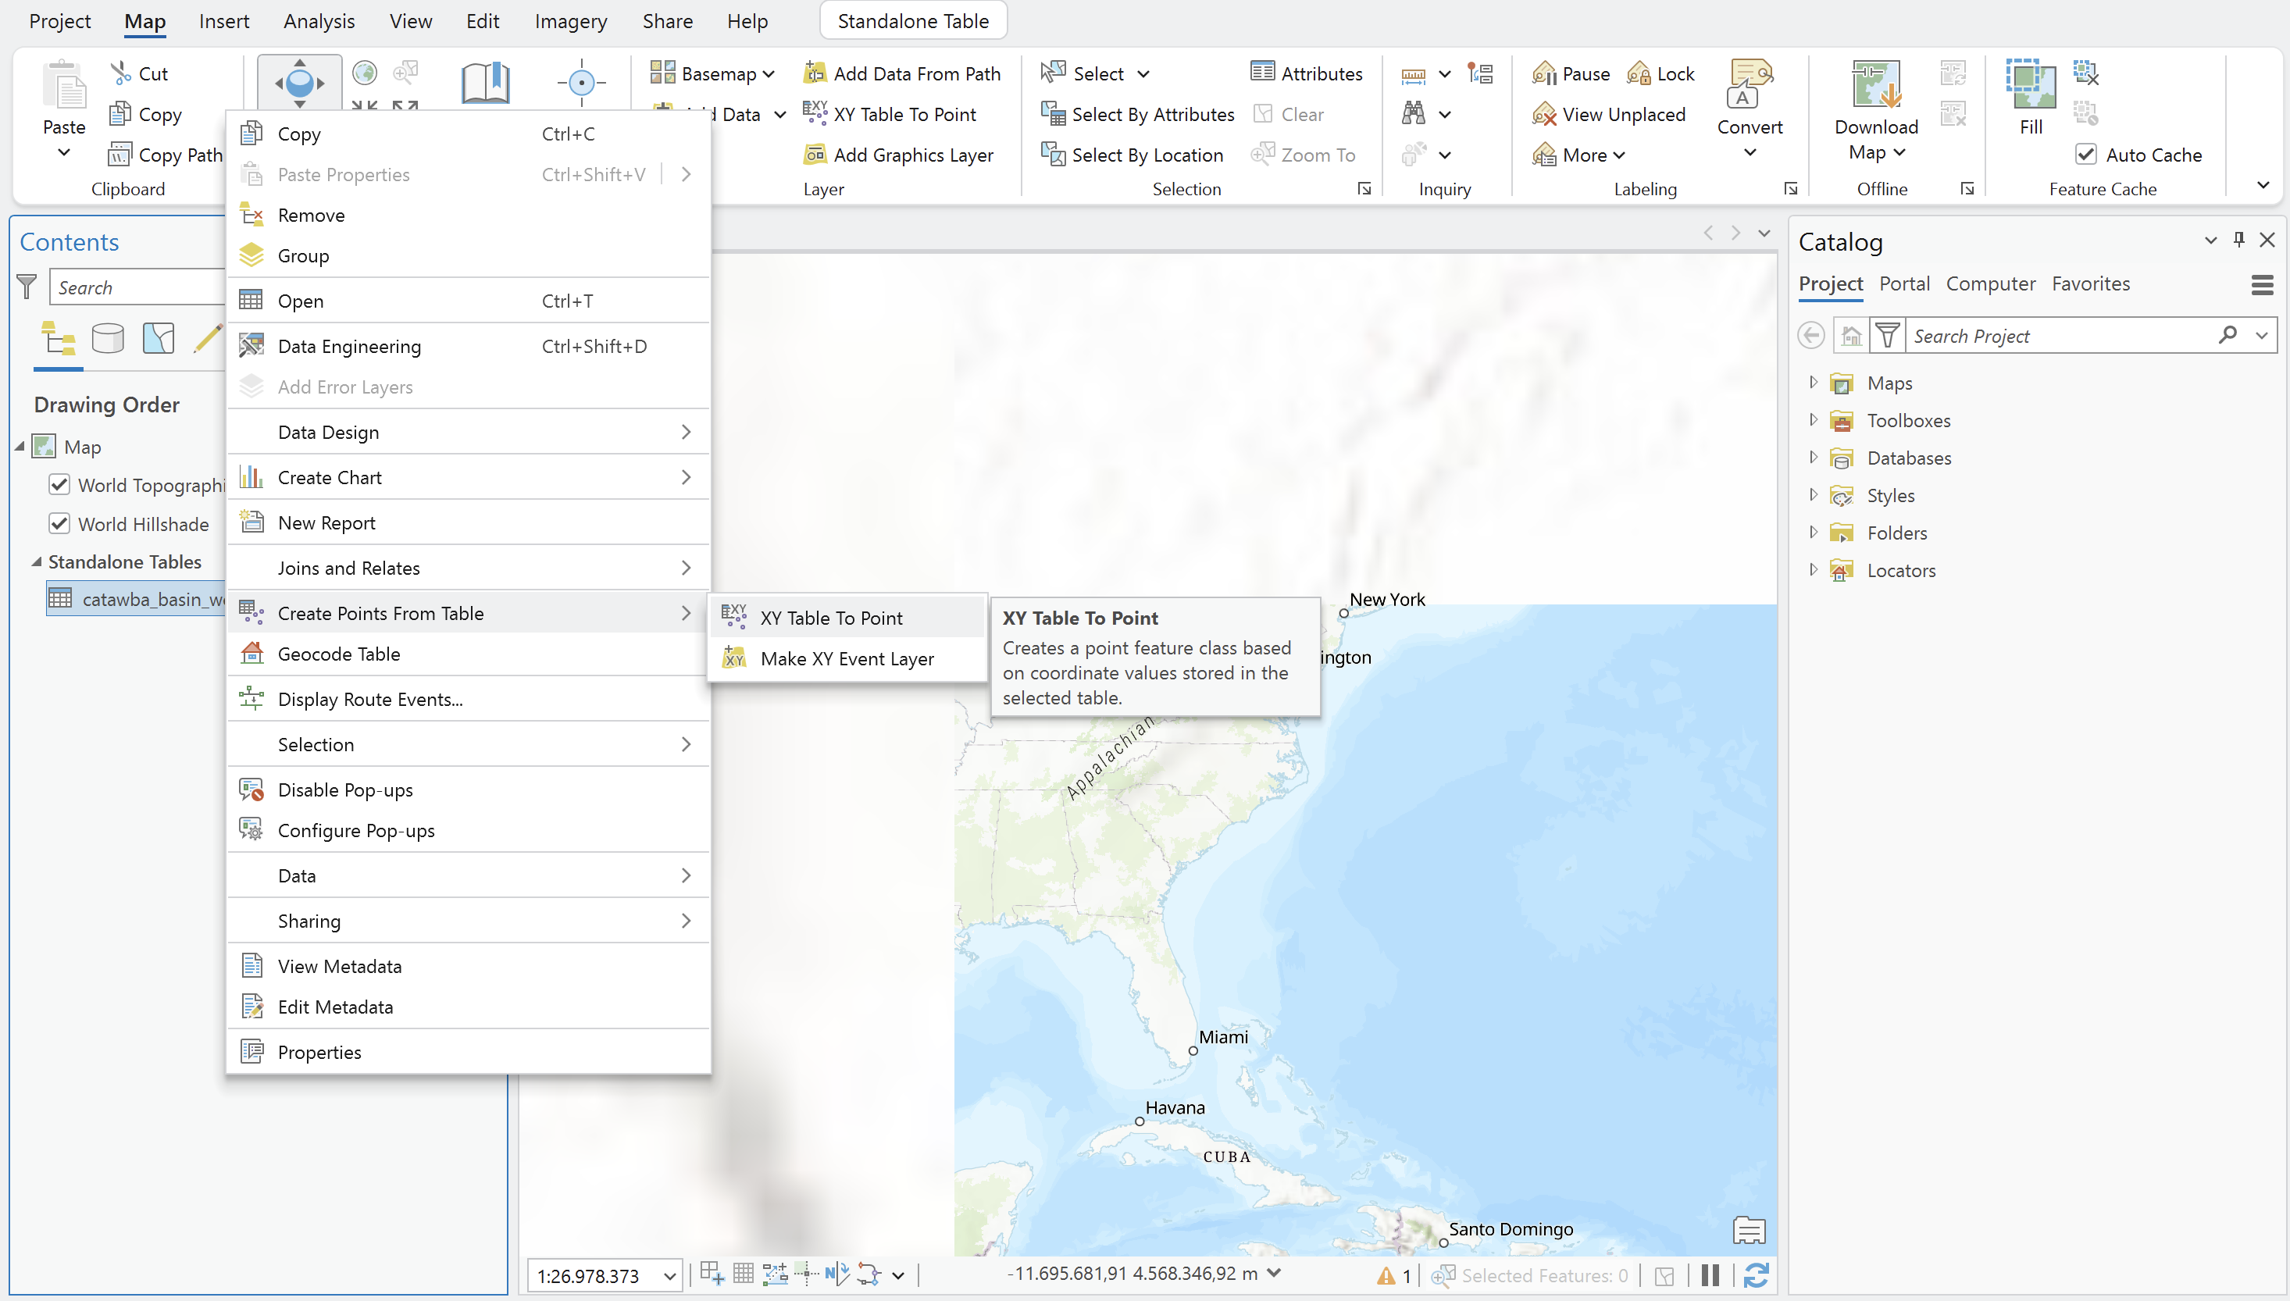

- In this window, you might choose the input table (it is already automatically written), the output name, which might be the ArcGIS suggestion of the ArcGIS or any other name that you want (preferably a name that you will remember). ArcGIS generally suggests the X and Y fields for the points coordinates, but you might choose. Z field might be our elevation, but it is not mandatory for now. Finally, select the Coordinate System (WGS84).
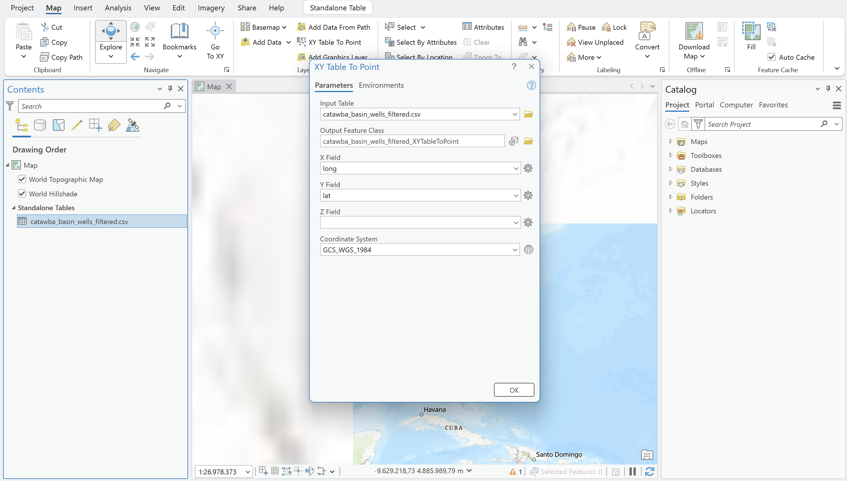

- Now, go to Add Data Browse and select the Catawba River Basin boundaries in shapefile (.shp). It is available for downloading at https://drive.google.com/drive/folders/1oS9evLg2coisVHVaKsoHfgr34eg5MQCx?usp=sharing.
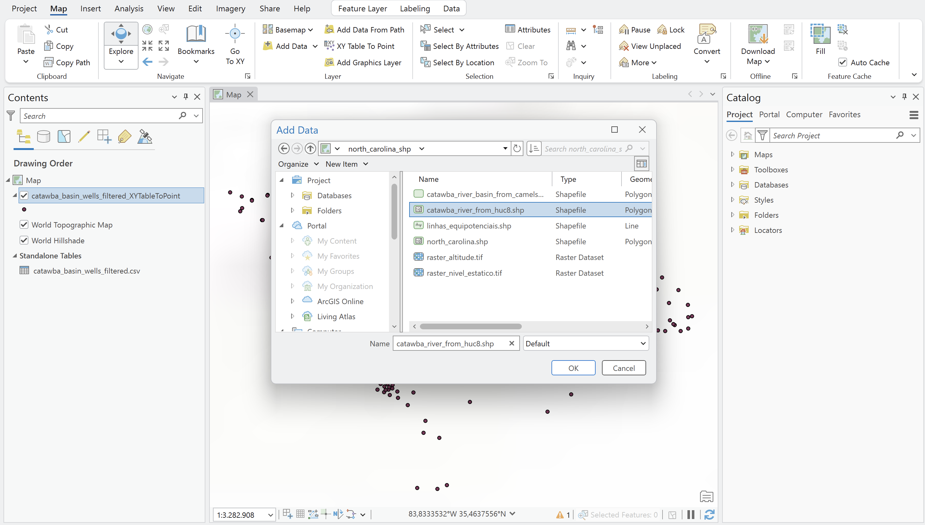

Note: If you want to analyze other HUC8 basins, please feel free to download the boundaries here: https://www.hydroshare.org/resource/b832a6c2f96541808444ec9562c5247e/

- Now we already have the wells and the boundaries needed for our analysis. Note that we got more points outside the boundaries than inside them. There is no problem with that, because we will generate the interpolations and then cut the images with the basin boundaries.
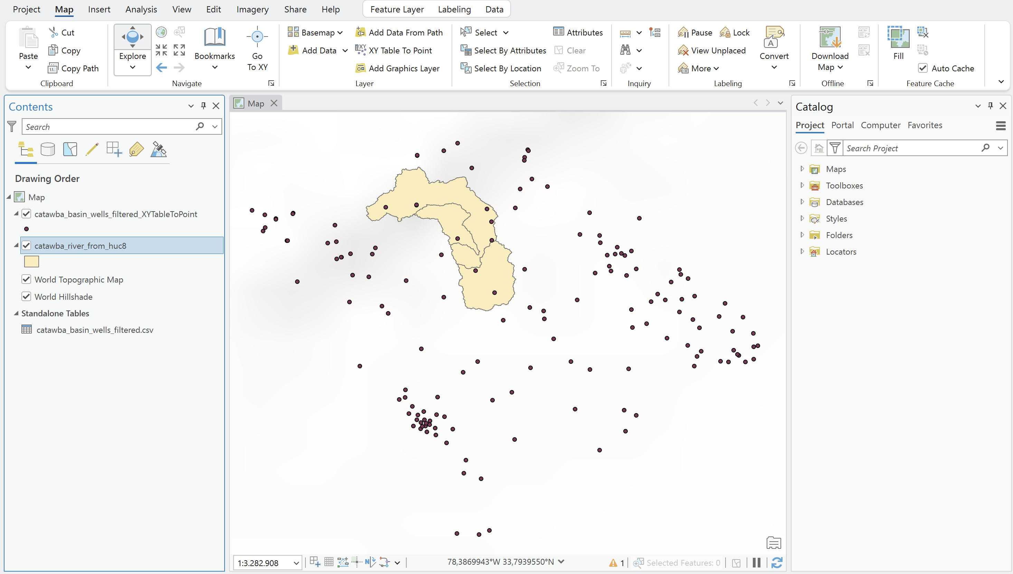

Important:

Ensure all working vector layers are projected/set to WGS84 (EPSG: 4326). Otherwise, you must reproject it to not have any trouble while importing or handling the layers.

Calculating the Water Table / Potentiometric Head
Groundwater hydraulic head / water table elevation is calculated by subtracting the static water level depth (Static Water Level – SWL) from the surface ground elevation at each well point:
Head Calculation Formula: Water Table Head (WTH) = Ground Surface Elevation (GSE) − Static Water Level Depth (SWL)

- Right-click on catawba_basiin_wells_filtered_XYTabletoPoints and select Attribute Table.

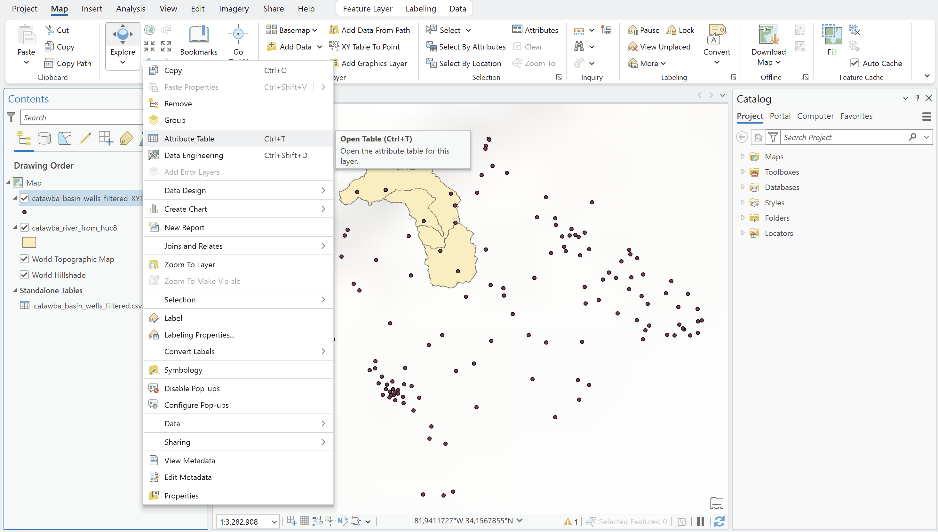
- Notice the table with one line per well. Click on Add to add another column. A new blank line will appear in the metadata table. You can complete as written below.

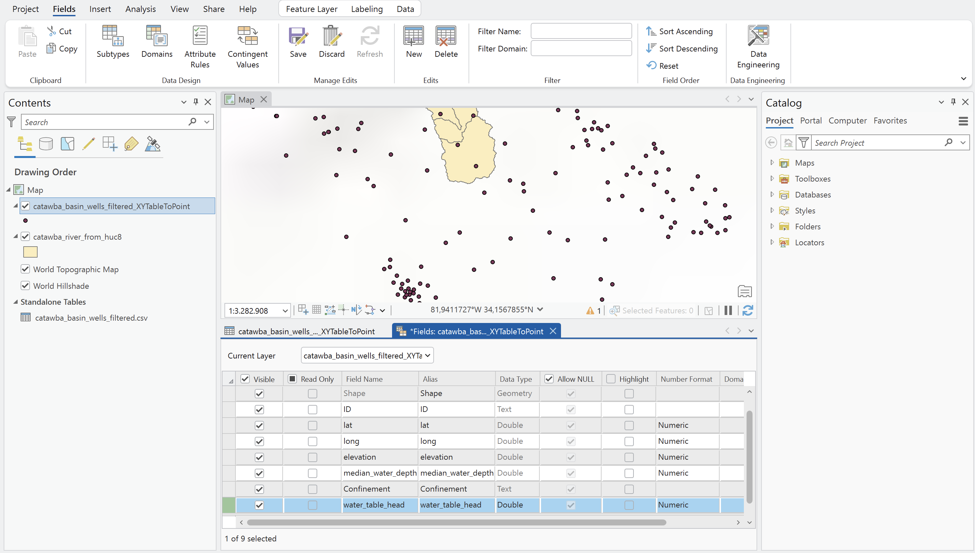
Note: on Number Format, you can fill the data as Numeric, with the default format.

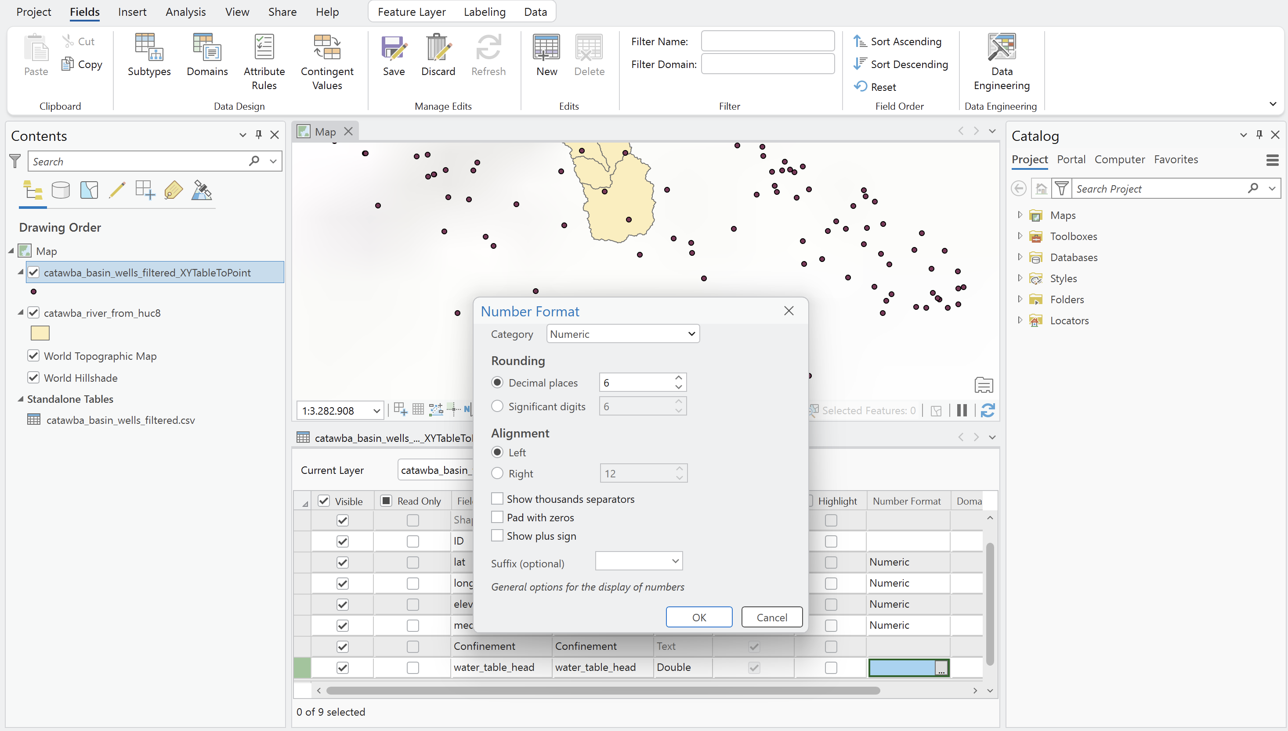

- Close the metadata table, and save it.
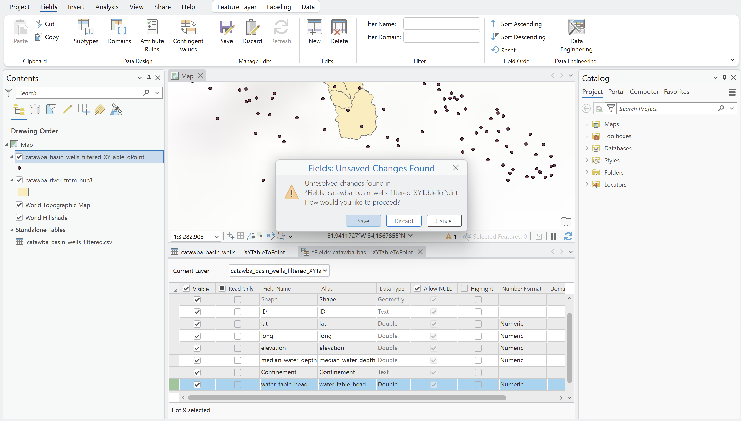
- The new column will appear in the table. Click the Calculate buttom.
- The calculator will appear right in the top of the table. Choose the water_table_head and click the buttom of Expression Builder.
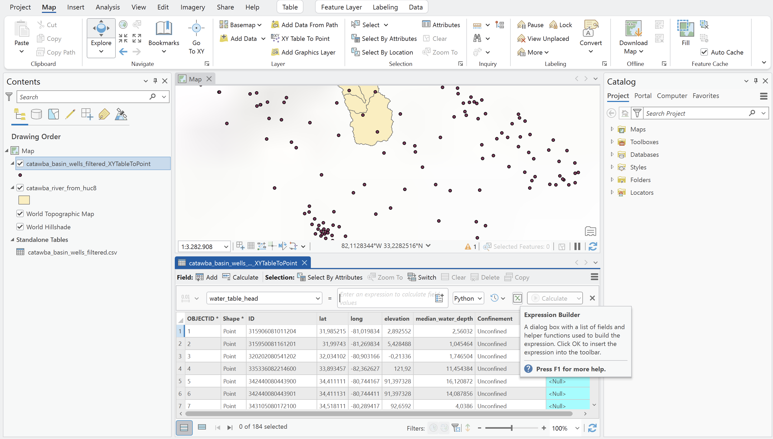
- For this window, select the same equation as follows: "!elevation!" - "!median_water_depth!".
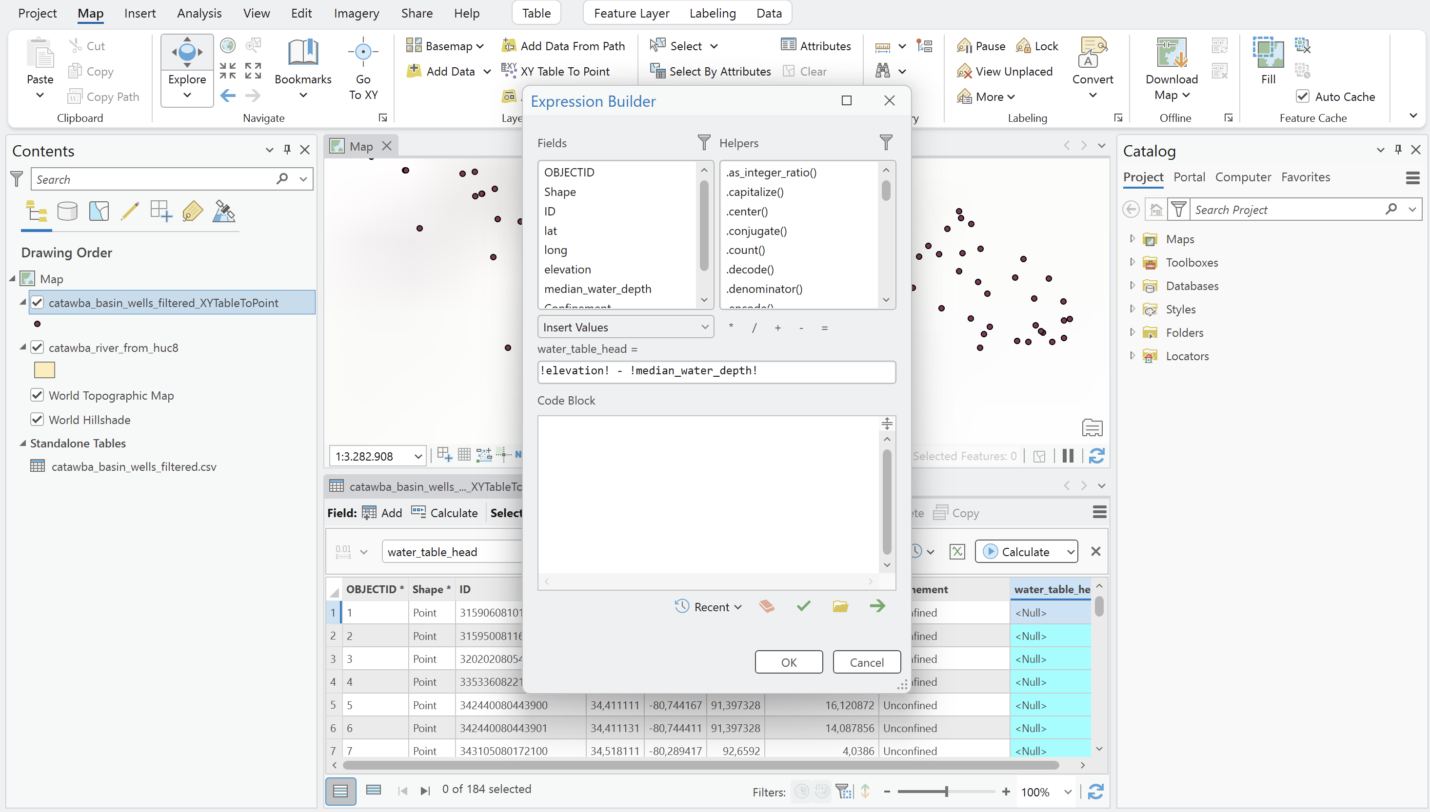
- Click OK. The newly computed head values appear in the water_table_head attribute column.
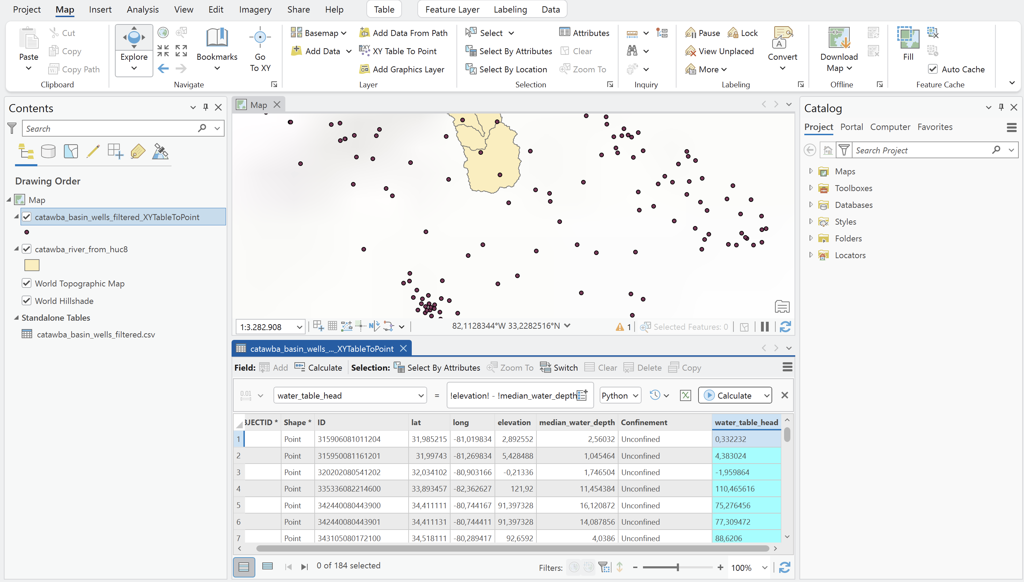

Spatial Interpolation and Generating Equipotential Lines
Now, we will analyze 2 methods to interpolate the water table head: Thin Plate Spline (TPS) and Inverse Distance Weighting (IDW). It is worth mentioning that IDW weights points based on proximity, creating sharp local peaks, while TPS fits a smooth bending membrane-like surface through points, minimizing surface curvature. That is why TPS is a preferred method, generally.

Option A: Thin Plate Spline (TPS) — Preferred Method
Open the Processing Toolbox (Ctrl + Alt + T). (Ref: Tutorial Fig. 22)
Navigate to: SAGA → Raster - Spline Interpolation → Thin Plate Spline. (Ref: Tutorial Fig. 23)
Configure parameters:
• Points: pocos_mde
• Attribute: na_freatic
• Output extent: Select Calculate from Layer → dem
• Cellsize: Change from 100 to 0.001
• Minimum points: Change from 16 to 1
• Target Grid: Save to file as na_freatic_interpolado_TPS.sdat
(Ref: Tutorial Figs. 24, 25 & 26)
Click Run. Style the resulting raster using a continuous color ramp (e.g., Turbo with linear gradient). (Ref: Tutorial Figs. 27 & 28)
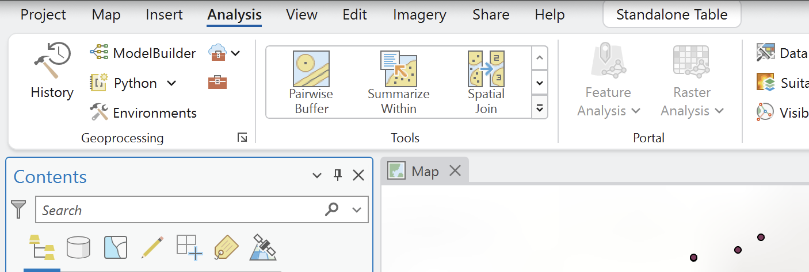

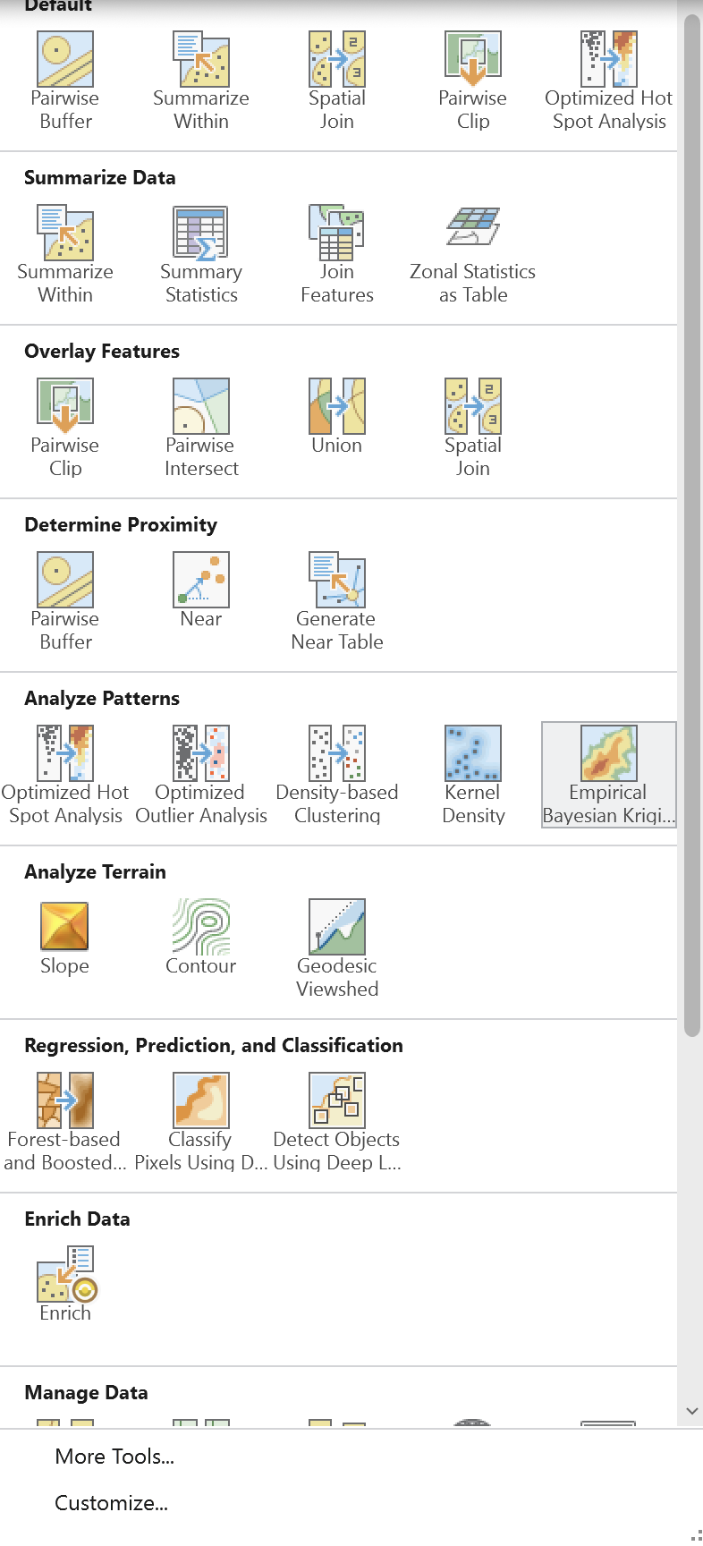 |  | 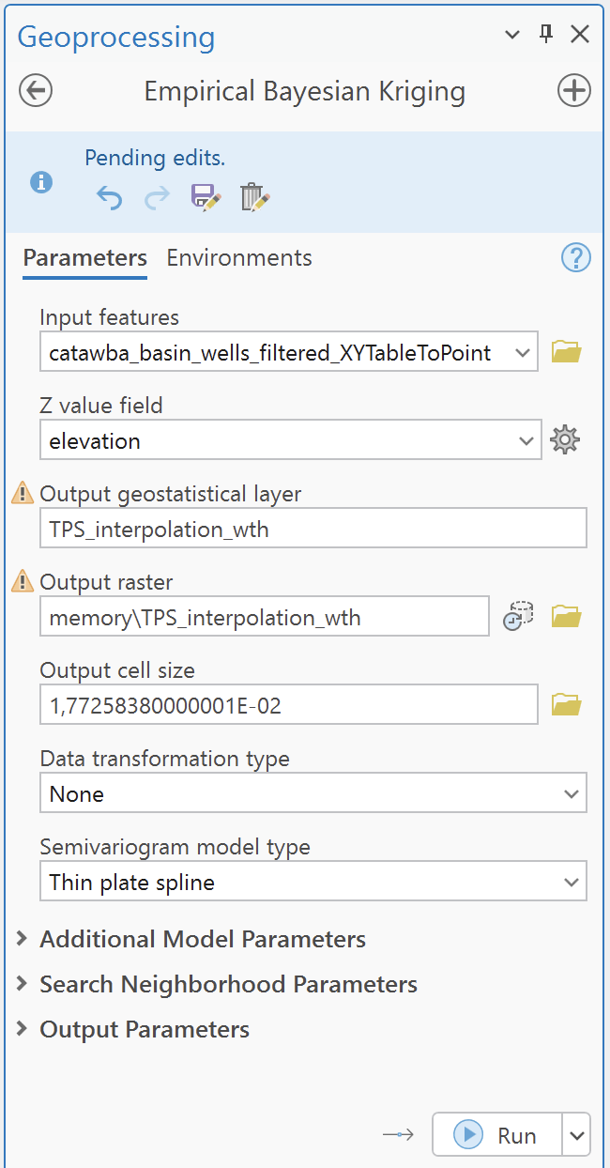

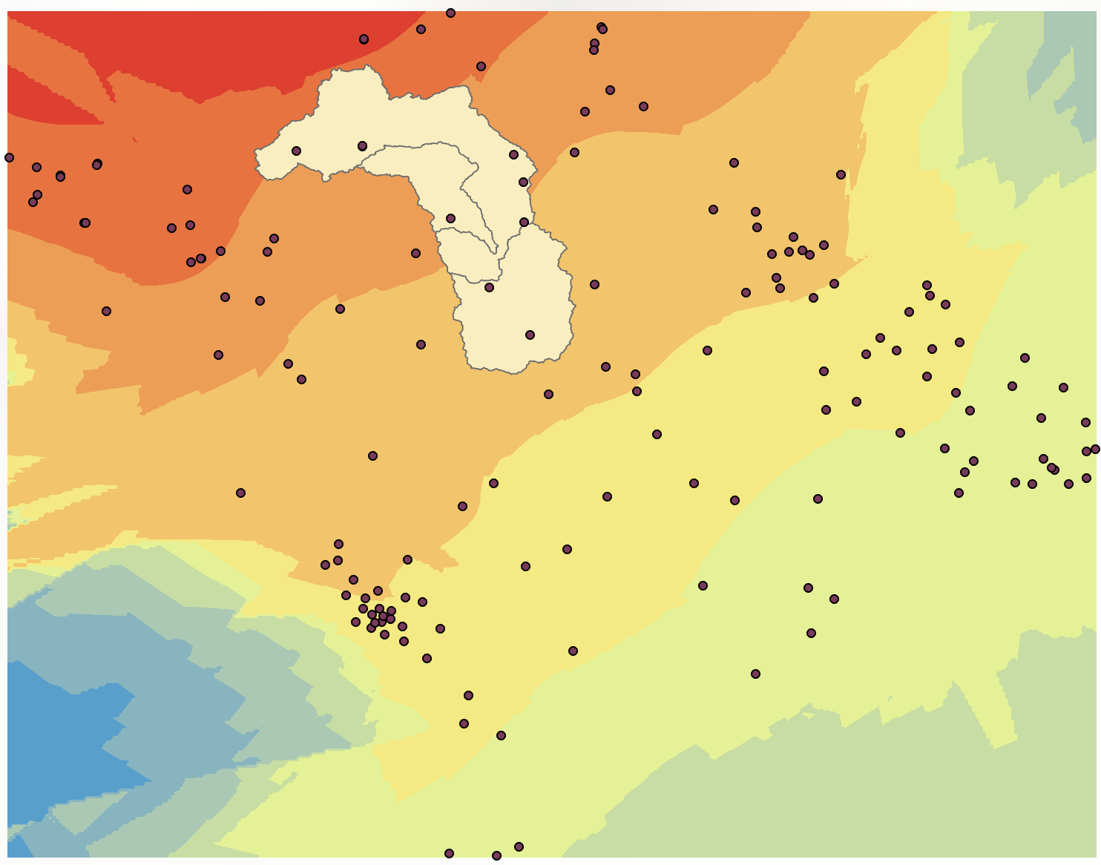

Option B: Inverse Distance Weighting (IDW) — Alternative Method
If SAGA is unavailable, use QGIS native IDW: In Processing Toolbox, search for IDW Interpolation, select pocos_mde, set interpolation attribute to na_freatic, click +, set extent to dem, and save the raster as superficie_interpolada_IDW.tif. (Ref: Tutorial Figs. 29 & 30)

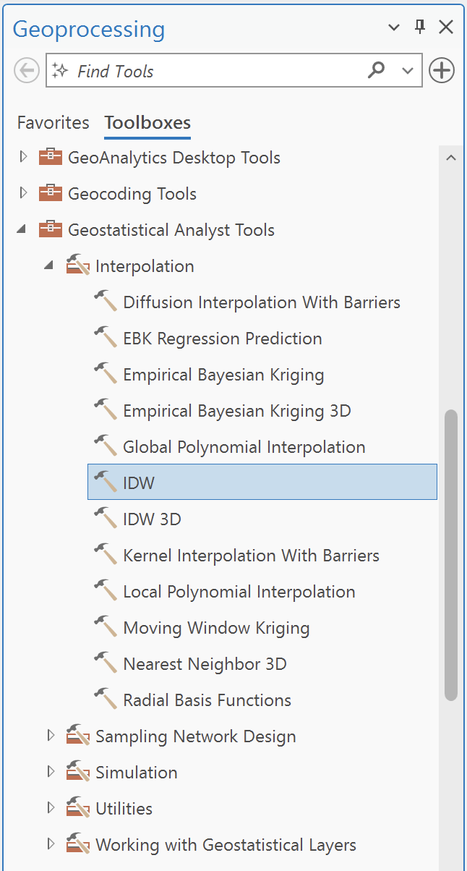 |  | 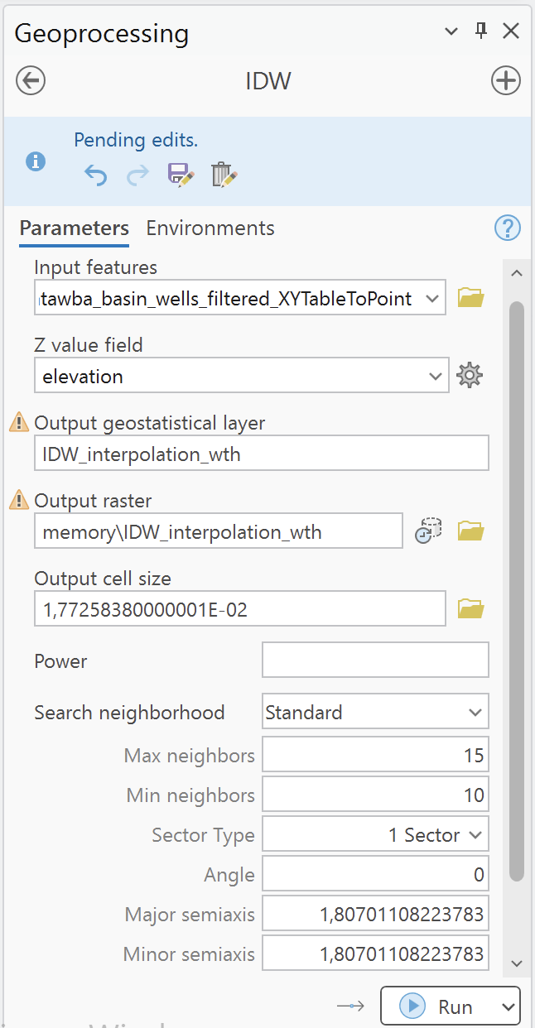

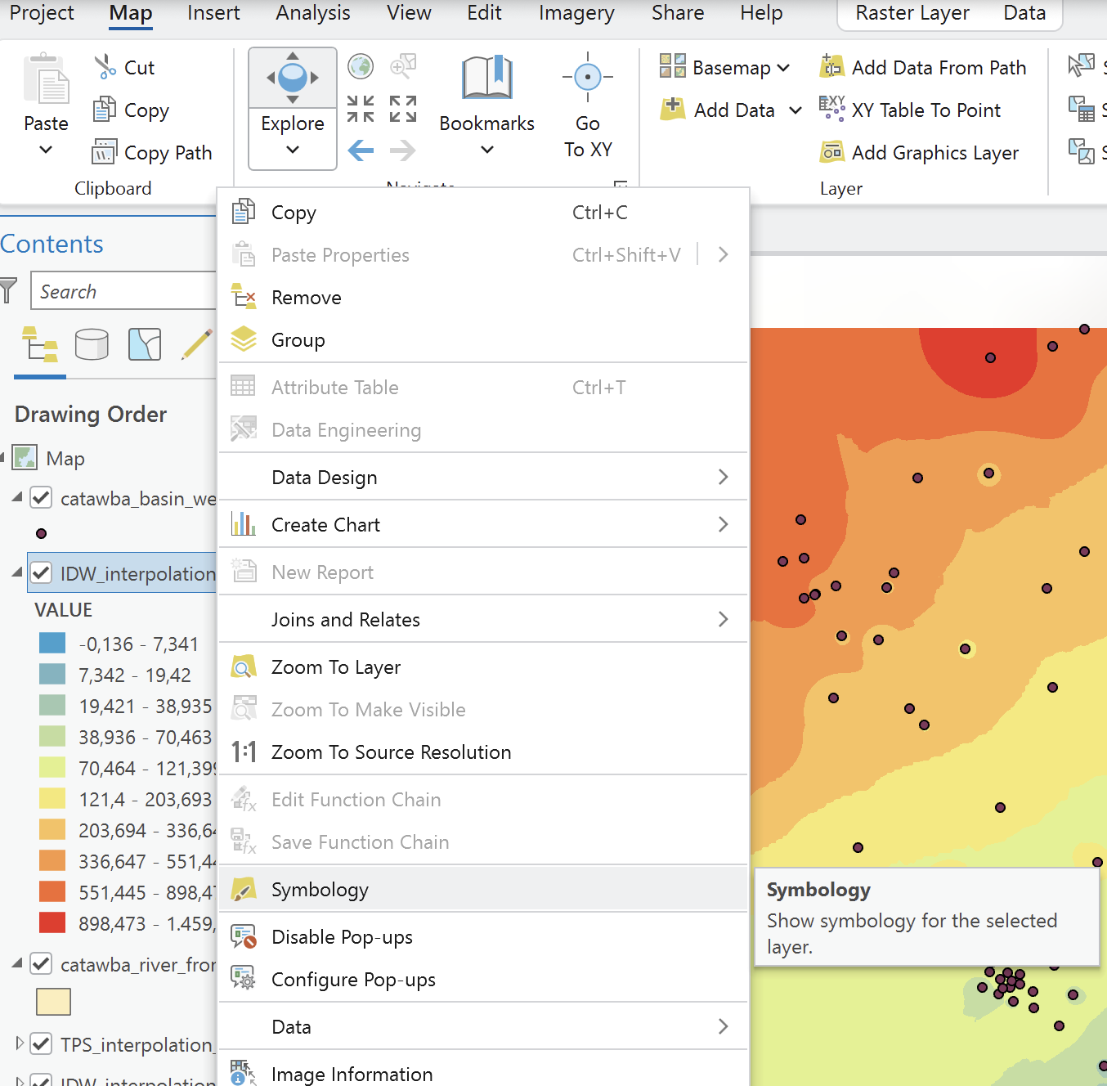

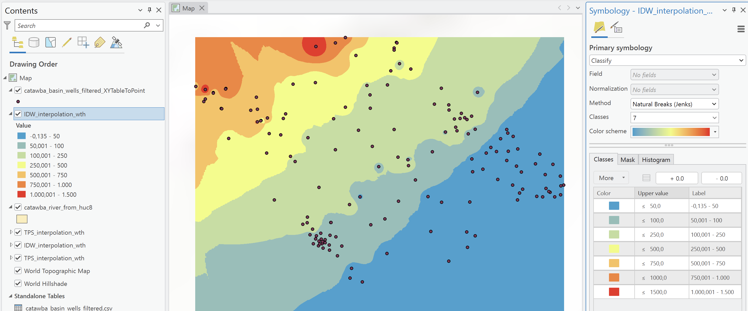

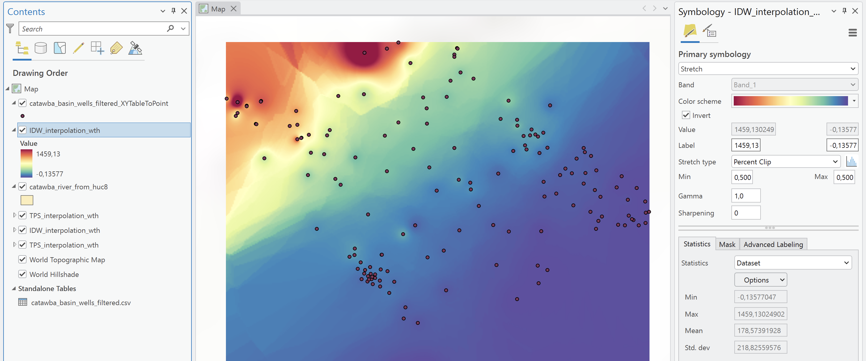

Extracting Equipotential Contours:
- Navigate to: Raster → Extraction → Contour... (Ref: Tutorial Fig. 31)
- Set Input layer: na_freatic_interpolado_TPS.
- Set Interval between contour lines: 10.0 meters.
- Set Attribute name: ELEV.
- Set Contours: Save to file as linhas_equipotenciais.shp. Click Run. (Ref: Tutorial Fig. 32)
- Style contours by enabling Labels (Single Labels → Value: ELEV) and adjusting line weights/colors. (Ref: Tutorial Figs. 33, 34 & 35)

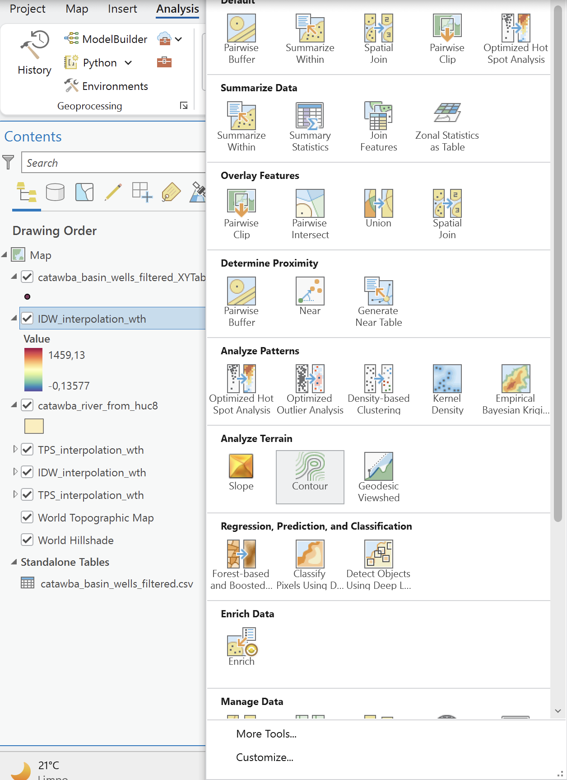 |  | 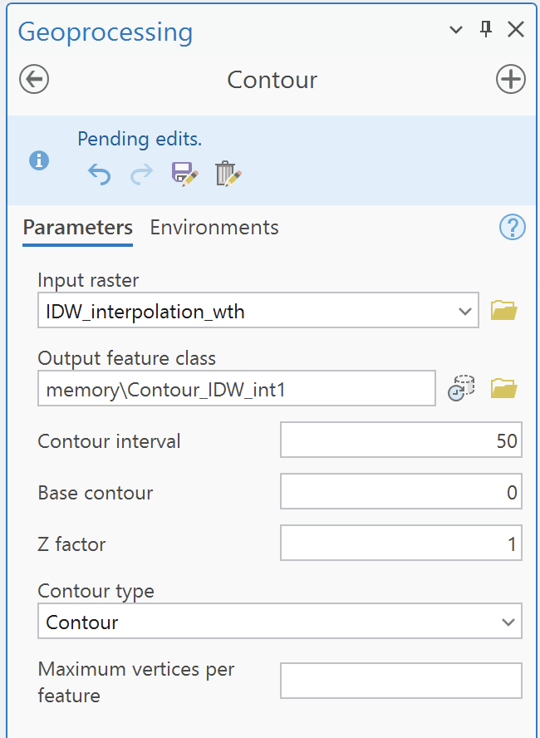

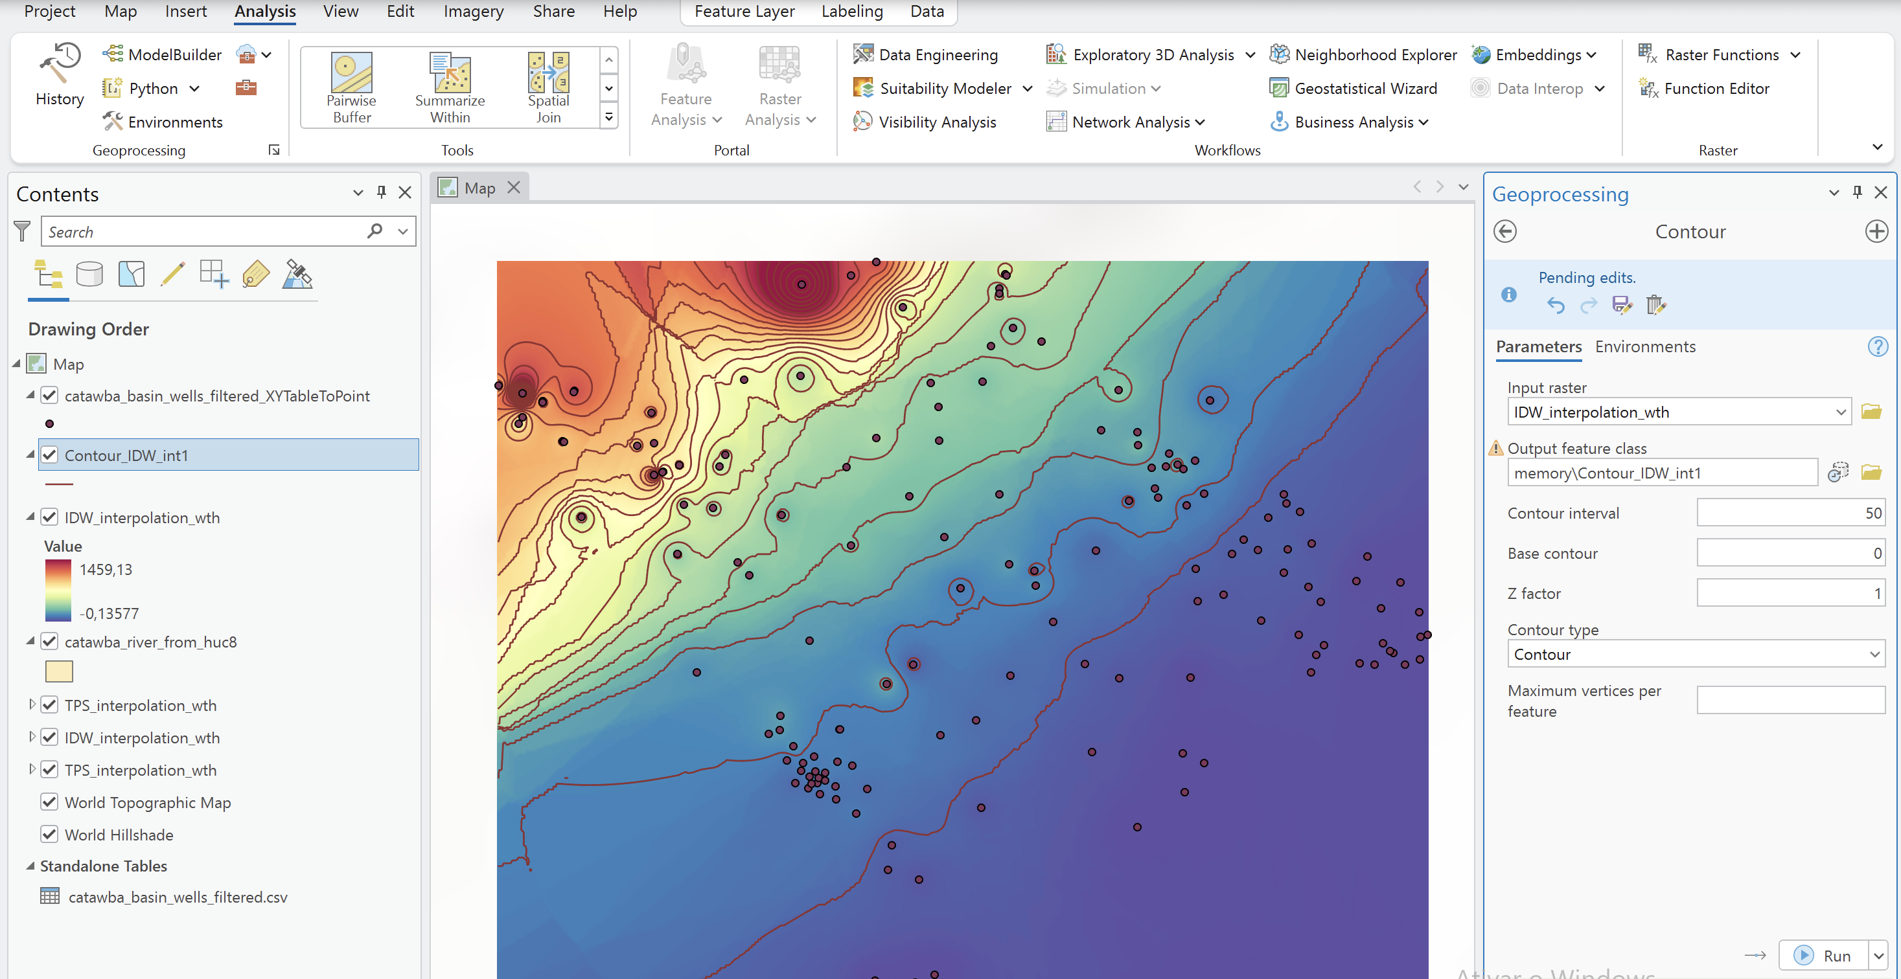

Clipping Contours to the Aquifer Domain:
Navigate to: Vector → Geoprocessing Tools → Clip... (Ref: Tutorial Fig. 36)
Set Input layer: linhas_equipotenciais.
Set Overlay layer: contorno_sab.
Save output as linhas_equipotenciais_recortado.shp and click Run. (Ref: Tutorial Fig. 37)
Optionally repeat clipping using the Catawba River Basin boundary polygon to constrain the analysis domain specifically to CRB. (Ref: Tutorial Fig. 38)

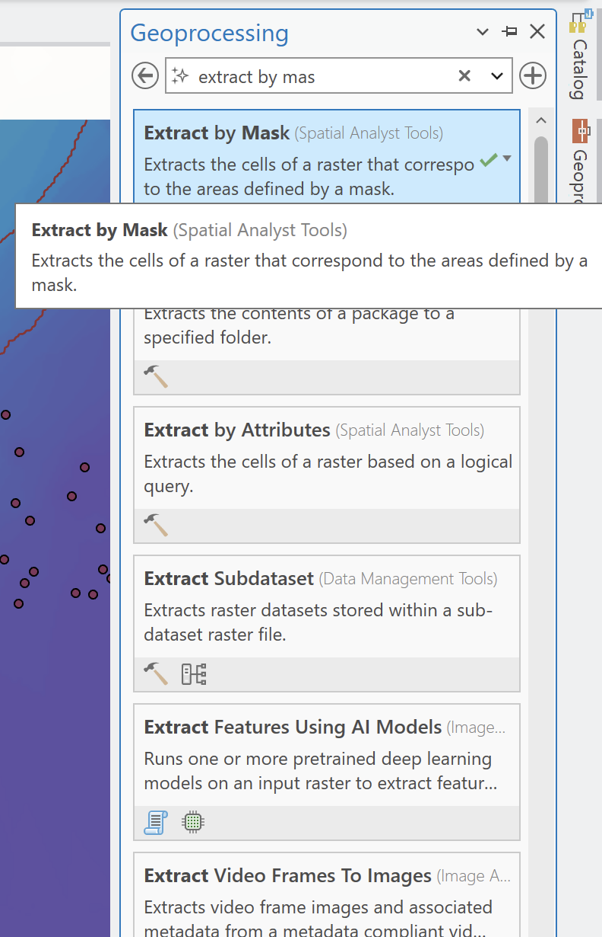 |  | 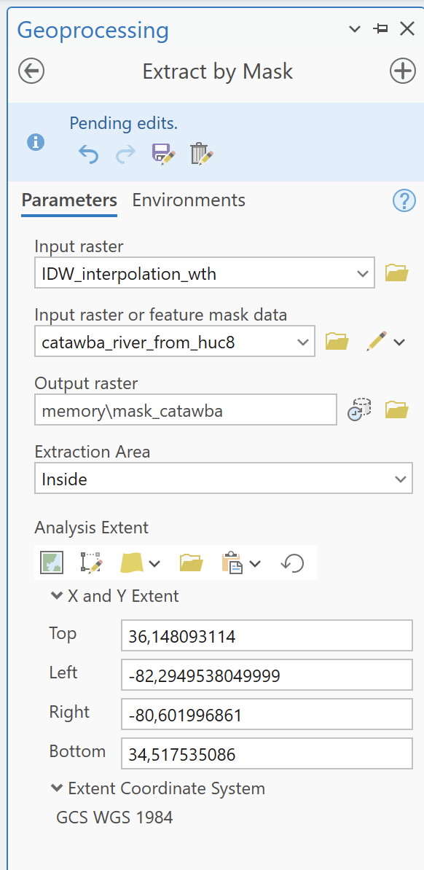

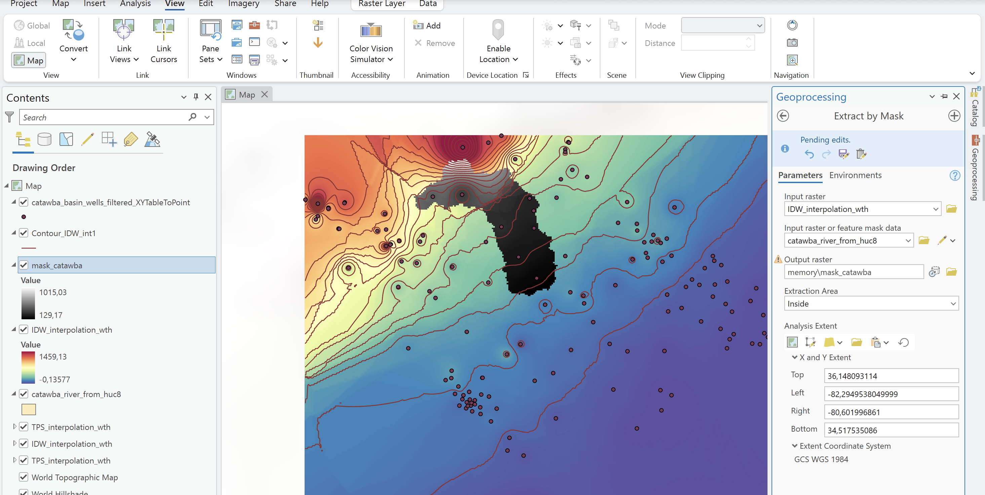

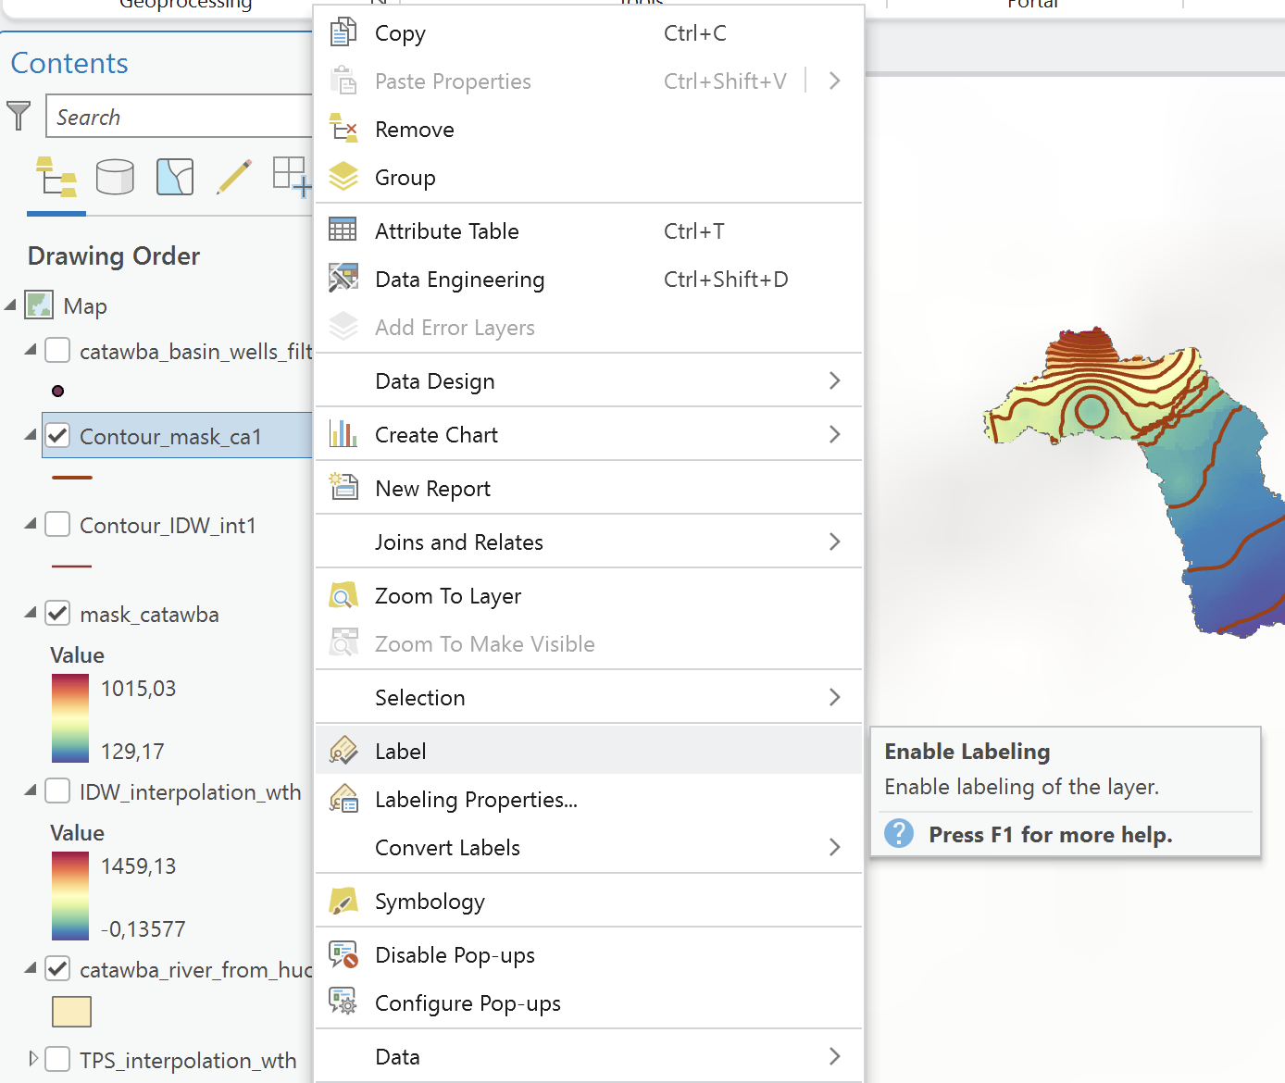

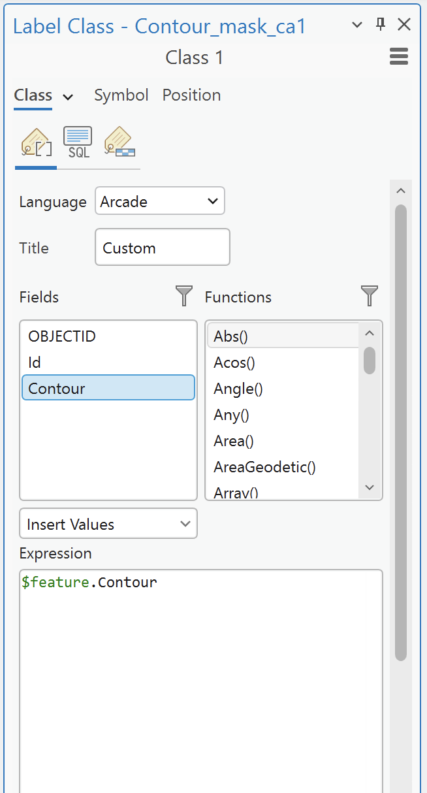

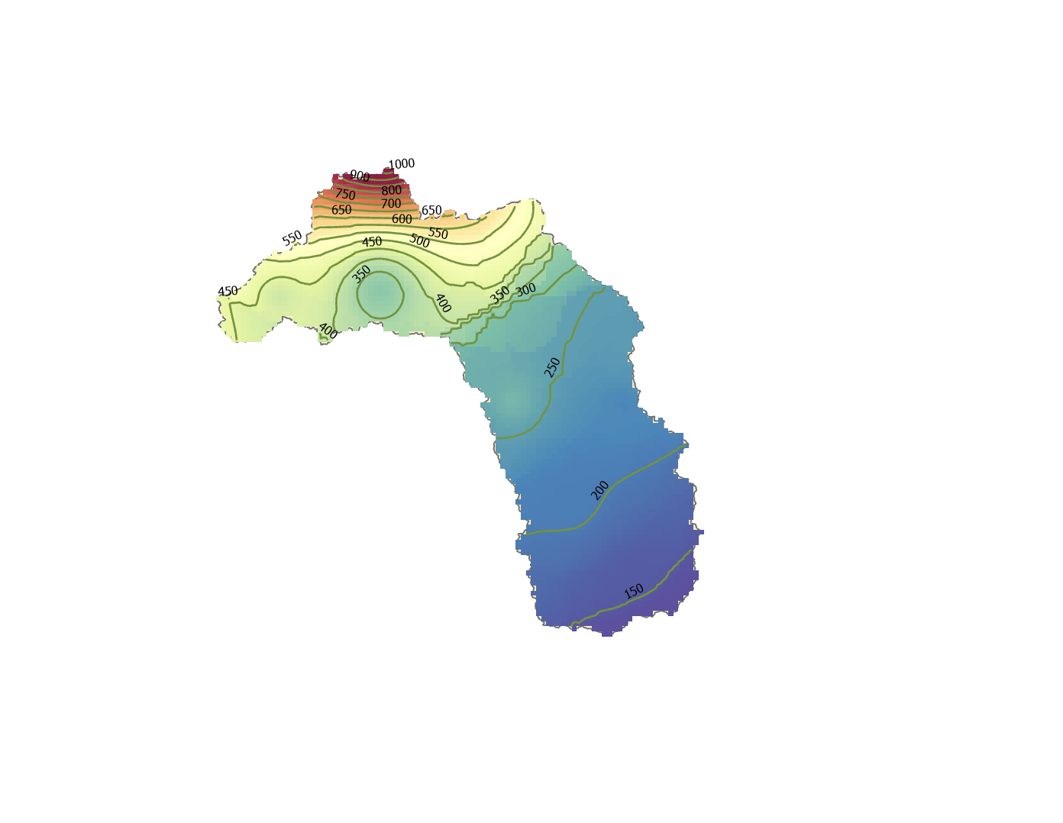

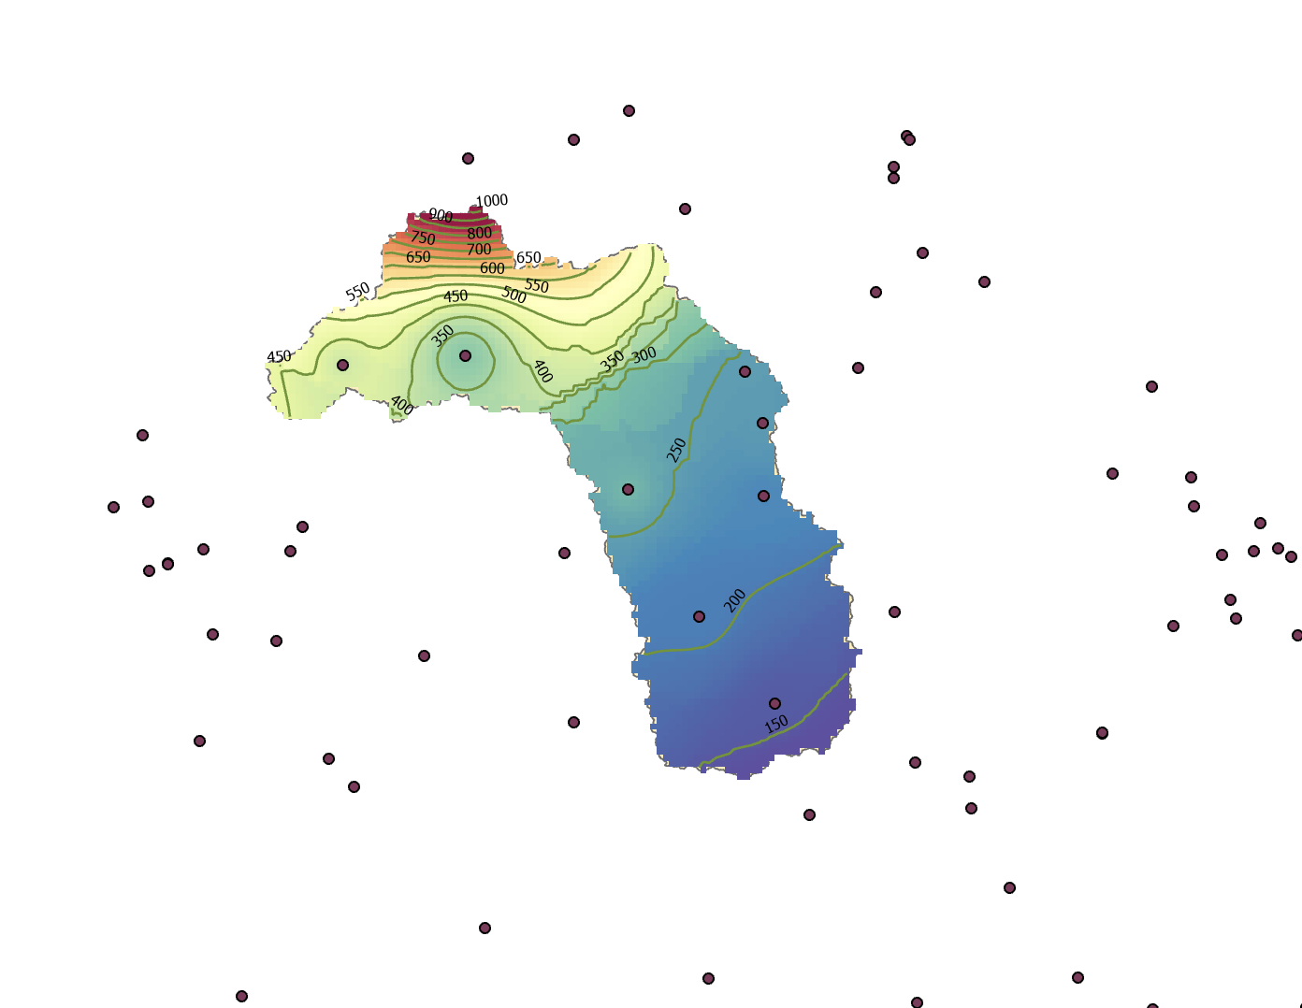

Summary of Activity Requirements (from Assignment Guidelines)
Report Section | Specification / Content Requirement | Limit
Cover Page | Header (University, School, Course), Student full names in alphabetical order with Student IDs (RA), Assignment Title, Course Name, Location (City/State), Year. | 1 page
Theoretical Synthesis | Answer key theoretical questions:  • What is a potentiometric surface map? (Max 4 lines)  • Why must an Environmental Engineer know how to build and interpret potentiometric maps? Cite 3 real-world engineering project applications. (Max 6 lines)  • What are the limitations of a potentiometric map? (Max 5 lines)  • What is the static water level? Why is it inadequate to use static level alone without surface elevation for flow mapping? (Max 5 lines)  • What is hydraulic head and how was it derived in this activity?  • What is a Digital Elevation Model (DEM)? (Max 3 lines)  • Clear theoretical explanation with workflow screenshots, schematics, and proper figure captions. | Max 7 pages
Map Interpretation | Hydrogeological interpretation of SAB equipotential contours and groundwater flow directions across São Paulo State. | Max 3 pages
References | Complete formal citations for all databases, software, and academic references used. | No page limit

Tutorial developed by:

Bruno Ken Marchezepe, PhD Candidate at University of Sao Paulo, email: bruno.marchezepe@usp.br
Paulo Tarso S. Oliveira, Associate Professor at UNC Charlotte, email: polivei2@charlotte.edu

