Project 01: Searching

Delivery System

Group 5 - Report

Table of Contents

1. Group Introduction 3

2. Overview 3

2.1 Purpose, Scope & Brief Description 3

2.2 Construction 3

2.3 Work assignment 4

2.4 Completion rate for project requirements 4

3. Implementation & GUI 5

3.1 Level 1 (Basic level) 5

3.2 Level 2 (Time limitation) 5

3.3 Level 3 (Fuel limitation) 5

3.4 Level 4 (Multiple agents) 5

3.5 Graphic User Interface (GUI) 5

4. Test Case 5

4.1 Test 01 (Test case description) 5

4.1.1 A* Search Result 6

4.1.2 Breadth - First Search Result 7

4.1.3 Depth - First Search Result 8

4.1.4 Uniform - Cost Search Result 9

4.1.5 Greedy Best First Search Result 10

4.1.6 Level 2 Result 11

4.1.7 Level 3 Result 12

4.2 Test 02 (Test case description) 13

4.3 Test 03 (Test case description) 13

4.4 Test 04 (Test case description) 13

4.5 Test 05 (Test case description) 13

5. Demo 13

Project 01 - Report

# Group Introduction

* This project was built, developed, and completed by a group of 4 members:
  + 22127273 - Phan Hải Minh - **Team Leader**.
  + 22127084 - Mai Đức Duy.
  + 22127130 - Nguyễn Trần Minh Hoàng.
  + 22127250 - Trần Thành Long.
* Group number: 5.

# Overview

## Purpose, Scope & Brief Description

* **Purpose:** Develop a comprehensive processing program to find the shortest path from the starting point to the endpoint of one or multiple delivery routes according to different levels (constraints):
  + **Level 1:** Find the basic shortest path (presenting DFS, BFS, UCS, GBFS, A* algorithms) for one delivery route.
  + **Level 2:** Find the shortest and fastest path (with time constraints) for one delivery route.
  + **Level 3:** Find the shortest and fastest path with an additional fuel level constraint (the fuel level must always be higher than 0 throughout the journey) for one delivery route.
  + **Level 4:** Find the shortest and fastest path that meets fuel requirements for multiple delivery routes.
* **Scope & Brief Description:**
  + The search algorithms are implemented on a grid consisting of m rows and n columns representing the map of a city:
    - A cell on the grid can represent either an open area (vehicles can easily move through) or a city building (vehicles cannot move into this cell). Some cells on the grid may indicate starting points (S1, S2,...) and endpoints (G1, G2) of certain delivery routes.
    - Moving between cells on the grid is considered as traveling on a road. At any position on the grid, there are up to four movement options: move up, move down, move left, and move right.
  + The project's task is to find the optimal path that meets the constraints at each required level.

## Construction

* **Programming Language:** Python.
* Including a GUI to visually describe the operation of the search algorithms that are built and presented to address the requirements (learn how to use it in demo video).

## Work assignment

| **STT** | **Description** | **Due Date** | **Responsibility** | **%Complete** |
| --- | --- | --- | --- | --- |
| 1 | Discuss the project requirements and divide the work among the team members. | 08/07/2024 | 22127273 | 100% |
| 2 | Implement Level 1 | 21/07/2024 | 22127273 | 100% |
| 3 | Implement Level 2 | 21/07/2024 | 22127273 | 100% |
| 4 | Implement Level 3 | 24/07/2024 | 22127273  22127250 | 100% |
| 5 | Implement Level 4 | 28/07/2024 |  | 0% |
| 6 | Construct & test GUI | 24/07/2024 | 22127084  22127130 | 100% |
| 6 | Perform preliminary testing of the project to ensure the program operates stably, without conflicts or minor errors. | 27/07/2024 | 22127084  22127130  22127250  22127273 | 100% |
| 7 | Discuss and propose suitable test cases (e.g., special cases, larger input data, etc.). | 27/07/2024 | 22127084  22127130  22127273 | 100% |
| 8 | Prepare the report document and complete it. | 27/07/2024 | 22127250 | 100% |
| 9 | Create a demo video | 28/07/2024 | 22127084 | 100% |
| 10 | Submission | 28/07/2024 | 22127273 | 100% |

## 

## Completion rate for project requirements

| **STT** | **Requirements** | **Responsibility** | **%Complete** |
| --- | --- | --- | --- |
| 1 | Finish Level 1 successfully | 22127273 | 100% |
| 2 | Finish Level 2 successfully | 22127273 | 100% |
| 3 | Finish Level 3 successfully. | 22127273  22127250 | 100% |
| 4 | Finish Level 4 successfully. |  | 0% |
| 5 | Graphical User Interface (GUI). | 22127084  22127130 | 100% |
| 6 | Generate at least 5 test cases for each level with different attributes. Describe them in the experiment section of your report. Videos to demonstrate each test case. | 22127084  22127130  22127273 | 100% |
| 7 | Report algorithms, and experiment with some reflection or comments. | 22127084  22127130  22127250  22127273 | 100% |

# 

# Implementation & GUI

## Level 1 (Basic level)

## Level 2 (Time limitation)

## Level 3 (Fuel limitation)

## Level 4 (Multiple agents)

## Graphic User Interface (GUI)

# Test Case

## Test 01 (Test case description)

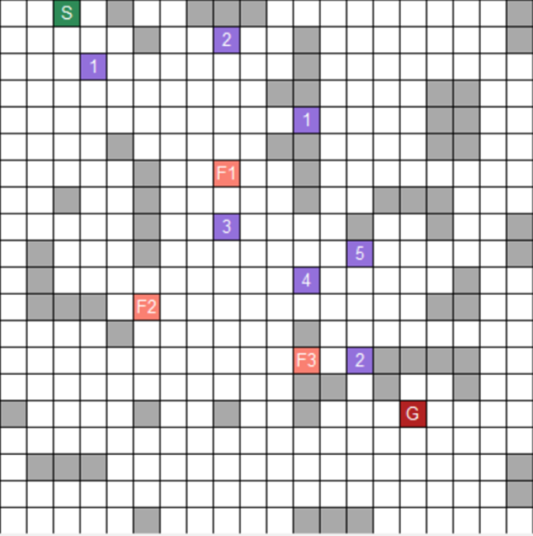

* This is the map for this test case at level 3. This test case is saved in the file “*input_1.txt*”
* With this test case, the start node is at cell (0, 2), and the goal node is at cell (15, 15). This case also has 7 toll booths and 3 gas stations. The time limit is 35 and the fuel limit is 15

### 

### **4.1.1** A* Search Result

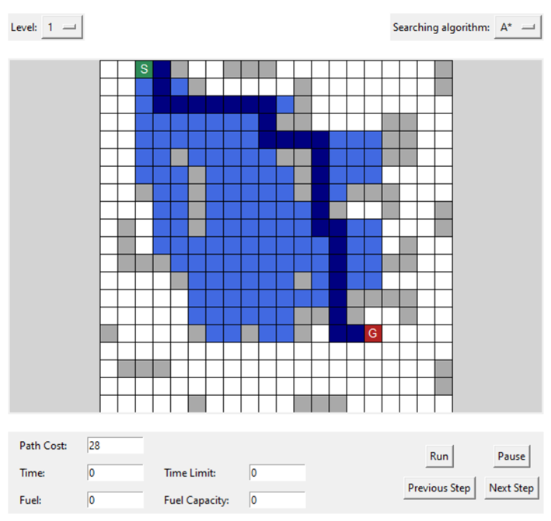

* This is the path that A* algorithm found. The path cost is 28.

### **4.1.2** Breadth - First Search Result

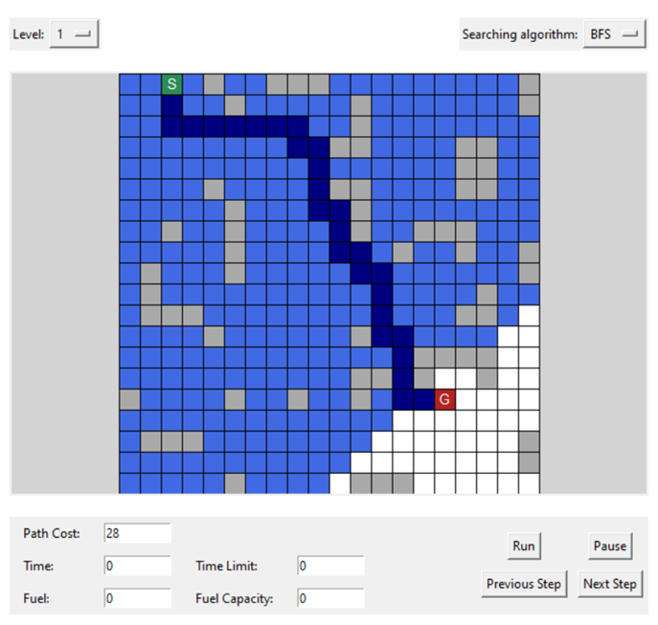

* This is the path found using BFS. The path cost is 28, the same as A*.

### **4.1.3** Depth - First Search Result

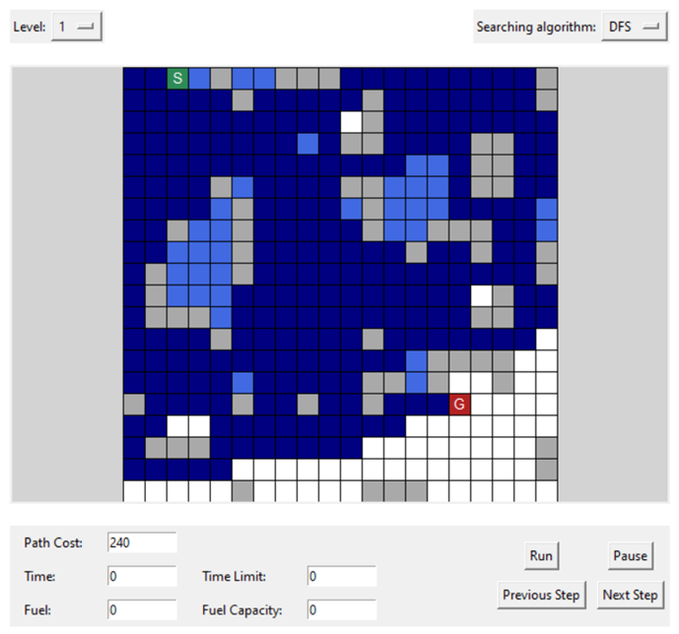

* With DFS, the path cost is 240. It shows the disadvantage of DFS. The path found is very long and time consuming compared to BFS and A*

### **4.1.4** Uniform - Cost Search Result

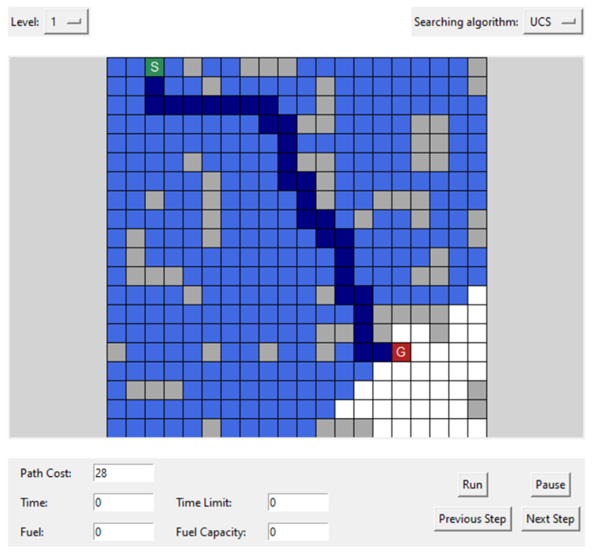

* The path found by UCS is the cost-optimal path with the cost of 28.

### **4.1.5** Greedy Best First Search Result

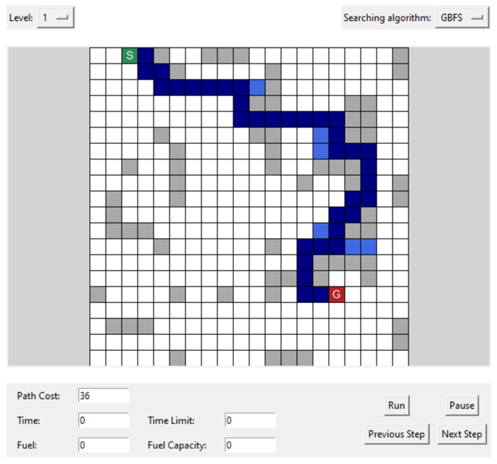

* This is the path found by GBFS with the path cost of 36

### **4.1.6** Level 2 Result

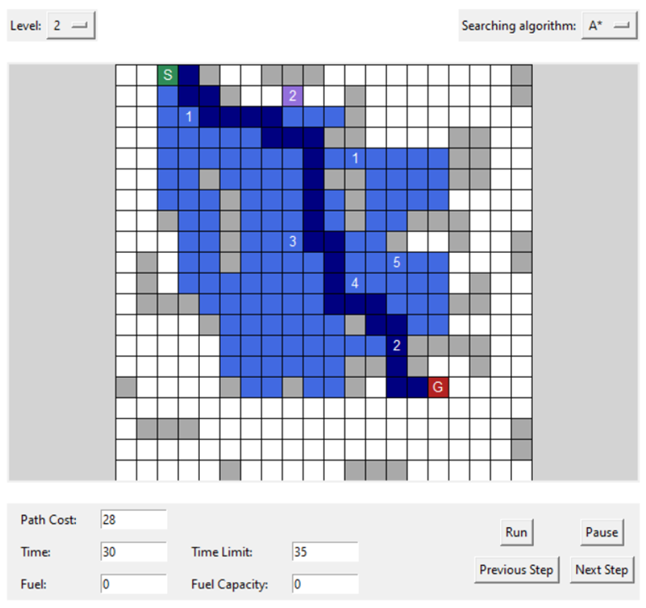

* This is the result for level 2 with time limitation. It uses A* for its search algorithm, but the path is different from the path in level 1 A*. Because if it follows the same path as in level 1, it will reach the time limit.
* The path cost is 28, the same as in level 1. The time needed is 30. This is acceptable because the time limit is 35.

### **4.1.7** Level 3 Result

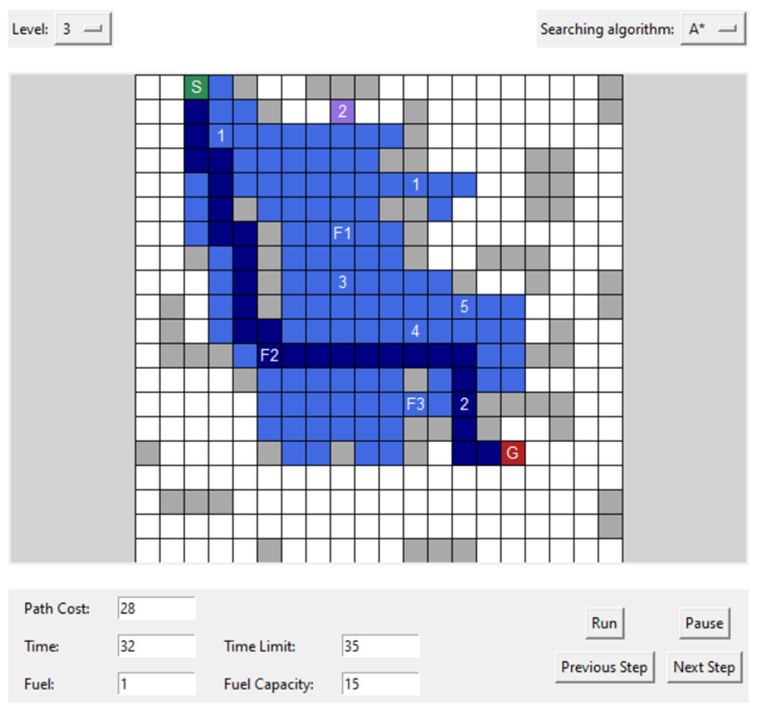

* With level 3, the search algorithm is A*, but the path is now completely different from the path in level 2. Because if it follows the same path, the fuel will not be enough.
* The path cost is 28, and the delivery time is 32, still acceptable. The remaining fuel is 1.

## Test 02 (Test case description)

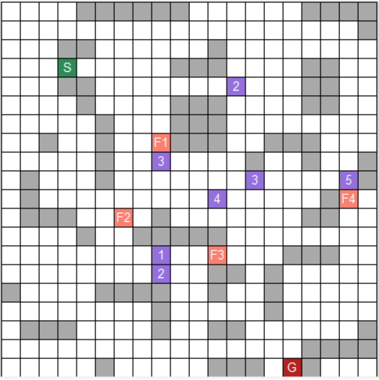

* Here is the map at level 3 for test case 2. It is stored in the file “input_2.txt”
* With this test case, the start node is at cell (3, 3), and the goal node is at cell (19, 15). This case also has 7 toll booths and 4 gas stations. The time limit is 35 and the fuel limit is 20

### ***4.2.1*** *A* Search Result*

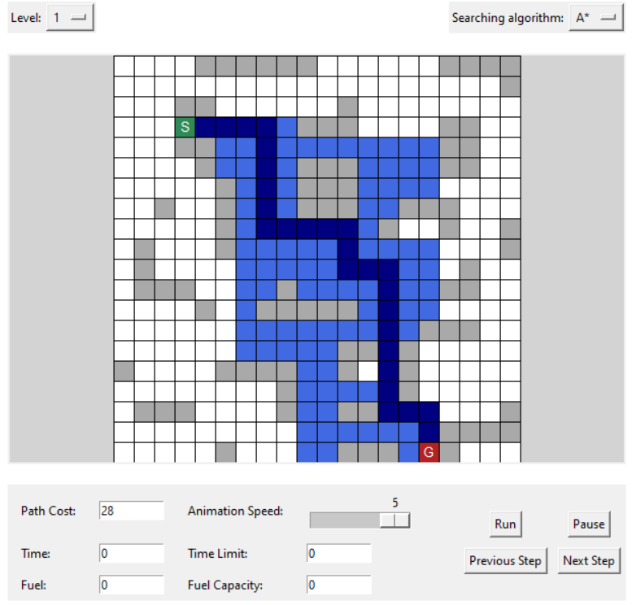

* This is the path that A* algorithm found. The path cost is 28.

### **4.2.2** Breadth - First Search Result

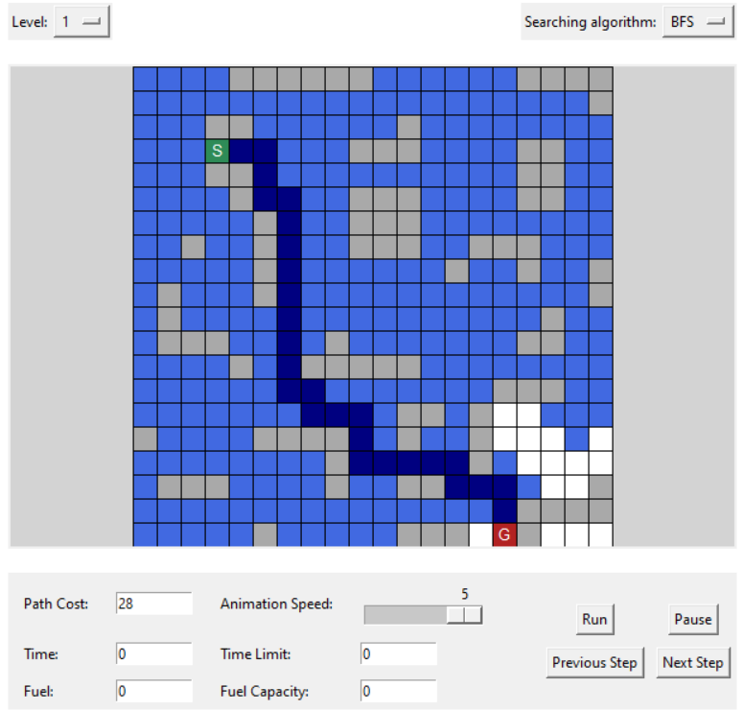

* This is the path found using BFS. The path cost is 28, the same as A*.

### **4.2.3** Depth - First Search Result

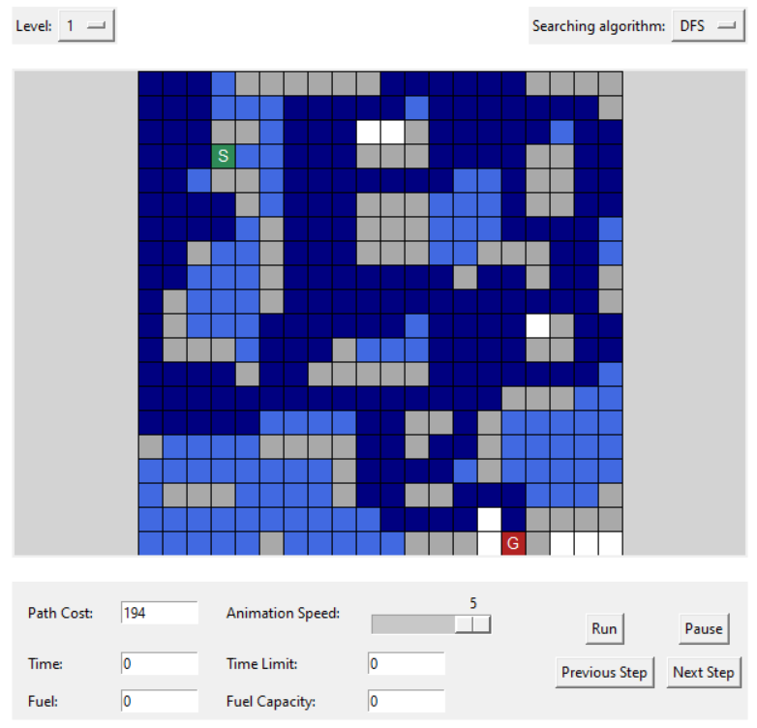

The path found with DFS in this test case is somewhat similar to test case 1. DFS has to expand a great amount of cells, and the path found is long and time consuming compared to BFS and A*

### **4.2.4** Uniform - Cost Search Result

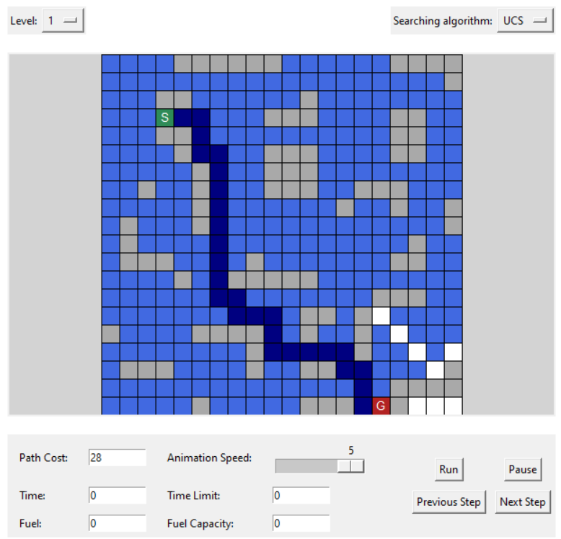

UCS expands quite a lot of cells, but the path found is cost-optimal with the cost of 28.

### **4.2.5** Greedy Best First Search Result

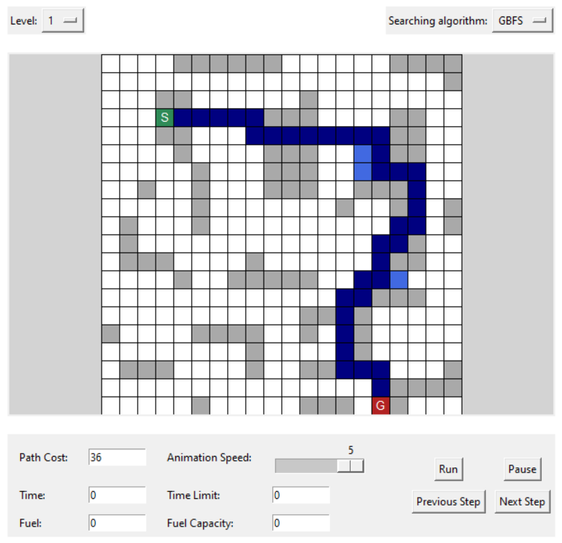

In this test case, GBFS expands quite a few cells, but the path found is not cost-optimal. However, this algorithm takes the least time to run and expands the fewest cells compared to the other algorithms mentioned above.

### **4.2.6** Level 2 Result

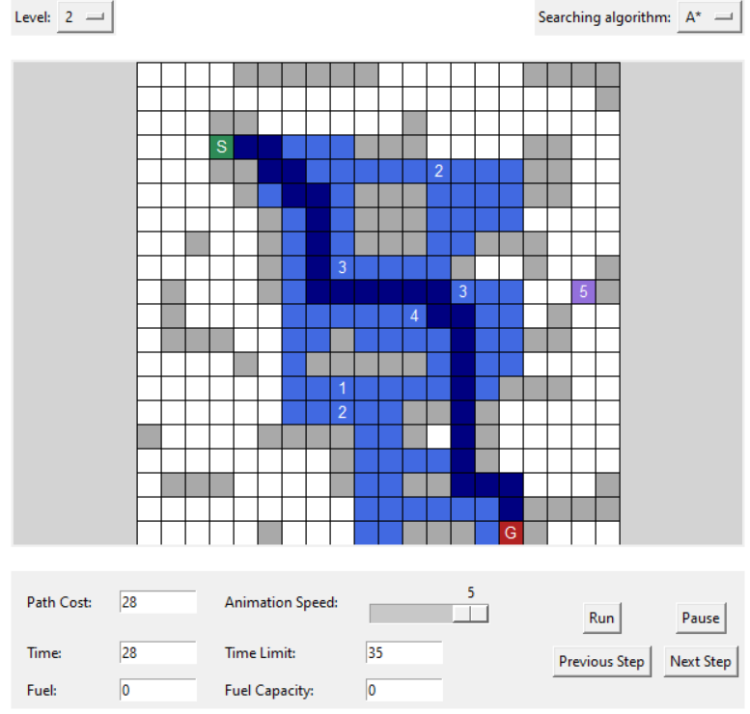

The path found in level 2 is quite similar to the path found by A* in level 1. The difference is that it avoids the toll booth to lower the delivery time.

The delivery time is 28, which is acceptable compared to the time limit of 35

## Test 03 (Test case description)

## Test 04 (Test case description)

## Test 05 (Test case description)

# Demo