BeyondTouch project report
Real football events with replayable movement evidence

Purpose and current result
BeyondTouch helps a judge, fan or analyst inspect movement that ordinary touch statistics do not describe. The updated demo puts real events first: a supplied evidence case for Ángel Di María’s 2022 World Cup final goal and twelve Premier League sequences from Liverpool’s 2019 matches. Each case exposes its source, player identity, available numbers and limitations. The earlier twelve synthetic scenarios remain a separate full-model validation laboratory.
The central design rule is to distinguish what was observed from what a model estimates. Rendered plot values are not treated as raw tracking. Partial educational tracking is not treated as a complete professional dataset. Synthetic pitch-control results are not transferred to real matches.
Evidence class | Included material | Supported output
World Cup final | Full Basel visualizations and checkpoints | Source-annotated ΔPC values and visual explanation
Premier League | Twelve Last Row goal sequences | Approximate paths and conditional moving-scene sensitivity
Synthetic validation | Twelve authored 50 Hz fixtures | Full pitch-control sensitivity and receiving-window tests

What the judge receives
Download and extract the repository, then open START_HERE.html. No Python, account, API key or server is needed to view it. The featured World Cup case, twelve Premier League cards, saved videos and written analyses are all available offline. The validation laboratory is collapsed below the real cases. A single MP4 evidence explainer and one PNG picture are supplied for the submission form.

Project foundation
The code extends Bassel Hammad and coauthors’ off-ball attacking influence research, LaurieOnTracking and a Spearman-style pitch-control implementation. New work adds quantitative metrics, input and possession-role corrections, reproducible examples, source-aware explanations and a simple judging workflow. Credit for earlier research is preserved separately from the new product work.

Di María World Cup final evidence
FIFA identifies Ángel Di María as Argentina’s scorer in the 36th minute of the final against France on 18 December 2022. The user supplied Basel’s rendered pitch-control visualizations for this event. The complete supplied animations, the sequence 94 video and three annotated checkpoints are included and inspected. No tracking CSV, numeric grid, player-dot mapping or exact ΔPC baseline definition was supplied.
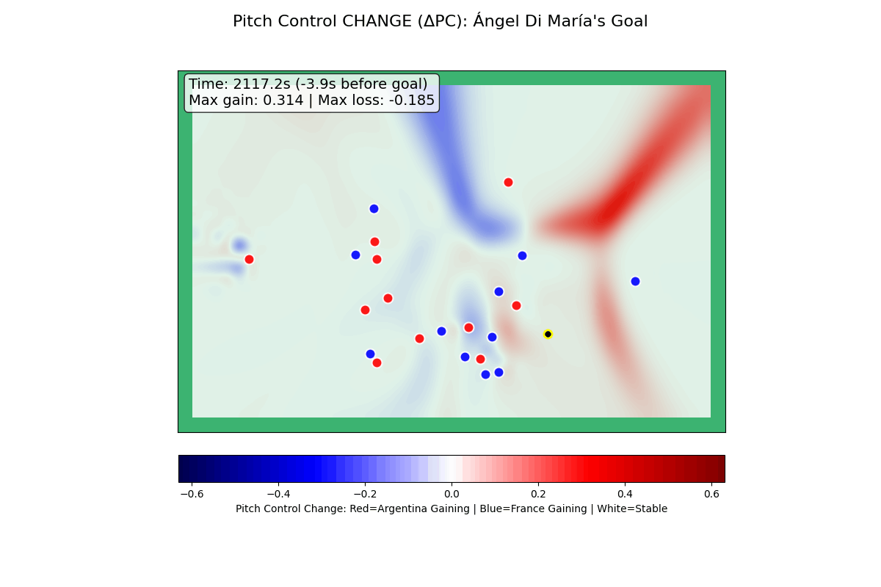
Source clock s | Goal marker offset s | Displayed max gain | Displayed max loss
2111.2 | -9.9 | +0.047 | -0.027
2117.2 | -3.9 | +0.314 | -0.185
2123.1 | +2.0 | +0.209 | -0.145
These are transcribed extrema of the displayed ΔPC field, not total area, xG or exclusive Di María credit. The plot clock and goal marker are source annotations rather than independently aligned broadcast times. The after-goal frame is context only. The upload video uses the full supplied rendered animation and attributed event analysis; it is not a reconstruction of raw tracking. Raw movement metrics remain unavailable for this case. Independently sourced StatsBomb analysis gives shot xG 0.30340916, five completed passes and 9.757 seconds from the first recorded pass to the shot. The provider shot value is not off-ball run credit, and its event clock is not aligned to the supplied plot.

Twelve real Premier League sequences
The table uses Ricardo Tavares / Last Row’s educational trajectories. Path lengths are approximate nominal metres obtained by scaling normalized coordinates onto an assumed 105 × 68 m pitch. Actual pitch calibration is unverified. Source scorelines describe the goal-state, not necessarily the final result. Each case includes its focus player, date, official context link, source subset, evidence CSV and replay.
ID | Source goal-state | Focus | Path m* | Clip s | A D
PL-01 | Bournemouth 0 - 3 Liverpool | Naby Keïta | 35.66 | 8.50 | 7 / 10
PL-02 | Fulham 0 - 1 Liverpool | Roberto Firmino | 49.70 | 9.10 | 9 / 11
PL-03 | Leicester 0 - 3 Liverpool | Trent Alexander-Arnold | 25.54 | 6.20 | 10 / 11
PL-04 | Liverpool 1 - 0 Everton | Sadio Mané | 54.88 | 9.90 | 10 / 11
PL-05 | Liverpool 1 - 0 Watford | Sadio Mané | 70.17 | 11.20 | 10 / 11
PL-06 | Liverpool 1 - 0 Wolves | Trent Alexander-Arnold | 37.79 | 7.80 | 8 / 11
PL-07 | Liverpool 2 - 0 Everton | Sadio Mané | 72.86 | 14.30 | 10 / 11
PL-08 | Liverpool 2 - 0 Man City | Andy Robertson | 39.46 | 8.30 | 10 / 11
PL-09 | Liverpool 2 - 1 Newcastle | Roberto Firmino | 30.67 | 7.40 | 10 / 11
PL-10 | Liverpool 3 - 0 Bournemouth | Roberto Firmino | 51.54 | 7.70 | 8 / 10
PL-11 | Liverpool 3 - 0 Norwich | Jordan Henderson | 25.68 | 7.40 | 8 / 10
PL-12 | Southampton 1 - 2 Liverpool | Mohamed Salah | 77.78 | 12.80 | 8 / 9
* Approximate path under nominal pitch scaling. A D gives observed attacker and defender counts. Missing players and manually collected trajectories mean these are illustrative measurements, not research-grade player performance statistics.
Native source cadence remains 20 Hz. The browser interpolates positions for a 50 Hz display only; calculations retain the original samples. Preview exports are 5 fps. More display frames do not add observations or establish accuracy. Opponents and unnumbered players keep local source IDs rather than invented names. The current source does not supply synchronized possession/pass-release labels, so measurements cover the whole clip and can include on-ball movement or aftermath.

How the metrics should be explained

Observed movement in real educational tracking
Focus path is the sum of distances between consecutive source positions. Displacement is the straight-line distance from first to last position. Directness is displacement divided by path length. Source coordinates are scaled from 0–100 using 105 metres along x and 68 along y; these dimensions are assumptions, not a certified calibration. Frame times are source frame differences divided by 20.
Nearest observed defender gap is the smallest distance to a defender actually represented in the source. Omitted players may be closer. Up to two observed defenders within ten nominal metres of the focus at clip start are selected for associated travel. Their path lengths are observations, not distance caused by the focus. Goalkeeper identities are not inferred for this selection.
Time with an observed gap of at least three nominal metres sums qualifying native intervals using a left-interval rule. It is a separation-only diagnostic. It does not establish onside position, clear passing lanes or sufficient pitch control, so it is not labelled the full candidate receiving window.

Moving scene model comparison
For the real educational cases, all other observed players and the ball use their actual endpoint states. Only the selected focus player is held at its first observed position and velocity in the reference scene. The difference in pitch-control surfaces is weighted by nominal cell area. This removes the assumption that unrelated players remain frozen at run start. It is a conditional model-state contrast, not a counterfactual simulation of defender responses. Missing players, unknown goalkeeper identities, unverified scale and unavailable offside eligibility remain explicit. The 50-column surface is compared with a 75-column reference as a numerical diagnostic.

Full model metrics in synthetic validation
The inherited pitch-control engine compares a baseline with a counterfactual in which only one runner’s position and velocity advance to the run end. Cell control differences multiplied by physical cell area produce gains, losses and net control-equivalent m². Penalty-area cells use fractional overlap. This is endpoint model sensitivity, not causal credit or repeatedly accumulated space.
The synthetic receiving-window rule requires onside position, at least three metres of receiver separation, pitch control of at least 0.65 and straight-lane clearance of at least 1.5 metres. The 50 Hz synthetic pipeline and its finer-grid, reaction-time and integration-step checks remain available through the validation command. No synthetic numeric result is assigned to a real case.

Unavailable values stay unavailable
StatsBomb supplies shot xG as context for Di María’s shot; it is not a value assigned to his off-ball movement. No xG is supplied for the Premier League trajectories. We do not estimate energy expenditure from travel, assign a later goal’s value to a runner, or interpret a residual as pure synergy. Complete-match pitch control and the full receiving-window test are not asserted for partial real tracking; the conditional moving-scene contrast is labelled separately. Di María’s displayed ΔPC extrema cannot be integrated into m² without the original grid and a verified definition.

Run judge and developer workflows

Judge workflow without Python
Download the repository ZIP, extract it, and double-click START_HERE.html. Start with the Di María evidence page, then compare the Robertson and Salah Premier League sequences. Each case README can also be read on GitHub with an embedded animation. The upload files are in uploads/. The code and tests are under src/, while this report and the metric guide are under guide/.

Recalculate on macOS or Linux
cd "$HOME/Desktop/BeyondTouch"
git pull --ff-only
bash run.sh --all
open outputs/examples/index.html
The launcher selects Python 3.12 and installs pinned NumPy, pandas and Pillow dependencies into a virtual environment when required. Use --case 1 for one real case, --check for the tests, or --synthetic --all for the separate full-model laboratory. On Linux open the printed gallery path in your browser instead of using the macOS open command. Windows uses run.bat with the same options. No IDE or notebook platform is required.

Verification and limitations
Twenty-six unit and regression checks cover the original model, real-source scaling, cadence, duplicate/gap rejection and scene construction. The moving-scene checks confirm that only the focus changes between reference and observed endpoint states, that initial scenes agree, and that a stationary focus does not receive credit for other players’ motion. Package checks verify identities, source coverage, retained World Cup annotations, local links and replay/media files. Numerical consistency is distinct from empirical football accuracy. The next accuracy step requires licensed complete tracking, identity mapping, event synchronization and external validation.

Explanation and generative AI status
Current text is deterministically generated from evidence. A generative service is not connected. The developer guide supplies instructions for a future explanation model: preserve evidence class, signs, units, provenance and missing values; distinguish observation from sensitivity; never invent intent, names, xG or causal effort; validate every numerical claim against its source.

Primary sources
StatsBomb derived event analysis is credited with its logo in the featured case and upload video. Raw event data are not redistributed. Its provider agreement is included in guide/STATSBOMB_LICENSE.pdf and is distinct from the code license.
FIFA match context: https://www.fifa.com/en/tournaments/mens/worldcup/articles/argentina-france-2022-final-greatest-games
Last Row source and limitations: https://github.com/Friends-of-Tracking-Data-FoTD/Last-Row
Thesis implementation: https://github.com/bassel-hammad/LaurieOnTracking
Project: https://github.com/hydrosmasher/BeyondTouch

