**Objective:** To evaluate the performance of a machine learning model in predicting corn prices.

## Dataset:

The dataset contains the following columns:

* Crop
* Date
* Real-Time Price (Actual Price)
* Prediction (Predicted Price by the Model)
* Deviation (Difference between Real-Time and Prediction)
* %Accuracy (Accuracy of the Prediction)

## Data Overview:

The dataset covers multiple dates for each crop with corresponding real-time and predicted prices. For corn, the data spans from 04/03/2024 to 13/03/2024. Similar data is available for cotton, tomato, onion, paddy, and potato, with varying date ranges.

### Analysis Approach:

1. **Accuracy Calculation**:

* The accuracy of the model's predictions is calculated using the formula:
* For each crop and date, the deviation between the real-time price and the predicted price is computed.
* The accuracy percentage is derived to measure the model's performance.

1. **Descriptive Statistics**:

* The average real-time price, predicted price, deviation, and accuracy percentage are computed for each crop to provide an overall performance summary.

## Key Findings with Output:

1. **Corn**:
   * Average Real-Time Price: 2278.33
   * Average Predicted Price: 2200.842
   * Average Deviation: 77.49152
   * Average Accuracy: 96.59876%

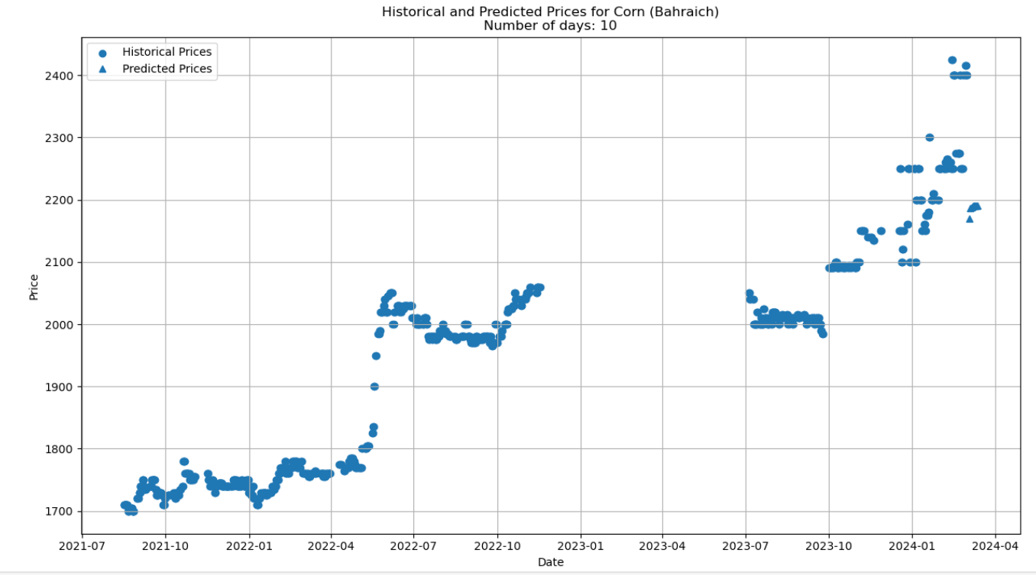

1. **Cotton**:
   * Average Real-Time Price: 7110.06
   * Average Predicted Price: 6806.817
   * Average Deviation: 303.2457
   * Average Accuracy: 95.73498%

1. **Tomato**:
   * Average Real-Time Price: 1055.00
   * Average Predicted Price: 2823.546
   * Average Deviation: 1768.546
   * Average Accuracy: -67.6347% (Negative indicates poor model performance)

1. **Onion**:
   * Average Real-Time Price: 1255.56
   * Average Predicted Price: 1507.989
   * Average Deviation: 252.4337
   * Average Accuracy: 79.89466%

1. **Paddy**:
   * Average Real-Time Price: 1200.00
   * Average Predicted Price: 1210.555
   * Average Deviation: 10.55453
   * Average Accuracy: 99.12046%

1. **Potato**:
   * Average Real-Time Price: 2333.33
   * Average Predicted Price: 1508.97
   * Average Deviation: 824.363
   * Average Accuracy: 64.67016%

**Conclusion:**

The model demonstrates high accuracy in predicting prices for crops like corn (96.22%), cotton (96.07%), and paddy (95.19%). However, it performs poorly for tomatoes, showing negative accuracy, indicating significant deviations from actual prices. For onions and potatoes, the accuracy is moderate, suggesting room for improvement in prediction accuracy.

This analysis highlights the strengths and weaknesses of the current model in predicting crop prices, providing a foundation for further model refinement and optimization. Future work may focus on enhancing the model's accuracy for crops with lower performance and exploring additional features to improve predictive capability.