**iMoMo hydro-climatological information system**

**What is it?**

The iMoMo hydro-climatological information system consists of a hydrological model which can simulate water fluxes on a sub-basin scale. Satellite and ground data (meteorological stations and gauging stations data) can be assimilated with the help of the Ensemble-Kalman-Filter to ensure the best possible representation of the current real situation in the catchment. From there, forecast from numerical weather models can be used to estimate the hydrological situation for the near future.

**How to set up the system for a new catchment?**

1. **Start the *setupGui.m* file in the folder *src/setup***

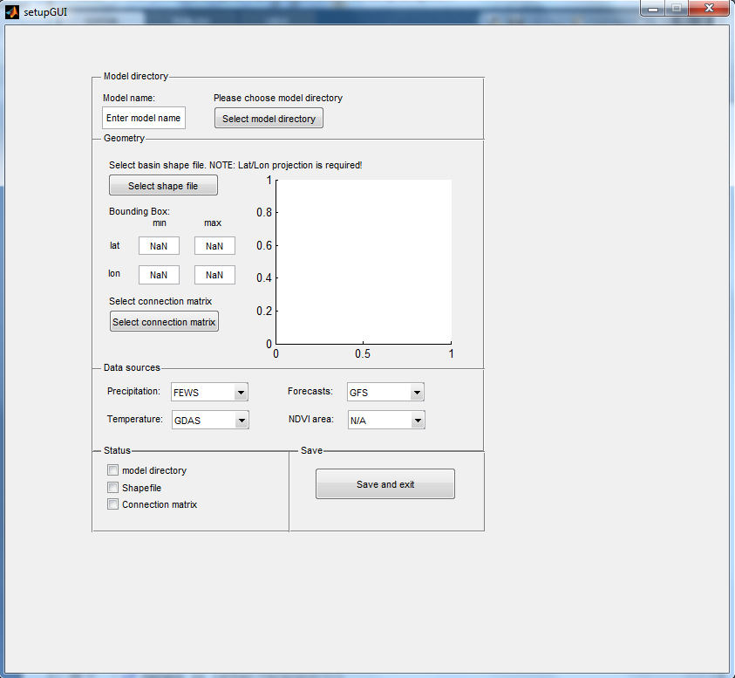

*Fig.1. Graphical user interface to set up the system for a new catchment.*

1. **Enter a model name and choose a model directory**

* Best practice: choose the folder RRM/app
* The folder structure is generated in the chosen directory

1. **Select a 2D basin shape file with a WGS84 coordinate system**

* Check the displayed shape file
* One can manually increase the area of interest by adjusting the bounding box

1. **Select a connection matrix specifying the organization of the subcatchments**

* See for example the connection matrix of the Themi

1. **Select a precipitation data source**

* At the moment only FEWS (see *getFEWS.m*) or TRMM (see *getTRMM.m*) is available

1. **Select a air temperature data source**

* At the moment only GDAS is available (see *getGDAS.m*)

1. **Select a weather forecast data source**

* At the moment only GFS is available (see *getGFS.m*)

1. **Select a NDVI area**

* Only the listed areas are available

1. **Push the save and exit button**

* The folder structure is generated in the chosen directory
* The file *setup.m* is generated in the folder *app/yourModel/src* containing all relevant information
* The file *master.m* is generated *app/yourModel/src*, which with execution starts the whole system

**How to start the system?**

1. **First installation**

* Add the model path specified in the GUI to your Matlab paths
* Add the model path *RRM/src* to your Matlab paths if you haven’t done it before
* Adjust the parameter files in the folder *RRM\app\yourModel\prm*
* Provide the files *E.mat* and *S0G0.mat* in the folder *RRM\app\yourModel\resources\restart* and the file *samples.mat* in the folder *RRM\app\yourModel\resources\samples* (this should be done automatically in the future!)
* Run the file *master.m* which was generated by finalizing the GUI

1. **Restart**

* Check the date of your latest successful execution of *getRaw.m*
* Adjust the parameter *ndays* (line 40) in the file *getRaw.m* accordingly if the latest successful execution was longer than 2 days ago.
* Run the file *master.m*
* If the model runs successful you can reduce the *ndays* parameter again

**Short description of the most important scripts:**

setupGUI.m

* Sets up the path directory and copies all necessary files
* Catchment organization is specified through the shape file and connection matrix
* Data resources are specified
* Creation of the file master.m containing timer object definition

getRaw.m

* Download of precipitation data from FEWS or TRMM
* Download of temperature data from GDAS
* Download of precipitation and temperature forecast data from GFS
* Download of WMO station data (if available)
* Download of latest eNDVI image (if available)
* Download of latest entries from the iMoMo database

processRaw.m

* Elevation adjustment and bias correction of temperature and precipitation
* Calculation of potential evapotranspiration using Hargreaves equation and crop coefficients obtained by eNDVI
* Downscaling of temperature, precipitation and potential evapotranspiration to sub catchments

runModel.m

* Assimilation of model states and forecasting of hydrological variables

sendtoDB.m

* Send processed data and model results to iMoMo database