How to Connect to Google Code using Eclipse Ganymede:
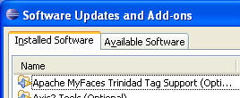
- Go to Help >> Software Updates
- Press the Available Software tab
- Press Add Site
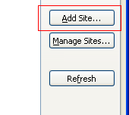
- Enter:
http://subclipse.tigris.org/update_1.6.x
and press OK
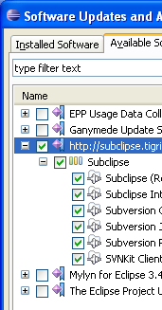
- Check the box next to the added site and press install
- Exit out of the Software Updates
- Open the perspective SVN Repository Exploring
  - 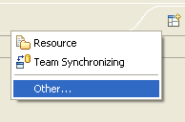
  - 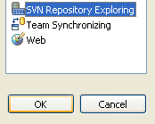
- Under the SVN Repository tab, right click and press new
- Enter:
https://healthpack.googlecode.com/svn
- Mine doesn’t prompt me anymore, but I think you need to enter
USERNAME: Vahan (im not sure if it was this or my gmail address)
PASSWORD: HU4Xw8DA8Qr2
(note: the password is found in google code under
- Now you can right click on the repository and checkout like you used to do for other projects.

