The game of set consists of a deck of 81 unique cards. Each card has a different combination of one of the three shapes (oval, squiggle, diamond), one of three shadings (solid, striped, open), one of three colors (red, green, purple), and either one two or three of that specific combination printed on the card.

As shown below:

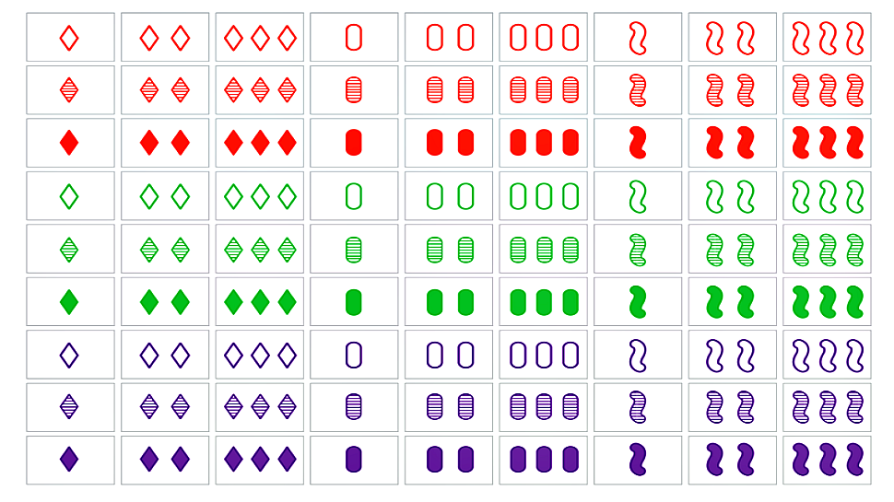

<https://geekandsundry.com/the-card-game-that-puzzled-mathematicians-for-decades/>

To start the game, we randomly deal out 12 cards, placing them in a 3 by 4 grid, face-up. The player tries to find a SET of three anywhere on the grid, removing the three cards if they find one. A SET includes: three cards that share only one common attribute, or three cards that share no common attributes.

Below is a visual example from <https://www.setgame.com/sites/default/files/instructions/SET%20INSTRUCTIONS%20-%20ENGLISH.pdf>:

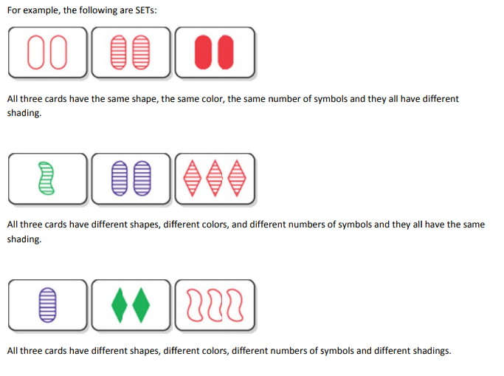

The game continues until no more cards remain (ideally). Or the game ends when no more SETs can be made with the cards laid out (note there are some iterations of this game where three new cards are laid out in this situation, but for the sake of this NP problem, we are playing the hard core way, so no adding cards!) Additionally, this game could be played with multiple players, where the person who collects the most sets at the end wins, but we are playing solitaire version, meaning only one player trying to beat their personal best (because we are all stuck at home alone anyways #COVID-19)!