**Applied Circuits and Electronics I**

**Lab 1**

Basic tools & Element

**Professor : Hyung-Bin Son**

**Group : 1**

**Students : Keun-Won Kang**

**Ho-Young Kim**

**Ji-Won Seol**

**Ye-Dam Lee**

**Hye-Jeong Cheon**

**Yoo-Joong Han**

**1. Purpose**

We learn about the structure of the multimeter and how to use it by measuring the current, the voltage, the resistance in a simple circuit with this equipment.

**2. Background & Introduction**

-Multimeter

The multimeter is an instrument that measures basical quantity of electricity such as voltage, current and resistance. It is also called tester and VOM(Volt-Ohm-Milliammeter) because it combines the voltmeter, the ammeter and the ohmmeter. In general, it can measure up to 1000V, 10A and 20MΩ.

There are two types of multimeter analog and digital. The analog multimeter has a needle style gauge and the digital has a LCD display. In this experiment, we use the latter one.

The principle of the multimeter is Fleming's left hand rule. When current flows in the circuit lying on magnetic field, the circuit receives the force and the dial connected with the circuit rotates, then we can read the value. The angle of the dial means the value of current. So we can know the value of current and by Ohm's law voltage, too. Resistance is measured by measuring the current flowed by another power supply in the multimeter.

*Brief explanation of functions

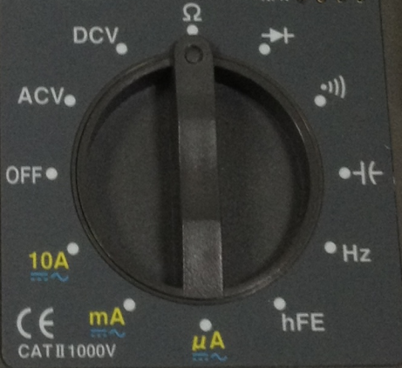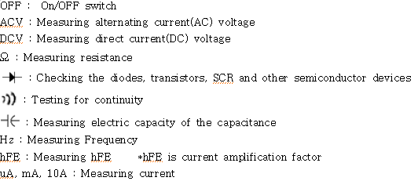

* How to connect the mulitmeter with the circuit

a) Measuring voltage

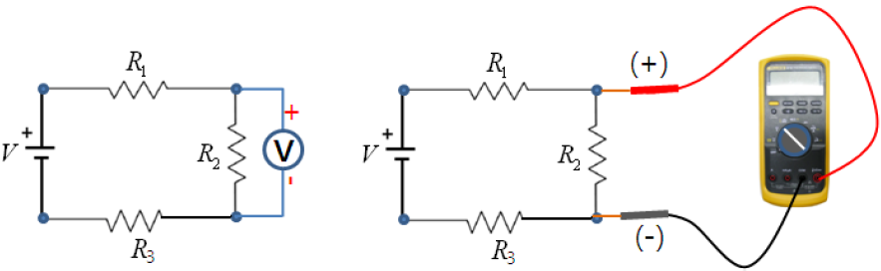

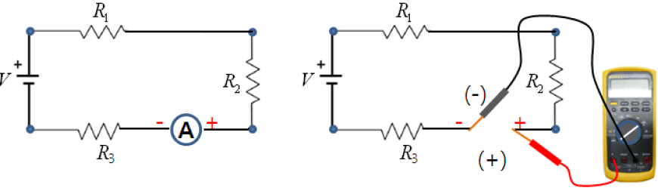b) Measuring current

*EMB00000e348597 Caution

a) Don't rotate the function switch when the multimeter is connected with the circuit.

b) Change the position of red probe when the function is changed ; You don't have to change 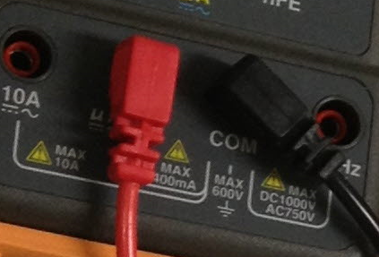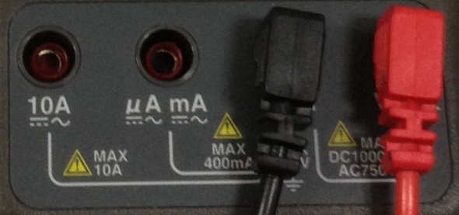the position of black probe.

-measuring resistance frequency and diode -measuring uA/mA

c) When measuring voltage or current, if the probes are connected reversely, the value we get is (-) value.

d) When using the probes, keep fingers from the exposed metal, transistor socket. Grab the finger guards behind transistor socket.

e) When measuring current, Don't connect directly with power supply. A lot amount of current flows, so multimeter may be out of order.

-Resistor

A. 3 types of resistor

1) Fixed resistors

Axial type - Carbon film resistor(usually ±5% tolerance)

Precision type - Resistor which is tolerable to temperature and humidity variation(±1%~±2% error range, Metal film resistor)

Chip type - Surface mount resistor

Array resistor - Resistors are compiled and arrayed to one resistor device.

2) Variable resistors

Variable resistors consist of a resistance track with connections at both ends and a wiper which moves along the track as you turn the spindle. The track may be made from carbon, cermet (ceramic and metal mixture) or a coil of wire (for low resistances). The track is usually rotary but straight track versions, usually called sliders, are also available.

3) Semi-fixed variable resistor

A semi-fixed type variable resistor is used in circuit where voltage could be varied constatly and includes an electrically insulating substrate, a semi-circular resistor member formed on the substrate, a slider member of similar semi-circular shape rotatably mounted on the substrate to slide over the resistor member, and a cover member rotatably mounted on the substrate and also serving as a knob for rotating the slider member.

B. Deep understanding of Axial resistor and SMD resistor

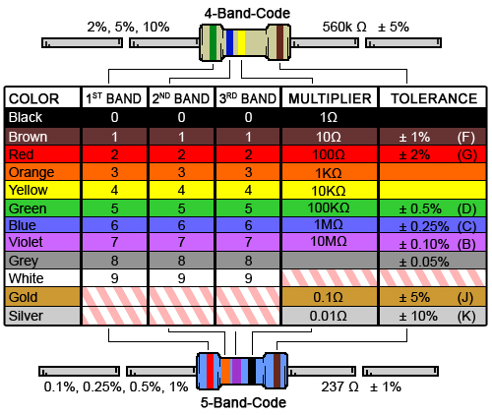1) Axial resistor

The axial lead carbon resistors measured by the colour codes marked on them. Information such as resistance value, tolerance, temperature co-efficient measured by the color codes, and the amount of power (wattage) identified by the size.

The colour bands of the carbon resistors can be four, five or, six bands, for all the first two bands represent first two digits to measure their value in Ohm. The third band of a four-banded resistor represents multiplier and the fourth band as tolerance. Whereas, the five and six colour-banded resistors, the third band rather represents as third digit but the fourth and fifth bands represent as multiplier and tolerance respectively. Only the sixth band represents temperature co-efficient in a six-banded resistor.

The number of color band on resistor would be 4 or 5(precision type resistor.

In case of 4 bands, the first and second from left side represent significant number, the third is multiplier exponent band and the fourth is tolerance band. In case of 5 bands, precision type resistor, the first, second and third bands represent number significant number, the fourth is multiplier exponent band and the fifth is tolerance band. Find the first band by identifying length gap of each bands. A gap between tolerance band and digit bands would be broader than a gap in other digit bands.

How to read color code - Example

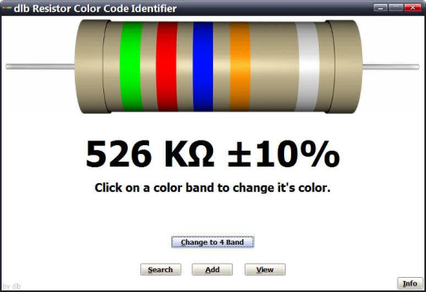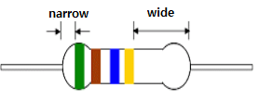(a) 4 color bands (b) 5 color bands

(a) First, find the tolerance band, black band means ±5% tolerance.DRW00000e3485a4 Starting from the other end, identify the first and second bands - write down the number associated with that color; in this case Green is 5 and Brown is 1. Now 'read' the next color, Blue band is multiplier exponent band, so it represents . As a result, resistor (a) represents 'DRW00000e3485a6 51× [Ω](tolerance ±5%)'

DRW00000e3485a8DRW00000e3485aa

(b) First, find the tolerance band, silver band means ±10% tolerance. Starting from the other end, identify the first, second and third bands - write down the number associated with that color; in this case Green is 5, Red is 2 and Blue is 6. Now 'read' the next color, Orange band is multiplier exponent band, so it represents . As a result, resistor (b) represents '526× [Ω](tolerance ±10%)'.

2) SMD resistor

SMD resistor is very tiny chip which has resistance. Resistance is presented on the chip with three or four figures. Unlike axial resistor, SMD resistor doesn't give a information about errors. If the numbers are three figures, first and second figures mean numbers and third figure means multiplier. Likewise, if the numbers are four figures, first, second and third figures mean numbers and the last one, fourth figure means multiplier. But there is one 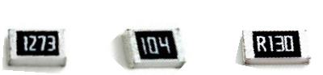caution. Often you can see not the number but alphabet R. This alphabet means the point(.). Let's read the resistance of bottom resistors!

First one has four figures 1273. 127 means the value and 3 means the multiplier. So resistance is 127×DRW00000e3485acΩ.

Second one has three figures 104. 10 means the value and 4 means the multiplier. So resistance is 10×DRW00000e3485aeΩ.

The last one has four figures R130. It has R!!! The first letter is R. So resistance is 0.130Ω.

**3. Materials**

-Multimeter

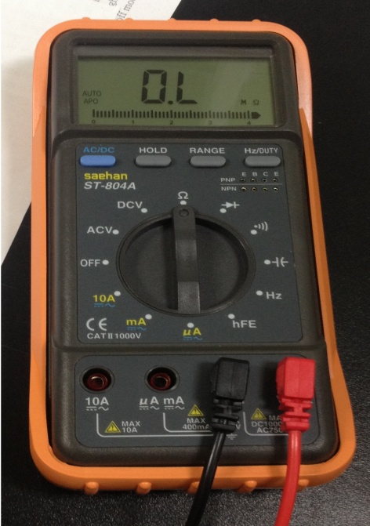

-Resistor

1) Axial resistor

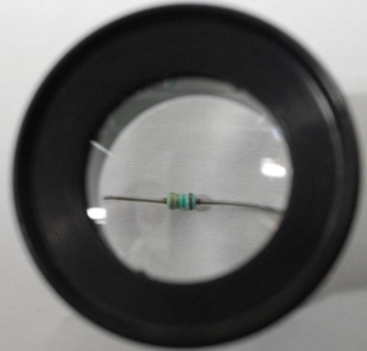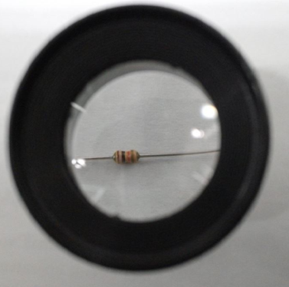

<axial resistor1> <axial resistor2>

2) SMD resistor

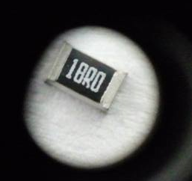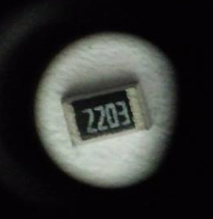

<SMD resistor1> <SMD resistor2>

**4. Experimental details**

1) Before starting to experiment, read Safety because of danger of electric shock or personal injury.

2) For measuring our multimeter's values, borrow another group's multimeter.

3) Change our multimeter's functions to voltmeter mode and the other to ohmmeter. Read voltmeter's resistance while changing the voltmeter's range.

4) Repeat 3) with changing our multimeter to ammeter.

5) Changing our multimeter to ohmmeter and the other to voltmeter. Read the values while changing the ohmmeter's range.

6) Repeat 5) with changing another group's multimeter to ammeter.

7) Measuring resistance of Axial resistor 1,2 and SMD resistor 1,2.

**5. Results**

-Know your multimeter

A. What is the internal resistance in voltmeter mode?

|  |  |  |  |  |  |
| --- | --- | --- | --- | --- | --- |
| **Resistance** | | | | **Voltage** | **Range** |
| **1** | **2** | **3** | **Average** |
| 494㏁ | 493㏁ | 493㏁ | 493.333㏁ | 145.2mV | 400.0mV |
| 3.428㏁ | 3.429㏁ | 3.428㏁ | 3.428㏁ | 0.339V | 4.000V |
| 3.327㏁ | 3.328㏁ | 3.327㏁ | 3.327㏁ | 00.33V | 40.00V |
| 3.318㏁ | 3.319㏁ | 3.318㏁ | 3.318㏁ | 000.3V | 400.0V |
| 3.313㏁ | 3.317㏁ | 3.318㏁ | 3.316㏁ | 0000V | 1000V |

B. What is the internal resistance in ammeter mode?

|  |  |  |  |  |  |
| --- | --- | --- | --- | --- | --- |
| **Resistance** | | | | **Current** | **Range** |
| **1** | **2** | **3** | **Average** |
| 000.8Ω | 000.9Ω | 001.0Ω | 000.9Ω | 00.18 mA | 40.00mA |
| 000.9Ω | 001.0Ω | 001.1Ω | 001.Ω | 000.1mA | 400.0mA |

|  |  |  |  |  |  |
| --- | --- | --- | --- | --- | --- |
| **Resistance** | | | | **Current** | **Range** |
| **1** | **2** | **3** | **Average** |
| 38.4Ω | 38.4Ω | 38.5Ω | 038.4Ω | 183.5uA | 400.0uA |
| 049.7Ω | 049.8Ω | 049.7Ω | 049.7Ω | 182uA | 4000uA |

|  |  |  |  |  |  |
| --- | --- | --- | --- | --- | --- |
| **Resistance** | | | | **Current** | **Range** |
| **1** | **2** | **3** | **Average** |
| 0.4Ω | 0.5Ω | 0.4Ω | 0.4333Ω | 0.00A | 1.000A |
| 0.3Ω | 0.2Ω | 0.2Ω | 0.2333Ω | 00.00A | 10.00A |

C. What is the test voltage/current in resistance mode?

|  |  |  |  |  |  |
| --- | --- | --- | --- | --- | --- |
| **DCV** | | | | **Resistance** | **Range** |
| **1** | **2** | **3** | **Average** |
| 0.426V | 0.439V | 0.438V | 0.4343V | 0L.Ω | 400.0Ω |
| 0.439V | 0.437V | 0.439V | 0.4383V | .0LkΩ | 4.000kΩ |
| 0.437V | 0.438V | 0.439V | 0.438V | 0.LkΩ | 40.00kΩ |
| 0.426V | 0.439V | 0.439V | 0.4347V | 0L.kΩ | 400.0kΩ |
| 365.9mV | 366.0mV | 366.mV | 365.967mV | .0L㏁ | 4.000MΩ |
| 145.7mV | 145.8mV | 145.9mV | 145.8mV | 04.94㏁ | 40.00MΩ |

**\*OL is overload**

|  |  |  |  |  |  |  |  |  |
| --- | --- | --- | --- | --- | --- | --- | --- | --- |
| **DC current** | | | | | | | **Resistance** | **Range** |
| **1** | | **2** | | **3** | | **Average** |
| 00.18mA | | 00.17mA | | 00.17mA | | 00.173mA | 001.0Ω | 400.0Ω |
| 00.16mA | | 00.17mA | | 00.17mA | | 00.165mA | 0.001kΩ | 4.000kΩ |
| 00.03mA | | 00.04mA | | 00.03mA | | 00.035mA | 00.00kΩ | 40.00kΩ |
| 00.00mA | | 00.00mA | | 00.00mA | | 00.00mA | 000.0kΩ | 400.0kΩ |
| 00.00mA | | 00.00mA | | 00.00mA | | 00.00mA | 0.000㏁ | 4.000MΩ |
| 00.00mA | | 00.00mA | | 00.00mA | | 00.00mA | 00.00㏁ | 40.00MΩ |
| **DC current** | | | | | | | **Resistance** | **Range** |
| **1** | **2** | | **3** | | **Average** | |
| 176.1uA | 176.0uA | | 176.1uA | | 176.0666uA | | 50.0Ω | 400.0Ω |
| 176.1uA | 176.2uA | | 176.0uA | | 176.1uA | | 0.049kΩ | 4.000kΩ |
| 38.4uA | 38.4uA | | 38.5uA | | 38.4333uA | | 00.04kΩ | 40.00kΩ |
| 4.3uA | 4.3uA | | 4.3uA | | 4.3uA | | 000.0kΩ | 400.0kΩ |
| 0.4uA | 0.4uA | | 0.3uA | | 0.3666uA | | 0.000MΩ | 4.000MΩ |
| 00.00uA | 00.00uA | | 00.00uA | | 00.00uA | | 00.00MΩ | 40.00MΩ |

|  |  |  |  |  |  |
| --- | --- | --- | --- | --- | --- |
| **DC current** | | | | **Resistance** | **Range** |
| **1** | **2** | **3** | **Average** |
| 0.000A | 0.000A | 0.000A | 0.000A | 000.3Ω | 400.0Ω |
| 0.000A | 0.000A | 0.000A | 0.000A | 0.000kΩ | 4.000kΩ |
| 0.000A | 0.000A | 0.000A | 0.000A | 00.00kΩ | 40.00kΩ |
| 0.000A | 0.000A | 0.000A | 0.000A | 000.0kΩ | 400.0kΩ |
| 0.000A | 0.000A | 0.000A | 0.000A | 0.000MΩ | 4.000MΩ |
| 0.000A | 0.000A | 0.000A | 0.000A | 00.00MΩ | 40.00MΩ |

-Measure resistance

A. Report the measured resistance values.

|  |  |  |  |  |  |
| --- | --- | --- | --- | --- | --- |
| **Resistor** | **1** | **2** | **3** | **Average** | **Expected value** |
| Axial resistor 1 | 1.7Ω | 1.6Ω | 1.6Ω | 1.63Ω | 1.5Ω |
| Axial resistor 2 | 9.88kΩ | 9.89kΩ | 9.88kΩ | 9.8833kΩ | 10.kΩ |
| SMD resistor 1 (18R0) | 18.2Ω | 18.3Ω | 18.2Ω | 18.23Ω | 18.Ω |
| SMD resistor 2 (2203) | 220.5kΩ | 220.4kΩ | 220.5kΩ | 220.4667kΩ | 220.kΩ |

B. What are the expected resistance values from the markings

We expect that the resistance value of axial resistor 1 is 1.5Ω . Because axial resistor 1 has 4 bands whose colors are brown, black, orange and gold. Axial resistor 2 also has 4 bands of brown, green and two gold colors, so it is expected that the resistance value of axial resistor 2 is 10kΩ. And Both resistors have ±5% errors because both have gold color band lastly.

Numbers printed at SMD resistor 1 are 18R0 and these mean 18.0Ω . Likewise, the resistance value of SMD resistor 2 is 220kΩ .

C. What are the errors?

The Error of axial resistor 1 : (1.63-1.5)/1.5 X100=8.667%

The error of axial resistor 2 : (9.8833-10)/10 X100=-1.1167%

The error of SMD resistor 1 : (18.23-18)/18 X100=1.278%

The error of SMD resistor 2 : (220.4667-220) X100=0.2122%

**6. Conclusion**

-Voltmeter's resistance

According to the chart about voltmeter's resistance, all values of resistance are very large. That is because the less current flows in voltmeter, the more accurate the values of voltage that is generated at the resistor which is our target are. So the value of voltmeter's resistance should be low. Ideally resistance of voltmeter is infinite value, but it is finite value in real.

-Why does overload occur in experiment C(What is the test voltage in resistance mode)?

The value of voltmeter's resistance is big, but the range of ohmmeter is very low. The value is 4.94MΩ, so in range to 4.000MΩ the ohmmeter can't read that high value and is overloaded.

-Ammeter's resistance

According to the chart about Ammeter's resistance, all values of resistance are very low. Because the less resistance of ammeter is, the exact the value of current that flows in the resistor is. Ammeter's resistance is ideally 0, but more than 0 in real.

-Why the values are different when the range changes?

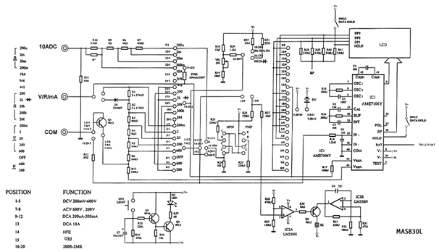 Bottom circuit is the multimeter's circuit.

There are many circuits in one multimeter and we choose different circuits each time as changing switches and ranges. Values are different from each other because each circuit paths in multimeter have different resistance value.

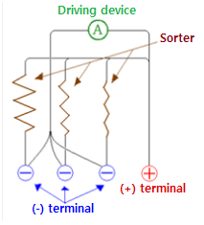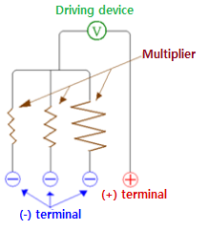

-Why are there errors?

There are some reasons that make errors.

1) Temperature variation in multimeter could make errors. Resistance of component in multimeter is varied on temperature. Also, humidity variation influences resistance of component in multimeter.

2) To turn on multimeter, difference between controlled variable and manipulated variable could be error.

3) Attached area between probe and probe is not constant at all time because two men control the probes.

4) There are a lot of electronic components in multimeter. Some erros from those components. ex: resistance in probe line. etc

5) When we attach two probes to lead of axial resistor, length of resistor in case of each experiment is all different.

6) There are errors in resistors itself. Sometimes the resistors present errors by some ways. For example, axial resistor shows errors by the last color band. But SMD resistor doesn't show errors.

**7. Reference**

http://airborn.com.au/circuits/meter.html

http://en.wikipedia.org/wiki/Multimeter

http://components.about.com/od/Components/a/Types-Of-Resistors.htm

http://en.wikipedia.org/wiki/Electronic_color_code

http://en.wikipedia.org/wiki/Resistor

**8. Contribution**

Data collection : Ye-dam Lee

Data analysis : Ho-young Kim, Keun-won Kang

Writing : Ji-won Seol

Conclusion : Hye-jeong Cheon, Yoo-joong Han