**Applied circuits and Electronics I**

**Lab 3**

Capacitor

**Professor : Hyung-Bin Son**

**Group : 1**

**Students : Keun-Won Kang (20115395)**

**Ho-Young Kim (20123943)**

**Ji-Won Seol (20115400)**

**Ye-Dam Lee (20122445)**

**Hye-Jeong Cheon (20113241)**

**Yoo-Joong Han (20120565)**

**1. Purpose**

Understanding the capacitor and making a simple circuit with it.

**2. Background & Introduction**

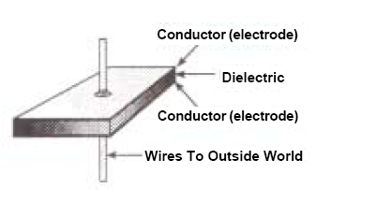-Capacitor

A capacitor (originally known as a condenser) is a passive two-terminal electrical component

used to store energy electrostatically in an electric field. One common construction consists of metal foils separated by a thin layer of insulating film. Capacitors are widely used in electronic circuits for blocking direct current while allowing alternating current to pass. In analog filter networks, they smooth the output of power supplies. In resonant circuits they tune radios to particular frequencies. In electric power transmission systems they stabilize voltage and power flow.

When there is a potential difference across the conductors, an electric field develops across the dielectric, causing positive charge to collect on one plate and negative charge on the other plate. Energy is stored in the electrostatic field. An ideal capacitor is characterized by a single constant value, capacitance. This is the ratio of the electric charge on each conductor to the potential difference between them.

The capacitance is greatest when there is a narrow separation between large areas of conductor, hence capacitor conductors are often called plates, referring to an early means of construction. In practice, the dielectric between the plates passes a small amount of leakage current and also has an electric field strength limit, the breakdown voltage. The conductors and leads introduce an undesired inductance and resistance.

**3. Materials**

-Breadboard -Power supply

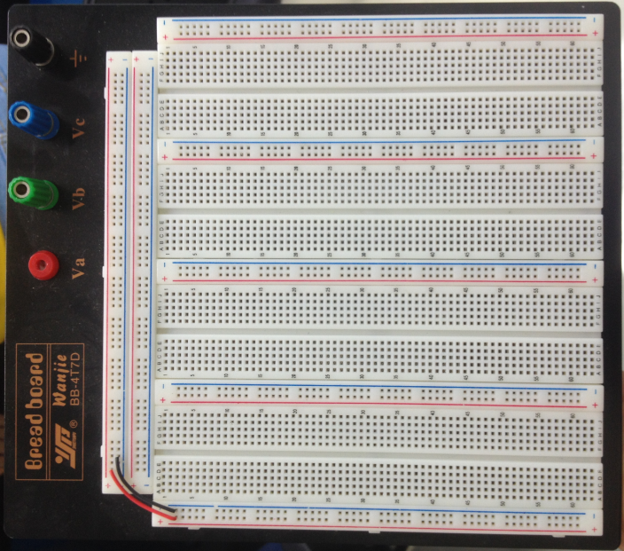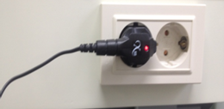

-Resistance

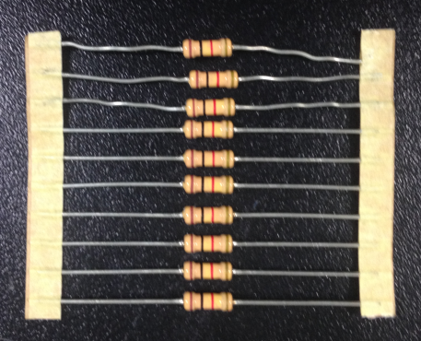

-Capacitor -Multimeter -wire

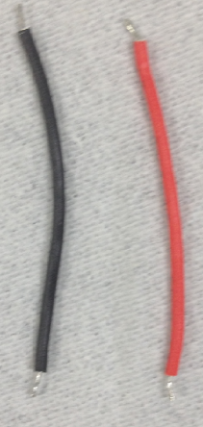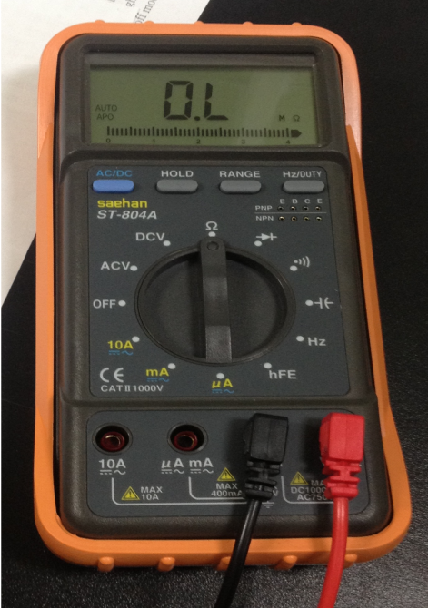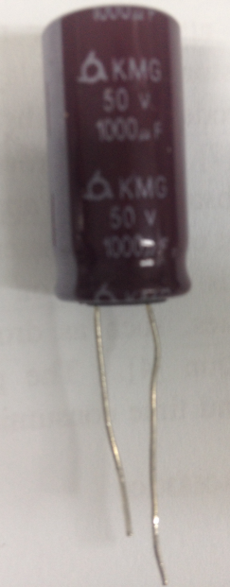

**4. Experimental details**

-Charging a capacitor

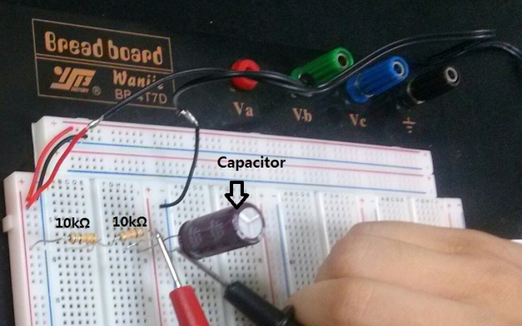1) Construct the circuit shown on the right with R=20000Ω and C=1000uF.

2) Make sure that the capacitor is initially discharged.

3) Start charging the capacitor with a finite power supply voltage V.

Measure the voltage across the capacitor as a function of time.

4) Stop the measurement when the capacitor is nearly fully charged.

5) Plot the voltage as a function of time and compare with the theoretical value.

-Discharging a capacitor

1) Stop charging the capacitor in 1 and the capacitor will start to self discharge.

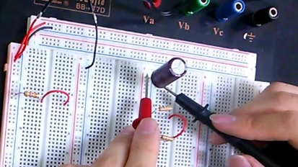 Start the measurement as soon as possible.

2) Start discharging the fully charged capacitor with V=0.

3) Plot the voltage as a function of time and compare with the theoretical value.

**5. Results**

-Charging a capacitor

1) Measure the voltage across the capacitor as a function of time.

|  |  |  |  |  |  |
| --- | --- | --- | --- | --- | --- |
| **Sec** | **V** | **Sec** | **V** | **Sec** | **V** |
| 0 | 0.0043 | 20 | 2.928 | 130 | 4.54 |
| 1 | 0.0531 | 30 | 3.584 | 131 | 4.54 |
| 2 | 0.2489 | 40 | 3.959 | 132 | 4.54 |
| 3 | 0.3948 | 50 | 4.19 |  |  |
| 4 | 0.78 | 60 | 4.33 |  |  |
| 5 | 0.962 | 70 | 4.42 |  |  |
| 6 | 1.192 | 80 | 4.47 |  |  |
| 7 | 1.1349 | 90 | 4.5 |  |  |
| 8 | 1.51 | 100 | 4.52 |  |  |
| 9 | 1.66 | 110 | 4.53 |  |  |
| 10 | 1.806 | 120 | 4.54 |  |  |

The voltage of power supply is 4.58V. And We measured voltage from 0V~to 4.54V (0s~132s).

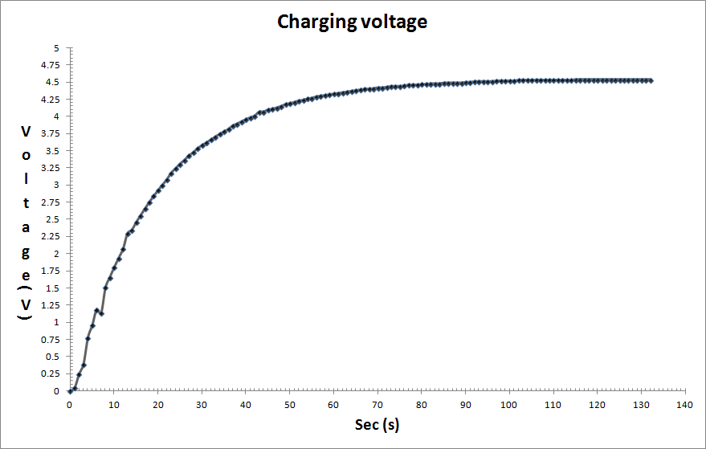2) Plot the voltage as a function of time.

The above graph is made by excel.

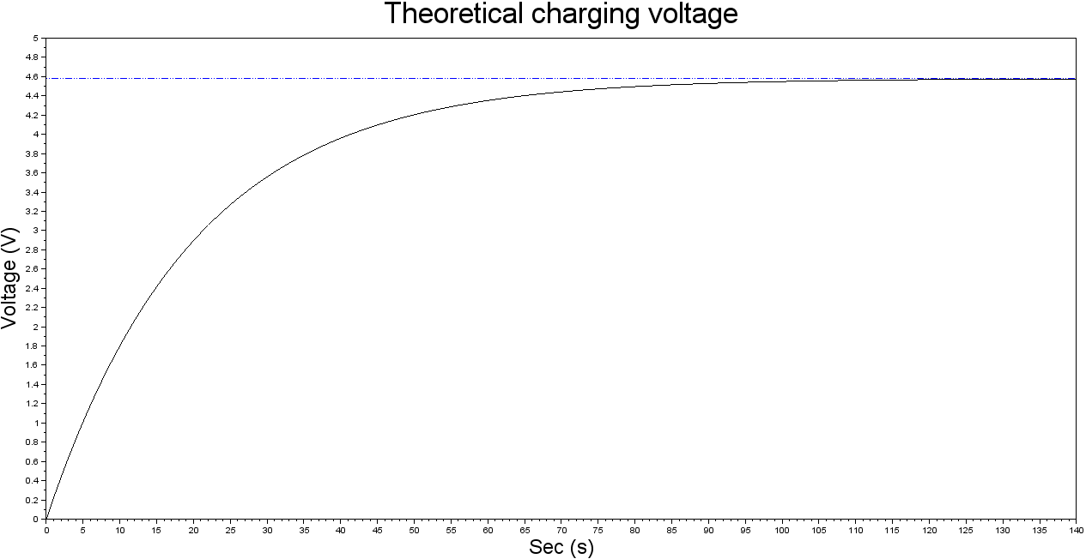3) Plot the theoretical charging voltage as a function of time

The above graph is made by scilab. And the codes of it is as follows.

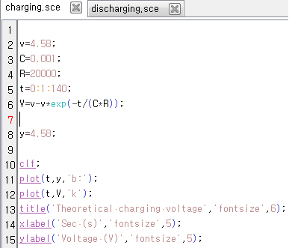

-Discharging a capacitor

1) Measure the voltage across the capacitor as a function of time.

|  |  |  |  |  |  |  |  |
| --- | --- | --- | --- | --- | --- | --- | --- |
| **Sec** | **V** | **Sec** | **V** | **Sec** | **V** | **Sec** | **V** |
| 1 | 4.27 | 20 | 1.555 | 120 | 0.0127 | 220 | 0.0021 |
| 2 | 4.08 | 30 | 0.85 | 130 | 0.0092 | 230 | 0.0019 |
| 3 | 3.87 | 40 | 0.516 | 140 | 0.0069 | 240 | 0.0018 |
| 4 | 3.69 | 50 | 0.2841 | 150 | 0.0054 | 250 | 0.0016 |
| 5 | 3.395 | 60 | 0.175 | 160 | 0.0044 | 260 | 0.0016 |
| 6 | 3.238 | 70 | 0.11 | 170 | 0.0037 | 261 | 0.0016 |
| 7 | 3.076 | 80 | 0.066 | 180 | 0.0032 | 262 | 0.0015 |
| 8 | 2.889 | 90 | 0.0425 | 190 | 0.0028 |  |  |
| 9 | 2.756 | 100 | 0.0267 | 200 | 0.0025 |  |  |
| 10 | 2.616 | 110 | 0.0182 | 210 | 0.0023 |  |  |

We started the experiment when the capacitor was almost fully charged(4.54V). The reason that the voltage is 4.27V when 1s is that the self-discharge was started when we construct new circuit.

We measured voltage from 4.27V to 0.0015V(1.5mV).

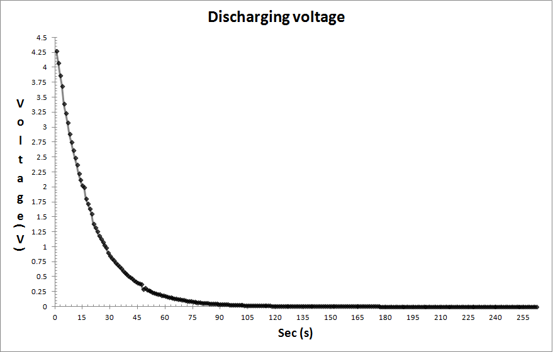2) Plot the voltage as a function of time.

The above graph is made by excel.

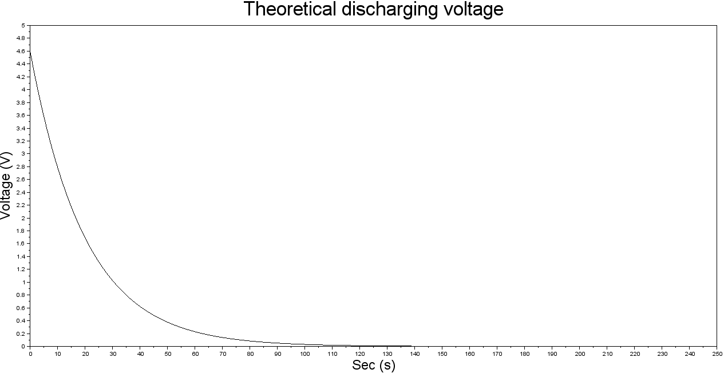3) Plot the theoretical discharging voltage as a function of time.

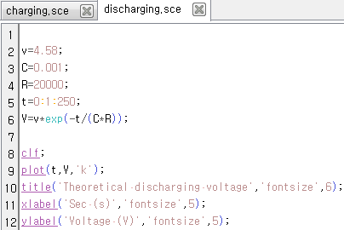

The above graph is made by scilab. And the codes of it is as follows.

**6. Conclusion**

-Charging a capacitor

1) Describe how the capacitor is initially discharged.

Before we experiment, the capacitor can’t be fully discharged. That can affect the result, so we

need to check that the voltage of the capacitor is nearly 0V. To be convinced, we construct the

circuit like when we discharging experiment. And measured the voltage of capacitor until the

value is 0V. When 0V, we can start the charging experiment.

2) How can we change the rate of charging

When the resistance changes, the rate of charging changes. If the resistance increases, in circuit, the electrons are disturbed more, so the rate of charging decreases. On the contrary, if the resistance decreases, the electrons move with less disturbance, so the rate of charging increases. Therefore, the rate of charging is inversely proportional to resistance.

3) Do the theoretical values match the experimental ones? Explain the source of errors.

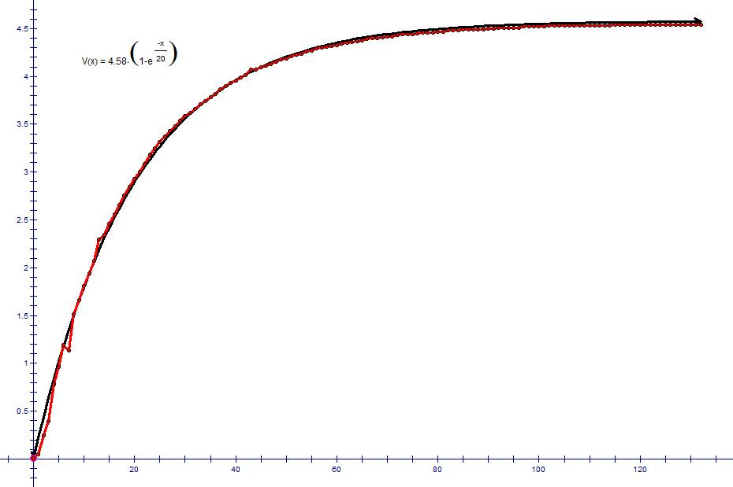

The above graph is made by gsp4.

According to the graph, the experimental values almost match with the theoretical values. Some sections show the errors. The sources of these errors are the temperature and humidity in laboratory, the resistance of breadboard, wire, multimeter and so on.

-Discharging a capacitor

1) Why the self-discharging occurs in capacitor?

If between two conductors there is not vacuum, the electrons can transfer through the some materials.

2) Do the theoretical values match the experimental ones? Explain the source of errors.

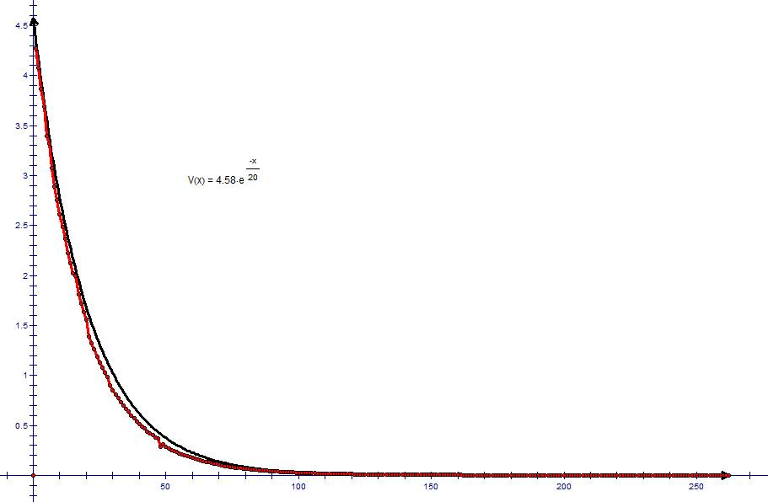The above graph is made by gsp4.

According to the graph, the experimental values almost match with the theoretical values. Some sections show the errors. The sources of these errors are alike with charging experiment. The temperature and humidity in laboratory, the resistance of breadboard, wire, multimeter make errors.

**7. Reference**

<http://blog.naver.com/slg556?Redirect=Log&logNo=10175031972>

<http://en.wikipedia.org/wiki/Capacitor>

http://blog.daum.net/nagok/361216

Scilab.exe

<http://m.blog.daum.net/_blog/_m/articleView.do?blogid=0LFOU&articleno=4788782>

**8. Contribution**

Data collection : Hye-Jeong Cheon

Data analysis : Ho-Young Kim, Keun-Won Kang

Writing : Ye-Dam Lee, Yoo-Joong Han

Conclusion : Ji-Won Seol, Ho-Young Kim, Yoo-Joong Han