**Applied circuits and Electronics I**

**Lab 4**

Diode & MOSFET

**Professor : Hyung-Bin Son**

**Group : 1**

**Students : Keun-Won Kang (20115395)**

**Ho-Young Kim (20123943)**

**Ji-Won Seol (20115400)**

**Ye-Dam Lee (20122445)**

**Hye-Jeong Cheon (20113241)**

**Yoo-Joong Han (20120565)**

**1. Purpose**

Make the circuits with diode and MOSFET, compare the experimental data with the theoretical data and understand their properties.

**2. Background & Introduction**

-Shockley diode model

The Shockley ideal diode equation or the diode law (named after transistor co-inventor William Bradford Shockley) gives the I–V characteristic of an ideal diode in either forward or reverse bias (or no bias). The Shockley ideal diode equation is below, where n, the ideality factor, is equal to 1 :

EMB00001a10859b

where

I is the diode current,

IS is the reverse bias saturation current (or scale current),

VD is the voltage across the diode,

VT is the thermal voltage, and

n is the ideality factor, also known as the quality factor or sometimes emission coefficient. The ideality factor n typically varies from 1 to 2 (though can in some cases be higher), depending on the fabrication process and semiconductor material and in many cases is assumed to be approximately equal to 1 (thus the notation n is omitted). The ideality factor does not form part of the Shockley ideal diode equation, and was added to account for imperfect junctions as observed in real transistors. By setting n = 1 above, the equation reduces to the Shockley ideal diode equation.

The thermal voltageVT is approximately 25.85 mV at 300 K, a temperature close to "room temperature" commonly used in device simulation software. At any temperature it is a known constant defined by:

EMB00001a10859a

where k is the Boltzmann constant, T is the absolute temperature of the p–n junction, and q is the magnitude of charge of an electron (the elementary charge).

The reverse saturation current, IS, is not constant for a given device, but varies with temperature; usually more significantly than VT, so that VD typically decreases as T increases.

-MOSFET

The metal–oxide–semiconductor field-effect transistor (MOSFET, MOS-FET, or MOS FET) is a transistor used for amplifying or switching electronic signals. Although the MOSFET is a four-terminal device with source (S), gate (G), drain (D), and body (B) terminals,[1] the body (or substrate) of the MOSFET often is connected to the source terminal, making it a three-terminal device like other field-effect transistors. Because these two terminals are normally connected to each other (short-circuited) internally, only three terminals appear in electrical diagrams. The MOSFET is by far the most common transistor in both digital and analog circuits, though the bipolar junction transistor was at one time much more common.

For an enhancement-mode, n-channel MOSFET, the three operational modes are:

A. Cutoff, subthreshold, or weak-inversion mode

When VGS < Vth:

Where VGS is gate-to-source bias and Vth is the threshold voltage of the device.According to the basic threshold model, the transistor is turned off, and there is no conduction between drain and source. A more accurate model considers the effect of thermal energy on the Boltzmann distribution of electron energies which allow some of the more energetic electrons at the source to enter the channel and flow to the drain. This results in a subthreshold current that is an exponential function of gate–source voltage. While the current between drain and source should ideally be zero when the transistor is being used as a turned-off switch, there is a weak-inversion current, sometimes called subthreshold leakage.

B. Triode mode or linear region

When VGS > Vth and VDS < ( VGS – Vth )

The transistor is turned on, and a channel has been created which allows current to flow between the drain and the source. The MOSFET operates like a resistor, controlled by the gate voltage relative to both the source and drain voltages. The current from drain to source is modeled as:

EMB00000f9416cc

where EMB00000f9416cd is the charge-carrier effective mobility, EMB00000f9416ce is the gate width, EMB00000f9416cf is the gate length and EMB00000f9416d0 is the gate oxide capacitance per unit area. The transition from the exponential subthreshold region to the triode region is not as sharp as the equations suggest.

C. Saturation or active mode

When VGS > Vth and VDS ≥ ( VGS – Vth )

The switch is turned on, and a channel has been created, which allows current to flow between the drain and source. Since the drain voltage is higher than the source voltage, the electrons spread out, and conduction is not through a narrow channel but through a broader, two- or three-dimensional current distribution extending away from the interface and deeper in the substrate. The onset of this region is also known as pinch-off to indicate the lack of channel region near the drain. The drain current is now weakly dependent upon drain voltage and controlled primarily by the gate–source voltage, and modeled approximately as:

EMB00000f9416da

**3. Materials**

-Power supply (5V)

-Breadboard

-Wire

-Multimeter

-Diode

-MOSFET

-Variable resistor

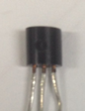

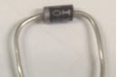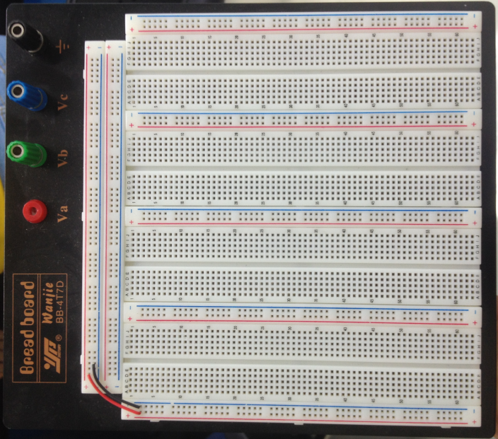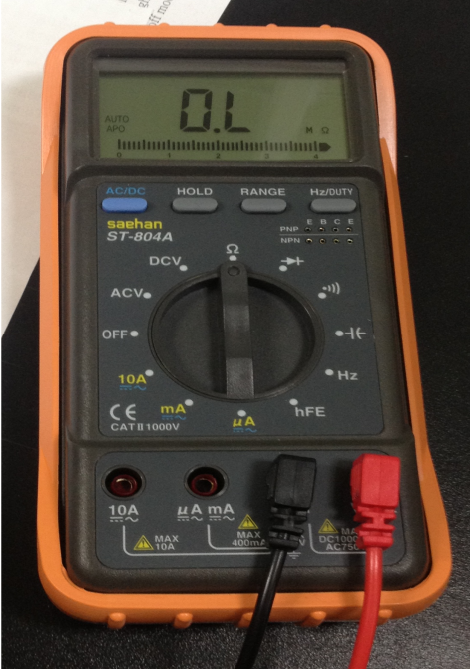 **(b)**



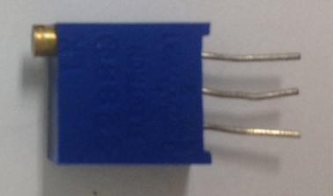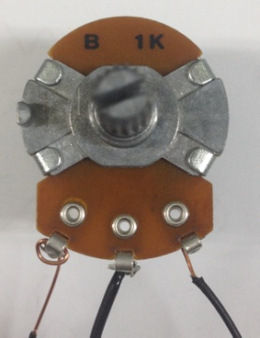

1. is MOSFET
2. is Diode
3. and (d) are variable resistor

**(c) (d)**

**4. Experimental details**

-Diode IV characteristics

1) Use the variable resistor circuit to apply a continuously variable voltage to a diode.

2) Measure the voltage across the diode and the current flowing through the diode.

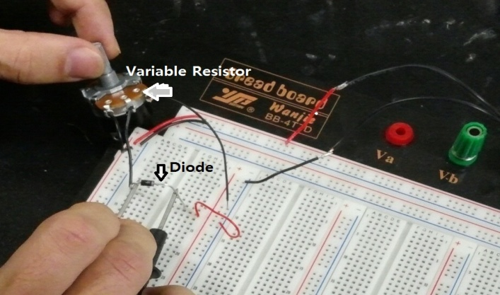 3) Plot the current as a function of the voltage.

-MOSFET characteristics

1) Use two variable resistor circuits to generate VG and VD.

Set VS = GND.

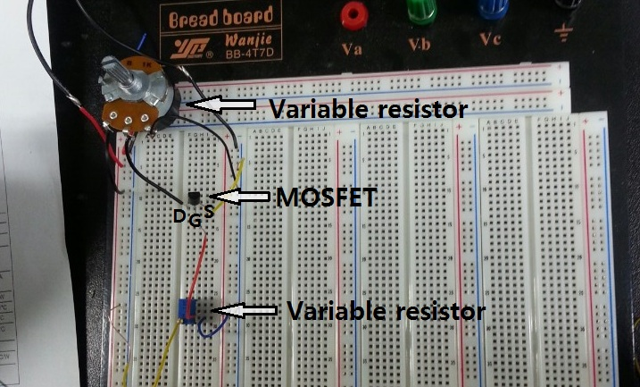

2) Measure the mosfet chracteristic using many different VGS and VDS values.

For example, vary VDS continuously at some discrete VGS values. (ex VGS=0, 0.5, 1, 1.5, 2, 3, 4V)

3) Plot the experimental data with theoretical model.

**5. Results**

-Diode IV characteristics

A. Measure the voltage across the diode and the current flowing through the diode.

|  |  |  |  |  |  |  |  |
| --- | --- | --- | --- | --- | --- | --- | --- |
| **V(V)** | **I(mA)** | **V(V)** | **I(mA)** | **V(V)** | **I(mA)** | **V(V)** | **I(mA)** |
| 0 | 0 | 0.452 | 0.06 | 0.673 | 7.8 | 0.772 | 78.2 |
| 0.1 | 0 | 0.502 | 0.1574 | 0.674 | 8.28 | 0.8 | 165.6 |
| 0.2 | 0 | 0.6 | 1.53 | 0.7 | 13.88 | 0.824 | 245 |
| 0.3003 | 0.0007 | 0.63 | 3.53 | 0.722 | 22.34 | 0.852 | 963 |
| 0.4004 | 0.014 | 0.645 | 4.26 | 0.753 | 46.3 | 0.867 | 1005 |

B. Plot the current as a function of the voltage.

We can know that the current is sharply increasing over the certain point.

-MOSFET characteristics

A. Measure the MOSFET characteristic using many different VGS and VDS values

|  |  |  |  |  |  |
| --- | --- | --- | --- | --- | --- |
| **VGS(V)** | **VDS(V)** | **ID(mA)** | **VGS(V)** | **VDS(V)** | **ID(mA)** |
| **2** | 0.0017 | 0 | **2.505** | 0.0011 | 0.08 |
| 0.997 | 0.14 | 0.528 | 9.79 |
| 1.505 | 0.15 | 1.07 | 10.77 |
| 1.997 | 0.16 | 1.493 | 11.34 |
| 2.511 | 0.17 | 2.08 | 11.96 |
| 3.023 | 0.18 | 2.515 | 12.41 |
| 3.495 | 0.19 | 2.971 | 12.83 |
| 4.008 | 0.2 | 3.555 | 13.39 |
| 4.58 | 0.21 | 3.91 | 13.74 |
|  |  | 4.36 | 14.12 |

|  |  |  |  |  |  |
| --- | --- | --- | --- | --- | --- |
| **VGS(V)** | **VDS(V)** | **ID(mA)** | **VGS(V)** | **VDS(V)** | **ID(mA)** |
| **3** | 0.0007 | 0.14 | **3.5** | 0.0005 | 0.16 |
| 0.505 | 70.7 | 0.552 | 140.9 |
| 0.996 | 82.8 | 0.991 | 188.3 |
| 1.52 | 87.4 | 2.533 | 241.3 |
| 1.905 | 93.7 | 2.825 | 244.6 |
| 2.45 | 99.4 | 2.959 | 244.7 |
| 2.907 | 103.1 | 3.074 | 245.1 |
| 3.668 | 108.4 | 3.118 | 247.3 |
| 3.866 | 110 |  |  |

When VGS is 2V, the current is very low and the change is little during increasing of VDS. And when VGS is larger than 2.505V, the current is increasing evidently.

B. Plot the experimental data.

**6. Conclusion**

-Diode IV characteristics

A. Use Shockley diode model to explain the observed data. EMB00001a10859b

What are the values of **Is** and **n** that best describe the experimental results? Plot the theoretical data on the same plot as the experimental data.

When Is=2x10^-7, n=1.5, the experimental data matches well with the theoretical data.

The above graphs are Log(current)-Voltage ones. These graphs can show association between the experimental values and the theoretical ones better than current-voltage ones.

B. What can explain the difference between the experimental results and the Shockley diode model.

Looking at the graph in detail, the experimental data don’t match the theoretical data completely, of course. Because there are always many errors. In this time, we assume that VT is 25.85mV (when T=300K, VT is 25.85mV), but the temperature in laboratory changes. The errors also can be made by multimeter, variable resistor, breadboard and etc.

-MOSFET characteristics

A. What are the values of Vth and β used?

When Vth=2.2V, b=0.25, the experimental graphs match with the theoretical graphs approximately.

**7. Reference**

-http://en.wikipedia.org/wiki/Diode#Shockley_diode_equation

-http://en.wikipedia.org/wiki/MOSFET

**8. Contribution**

Data collection : Hye-Jeong Cheon, Ji-Won Seol, Ho-Young Kim

Data analysis : Hye-Jeong Cheon, Yoo-Joong Han

Writing : Ye-Dam Lee, Yoo-Joong Han, Ho-Young Kim

Conclusion : Keun-Won Kang, Yoo-Joong Han